**[](http://iddsi.org/wp-content/uploads/2018/01/5i-Minced-Moist.png)**



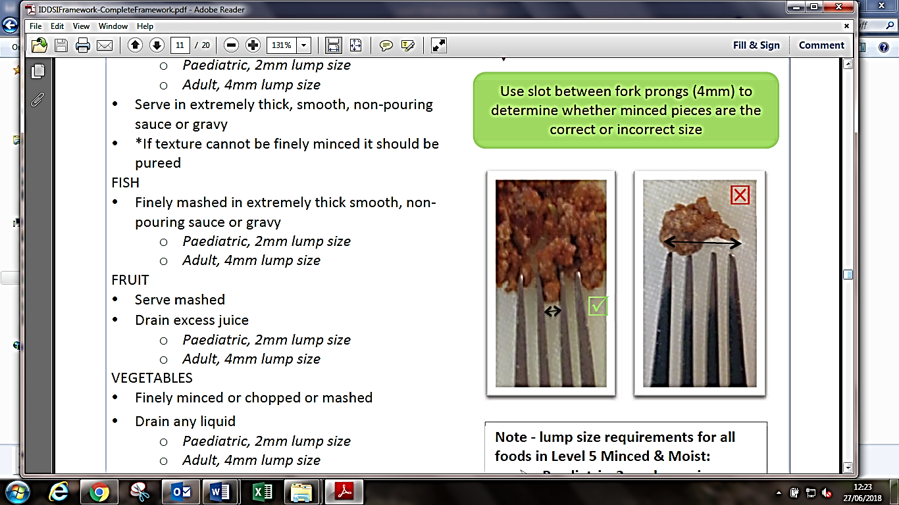

Use slot between fork prongs (4mm) to determine whether minced pieces are the correct or incorrect size