**[](http://iddsi.org/wp-content/uploads/2018/01/6i-Soft-Bite-Sized.png)**

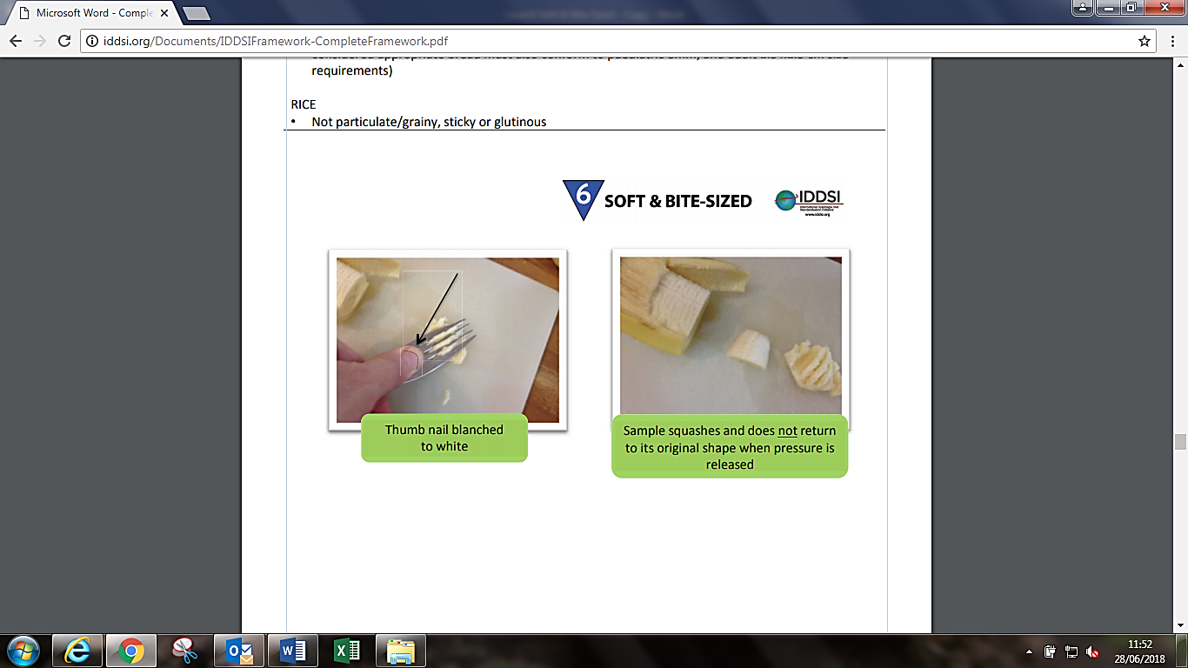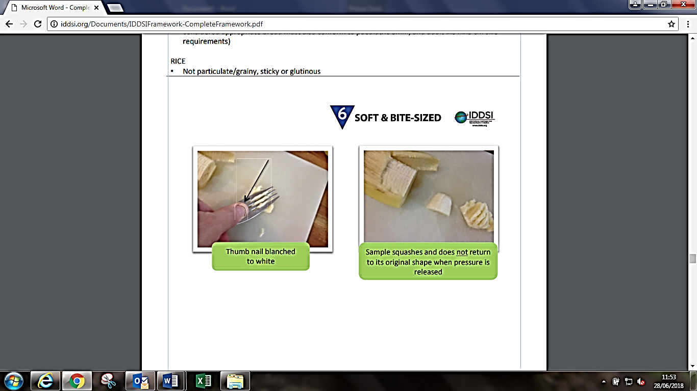

Sample squashes and does **not** return to its original shape when pressure is released

Thumb nail changed to white