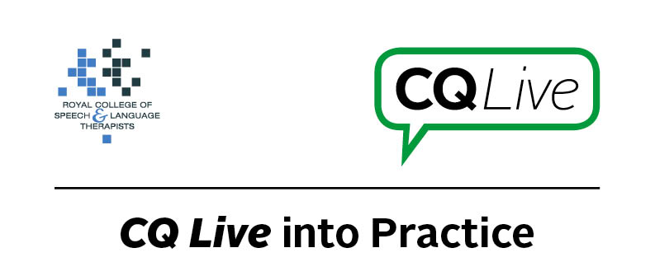
Review of AAC app use

About this document
This document is designed to take you through a practice-based scenario to help you reflect on what you might do if faced with a similar situation. It can be used to guide your thoughts and prompt discussion with your colleagues. Working through this document counts towards your continuing professional development (CPD). Your reflections on this document are not assessed and you do not have to send your responses to the RCSLT.
You can work through it on your own, with a colleague or supervisor, or in groups, eg as part of an RCSLT Hub or Clinical Excellence Network.
This document is broken into five parts:
- The scenario: for you to read
- The issues to consider: for you to gather your thoughts on practice issues relating to this scenario
- Next steps: for you to plan out what you would need to do next
- Prompts for consideration: RCSLT prompts for further consideration
- Sources of further information: links to CQ Live themes
- Update your CPD diary: for you to do

- The scenario

You visit a patient in their home to review their use of an AAC app.
You discover that they have not been using the AAC app but that they have been enjoying using other functions on the iPad, eg listening to music, browsing the internet.
The iPad had been loaned to the patient by the speech and language therapy department.

What do you do in this scenario?

- The issues to consider

What do you need to consider?
Think about the above scenario and its implications and jot down your notes about issues you may need to consider. Please feel free to use extra sheets of paper if you need. Or, if you are in a group, you may like to record on a whiteboard or flipchart.

- Next steps

What steps do you think you need to take next?

- Prompts for consideration

The successful and ongoing use of an AAC app is dependent on a number of factors such as client motivation, effort required to use the app, the support of others, speed of usage, and accessibility issues. Tablet devices also have many other features that individuals may enjoy using. These may or may not distract the user from the primary aim of using the device as a communication aid.
It is recommended that you think about the following prompt questions and formulate a considered strategy to deal with the problem.
Remember that if you are faced with a similar situation you will need to think about it in relation to the frameworks within which you work, such as the Health and Care Professions Council (HCPC) Standards, RCSLT professional guidance and resources, local and national policies and also policies of your employer (or your own policies if practising independently). Communicating Quality Live (www.rcslt.org/cq_live) and the list of prompts that follow, will help with your thinking.
Please note that this list is not exhaustive and does not constitute legal advice.
Prompt questions to consider
- Has the client demonstrated the ability to use the app without assistance?
- Is the client able to indicate their needs by other means?
- Has the client’s communication needs or ability to use the AAC app changed?
- Would an alternative app or other low-tech AAC be more suitable?
- How long was the trial prior to loaning the device to the client?
- Did the client demonstrate motivation to use the device during and at the end of the trial?
- Had the client and their family been informed the device could only remain on loan if they were using it as a communication aid?
- Did the client have support from family to use the app?
- Were family members trained in the use of the app and how best to support the client?
- Could the device be locked down to use only for AAC?
Possible next steps
- See local guidelines on loaning equipment to patients.
- Explore the reasons why the client is not using the AAC app.
- Reiterate the reason why the iPad with AAC app was loaned to the patient.
- Explore other options which may be suitable.
- Consider ways of making the app more accessible if accessibility has become a problem.
- When loaning devices for use as a communication aid, consider locking the device down for single-app use by using Guided Access on an iPad or the Sure Lock app on Android tablets.
- Consider discussing how someone else with a communication difficulty may benefit from using the app on the iPad.

- Sources of further information

Communicating Quality Live (http://www.rcslt.org/cq_live)
The following areas of professional practice within CQ Live are particularly relevant:
2 - Communicate appropriately and effectively http://www.rcslt.org/cq_live/communication/communicate_appropriately_and_effectively

- Update your CPD diary

Working through this scenario counts towards your continuing professional development (CPD). Once you have completed this scenario, please record this learning and your reflections in your CPD diary.

