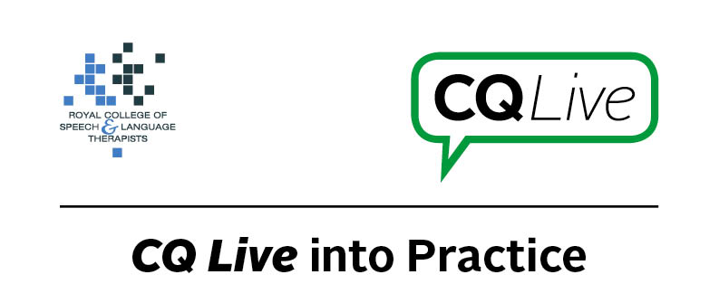
Apps with no evidence base

About this document
This document is designed to take you through a practice-based scenario to help you reflect on what you might do if faced with a similar situation. It can be used to guide your thoughts and prompt discussion with your colleagues. Working through this document counts towards your continuing professional development (CPD). Your reflections on this document are not assessed and you do not have to send your responses to the RCSLT.
You can work through it on your own, with a colleague or supervisor, or in groups, eg as part of an RCSLT Hub or Clinical Excellence Network.
This document is broken into five parts:
- The scenario: for you to read
- The issues to consider: for you to gather your thoughts on practice issues relating to this scenario
- Next steps: for you to plan out what you would need to do next
- Prompts for consideration: RCSLT prompts for further consideration
- Sources of further information: links to CQ Live themes
- Update your CPD diary: for you to do

- The scenario

During a session a parent proudly shows you an app they have downloaded and been using with their child. You do not think there is any clinical evidence to support the claims the app’s creators say it achieves.
What do you do in this scenario?

- The issues to consider

What do you need to consider?
Think about the above scenario and its implications and jot down your notes about issues you may need to consider. Please feel free to use extra sheets of paper if you need. Or, if you are in a group, you may like to record on a whiteboard or flipchart.

- Next steps

What steps do you think you need to take next?

- Prompts for consideration

Apps are a relatively new tool available for use in speech and language therapy so this scenario may become more common. If you are faced with a similar situation you will need to approach it tactfully to ensure that you do not upset the service user or their guardian, but rather, engage their positivity in looking for alternative apps which are more appropriate.
It is recommended that you think about the following prompt questions and formulate a considered strategy to deal with the problem.
Remember that if you are faced with a similar situation you will need to think about it in relation to the frameworks within which you work, such as the Health and Care Professions Council (HCPC) Standards, RCSLT professional guidance and resources, local and national policies and also policies of your employer (or your own policies if practising independently). Communicating Quality Live (www.rcslt.org/cq_live) and the list of prompts that follow, will help with your thinking.
Please note that this list is not exhaustive and does not constitute legal advice.
Prompt questions to consider
- Where has the recommendation for the app come from?
- Is there a reason why the parent is researching apps for their child?
- Why is there no evidence base? Has it been shown to be ineffective or just not yet researched? Bear in mind that apps are relatively new so clinical evidence on the effectiveness of specific apps is generally limited.
Possible next steps
- Investigate the app further to see if it is appropriate, considering:
  - The child’s therapy goals and whether or not you think the app may help in achieving them.
  - If any research into the effectiveness of the app has been carried out? Does it adopt a treatment approach for which there is an evidence-base?
  - Asking other SLTs who may have used the app for their opinion? Are there any (case studies about its use) reviews on the AppStore/PlayStore or blog reviews by other SLTs who have used it?
- When thinking about the appropriateness of the app remember that apps have cultural variation too so consider its usefulness in relation to the particular child.
- If you cannot endorse the app might it be possible to use it in a more facilitative way?
- If the app is not appropriate look for alternatives with clinical evidence or that adopt an evidence-based treatment approach.
- It is good that there is parental involvement so you should support and encourage this. Try tactfully explaining your reasoning, then get the parent involved in joint goal setting.

- Sources of further information

Communicating Quality Live (http://www.rcslt.org/cq_live)
The following areas of professional practice within CQ Live are particularly relevant:
1 - Promote and safeguard the interests of service users and carers
http://www.rcslt.org/cq_live/service_user_interests/service_user_interests
2 - Communicate appropriately and effectively http://www.rcslt.org/cq_live/communication/communicate_appropriately_and_effectively
3 - Work within the limits of their knowledge and skills
http://www.rcslt.org/cq_live/Knowledge_and_skills/rcslt_guidance/rcslt_guidance
6 - Manage risk
http://www.rcslt.org/cq_live/manage_risk/manage_risk
9 - Be honest and trustworthy
http://www.rcslt.org/cq_live/be_honest_and_trustworthy/rcslt_guidance/rcslt_guidance
Role of apps in speech and language therapy https://www.rcslt.org/cq_live/resources_a_z/apps/role
Apps: advantages and disadvantages
https://www.rcslt.org/cq_live/resources_a_z/apps/advantages
- Update your CPD diary

Working through this scenario counts towards your continuing professional development (CPD). Once you have completed this scenario, please record this learning and your reflections in your CPD diary.

