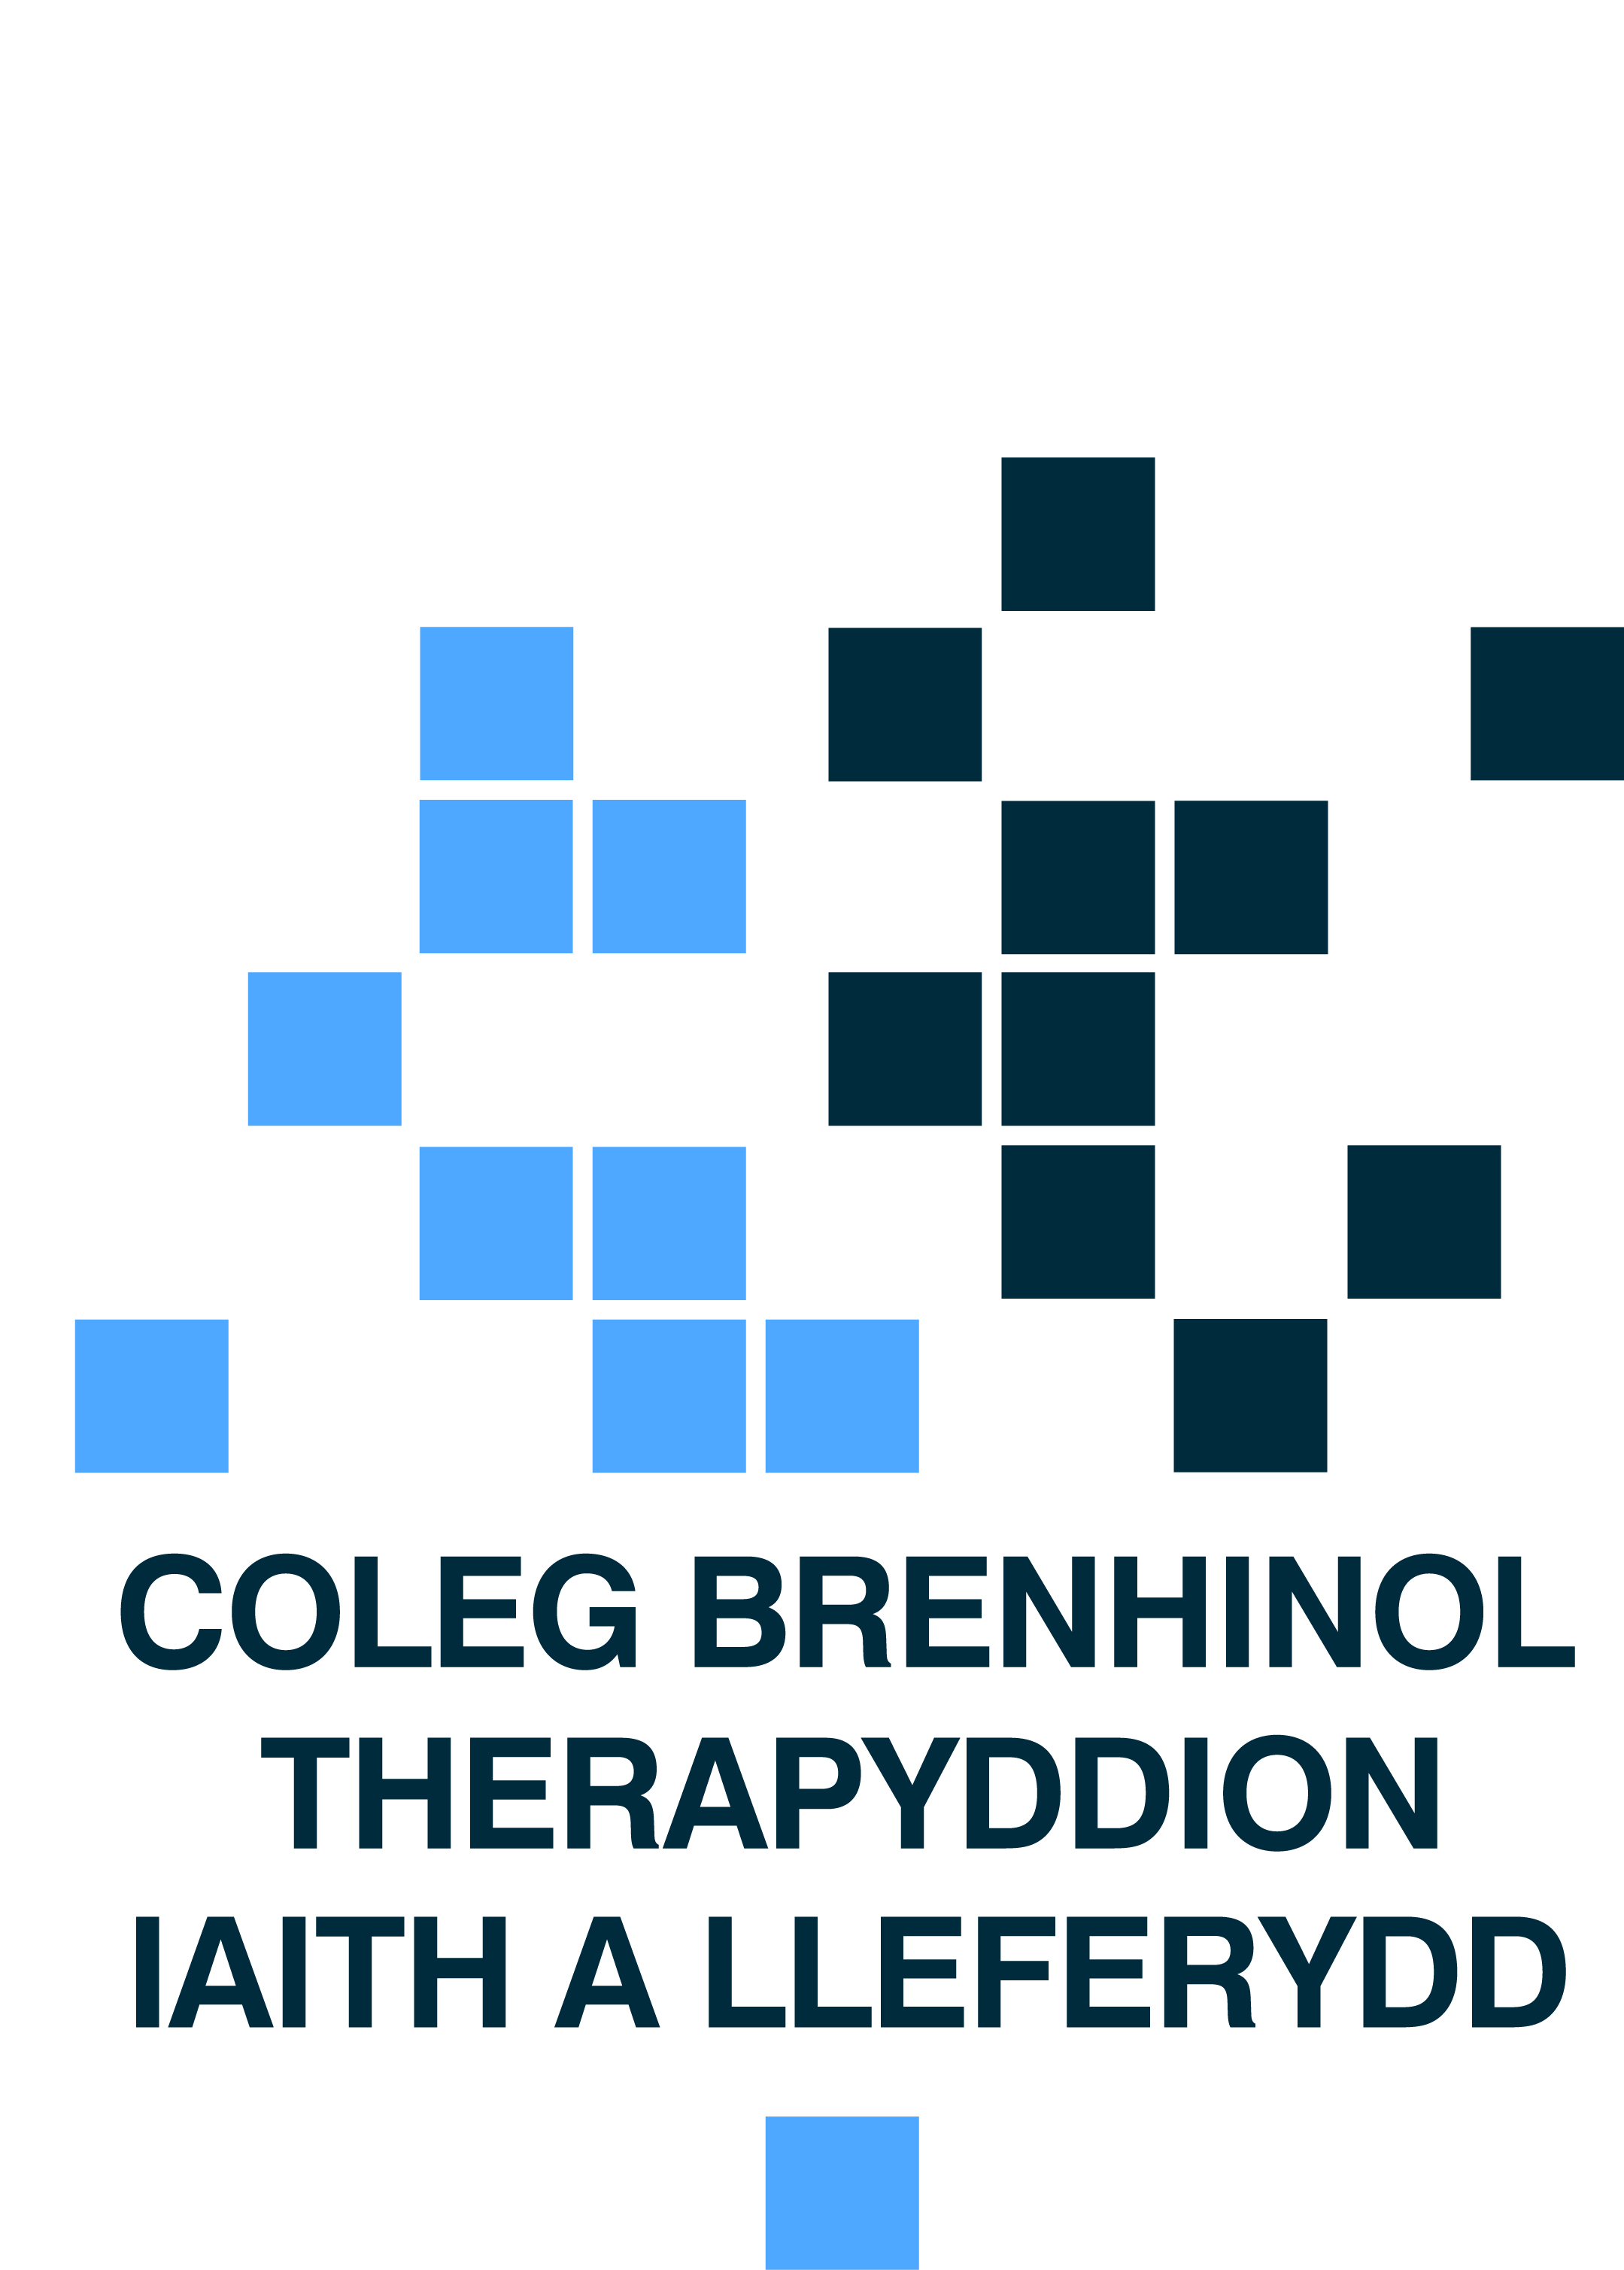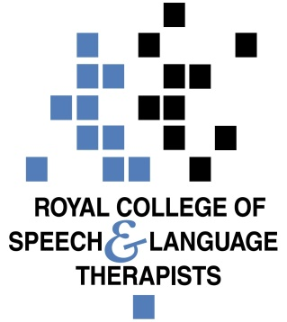

National Assembly for Wales Health, Social Care and Sport Committee Consultation on Primary Care

Executive Summary

- The Royal College of Speech and Language Therapists (RCSLT) Wales welcomes the opportunity to contribute to the Health, Social Care and Sport Committee consultation on primary care. Our response below focusses on one key element within the terms of reference namely;

- the emerging multi-disciplinary team (how health and care professionals fit into the new cluster model and how their contribution can be measured)

- RCSLT Wales believes that in order to respond to the dual challenge of budget pressures and a rising population with complex needs, it is vital that the skills of allied health professionals, and in particular speech and language therapists (SLTs) are used more fully. Despite evidence of the value of the inclusion of SLTs within multi-disciplinary community teams and the potential opportunities which exist, we are aware that too few GP Clusters include the role as part of a dedicated primary care integrated workforce. In the current model, our services are often provided by small, flexible teams who must meet the competing demands of primary and secondary care and this can often mean the pressures in secondary care take precedence over opportunities to develop upstream approaches in the community to keep people well and avoid hospital admissions.

- RCSLT are keen to emphasise a strategic approach to access for therapies for GP clusters. Without a strategic approach inequity of service is a risk across Wales.

About the Royal College of Speech and Language Therapists

- RCSLT is the professional body for speech and language therapists, SLT students and support workers working in the UK. The RCSLT has 15,000 members in the UK (450 in Wales) representing approximately 95% of SLTs working in the UK (who are registered with the Health & Care Professions Council). We promote excellence in practice and influence health, education, care and justice policies.

- Speech and Language therapists treat, support and care for children and adults in community settings who have difficulties with speech, language and communication, and/or eating, drinking and swallowing. Managing swallowing problems (dysphagia) at home or in residential care reduces the risks of choking, chest infections, aspiration pneumonia, dehydration and malnutrition and decreases the need for crisis management that often results in unnecessary hospital admissions.

The Emerging Multi-Disciplinary team (how health and care professionals fit into the new cluster model and how their contribution can be measured)

- RCSLT Wales believes that in order to respond to the dual challenge of budget pressures and a rising population with complex needs, it is vital that the skills of allied health professionals (AHPs), and in particular SLTs are used more fully. As highlighted by the Nuffield Trust, there is a need to reshape the health workforce to deliver the care that patients need and alleviate pressures on the health system. SLT, as a profession, has developed considerably over recent years to adopt a more consultative, collaborative approach, in addition to its specialist role in managing the risk of harm and reducing functional impact for people with Speech, Language and communication support needs and swallowing difficulties. The profession has a vital role to play in the delivery of new models of care and shifting care from hospitals to community settings.

- SLTs already undertake a number of roles as part of primary care teams with the aim of maximising independence and avoiding hospital admission. For example,

- SLTs provide telephone triage to care homes managing the communication and swallowing problems of those in their care, removing the need for a GP visit. They provide training to care home staff and others in the community to manage decline in swallowing performance from age and disease. SLT intervention is proven to reduce morbidity, mortality and prevent hospital admissions. SLTs have also been developing efficient and effective telehealth solutions in this regard. Evidence from a telehealth project in care homes has indicating savings of £60 on each tele swallowing assessment.
- Social return on investment research has highlighted the value of the provision of speech and language therapy for post-acute stroke patients. Every £1 invested in low intensity SLT is estimated to generate £2.30 in health care cost savings through avoided cases of chest infections.
- There is emerging evidence of non-pharmacological treatment approaches and specifically speech and language interventions in the treatment of coughs. Cough is the most common symptom for which patients seek medical advice and thus if speech and language therapy were to be considered as a routine treatment for the estimated 20% of chronic cough patients for whom medication is ineffective, there could be a significant positive impact on the reducing the economic burden of this condition.
- The Betsi Cadwaladr University Health board Speech and Language Therapy service provide a ‘communicating with confidence’ package that supports people living with communication disability to identify and work towards their functional and participative communication goals.

- RCSLT believe that there would be significant benefits to innovations from these roles becoming more established within GP Clusters across Wales. In addition, significant additional opportunities exist to utilise SLTs to support the shift from hospital to community care. For example;

- providing rapid access to highly skilled dysphagia practitioners at the front door of hospitals or as a referral option for GPs/ DNs/Care Homes and ambulance services. This requires highly skilled professionals (Band 6 at a minimum).
- SLTs also provide support to care homes for communication difficulties and are well placed and skilled to support the dementia agenda. Opportunities exist for SLT/assistant skill mix for triage, education of nursing home staff, risk feeding management and Advanced Care Planning to support hospital admission avoidance.
- SLTs are well placed to deliver assessment for Mental Capacity.
- There is emerging evidence of the value of SLT posts in palliative care.
- Opportunities to input into primary care for children with multiple complex needs and the older child around transition where there are no services.
- The contribution SLT can make to the reduction of isolation and loneliness in elderly people which is more evident in those with communication difficulties.

- Despite evidence of the value of the inclusion of SLTs within multi-disciplinary community teams and the potential opportunities which exist, we are aware that too few teams across Wales stipulate inclusion of the role as part of a dedicated primary care integrated workforce. In the current model, our services are often provided by small, flexible teams who must meet the competing demands of primary and secondary care – and this can often mean the pressures in secondary care take precedence over opportunities to develop upstream approaches in the community to keep people well and avoid hospital admissions. We would be keen to explore how we can exploit skill mix to ensure the contribution of the profession to primary care clusters and to community care in the long-term. Considerations need to focus on how we can ensure a team approach and look beyond individual roles to ensure the resilience of services.

- Whilst understanding of the need for primary clusters to meet the needs of localities, RCSLT are keen to emphasise a strategic approach to access for therapies for GP clusters. Without a strategic approach inequity of service is a risk across Wales. Workforce planning and supply of workforce is likely to enter a new era of shortage of supply.

Further Information

- We would be happy to provide any additional information required to support the Committee’s decision making and scrutiny. For further information, please contact:

Dr Alison Stroud
Head of Wales Office
029 2039 7729/ alison.stroud@rcslt.org

Nuffield Trust (2016) Reshaping the workforce to deliver the care patients need: http://www.nuffieldtrust.org.uk/sites/files/nuffield/publication/reshaping_the_workforce_web_0.pdf
University College London (2016) London Speech and Language Therapy workforce scoping project, phase 2: modelling workforce transformation example, report available upon request.
Matrix Evidence (2010). An Economic Evaluation of Speech and Language Therapy – Final report. London:Matrix Evidence
Schappert, SM and Burt, CM (2006). Ambulatory care visits to physician offices, hospital outpatient departments, and emergency departments: United States, 2001-02. Vital Health Statistics 13. Feb;(159):1-66.
Vertigan a and Gibson, P (2009). Chronic cough and laryngeal dysfunction improve with specific treatment of cough and paradoxical vocal fold movement. Cough 5: 4
Yorkston, K M, Bourgeois, M S and Baylor, C R (2010). ‘ Communication and Ageing’. Physical Medicine and Rehabilitation Clinics of North America, Volume 21, Issue 2, Pages 309-319

