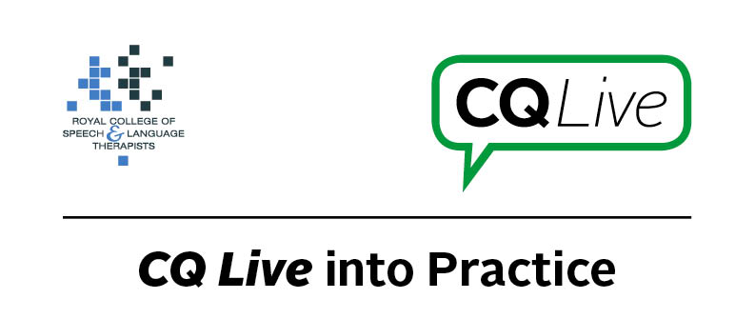
Twitter

About this document
This document is designed to take you through a practice-based scenario to help you reflect on what you might do if faced with a similar situation. It can be used to guide your thoughts and prompt discussion with your colleagues. Working through this document counts towards your continuing professional development (CPD). Your reflections on this document are not assessed and you do not have to send your responses to the RCSLT.
You can work through it on your own, with a colleague or supervisor, or in groups, eg as part of an RCSLT Hub or Clinical Excellence Network.
This document is broken into five parts:
- The scenario: for you to read
- The issues to consider: for you to gather your thoughts on practice issues relating to this scenario
- Next steps: for you to plan out what you would need to do next
- Prompts for consideration: RCSLT prompts for further consideration
- Sources of further information: links to CQ Live themes
- Update your CPD diary: for you to do

- The scenario

You’re using Twitter to share general links and information with SLTs from around the world. A parent/carer of one of your service users asks you to retweet a petition against service cuts in your area.
What do you do in this scenario?

- The issues to consider

What do you need to consider?
Think about the above scenario and its implications and jot down your notes about issues you may need to consider. Please feel free to use extra sheets of paper if you need. Or, if you are in a group, you may like to record on a whiteboard or flipchart.

- Next steps

What steps do you think you need to take next?

- Prompts for consideration

In this scenario, there are different elements to consider that will be specific to where you work. However as general guidance, you may wish to consider your professional reputation, where your comments may be taken next and whether you would be happy being associated with a petition unless you have done significant research. Remember that comments made on social media can easily be taken out of context and can also be shared beyond your networks.
It is recommended that you think about the following prompt questions and formulate a considered strategy to deal with the problem.
Remember that if you are faced with a similar situation you will need to think about it in relation to the frameworks within which you work, such as the Health and Care Professions Council (HCPC) Standards, RCSLT professional guidance and resources, local and national policies and also policies of your employer (or your own policies if practising independently). Communicating Quality Live (www.rcslt.org/cq_live) and the list of prompts that follow, will help with your thinking.
Please note that this list is not exhaustive and does not constitute legal advice.
Prompt questions to consider
- Is there local or employer guidance around this issue?
- Are you working within your job description?
- What are the likely consequences?
- Have you documented the risks?
- Are there safeguarding issues?
- Is there a need to report concerns? Also, for service or organisational Twitter accounts, are all those who manage the account aware of the tweet and the identified response to it?
- Are there issues around information governance?
- Is there a risk to your/your employer’s/your profession’s reputation if you get involved?
- Is the petition legitimate?
- Are other respected bodies behind the petition?
- Would you be able to ignore the request or do you need to respond in some way?
- Are you being impartial?
- What is your working relationship like with the family?
- Is it a private or professional Twitter account?
- Consider boundary issues, ie should a parent/carer even be following you?
- Have you communicated effectively with key stakeholders including service users?
- Will the parent involved tag you anyway? If so, what can you do?
Possible next steps
- Report the situation to your line manager or supervisor or, if you are working independently, speak to other professionals in your networks to get their opinion.
- Research policies/guidelines on personal involvement in public issues.
- If you are employed, seek out your employer’s guidelines.
- If you are independently employed, consider writing a social media policy (if you do not already have one).
- Add a disclaimer to your Twitter account stating your position on petitions.
- Consider having personal and public Twitter accounts (if you do not already).

- Sources of further information

Communicating Quality Live (http://www.rcslt.org/cq_live)
The following areas of professional practice within CQ Live are particularly relevant:
2 - Communicate appropriately and effectively http://www.rcslt.org/cq_live/communication/communicate_appropriately_and_effectively
6 - Manage risk
http://www.rcslt.org/cq_live/manage_risk/manage_risk

- Update your CPD diary

Working through this scenario counts towards your continuing professional development (CPD). Once you have completed this scenario, please record this learning and your reflections in your CPD diary.

