Practice Based Scenario
Goal setting for aphasia

About this document
This document is designed to take you through a practice-based scenario to help you reflect on what you might do if faced with a similar situation. It can be used to guide your thoughts and prompt discussion with your colleagues. Working through this document counts towards your continuing professional development (CPD). Your reflections on this document are not assessed and you do not have to send your responses to the RCSLT.
You can work through it on your own, with a colleague or supervisor, or in groups, e.g. as part of an RCSLT Hub or Clinical Excellence Network.
This document is broken into five parts:
- The scenario: for you to read
- The issues to consider: for you to gather your thoughts on practice issues relating to this scenario
- Next steps: for you to plan out what you would need to do next
- Prompts for consideration: RCSLT prompts for further consideration
- Sources of further information: links to CQ Live themes
- Update your CPD diary: for you to do

- The scenario

Your service user had a stroke 6 weeks ago. When discussing goals, they identify their personal goal as “I want my speech to be back to normal”.
Prognostically you know this is an unrealistic goal and that they will probably experience some lifelong communication impairment.
What is the value of goal setting in this scenario and how would you manage this scenario in terms of goal setting.

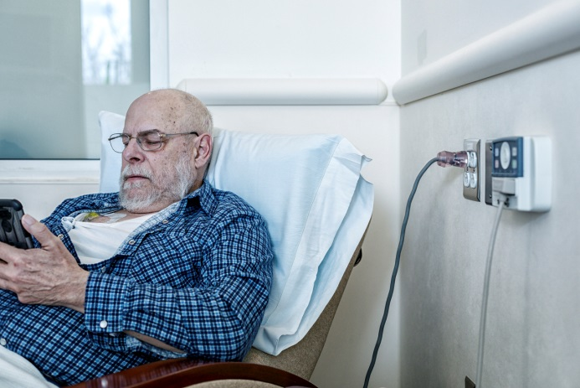

What do you do in this scenario?

- The issues to consider

What do you need to consider?
Think about the above scenario and its implications and jot down your notes about issues you may need to consider. Please feel free to use extra sheets of paper if you need. Or, if you are in a group, you may like to record on a whiteboard or flipchart.

- Next steps

What steps do you think you need to take next?

- Prompts for consideration

It is recommended that you think about the following prompt questions and formulate a considered strategy to deal with the problem.
Remember that if you are faced with a similar situation you will need to think about it in relation to the frameworks within which you work, such as the Health and Care Professions Council (HCPC) Standards, RCSLT professional guidance and resources, local and national policies and also policies of your employer (or your own policies if practising independently) Explore these webpages for information related to this topic and consider the list of prompts that follow, to help with your thinking.
Please note that this list is not exhaustive and does not constitute legal advice.
Prompt questions to consider
- Why isn’t this an effective goal?
- What formats could you use for setting goals?
- What makes a good goal?
- Why is it sometimes difficult for service user to think in terms of SMART goals?
- What alternatives are there to the SMART goal format?
- What information should you incorporate into your therapy to promote realistic goal setting?
- How can you make this information aphasia friendly?
- What are the short and long term benefits of supporting people with aphasia to participate in setting their personal goals?
- How can you support people with severe aphasia to participate in personal goal setting?
- Should the long term, unrelaistic goal of ‘getting my speech back’ be addressed or not?
Possible next steps
- Support the service user to understand the value of making achievable goals within specified time frames
- Use supportive aphasia friendly materials to discuss goals
- Consider engaging key conversational partners in the goal setting activity.
- Provide clear aphasia friendly documentation and feedback tools for goals set.

- Consider
- Sources of further information

The following information in the professional accountability and autonomy, and professional guidance sections of the RCSLT website is also particularly relevant:
1 – Promote and safeguard the interests of service users and carers
2 - Communicate appropriately and effectively
10 – Record keeping
Aphasia
Stroke
Goals

- Update your CPD diary

Working through this scenario counts towards your continuing professional development (CPD). Once you have completed this scenario, please record this learning and your reflections in your CPD diary.

