RCSLT EasyRead survey on access to speech and language therapy: people aged 18+

* Required
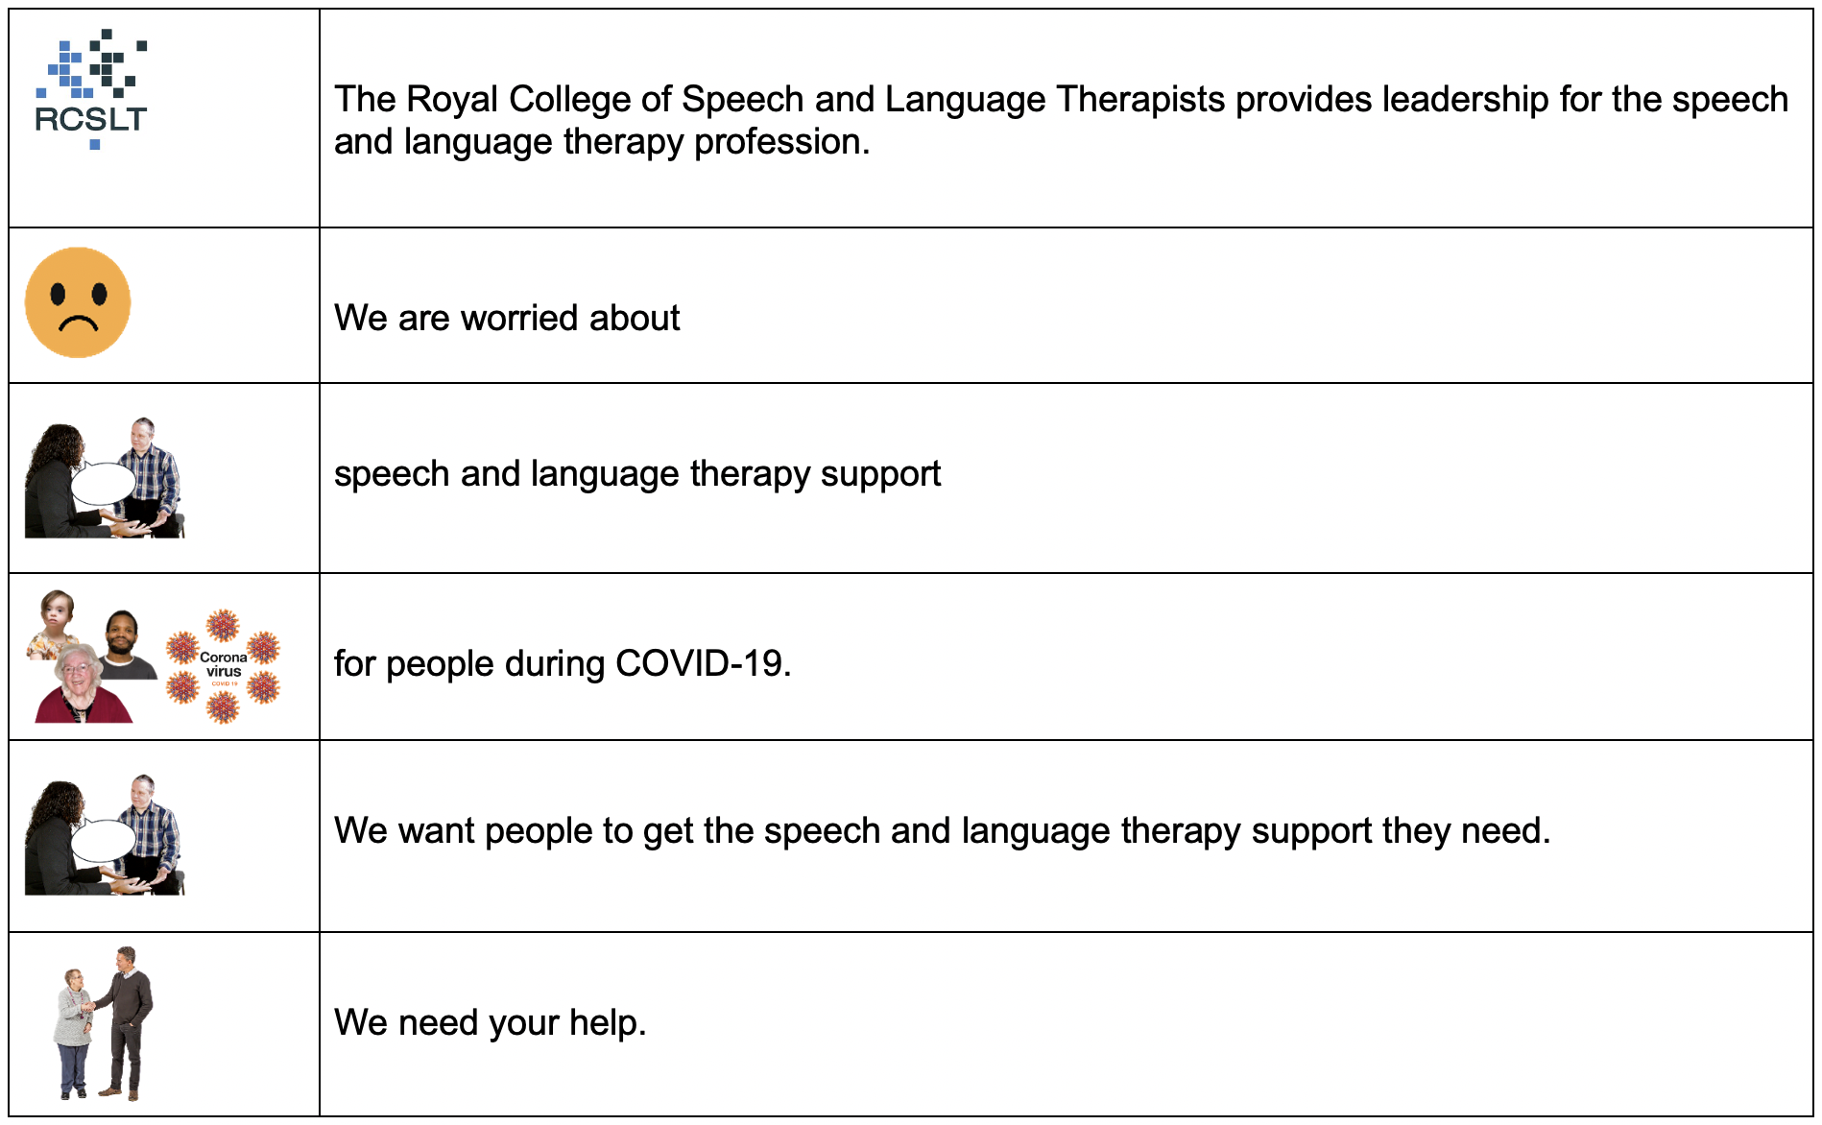

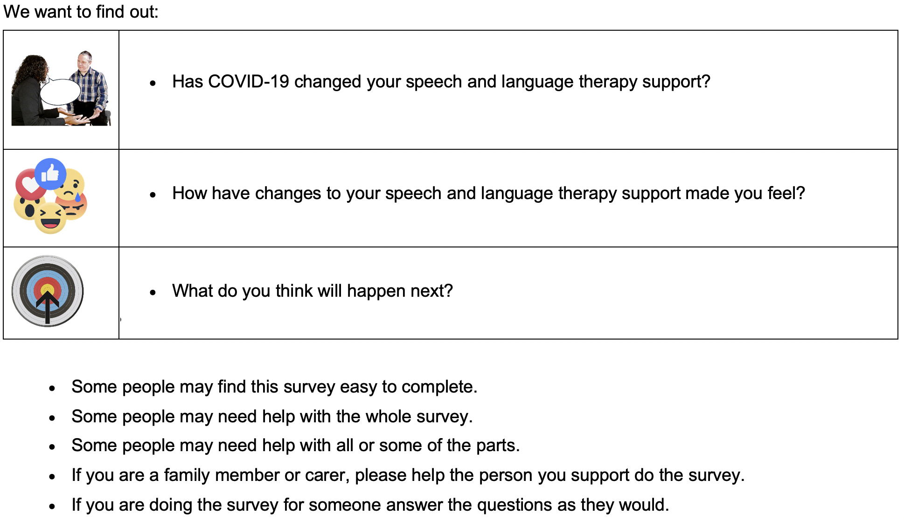

Please help us by filling in this survey by the 8 January 2021.

Following guidance from the Health Research Authority (HRA, 2020), this survey is not deemed to be research and thus does not require approval from a Research Ethics Committee.

The Royal College of Speech and Language Therapists is the Data Controller for the information you give us on this form. That means they keep your information safe. If you don't want to share this information, you can email info@rcslt.org.

You can read more information about RCSLT, your personal information and your rights here: https://www.rcslt.org/data-protection-policy

If you need support with this survey, please contact peter.just@rcslt.org or padraigin.oflynn@rcslt.org.

Please return your completed survey to peter.just@rcslt.org and padraigin.oflynn@rcslt.org.

Section A: About you

[If you are doing the survey for someone, answer the questions as they would.]

- What is your postcode? [You don’t have to answer this question, but it would be helpful].
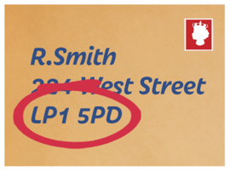

________________________________________

- Which country do you live in? *

Tick only one.
- 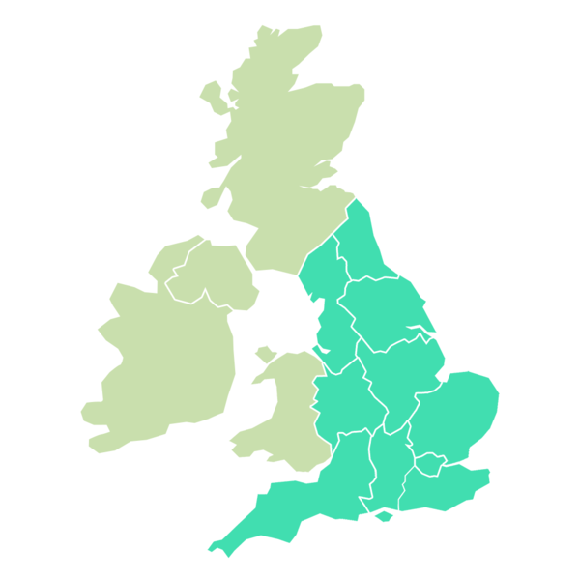England

- 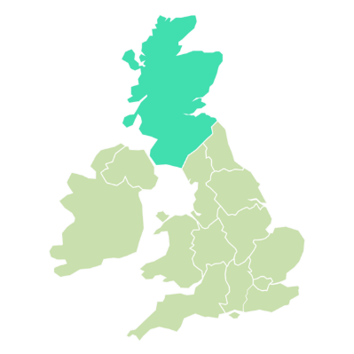Scotland

- 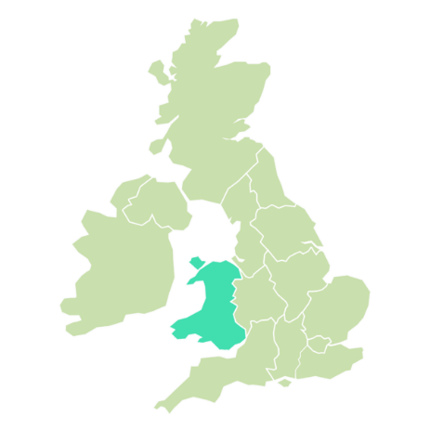Wales

- 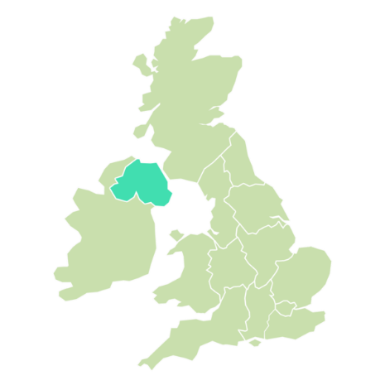Northern Ireland

- 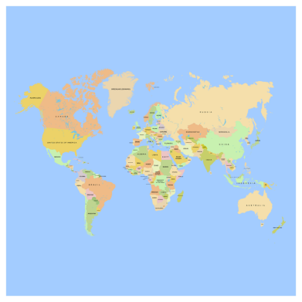 Somewhere else
- Please tell us who you are *

Tick all that apply.

- I am a person who has speech and language therapy
- I am a paid carer
- I am a family member or unpaid carer
- Other

- Do you get speech and language therapy support for your further education or training?
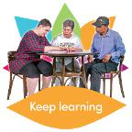

Tick only one.

- Yes
- No

- When did you start having speech and language therapy? *

Tick only one.
- 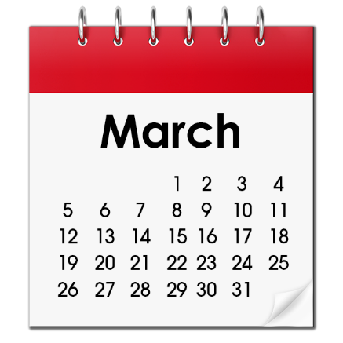Before March 2020

- After March 2020 (during the virus time)

- Why do you have speech and language therapy? *
Tick all that apply.

- It helps me with my speech, language and communication
- It helps me with my eating and drinking
- Something else

- Why do you need speech and language therapy? *

Tick all that apply.
- Autism
- Brain injury
- Hearing loss / deafness
- Developmental language disorder or language disorder
- Stammer
- Head and neck cancer
- Learning disability
- Mental health
- Selective mutism
- Dementia
- Parkinson's disease
- Multiple sclerosis
- Motor neurone disease
- Stroke
- Waiting for diagnosis
- Do not know
- Other: _________________________________

Section B: Your speech and language therapy during lockdown (March - June 2020)

[If you are doing the survey for someone, answer the questions as they would.]

- How did your speech and language therapy change during lockdown (March – June 2020)?

Tick only one.
- I had more therapy during lockdown
- I had the same amount of therapy during lockdown
- I had less therapy during lockdown
- I had no therapy during lockdown
- I do not know

- What happened to your speech and language therapy appointments?
Tick only one.

- 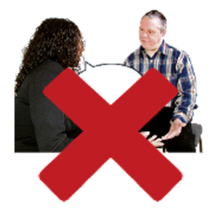The speech & language therapist cancelled my appointment
- I / my carer cancelled my appointment
- 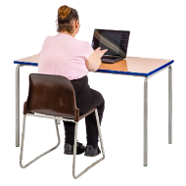I had my speech and language therapy appointment using video
- 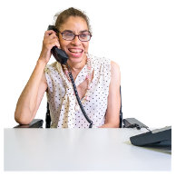I had speech & language therapy help over the phone

- How did you have your speech and language therapy before lockdown (March - June 2020)?

Tick all that apply.

- 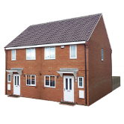At home in person
- 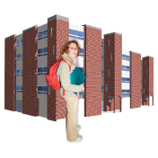Not at home but face to face (for example at a clinic or hospital)
- Over the phone
- By video
- 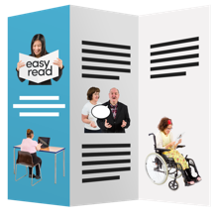 Through other support, for example social media or printed materials
- Other
- Did you get face to face speech and language therapy during the virus lockdown (March - June 2020)?

Tick only one.

- Yes, I got face to face therapy at home
- Yes, I got face to face therapy, but not at home (for example clinic/hospital day service)
- No, I did not get face to face therapy during lockdown
- I did not get any speech and language therapy at all during lockdown

- Did you have speech and language therapy over the phone during lockdown (March - June 2020)?

Tick only one.
- Yes
- No

- If yes, how was your speech and language therapy help on the phone?

Tick only one.

- Good – I liked it
- Okay
- Bad – I did not like it
- I could not do it at all
- Do not know

- Did you get your speech and language therapy by video during lockdown (March - June 2020)?

Tick only one.

- Yes
- No

- If yes, how was your speech and language therapy help on video?
Tick only one.

- Good – I liked it
- Okay
- Bad – I did not like it
- I could not do it at all
- Do not know

- How easy was it to use a computer / laptop / tablet / smartphone for speech and language therapy?

Tick only one.

- Easy
- Okay
- Hard
- I do not use a computer/laptop/tablet/smartphone

- Did you get your speech and language therapy through other support, for example social media or printed materials, during the virus lockdown (March - June 2020)?
Tick only one.
- Yes
- No

- Did you get help updating your communication support tools? (For example, communication pictures, communication books, electronic aids)
Tick only one.
- Yes
- No
- I do not have communication support tools

- What is it like wearing a mask during your speech and language therapy appointment?
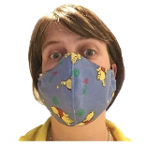
Tick only one.

- Good
- Okay
- Hard
- 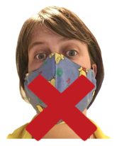I do not wear a mask

- What it is like having your therapist wearing a mask during your speech and language therapy appointment?
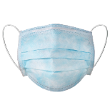
Tick only one.

- Easy
- Okay
- Hard
- They do not wear a mask

- How has your communication and swallowing been during COVID-19?

Tick only one.
- Better
- The same
- Worse
- Do not know

Section C: Your life and wellbeing

If you are doing the survey for someone, answer the questions as they would.

- How does your speech and language therapy help you?

Tick all that apply.
- Makes my life better
- Makes my carer’s life better
- Makes no difference to me
- Makes no difference to my carers
- Makes my life worse
- Makes my carer’s life worse
- Do not know

- What got worse during lockdown (March - June 2020)?

Tick all that apply.

- 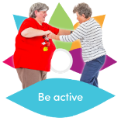Physical health
- 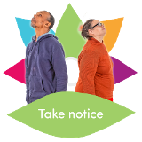Mental health
- Home and domestic life
- 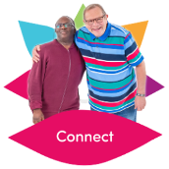Social life / friendships
- Hobbies / leisure
- Education
- Employment
- Other

- If you are a family member or carer of someone who had less speech and language therapy during lockdown (March - June 2020), tick the things it made worse for you.

Tick all that apply.

- Physical health
- Mental health
- Home and domestic life
- Social life / friendships
- Hobbies / leisure
- Education
- Employment
- Other

- Are you worried about getting your speech and language therapy help in the future?

Tick only one.

- Yes
- No
- Do not know

Section D: Other information

If you are doing the survey for someone, answer the questions as they would.

- Is there anything else about your experience of speech and language therapy during lockdown that you would like to tell us?

Please write it below.

Section E: More about you

If you are doing the survey for someone, answer the questions as they would.

- How old are you?
Tick only one.
- 18-25
- 25-34
- 35-44
- 45-54
- 55-64
- 65+
- Prefer not to say
- Do not know

- How would you describe your gender?
Tick only one.
- Male
- Female
- Non-binary
- Prefer not to say
- Prefer to self-describe: _________________________
- What is your ethnicity?
Tick only one.
- White British/Irish
- Gypsy or Irish Traveller
- Other white background
- Black/African/Caribbean/Black British
- Asian/Asian British
- Other ethnic group
- Mixed/Multiple ethnic groups
- Prefer not to say
- Do not know

Section F: Consent (saying yes or no)

If you are doing the survey for someone, answer the questions as they would.

- Can we contact you about this survey? *
Tick only one.

- Yes
- No

- If yes, please tell us your email address or telephone/mobile number.

___________________________________

Thank you!

