Joining and participating in a webinar (attendee)

Overview
If you are registering or joining a webinar and haven’t received an email confirmation that’s for a panellist or alternative host, you are an attendee in the webinar. As an attendee, you can mute/unmute your audio, virtually raise your hand, and send messages to others.
Note: Some attendee controls won’t be available if disabled by the host. If you have additional controls not shown here, you may be a co-host or panellist in a webinar or an attendee in a meeting.
This article covers:
- Joining a webinar by invitation link
- Manually joining a webinar
- Waiting for the host to start the webinar
- Webinar controls

Prerequisites
- Zoom Desktop Client or Mobile App

Joining a webinar by invitation link
To join the webinar, click the link that the host provided you or that you received in the confirmation page after you registered. If the host sent a registration confirmation email, the link can also be found there.

Hi May,
Thank you for registering for "RCSLT Webinar".
Please submit any questions to: rsvp@rcslt.org
Date Time: Apr 29, 2020 10:30 AM London
Join from a PC, Mac, iPad, iPhone or Android device:
Click Here to Join
Note: This link should not be shared with others; it is unique to you.
Add to Calendar Add to Google Calendar Add to Yahoo Calendar
Description: Webinar
Or iPhone one-tap :
United Kingdom: +442034815240, 88178199261# or +441314601196#, +88178199261#
Or Telephone:
Dial(for higher quality, dial a number based on your current location):
United Kingdom: +44 203 481 5240 or +44 131 460 1196 or +44 203 051 2874 or +44 203 481 5237
Webinar ID: 881 7819 9261
International numbers available: https://us02web.zoom.us/u/kb5RKR5nOm
You can cancel your registration at any time.

Manually joining a webinar
- Locate the 9-digit meeting ID/webinar ID from your registration email. It may appear at the end of the phone dial-in information, or it will be in the join link, just after https://zoom.us/w/
- Sign in to the Zoom Desktop Client or Mobile App.
- Click or tap Join a Meeting.
- Enter the 9-digit webinar ID, and click Join or tap Join Meeting.
- If prompted, enter your name and email address, then click Join Webinar or tap Join.

Waiting for the host to start the webinar
If the host hasn’t started broadcasting the webinar or is preparing using a practice session, you’ll receive the following message:
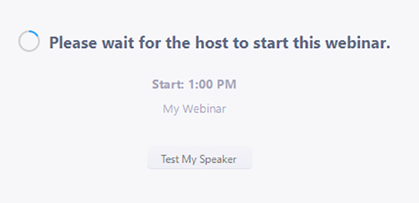
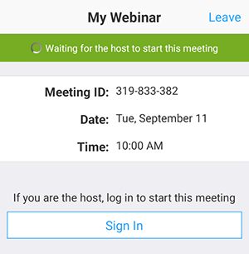
If you receive a message showing the date and time of the webinar, check the the date and start time of the webinar including the timezone. Make sure to join when the webinar starts.
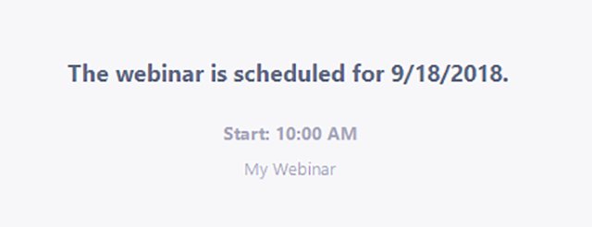

Webinar controls
Audio Settings (only visible if the host hasn't granted you permission to talk): Change your audio settings. You can also click the upward arrow (^) next to change your speaker.
Unmute/Mute: If the host gives you permission, you can unmute and talk during the webinar. All participants will be able to hear you. If the host allows you to talk, you will receive a notification.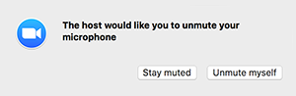
Note: You can still access the audio settings by click on the ^ arrow next to the Unmute/Mute button.
Chat: Open in-meeting chat, allowing you to send chat messages to and send a message to the host, panelists, and attendees (if permitted).
Raise Hand: Raise your hand in the webinar to indicate that you need something from the host. The host may instruct you on how they plan to use this. Many webinar hosts use this feature to know if an attendee has a question and would like to speak out loud.
Question & Answer: Open the Q&A window, allowing you to ask questions to the host and panellists. They can either reply back to you via text in the Q&A window or answer your question live.
To ask a question:
- Type your question into the Q&A box. Click Send.
Note: Check Send Anonymously if you do not want your name attached to your question in the Q&A.
- If the host replies via the Q&A, you will see a reply in the Q&A window.
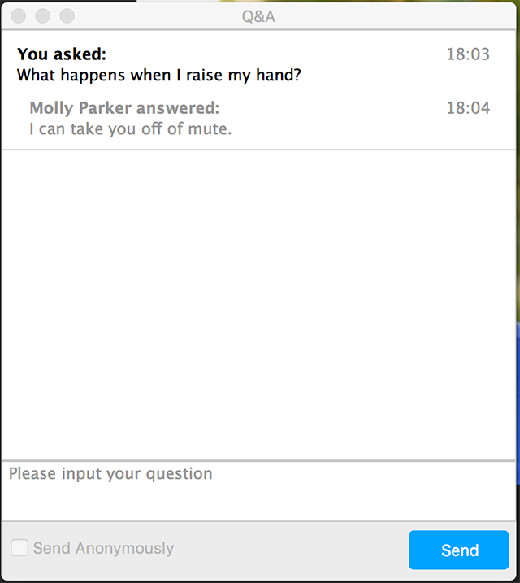
- The host can also answer your question live (out loud). You will see a notification in the Q&A window if the host plans to do this.
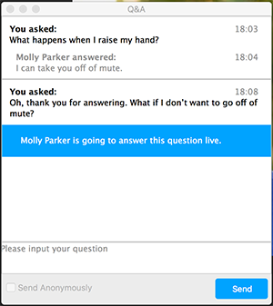
As an attendee you can also like or comment on other attendee’s questions. This helps the host or participant identify popular questions, especially in a webinar with many attendees.

- Click the thumbs up icon to like a comment.
Tip: The number beside the icon is the total number of likes the question has received so far.
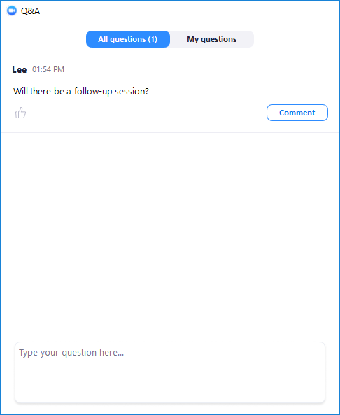
- Click the red thumbs up icon to unlike a comment.
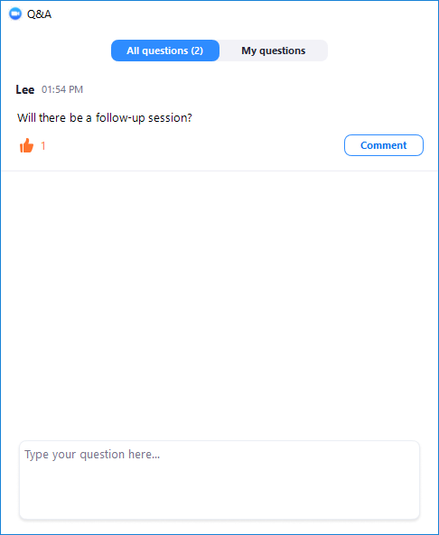
- Click Comment to write a reply to an existing question.
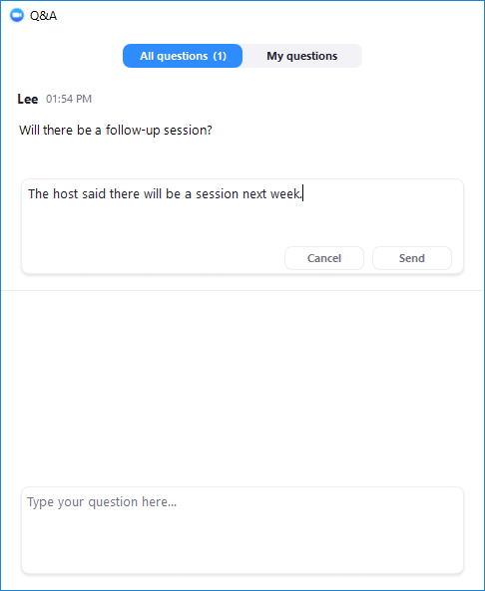
- Type your comment and click Send.
Your comment will appear beneath the question.
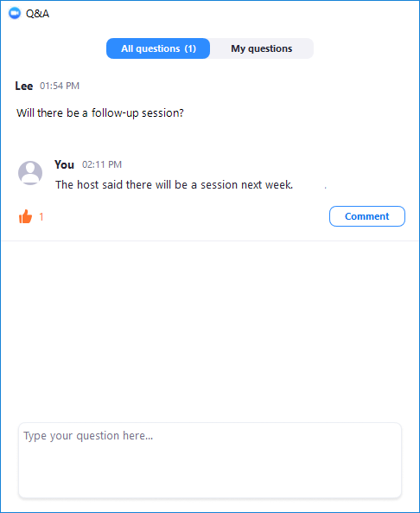
Leave meeting: Click Leave meeting to leave the webinar at any time. If you leave, you can re-join if the webinar is still in progress, as long as the host has not locked the webinar.
We hope this was helpful.

