FEES

Aphasia Friendly Information Leaflet.

You have difficulties with your swallow.

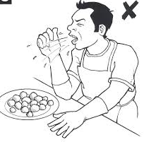

This makes eating and drinking difficult.

We can use this camera and computer to look at your swallow.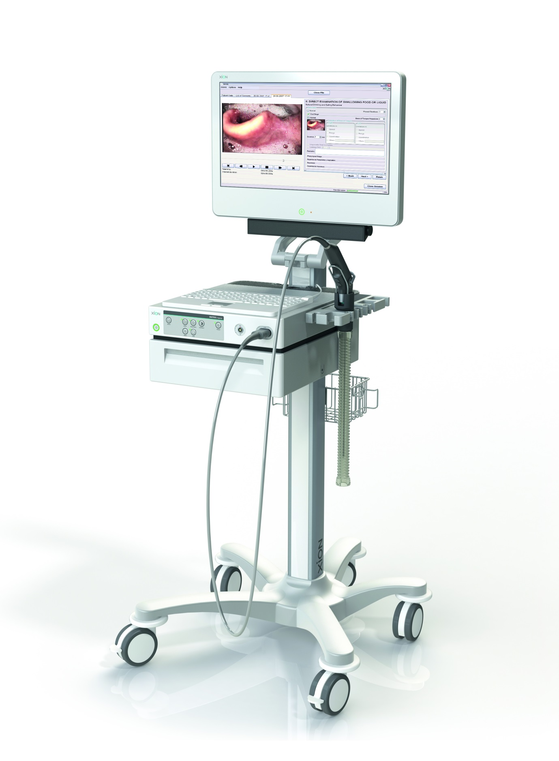
This gives us a video of your swallow.

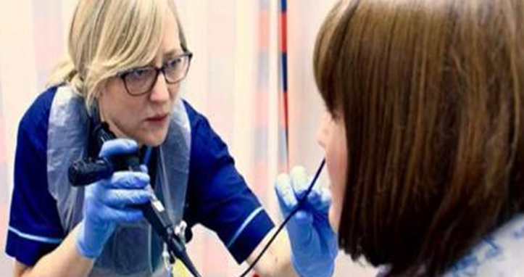
The camera will go in your nose.

It looks at your throat. 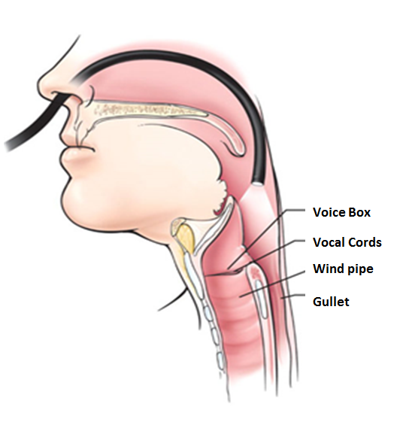
This is your voice box.

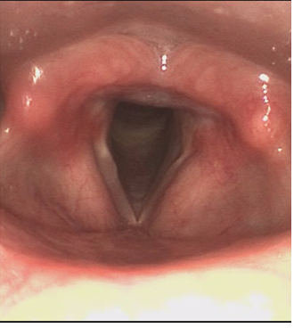
Oesophagus (food pipe)
Wind Pipe
Voice box

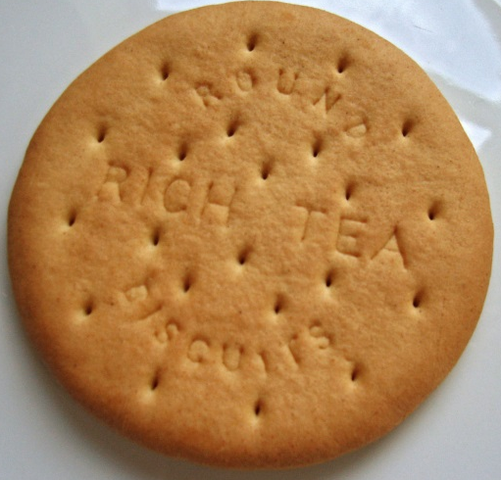
You will have food and drink.

We will check if it goes the right way down.

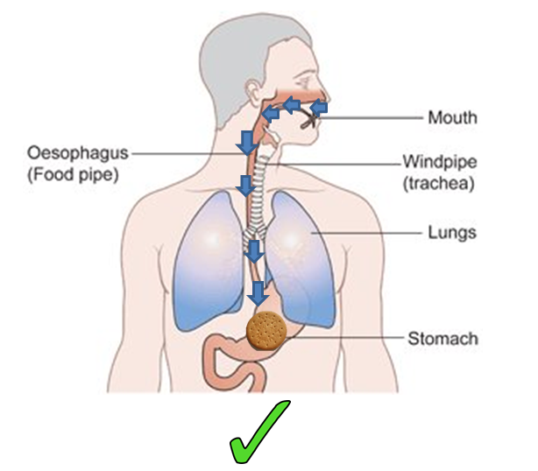
The voice box looks like this with food.

Oesophagus
Food

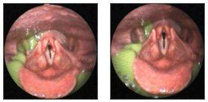

Airway

A small risk of:

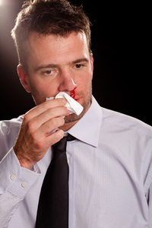
Nose bleed

Fainting

FEES: CONSENT FORM

Assessment has been explained to me by:

- I would like a swallow assessment with a camera.
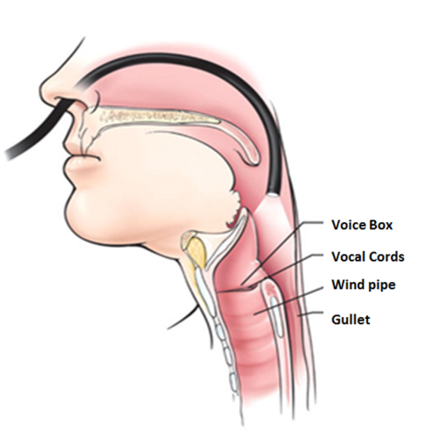
YES

NO

Witness signature (if applicable):

Speech and language Therapist:

