Rating scales

Airway protection Scale

- Laryngeal closure not achieved
- Transient true fold closure
- Sustained true fold closure
- Transient ventricular fold closure
- Sustained ventricular fold closure

Murray (1999) “The Laryngoscopic Evaluation of Swallowing or FEES”. In: Manual of Dysphagia Assessment in Adults, 1999, Singular Publishing Company.

Secretion severity rating scale

0 - Normal rating. Ranges from no visible secretions anywhere in the hypopharynx to some transient secretion bubbles visible in the valleculae and pyriform sinuses.

1 - Any secretions evident upon entry or following a dry swallow in the protective structures surrounding the laryngeal vestibule that are bilaterally represented or deeply pooled.

2 - Any secretions that change from “1” rating to a “3” rating during the observation period.

3 - Most severe rating. Any secretions seen in the area defined as laryngeal vestibule. Pulmonary secretions are included if they are not cleared by swallowing or coughing by the close of the segment.

Murray (1999) “The Laryngoscopic Evaluation of Swallowing or FEES”. In: Manual of Dysphagia Assessment in Adults, 1999, Singular Publishing Company.

New Zealand Secretion Scale NZSS

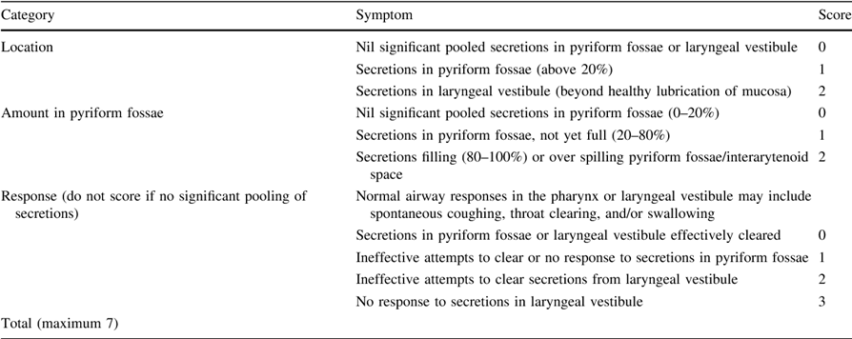

Miles A, Hunting A. Development, intra- and inter-rater reliability of the New Zealand Secretion Scale (NZSS). 2018. Int J Sp Lang Path DOI: 10.1080/17549507.2018.1458901.

Penetration-Aspiration scale

- Material does not enter the airway
- Material enters the airway, remains above the vocal folds and is ejected from the airway
- Material enters the airway, remains above the vocal folds and is not ejected from the airway
- Material enters the airway, contacts the vocal folds, and is ejected from the airway
- Material enters the airway, contacts the vocal folds and is not ejected from the airway
- Material enters the airway, passes below the vocal folds and is ejected into the larynx or out of the airway
- Material enters the airway, passes below the vocal folds and is not ejected from the trachea despite effort
- Material enters the airway, passes below the vocal folds and no effort is made to eject

Rosenbek J, et al. Dysphagia 1996; Vol 11: pp93-98.

Yale Residue Scale

Images with the greatest inter-rater agreement for each residue level
Valleculae Residue
A None 0% No residue
B Trace 1-5% Trace coating of mucosa
C Mild 5-25% Epiglottic ligament visible
D Moderate 25-50% Epiglottic ligament covered
E Severe >50% Filled to epiglottic rim

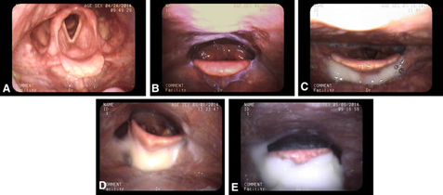

Pyriform Residue
A None 0% No residue
B Trace 1-5% Trace coating of mucosa
C Mild 5-25% Up wall to quarter full
D Moderate 25-50% Up wall to half full
E Severe >50% Filled to aryepiglottic fold

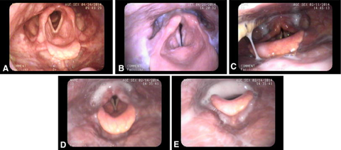

P.D Neubaher et al Dysphagia. 2015 Oct;30(5):521-8. doi: 10.1007/s00455-015-9631-4. Epub 2015 Jun 7.

Reflux Finding Score

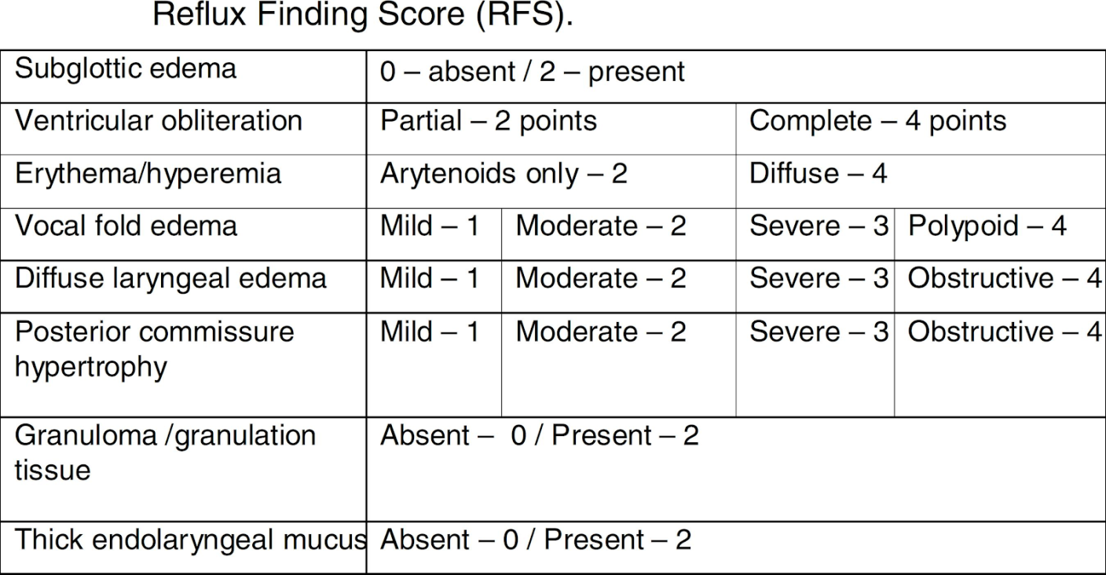

Belafsky PC1, Postma GN, Koufman JA. The validity and reliability of the reflux finding score (RFS). Laryngoscope. 2001 Aug;111(8):1313-7.

