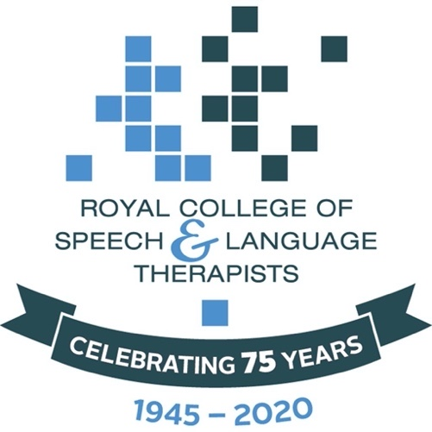
We are the Royal College of Speech and Language Therapists.

We want everyone to get the speech and language therapy they need.

We want to know about your speech and language therapy during the COVID-19 lockdown.

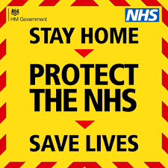

This survey finishes on 8 January 2021.

If you need support with this survey, please contact peter.just@rcslt.org or padraigin.oflynn@rcslt.org.

Following guidance from the Health Research Authority (HRA, 2020), this survey is not deemed to be research and thus does not require approval from a Research Ethics Committee.

The RCSLT is the Data Controller for the information you give us on this form. That means they keep your information safe. If you don't want to share this information, you can email info@rcslt.org.

You can read more information about RCSLT, your personal information and your rights here: https://www.rcslt.org/data-protection-policy

Please return your completed survey to peter.just@rcslt.org and padraigin.oflynn@rcslt.org.

Introduction
We all went into the Covid19 virus lockdown in March.

Lockdown affected how speech and language therapists could work.

The Royal College of Speech and Language Therapists want to know how lockdown affected you and your speech and language therapy.

Please answer the questions one at a time.

Section A. About me.
Question 1.
My postcode is ____________________________

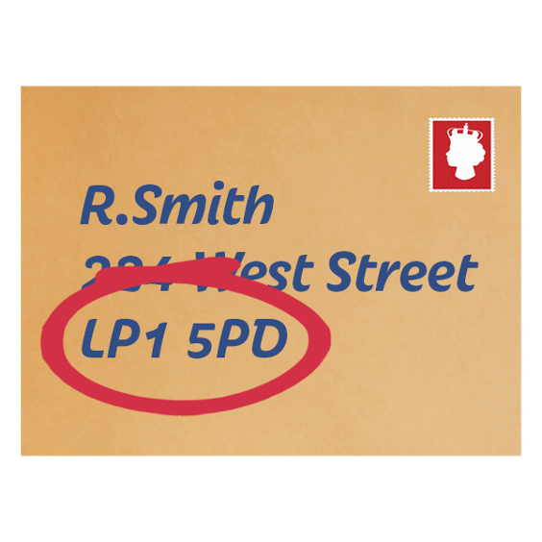

Question 2.

Look at the map. Where do you live?

Tick what is true for you.
I live in England.

I live in Scotland.

I live in Wales.

I live in Northern Ireland.
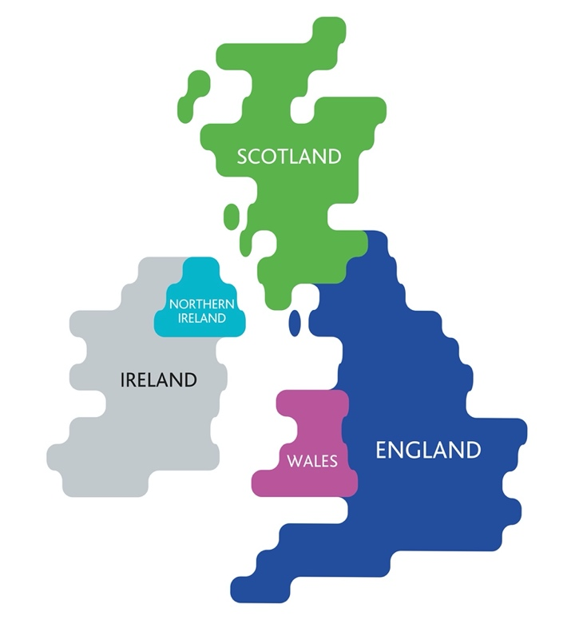

Question 3.

When did you start having speech and language therapy?

Look at the options.

Tick what is true for you.
I started having speech and language therapy…

Before February 2019.

Between February 2019 and February 2020.

During coronavirus (since March 2020).

Question 4.

What does speech and language therapy help you with?

Look at the options.

Tick what is true for you.

Speech and language therapy helps me with my speech, language, and communication.

Speech and language therapy helps me with eating and drinking.

Question 5.

Why did you need to have speech and language therapy?

Look at the options.

Tick what is true for you.

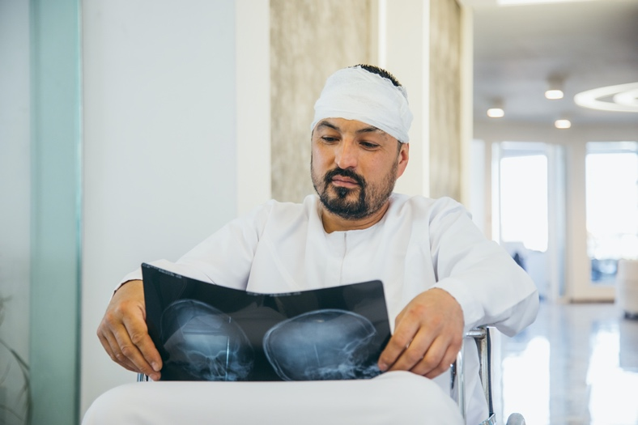
I have speech and language therapy because of a head injury.

I have speech and language therapy because of a brain haemorrhage or stroke.

I have speech and language therapy because of something else (for example a brain tumour).

Question 6.

Think about your speech and language therapy before lockdown.

Look at the options.

Tick what is true for you.

I had speech and language therapy at home.

I had speech and language therapy outside of my home (for example a clinic or hospital).
I had speech and language therapy by phone.

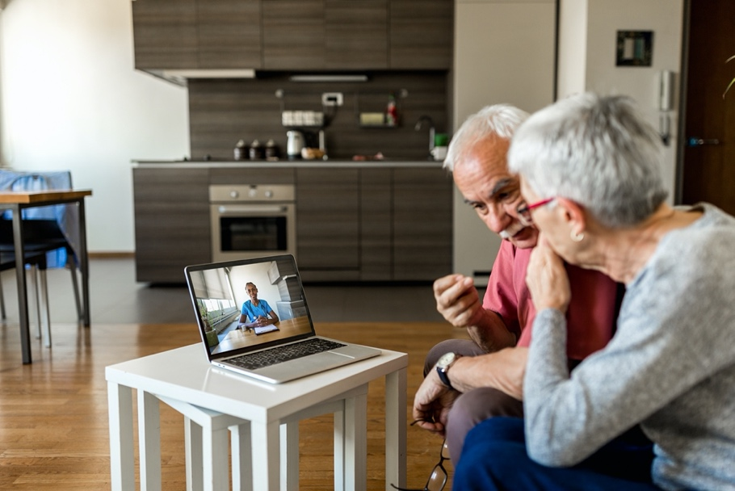
I had speech and language therapy using a video call.

Section B.
Speech and language therapy during lockdown.

Question 1.

Tell us how much speech and language therapy you had during lockdown.

Look at the options.

Tick what is true for you.
I had the same amount of speech and language therapy

I had less speech and language therapy than before lockdown.

I had more speech and language therapy than before lockdown.

I do not know
Question 2.

Did your speech and language therapy change during lockdown?

Tick the statement that is true for you.
My speech and language therapist cancelled my appointment.
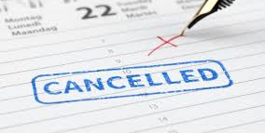
example https://directdentalstaffing.com/avoid-rescheduled-cancelled-no-show-appointments/

I cancelled my appointment myself.

I spoke to my speech and language therapist on the phone.

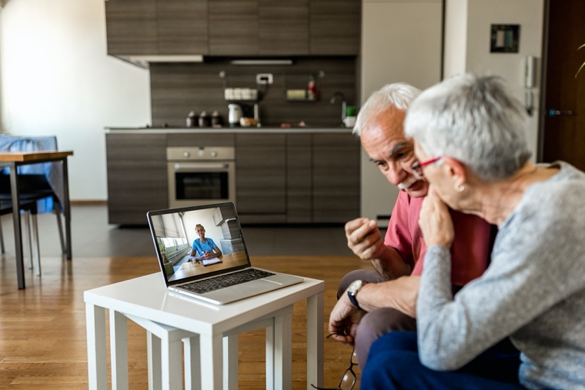
I saw my speech and language therapist on a video call.

Question 3.

Think about your speech and language therapy during lockdown.

Tick the statement that is true for you.
I had speech and language therapy at home.

I had speech and language therapy outside of my home (for example a clinic or hospital).
I had speech and language therapy on the phone

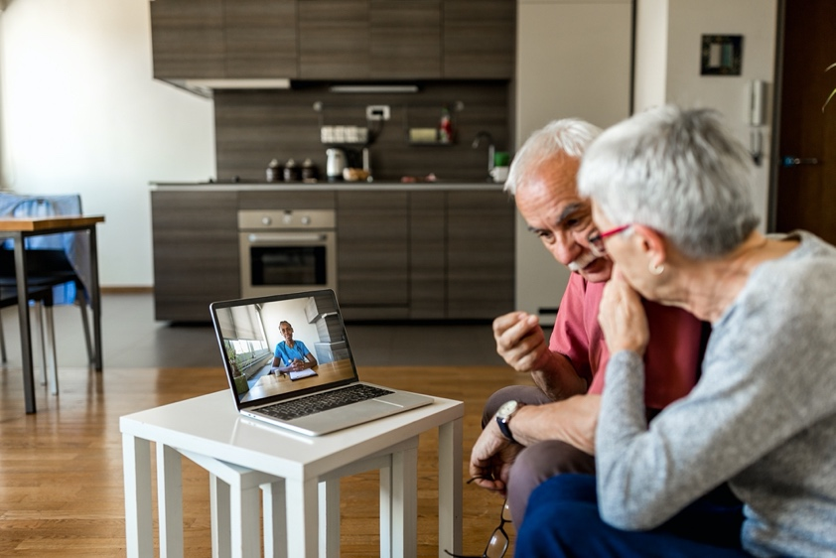
I had speech and language therapy by video call.

Question 4.

How do you feel about speech and language therapy on the phone?

Tick the symbol that says how you feel.

Question 5.

How do you feel about speech and language therapy using a video call?

Tick the symbol that says how you feel.

Question 6.

Is speech and language therapy on a video call hard or easy?

Tick the symbol that says what you think.

Question 7.

What do you think about wearing a mask for speech and language therapy?

Tick the symbol that says what you think.

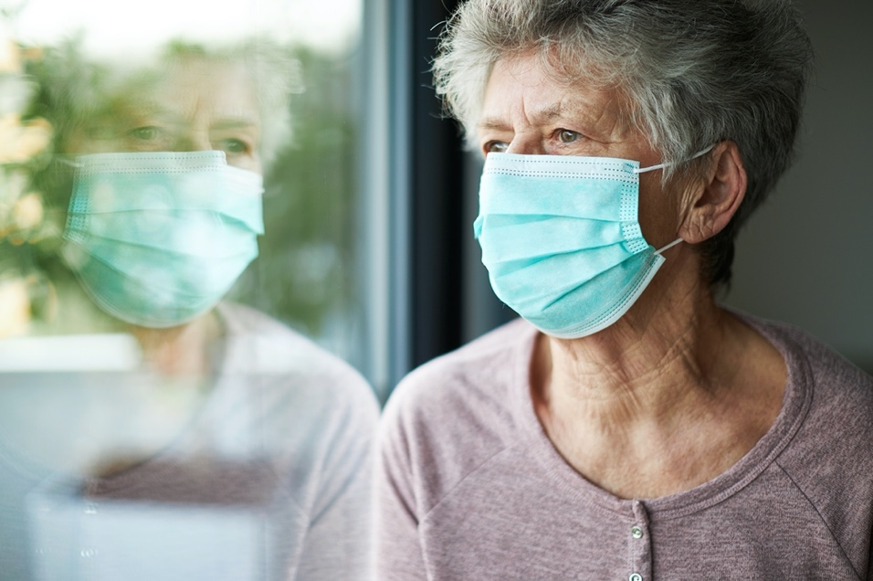

Question 9.

What do you think about your speech and language therapist wearing a mask for speech and language therapy?

Tick the symbol that says what you think.

Question 10.

Tell us about your communication during lockdown.
Tick what is true for you.
My communication got better during lockdown.

My communication was the same during lockdown.

My communication got worse during lockdown.

I do not know if my communication got better or worse.

Question 11.

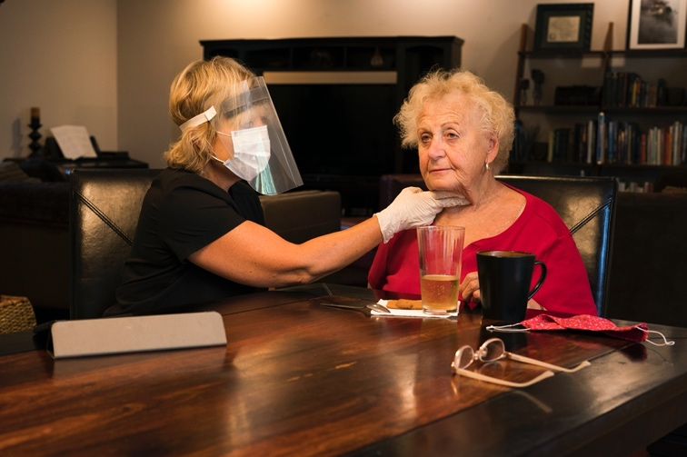
Tell us about your swallowing during lockdown.

Tick what is true for you.

My swallowing got better during lockdown.

My swallowing was the same during lockdown.

My swallowing got worse during lockdown.

I do not know if my swallowing got better or worse.

Section C.
Your life and wellbeing during lockdown.
Question 1.

Does speech and language therapy help you?

Look at the different options.

Tick what is true for you.
Speech and language therapy makes my life better.

Yes

No

I do not know

Question 2.

This question is for people who had less speech and language therapy during lockdown.

Did having less speech and language therapy affect you?

Look at the different options.

Tick what is true for you.

Having less speech and language therapy affected my physical
health.

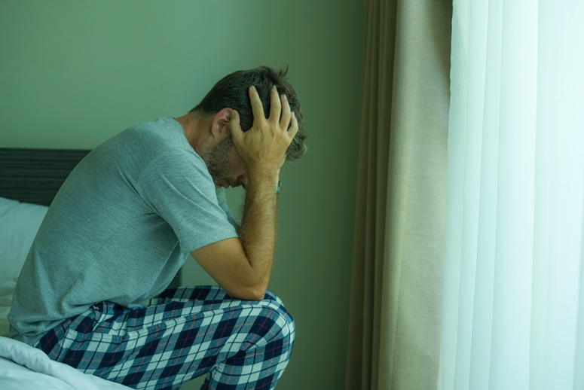
Having less speech and language therapy affected my mental
health.

Having less speech and language therapy affected my home
life.

Having less speech and language therapy affected my social
life.

Having less speech and language therapy affected my
hobbies.

Having less speech and language therapy affected my
education.

Having less speech and language therapy affected my work.

Question 3.

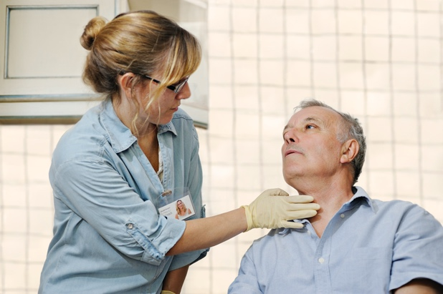
Are you worried about getting speech and language therapy help in the future?

Look at the different options.

Tick what is true for you.

Yes I’m worried about getting speech and language therapy.

No I’m not worried about getting speech and language therapy.

I do not know.

?

Question 4.

Do you have other worries?

Look at the different options.

Tick what is true for you.

I am worried about my physical health.

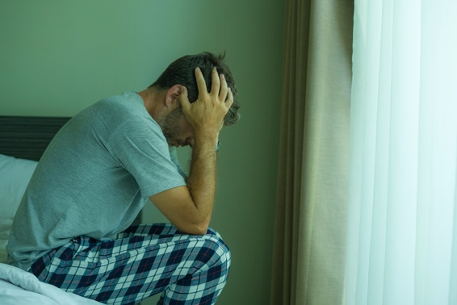
I am worried about my mental health.

I am worried about my home life.

I am worried about my social life.

I am worried about doing my hobbies.

I am worried about my education.

I am worried about my work.

I am worried about something else. Tell us more here:

Section D:
Other information

Think about your speech and language therapy experience.

Is there anything else you want to say?

Section E.

More information about you.

Question 1.

How old are you?

Tick what is true for you.
18-25

25-34

35-44

45-54

55-64

65+

I prefer not to say.

Question 2.

What is your gender?

Tick what is true for you.

Male

Female

Non-binary

I prefer not to say

I prefer to describe myself

………………………………………………………………

Question 3.

What is your ethnicity?

Tick what is true for you.

White British/Irish

Gypsy or Irish Traveller

Other white background

Black/African/Caribbean/Black British

Asian/Asian British

Other ethnic group

Mixed/Multiple ethnic groups

Prefer not to say

I do not know

Section F.
Consent to share your information.

Question 1.

Can we contact you about this survey?

Yes. You can contact me.

No. You cannot contact me.

Question 2.

If yes, how can we contact you?

Email address

…………………………………………………………………………………….

Telephone / mobile number

…………………………………………………………………….

Postal address

………………………………………………………………………………………………..

Please return your completed survey to peter.just@rcslt.org and padraigin.oflynn@rcslt.org.

Thank you!

