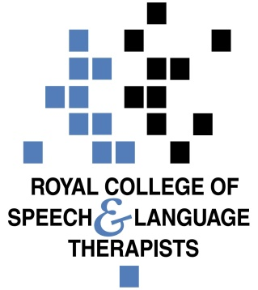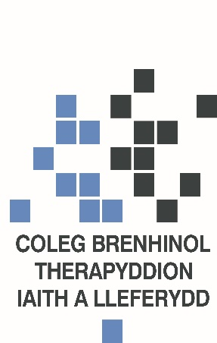

Briefing on Welsh Government National Clinical Framework – A Learning Health and Social Care System
On the 22nd March 2021, the Welsh Government published a National Clinical Framework which sets out how Welsh Government will seek to set the parameters for a wider set of clinical changes required through national, regional and local NHS planning processes. Over time the Executive will incorporate the existing national networks, programmes and support units. It will use these components to direct, support and enable the NHS in Wales to transform clinical services in line with national priorities The Framework sits between A Healthier Wales as the overarching strategy and the clinical aspect of local plans that reflect the realities of their geography, population and workforce. Please see below a summary of the document. Particularly relevant sections are highlighted in red.

National Clinical Framework – A Learning Health and Social Care System –
This National Clinical Framework sets out a coherent vision for the strategic and local development of NHS clinical services. Its intent is to improve patient outcomes and support the planning and delivery of resilient clinical services. It builds upon the findings of a Parliamentary Review and the direction set in A Healthier Wales which was published in 2018. Among its actions was a national clinical plan. The clinical plan was intended to set out Welsh Government’s strategic approach to delivering high quality healthcare services, which meet the needs of people across Wales. This was to include consideration of how specialist services and hospital-based services should be provided, and the skills and technologies needed to support them, as part of the broader health and social care offer. In recognition of the scale of the national challenge and the complexity of operationalising this locally, it was decided to develop a National Clinical Framework.
The Framework describes how clinical services should be planned and developed in Wales based on an application of prudent and value based healthcare principles, which is referred to as ‘prudent in practice’. In doing so, it recognises the need to continue to shift focus from hospital based care to person centred, community based care. Care that can support people to stay well, self-manage their condition and when necessary provides seamless and appropriate specialist support. Central to this is the creation nationally and local adoption of higher value pathways that focus on the patient rather than the setting in which the service is delivered.

The future clinical model –

- This National Clinical Framework sets out a new model of planning and delivery for clinical services. It sets out how the NHS Executive will emerge as the central guiding hand.
- Over time the Executive will incorporate the existing national networks, programmes and support units. It will use these components to direct, support and enable the NHS in Wales to transform clinical services in line with national priorities.
- It will have a significant focus on ensuring that nationally agreed service innovations and holistic pathways of care that have been developed through the collaboration of NHS bodies are then implemented.
- The National Clinical Framework links the Executive to other NHS bodies through its national programmes and networks. The Framework confirms the introduction of a new suite of documents to guide the development of clinical services called ‘quality statements’. These quality statements will set out the vision for specific clinical services and be underpinned by more detailed service specifications.
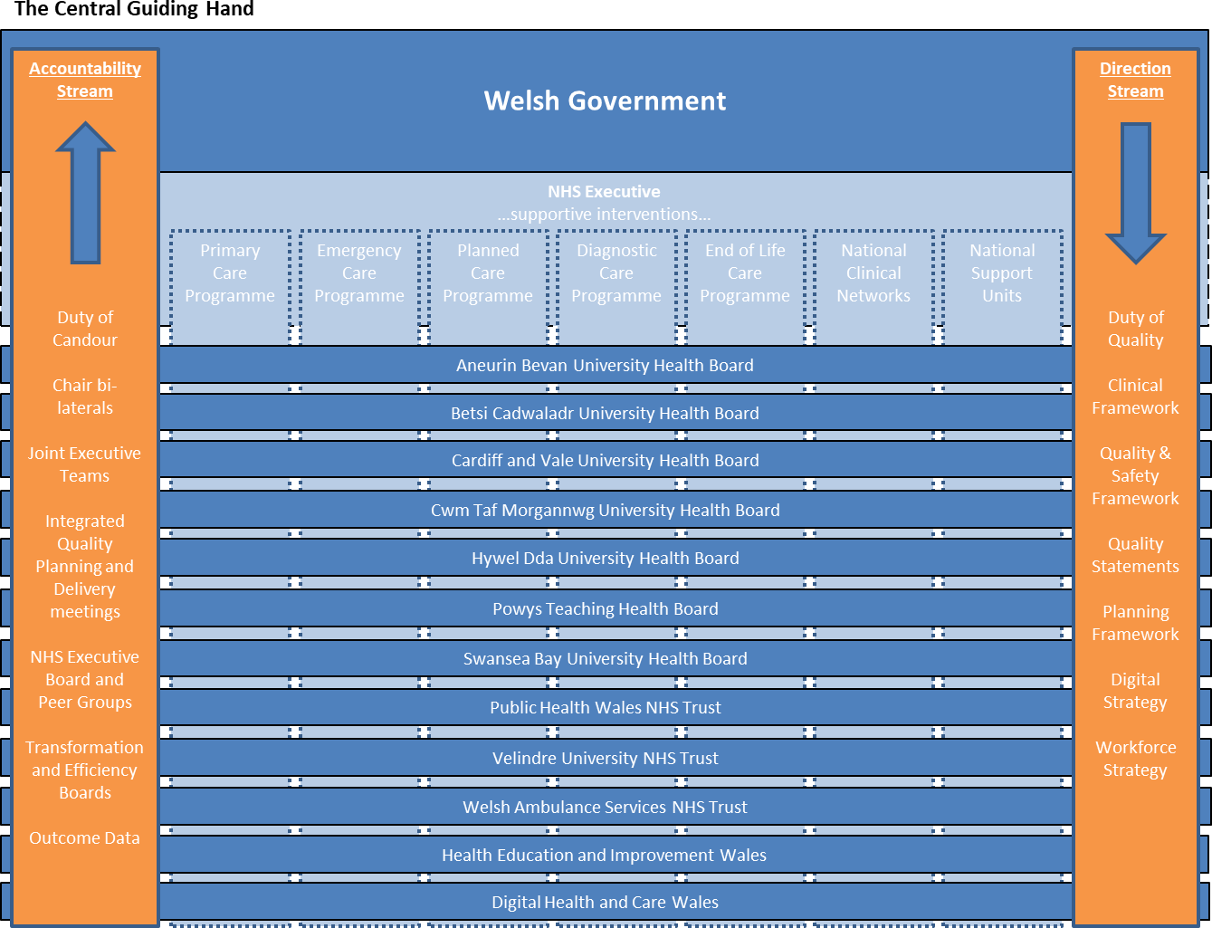

The revolution within-

- The National Clinical Framework also sets out how to stimulate the revolution from within called for by the Parliamentary Review.
- It envisages that health boards and trusts take a population health approach to planning services, grounded in the life course approach.
- It sets out how health boards and trusts should adopt service innovations and higher value clinical pathways in a way that fits their local context.
- It emphasises the importance of local organisations applying quality system methodology and the duties of quality and candour.
- It reinforces the need for clinical teams to embed quality assurance cycles and clinicians to adopt prudent in practice behaviours.
- Finally it highlights the importance of using data on what matters to patients and how the integrated healthcare system is working to guide service development.

NATIONAL ACTION | LOCAL SYSTEM ACTION | PROFESSIONAL ACTION
The NHS Executive will oversee the implementation of the Framework and provide supportive interventions through its national programmes and networks. | Local and regional plans will respond to the Framework and ensure alignment with RPBs and PSBs. | Take part in agreeing national innovations and pathways; as well as implementing them according to local context.

Population health –
- Health boards are responsible for meeting the healthcare needs of their resident population.
- It is important that organisations plan their services with the principle of the life course firmly in mind. In taking a life course approach, the NHS can play its part via Public Services Boards in the wider partnership agenda to tackle the socio-economic determinants of health and health inequality. It must also respond to inequity of access and outcomes. Health boards may wish to consider how their clinical board structure can change to support a more holistic approach to delivering services.
- A key aspect of the vision for healthcare delivery must be the shift of focus from hospital to primary and community care, a shift which makes the best use of all the professionals, providers and sectors.
- When faced with the situation where demand for treatment exceeds capacity to deliver it, access needs to be prioritised according to the clinical need and service models may need to change to meet different levels of need in different ways. This should help to manage risk among those waiting but ultimately, completely new models are required to eradicate waits and the inherent risk of harm that waiting lists tolerate.
- Health boards will need to willingly collaborate where there is a robust case for delivering services across their boundaries in the interests of the population of Wales.
NATIONAL ACTION | LOCAL SYSTEM ACTION | PROFESSIONAL ACTION
More robust collaborations should be enabled to plan fragile services on regional and super-regional footprints. | Health boards will plan across sector boundaries via regional health planning mechanisms and RPBs to meet population need. | Prioritise capacity and adjust delivery models to meet population need rather than demand.

Quality and Safety –
- A new Quality and Safety Framework we will set out how we must address the six domains of quality: safe, effective, person-centred, timely, efficient and equitable.
- A Healthier Wales also called for the introduction of Quality Statements to describe the outcomes and standards we expect to see in high quality, patient focussed services. They will be produced by the n national programmes and networks and replace strategies and delivery plans.
- Having the right data on what the health system does is integral to minimising the potential for harm and understanding where it is happening. Through routine collection of clinical pathway data that work across professional and organisational boundaries we can better understand the impact of healthcare processes on whole groups of patients - such as racial or deprivation driven inequity.
- Another important aspect of quality is patient experience. Patient reported experience measures (PREMs) are an important aspect of outcomes and can act as an early alarm when something is going wrong in healthcare delivery.
NATIONAL ACTION | LOCAL SYSTEM ACTION | PROFESSIONAL ACTION
The development of a new quality and safety framework, and quality statements, to improve the  system focus on quality of healthcare delivery. | All organisations will adopt a quality improvement system and provide annual reports on quality. | All clinical teams will implement quality improvement projects using the quality assurance cycle.

Pathways –
- ‘integrated care pathways’ have been suggested in recent years as the appropriate mechanism for achieving the Institute of Health Improvement triple (now quadruple) aim. They can work as a shared understanding of what each party is aiming to deliver for the patient and thereby help to better integrate the various providers into a seamless model of delivery.
- The priority areas for pathway development flow from the population’s burden of disease. They can be grouped under the following broad headings: cancer, cardiovascular disease and diabetes, musculoskeletal conditions, mental health, substance misuse, multi-morbidity and frailty, and infectious disease. At this level the pathways are not specific to organisation or professional groups. This produces the opportunity for evidence based, standard approaches across Wales. Local organisations who will then implement these national pathways will have flexibility to respond to local need and to innovate but within evidence-based parameters.

NATIONAL ACTION | LOCAL SYSTEM ACTION | PROFESSIONAL ACTION
National pathways will be developed, based on evidence, with broad professional and patient input. | Health boards will localise national pathways in a way which reflects the needs of their populations and the characteristics of their workforce | Implement and continuously improve how local pathways are delivered.

Prudent and value-based healthcare –
- The healthcare system needs to learn to live within the available funding by reorienting its resource towards the interventions that offer the highest value. The emphasis should be on quality of life and what matters to the patient.
- There is increasing recognition of the place for rehabilitation, early therapeutic intervention and self-management, group consultations and interventions, as well as other options such as social prescribing and community support groups. Local organisations will need to allocate resources across the life course and within pathways to achieve value based healthcare.
NATIONAL ACTION | LOCAL SYSTEM ACTION | PROFESSIONAL ACTION
National programmes and clinical networks design higher value interventions. | Local organisations re- allocate resources to higher value interventions. | Change clinical practice to deliver higher value interventions.

Outcome measures –
- The development of Patient Reported Outcome Measures (PROMs) and Patient Reported Experience Measures (PREMs) are important opportunities to understand the patient’s perception of symptoms, treatment, rehabilitation and its outcomes compared to their priorities and experience. It can be used directly as part of the patient’s care to guide decision making or more generally as aggregated data to support service improvement.
- Providing timely access and high levels of service productivity will always be important in healthcare delivery but this new approach attempts to adjust the balance away from activity and toward outcomes that matter to patients.
NATIONAL ACTION | LOCAL SYSTEM ACTION | PROFESSIONAL ACTION
Enable the development of PROMs capability and capacity. | Make greater use of PROMs in planning and managing pathways | Use PROMs where available to guide patient management.

The Enablers –
- Clinical networks –
The role of clinical networks in this Framework is the facilitated bringing together of all the clinical communities, NHS partners and our patients to set out the high level, national pathway for the relevant service or condition. This model will build upon the work of the NHS Collaborative’s existing clinical networks; although these presently only cover a small number of conditions.
Guided by a suite of Quality Statements, clinical networks will create consensus on high value, comprehensive clinical pathways based on evidence-based practice and co- production.
The networks will not duplicate the specific highly specialised standards set by professional bodies apply them and fused them together with the wider requirements of the pathway.
NATIONAL ACTION | LOCAL SYSTEM ACTION | PROFESSIONAL ACTION
Clinical networks will reform and align to the population’s burden of disease, using standards and data to develop and monitor national clinical  pathways. | Provide the local pathway data and engagement with the pathway setting process. | Participate in the clinical networks

- National programmes –
There are several national programmes that have been established to provide greater central direction and to support the local transformation of services. These national programmes have a vital role to play in making this Framework a reality. The Programmes are there to support equity of service offer and local change with additional resource and expertise. For example, the strategic programme for primary care is focusing on supporting health boards to develop sustainable and more integrated primary and community care models. It includes six work streams: prevention and wellbeing, a 24/7 model, data and technology, workforce and organisational development, communication and engagement, and transformation and the vision for clusters.

NATIONAL ACTION | LOCAL SYSTEM ACTION | PROFESSIONAL ACTION
The national programmes will realign to support the Framework described. | Local health organisations will engage in the national programmes. | Inform and deliver outputs of the national programmes.

- Workforce strategy –
A core element of the Parliamentary Review and A Healthier Wales’ Quadruple Aim is to deliver an inclusive, engaged, sustainable, flexible and responsive workforce.
Alongside the uplifts in capacity and targeted interventions, will be a need to consider the impact of specialisation and the importance of multi-disciplinary working. Specialisation improves outcomes for very specific interventions and this will be an important part of future healthcare delivery.
The correct balance and institutional value needs to be placed on providing general practice and general medicine based services. Related to this is the issue of over-medicalising need and the potential to meet need in different, more appropriate ways. That can be done by better integration of non-medical professionals through multi-disciplinary approaches and services led by nurses, midwives, pharmacists or Allied Health Professional; as well as forging closer working relationship with social services and third sector partners.

NATIONAL ACTION | LOCAL SYSTEM ACTION | PROFESSIONAL ACTION
Strategic targeting of training to meet future burden of disease. | Make the most of all clinical disciplines to deliver more sustainable workforce models. | Local pathways will be implemented in a way that supports clinicians to work at the top of their license.

- Digital strategy –
In order for healthcare to be seamless, safe and efficient it needs to be supported by integrated digital systems. The ultimate goal is to develop an interface of systems that constitutes a digital health record for the patient.
NATIONAL ACTION | LOCAL SYSTEM ACTION | PROFESSIONAL ACTION
Establish Digital Health and Care Wales and publish a revised Digital Health and Care Strategy. | Development of the national data resource and service specific dashboards, fusing together data on delivery to support service change | Use service dashboards and other digital tools to plan and deliver services that can better meet need

Implementation –
We have many of the tools to guide , including our prudent and value based principles, and our national enablers, such as the approach to networks and our national programmes, all orientated towards delivering higher value pathways and interventions.

This Framework has a number of system behaviours set out that will be taken forward through the next layer of approaches, such as the planning framework and approach to quality. But it also speaks directly to the clinician, to the service manager, and to everyone else involved in the planning and delivery of clinical services.

The message is to take the framework as a permission to act.

Next steps

It may be helpful to read this summary in conjuction with the briefing on Welsh Government plans for recovery in health and social care.

Over the next few months, the RCSLT Wales office will be continue to horizon scan to look at opportunities for the profession related to the clinical framework and listen to members’ experiences of recovery. Please get in touch to share your thoughts. We can be contacted on wales@rcslt.org

Naila Noori
Policy Team Wales
Naila.noori@rcslt.org

