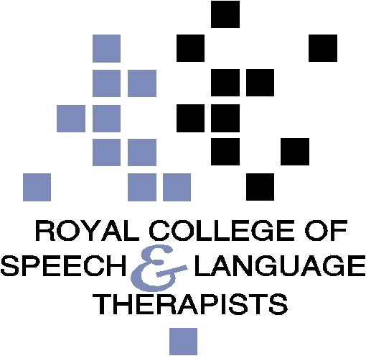

RCSLT NI Ministerial Briefing: The communication needs of young people in contact with the youth justice system

February 2021

1. The Royal College of Speech and Language Therapists

1.1. The Royal College of Speech and Language Therapists (RCSLT) is the professional body for speech and language therapists (SLTs), students and support workers working in the UK. The RCSLT has over 18,000 members (around 700 in Northern Ireland), including almost 95% of the speech and language therapists working in the UK. We promote excellence in practice and influence health, education, employment, social care and justice policies.

1.2. Speech and language therapists have a major role in working directly with children, young people and adults, as well as supporting and training other professionals in working with speech, language and communication needs (SLCN).

1.3. The RCSLT NI has been calling for greater identification and support for SLCN among children, young people and adults within the criminal justice system in NI. Our previous work in this area includes responses to: ‘NI Probation Board Corporate Plan’ (2019), ‘Improving Health Outcomes in Criminal Justice’ (2016), the ‘Youth Justice Review’ (2013) and the report ‘Locked up and Locked Out: Communication is the Key’ in partnership with the Youth Justice Agency (2011).

1.4. The RCSLT Criminal Justice and Secure Settings Clinical Excellence Network is a network of
SLTs working in the field of justice across the UK. In 2017 the RCSLT published a dossier, ‘Justice Evidence Base: Consolidation 2017’, which is a comprehensive evidence base examining speech and language therapy research and professional practice relating to SLCN and offenders.

1.5. As part of its UK-wide work in this area, the RCSLT has developed The Box - a free eLearning package designed for the justice system across the UK to help support people with SLCN. The Box enables communication barriers to be broken down, saving time, frustration and money, and, most importantly, improving outcomes for people with SLCN. It is relevant to those working in youth-offending teams, probation officers, prison staff, the police and other professionals in the courts system; including judges, barristers, and solicitors.

2. Prevalence of SLCN in the youth justice system in NI

2.1. Research shows up to 60% of young people who offend have low language skills, with 46-47% of these being in the poor or very poor range. Many of these young people have grown up with experience of multiple adverse childhood experiences including deprivation and poverty, trauma, neglect, abuse, and many are care experienced or looked after children.

2.2 As highlighted in the consultation document, children who are looked after have a much higher rate of involvement with the Juvenile Justice Centre than the general population, and as the below research demonstrates these children are much more likely to have communication and language difficulties.

Prevalence of SLCN amongst looked-after children
- A study published in the International Journal of Language and Communication Disorders in 2011 found high levels of communication impairment amongst children and young people in residential care. Much of it was severe and pervasive, and largely previously unidentified.
- An Office of National Statistics review of the health needs of looked after children found that speech, language and communication needs were the second most frequently reported difficulty for looked after children.
- No Wrong Door, the service for looked after children in North Yorkshire, found 62% of its looked after children had communication needs. Only two of the children had previously seen a speech and language therapist (SLT).
- A screening of 39 children in residential settings in the Western Trust (2020) found 75% of children have speech, language and communication needs – of these, none were open to core services and only 2 of these were previously referred to services.

2.3. As outlined in the 2019 ‘Improving healthcare in criminal Justice Strategy’, the RCSLT and YJA study in the Lisburn area (2012) carried out 147 screening assessments in six months and found 54% of young people had some communication needs (79 clients). Of those, 78% could probably have had their needs met by a suitably trained CJS professional and 22% probably needed a specialist SLT (17 clients).

2.4 There is also now substantial evidence through the evaluation of the Registered Intermediary scheme in Northern Ireland that significant numbers of individuals, including many children and young people, in the justice system require support with their communication,.

3. The impact of SLCN for children and young people in the criminal justice system

3.1. Some of the types of SLCN experienced by individuals in the justice system include:
- Difficulty understanding spoken words and using language to communicate.
- Difficulties remembering and recalling information accurately.
- Difficulty understanding commonly used legal vocabulary, for example Liable, Remorse, Reparation, Threatening or Victim. These difficulties have prevented effective access to the legal and court system.
- Difficulties in listening and understanding
- Difficulties sequencing information to tell a story.
- Difficulty using abstract language (for example idioms, metaphors).
- Difficulties staying on topic.
- Understanding non-verbal communication and relating to others in socially acceptable ways.
- Difficulty expressing feelings and emotions in an appropriate way, for example they may use aggressive behaviour, instead of words, to express themselves.

  - Communication difficulty and disability have a great impact upon every process within the legal and judicial system as there are huge demands placed on language throughout the justice system and these difficulties affect a person’s ability to fully participate at every stage of the CJS.

  - The implications for a young person with SLCN within the CJS can be profound. Young people with SLCN may not understand the terms of their sentence and what is required of them in their court order or under a licence agreement. Evidence has showed that
one of the main reasons for breach of community licence is failure to meet the terms of that sentence due to a lack of understanding of the terms.

  - Interventions to support rehabilitation can include education, counselling and those related to their offending behaviour (for example weapons awareness, substance misuse). The verbal context of such programmes often disadvantage young people with SLCN, making information and support difficult to access. It also means that the programmes are less likely to be successfully contributing to re-offending.

4. The role of SLTs in the criminal justice system

4.1. Speech and language therapists provide direct and indirect interventions for individuals speech, language and communication needs. Typically SLTs working in justice settings will:
- Screen and assess young people to determine their speech, language and communication needs and support the implementation of the forthcoming Mental Capacity Act (2016) where relevant.
- Support young people to develop their own strategies to facilitate communication
- Work with others to make treatment, education and information more accessible and ensure that programmes and regimes are aimed at appropriate levels for individuals.
- Train the workforce to be able to identify who may need support with speech, language and communication, understand how this might impact on the young person and how to improve their interaction with individuals.
- Act as Registered Intermediaries to facilitate participation and engagement of children and adults who are classed as vulnerable, to access the criminal justice system. Currently in Northern Ireland 65% of RIs are speech and language therapists.

Available at https://www.rcslt.org/members/clinical-guidance/justice/justice-guidance#section-11
Available at https://www.rcslt.org/learning/the-box-training/
Bryan, K., Freer, J. and Furlong, C. (2007), Language and Communication Difficulties in Juvenile Offenders. International Journal of Language and Communication Disorders, 42 (5), 505-520).
https://www.justice-ni.gov.uk/sites/default/files/consultations/justice/regional-care-justice-campus-consultation.pdf
https://www.justice-ni.gov.uk/sites/default/files/publications/doj/yja-and-rcslt-joint-conference-report.pdf.
Department of Justice, Northern Ireland Registered Intermediaries Schemes Pilot Project, Post-Project Review, January 2015, Pg 4. http://www.dojni.gov.uk/index/publications/publication-categories/pubs-criminal-justice/ri-post-project-reviewfeb15.pdf
See https://www.rcslt.org/-/media/Project/RCSLT/justice-evidence-base2017-1.pdf for a full review of the evidence base relating to SLCN and Justice.
RCSLT Justice Evidence Base: Consolidation 2017
McCool S and Stevens IC. Identifying speech, language and communication needs among children and young people in residential care. International Journal of Language and Communication Disorders 2011; 46(6): 665-74.
Meltzer H. The mental health of young people looked after by local authorities in England. Office of National Statistics 2002.
Information provided by Youth Communication Team North Yorkshire, 2016.
Data provided by WHSCT SLT Service, October 2019 - full case study available upon request.

