Part four: RCSLT clinical competencies for assistant practitioners

Context

This RCSLT clinical competencies framework is being developed by a project group of speech and language therapists (SLTs) and assistant practitioners (APs) as part of updating policy/guidelines for the professional development and training for APs.

This is designed to support assistants and their managers/supervisors. This needs to be considered alongside the project framework (see previous sections 1-3) which offers background and further context. There is a requirement that this model of practice is generic enough to cover as many services as possible yet detailed enough to give practitioners a sound basis for developing competencies in role.

Introduction

This RCSLT framework identifies the competencies required by an AP to develop their knowledge and skills within their role and enable them to perform at the limit of their scope of practice. The competencies have been divided into four sections, or quadrants (see below, figure 1).

As outlined in the RCSLT Delegation guidance (2017) the expectation is that it will be a registered practitioner who:
- makes the clinical diagnosis, analyses and interprets assessment results
- generates possible therapeutic options in discussion with the service user

The AP will be expected to make decisions within the context of designated work with a service-user, whilst working towards the aims set by the registered practitioner. This may mean that an AP working at more advanced levels is able to:
- Plan and implement a therapy/treatment programme or care plan within the scope of their skills and training — reporting to the registered practitioner for re-direction and advice, as necessary
- Judge the service users’ progress and make some treatment decisions based on that judgement, assess and reassess the service user’s progress.

Where a clear protocol for a service user group or pathway is in place the AP may have delegated discretion and autonomy for some elements of continual assessment. These will be clearly defined and agreed.

It is essential that the role and specific activities of the AP are made explicit in the design of such protocols.

It is expected that an AP who is delegated a task will be competent to:
- Continually monitor and report changes in the service users’ responses
- Feedback relevant information to the registered practitioner(s).

As the HCPC state, this information will be included in supervision discussions: “You must continue to provide appropriate supervision and support to those you delegate work to” (HCPC, 2016b, p. 7). There should also be a mechanism in place for the AP to access support at other times, as required.

Figure 1.
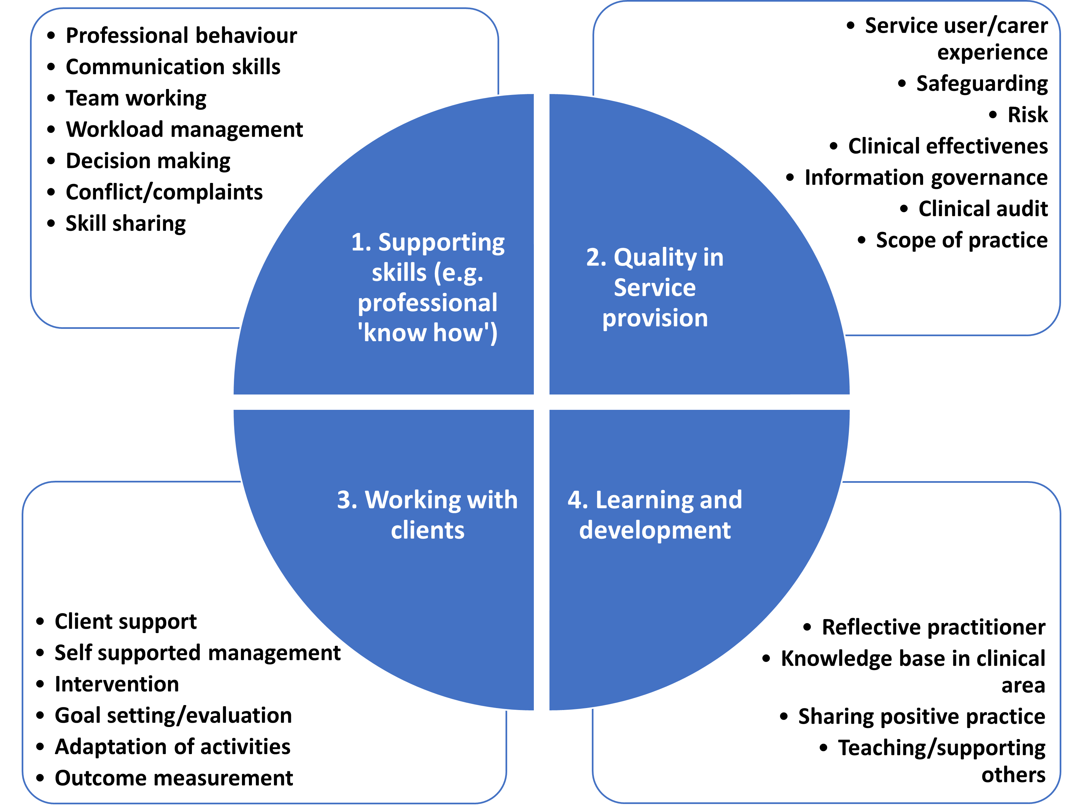

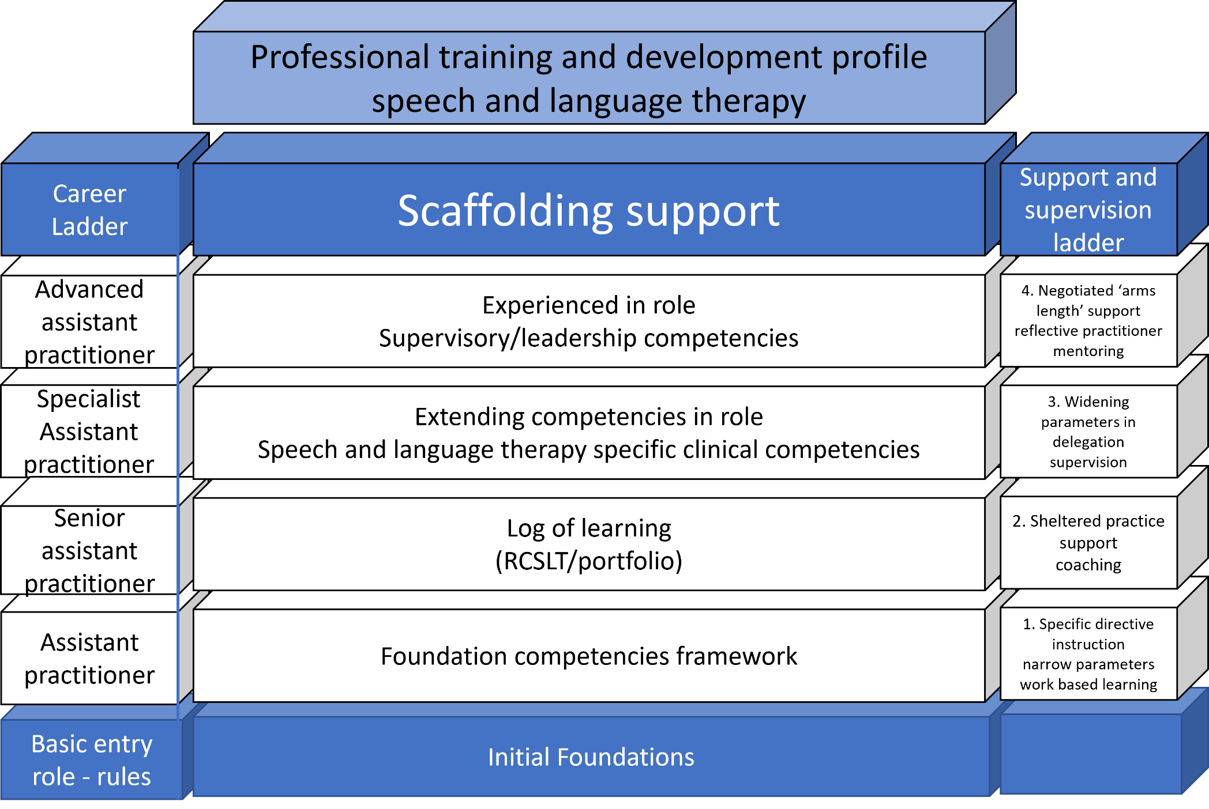
Figure 2.

Support and supervision ladder

The professional training and development profile (Figure 2) is supported by the support and supervision ladder (highlighted red on the model above) and shows the levels of support and supervision required at each stage of an AP’s development. These support levels should be used to determine the levels of support and supervision for each competency.

All APs should receive professional (clinical) supervision as stated in the RCSLT Supervision guidance. The support/supervision below is in connection with daily casework, scope of practice and making judgements and decisions on a day-to day basis.

Level | Support and supervision
4
Negotiated ‘arm’s length’ support  reflective practitioner  mentoring | - Working autonomously on care pathway or individual care plan with identified route for accessing support.  - Managing time/workload and prioritising duties  - Taking key role/ leading in aspect of quality/service development  e.g. such as questionnaires, interviews, patient stories.  - Discussing delegated case-working in supervision. Adapting aims and activities within agreed scope of practice.  - Reflective practitioner, evaluating and contributing pro-actively to case discussions  - Keep a reflective diary, highlighting learning from reflection and ability to reflect-in-action (thinking in the moment) as well as after events
3
Widening parameters in delegation  supervision | - Support, supervision and direction provided primarily through discussion with negotiated level of support  - Working autonomously with negotiated level of support.  - Managing own time/workload  - Makes decisions within clearly defined scope of practice, discussing decisions /dilemmas in supervision  - Adapting service user activities & recording and discussing in supervision  - Carrying out key role in service provision or quality e.g. Health and Safety  - Reflective practitioner, evaluating casework, knowing when additional support/supervision is needed  - Plans for supervision using reflective log/journal as a reference point.
2
Sheltered practice support  coaching | - Agreed level of support/supervision. Less direct support, more autonomy (arm’s length support) for routine tasks/decisions within scope of practice.  - Seeks support if decisions move out of agreed role/scope of practice.  - Workload structured by service with some flexibility within agreed parameters.  - Makes independent decisions in routine casework within clearly defined role boundaries.  - Contributing suggestions in planning for service user  - Making agreed minor adaptations within therapy plan  - Contributing to team projects e.g. quality/service improvement. Making suggestions/identified role  - Co-ordination role in service e.g. AAC equipment  - Able to discuss casework in reflective conversation with supervisor.
1
Specific directive instruction  narrow parameters  work based learning | - Directive support/supervision  - Knows when additional support is needed and seeks it out  - Supported decisions in clearly identified circumstances  - Decisions to be checked with a therapist  - Awareness of quality/governance  - Involvement in quality/service projects and makes suggestions for improvement  - Recognises responsibility regarding safety/risk  - Contributes observations to discussions about clinical planning

Learning log/journal approach

For each role/competency, evidence should be recorded and provided in a learning log/portfolio approach. This could be entered in the RCSLT CPD diary or alternative system.

For services which are very different e.g. universal health promotion or highly specialist unit, then services may need to adapt and develop something more individual which covers the roles undertaken by practitioners in that setting. This profile has been devised to be generic and relevant across a range of roles in adult, ALD and children’s services.

Clinical support competencies:
Role and scope of practice of the assistant practitioner

“Professional practice is rich and complex in nature. In order to capture some of this complexity, the speech and language therapy competencies frameworks need to be set within a concept of practice that goes beyond a functional analysis of job role”. (RCSLT, 2002)

The clinical competencies are divided in four sections to reflect the four quadrants outlined above (figure 1) and can be easily accessed here:

- Supporting skills (or professional ‘know how’)
- Quality in service provision
- Working with service users
- Training and CPD

Quadrant one — Supporting skills (or professional ‘know how’)
These competencies are critical to being a ‘successful AP’. The focus is on work-based competencies such as being a highly effective communicator e.g. actively listening, giving feedback, interacting, enabling and influencing others. Also excellence is required in interpersonal skills, including observation, listening and empathy skills.

Competency | Activities | Level of support agreed | Date achieved | Evidence
- Professional behaviour

- Values and professional behaviours | - Knowing organisation’s values and associated behaviours in compassion, integrity, accountability etc.  - Applying professional core values, knowledge and skills appropriately in working towards agreed service user goals  - Being a compassionate and caring practitioner who considers service users and carers holistic wellbeing
- Communication skills

- Communication with SLT colleagues | - Negotiates and agrees level of support/supervision  - Listens and contributes to conversations about implementing a care plan  - Engages in feedback conversations – reporting back about progress/difficulties and any decisions taken and next steps
- Communication with other professionals | - Demonstrates communication skills needed to build relationships with others around the needs of the service user.  - Negotiates and agrees level of support  - Listens and contributes to conversations about implementing support  - Provides timely and clear updates to professionals involved
- Communication with service users | - Communicates in an open way that is sensitive to the wishes and perspectives of service user/carers/significant others  - Is aware of the emotional needs of others and displays empathy with service users and carers during discussions  - Employs core skills of rapport making, putting others at ease, listening to the service user’s story, asking relevant questions and strategies such as introducing/adjusting/cueing /demonstrating activities
- In working with interpreters | - Communicates effectively through the use of interpreters and co-workers
- Communication in meetings | - Confident in contributing to meetings (team or service user related)  - Able to give presentations to colleagues on subjects within scope of practice
- Written information | - Effectively contributes to formal written information.  - Writes informatively about service users (writing confidently about own observations, activities, changes and progress made outside of formal reporting)
- Team Working

- Case sharing skills | - Works collaboratively with other SLTs  - Listens and contributes to conversations about implementing a care plan  - Engages in feedback conversations – reporting back about progress/difficulties and any decisions taken and next steps
- Teamwork  (uni-professional) | - Builds positive relationships with colleagues (other AP, SLTs, admin)  - Supports the team around clinical service and quality/governance  - Provides feedback on own role and interplay with others in team  - Contributes to team meetings e.g. giving opinion, presentations
- During the process of providing and enabling evidence-based, clinically competent care | - Recognises and respects the roles, responsibilities, competence and constraints of other professions in relation to speech and language therapy; knowing when, where and how to involve those others through agreed channels
- In partnership working | - Works collaboratively with other professionals e.g. teachers, teaching assistants  - Demonstrates communication skills needed to build relationships with others around the needs of the service user  - Building and extending partnerships working e.g. with group homes, educational settings  - Has a mindset for seeking partnerships/joint working opportunities in a ‘team around the service user’ approach  - Establishes and maintains positive working relationships with co-workers based on mutual respect
- Teamwork in MDT | - Works collaboratively with colleagues from other professions as part of a multidisciplinary team  - Understands the roles of other members of the team  - Confidently contributes to MDTs e.g. engaging in discussion with colleagues in one-to-one or meetings  - Carries out identified key roles in MDT settings e.g. rehab team/special school
- Partnership with service users/carers | - Works in partnership with service users/ carers and significant others towards the improvement of the service user’s quality of life  - Establishes and maintains positive working relationships with service users, carers and co-workers based on mutual respect  - Whenever possible, decisions regarding management of intervention are negotiated and agreed in partnership with the service user/carer/significant others
- Workload Management

- Caseload | - Keeps accurate, contemporaneous records of activity  - To manage the work involved in meeting the SLT needs of a defined service user caseload.
- Context | - Adapts and modifies approaches and activities in order to meet the requirements of different working contexts
- The wider workload (balancing priorities) | - Whilst keeping the needs of the individual service user to the fore, balances those needs with those of other service users, their profession, higher education, their work organisation and society  - Manages time for clinical/non-clinical responsibilities
- Workload | - Prioritises and co-ordinates a number of different and potentially conflicting roles and activities in order to attain a range of professional goals
- Decision Making

These judgement and decision-making competencies underpin practice. Practice is far greater than the ability to deliver a service through a predetermined care plan or pathway. Practitioners are constantly facing unique situations and practice dilemmas not just in relation to individual service users, but also in relation to case working demand

- Within scope of Practice | - Makes decisions within identified scope of practice e.g. adjusting level of activity
- Outside scope of practice | - Recognises when limits of own scope of practice are reached and there is a need for support in judgement and decision making
- Conflicts/complaints

- Resolving dissatisfaction and conflict | - Knows and follows service policies and procedures in de-escalation of dissatisfaction and resolving conflict  - Listens attentively and note the issues which are causing the dissatisfaction  - Suggests solutions where possible and ensure the other person feels ‘listened to’  - Escalates issues to supervisor/manager
- Skill sharing

- Profession | - Contributes to the body of knowledge about speech and language therapy practice through:  - sharing experience through discussion with colleagues and membership of support networks  - engaging in research, writing articles for publication etc.
- Support network | - Knows when and where to access a range of support, resources and further information to support clinical practice

Quadrant two — Quality in service provision
Knowing about the different strands of the Quality Agenda/clinical governance (in healthcare organisations)/quality/standards (within education/social care settings). It is recognised that some APs will work outside of a healthcare organisation with different quality standards/frameworks in Sure Start/Education.

Competency | Activities | Level of support agreed | Date achieved | Evidence
- Service user/carer experience

- Service user/carer involvement | - Participates in gathering information from service users/carers about their experience of service and level of satisfaction, e.g. designing surveys, questionnaire ‘patient stories’
- Safeguarding

- Knowledge and skills in safeguarding vulnerable adults and children | - Has knowledge and skills in safeguarding vulnerable adults and children in line with other practitioners in the service.  - Follows local process/ policies  - Engages in regular, and seeks out ad hoc, safeguarding supervision
- Risk

- Health and safety aware | - Provides safe care within working practice and keeps the work environment safe for self and everyone else through reference to health and safety procedures
- Reporting Risk | - Identifies, reports and escalates risks in the working environment or service provision
- Clinical effectiveness

- Up to date with knowledge/evidence | - Clinical activity based on up-to-date knowledge evidence  - Interested in developments in the areas relating to casework in research, technology, and approaches to intervention  - Understands the clinical evidence related to case working
- Critical appraisal of evidence | - Understands how new research/information needs to be objectively scrutinised (critical appraisal)
- Accountability | - Accepts accountability for actions which are based on the best available evidence at the time of intervention
- Service improvement | - Contributes to the continuous improvement of speech and language therapy services through:  - engaging in team reflection on service practice and service planning  - engaging in local research/audit projects focused on practice  - implementing agreed quality improvements within practice
- Information governance

- Information governance | - Conforms to legislation and protocols regarding security and confidentiality of patient-identifiable information |  |  | .
- Clinical audit (or audit of standards in non-clinical services)

- Clinical audit/audit of standards | - Participates in, contributes to, and may lead, audits, service evaluation relevant to own work. e.g., Case note audit
- Implementing audit results | - Embedding clinical audit results into working practice.  - Contributing to discussion/ agreement about these quality improvements within a team
- Scope of practice

In the previous RCSLT guidance (2002) this specified a small caseload with non-complex needs. The reality is many APs work in specialist areas such as head and neck service and in their daily casework their service users have complex needs. Increasingly the role is specified within a care pathway and there will be a case-managing SLT who sets direction, goals and gives feedback.

As the scope and role of the AP has expanded the term case-managing SLT is used to reinforce that care is delegated and supervised safely by this case-managing therapist but within the planned care the experienced AP may often proceed with autonomy, accessing support/supervision as needed. This can be ad-hoc as well as on an agreed schedule of case discussion. In the foreword to the AHP Framework (HEE, 2021) the expectation is that APs will be developed to work at the top end of their scope of practice. The support practitioner must remain aware at all times of the limits of his/her expertise and seek support from appropriate sources when those limits are reached.

- Code of Conduct | - Aware of and adheres to regulatory body, RCSLT and local employment codes of conduct
- Works within individual scope of practice undertaking only tasks for which trained and competent, seeking appropriate support when necessary | - Has a clear understanding of current role and responsibilities  - Knows and works within the limits of current scope of practice  - Recognises when limits of own scope of practice are reached and support for judgement and decision making is required
- Autonomy within scope of role | - Has own identified caseload previously seen by a therapist  - Works independently with service users on a day-to-day basis within the scope of the role and operational pathways, protocols and procedures with ongoing support available from a case-managing therapist

Quadrant three — Working with service users
The intervention process (in some clinical services, these are therapy skills, while in other preventative or educational services these are facilitative/developmental teaching skills) and can be broken down into:
- Assisting in assessment/information gathering. This may involve carrying out observations or specific assessment tasks which feed into evaluation which is co-ordinated by a case-managing therapist
- Intervention — contributing to developing, implementing, monitoring and evaluating the implementation of an intervention programme. Tasks may involve developing materials, working with the service user and family and liaising with people
- Making decisions within the context of designated work with a service user or setting whilst working within parameters set by therapist or within identified scope of practice within a care pathway
- Monitoring and evaluating changes in the service user’s responses and feeding back relevant information to the therapist(s)

Increasingly, models of practice in services are based on care pathways with much more collaborative case sharing between the SLT and AP, focusing on different aspects of care e.g. the SLT might initially evaluate and analyse needs and the AP might then continue with implementing a care plan before jointly discussing/evaluating progress and devising the next steps together. The level of insight/contribution varies according to experience/expertise of the AP (agreed scope of practice in service provision) and governed to some extent by banding.

Competency | Activity | Level of support agreed | Date achieved | Evidence
- Service user support

- Person centred care | - Keeping the service user’s needs and choices central to decision making and planning
- Supporting service users and families who are distressed | - Is able to support service users/ carers/ families in situations where difficult news is being conveyed.
- Different ways of communicating | - Responds appropriately and sensitively to the wide range of communicative channels used by people with communication difficulties
- Environmental support for communication | - Works with others to create and maintain environments and practices which facilitate people’s abilities to communicate (and/or eat and drink) to their full potential and which promote their emotional, social and cognitive well-being
- Self-supported management

- Enabler/facilitator | - Enabling carers/families to be confident in providing self-supported management
- Communication needs in an individual context | - Appreciative of the importance of gaining a holistic understanding of the service user’s needs, through reference to the social, cultural, economic, linguistic and environmental contexts; with full respect for differing values
- Intervention

Intervention is divided between:
- In a clinical service - implementing an evidence based and integrated approach to the management of the service user’s difficulties involving the individual, the family, other professionals and key people in the service user’s environment
- Within a Universal Service Model where there is an agreed universal/preventative approach. The focus is on preventative approach through facilitating development using supportive strategies or by adapting the environment. This is an approach utilised in Early Years settings (children’s centres)

- Early identification/  screening | - Contributes to the development of screenings for early identification of difficulties or ‘at risk’ factors in a given population (screenings to be carried out by other professionals/agencies)  - Assists other professionals in developing the skills to carry out screening procedures
- Assessment/ information gathering | - Provides information to others about the speech and language therapy approach/process  - Gains consent for speech and language therapy involvement from service user/carer.  - Carries out agreed activities linked to assessment overseen by a case managing therapist. E.g. observational schedule, informal activities, collecting information including discussion with service user/carer and colleagues.
- Intervention  a) In a clinical service:  implementing an evidence based and integrated approach to the management of the service user’s difficulties involving the individual, the family, other professionals and key people in the service user’s environment | - Uses a variety of specified means to meet the communication/eating and drinking difficulties of service users  - For an AP this means undertaking a role in intervention as specified in care pathway (in place at service level) or care plan (for individual) with guidance from a therapist, and could include supporting the service user in:  - resolving identified difficulty  - maximising improvement of function  - maximising the use of existing skills in achieving self-care/through effecting environmental modifications or  - coming to terms with difficulties where appropriate (e.g. in the context of a deteriorating condition) |  | .
- Intervention  b) Within a universal/facilitative service model: delivering an evidence-based approach providing facilitative strategies and enhancing the communicative environment | - Confidently undertakes role within a universal/facilitative approach, for example:  - empowering in an early years’ setting  - supporting a stroke group by acting as ‘a resource’  - Works at an environmental level: Supporting settings in adapting/engineering the environment so the interactions and resources are ‘communication friendly”
- Goal setting/evaluation

- Goal based work | - Contributes to the goal setting process  - Works towards goals set
- Monitoring and evaluating | - Monitors and evaluates progress responding by adapting approach/activities or escalating concerns to the case-managing therapist  - Provides feedback on service-user progress and condition, recognises the impact of support and interventions, and suggests ideas for improvement when developing, reviewing and evaluating care plans based on objective evidence and experience
- Adaptation of activities

- Adaptation of activities | - Adapts approaches and activities according to evaluation of effects and outcomes within agreed framework
- Outcome measurement

- Knowing and utilising outcome measurement systems as appropriate | - Knowledge of any locally implemented system of outcome measures  - Contributing to outcome measures for individual service users
- Discharge/completion of episode of care | - Knows about the discharge process in service  - Feeds back when goals/objectives in care plan are achieved  - Contributes collaboratively to case-managing therapists decision making about completion of an episode of care/intervention  - Supports service in carrying out discharge procedure, including providing information about referral back into the service.

Quadrant four — Training and CPD
This focuses on individual practice development, learning new skills and strengthening and extending existing competencies. Learning and development will be predominantly through work-based learning and reflection on development and quality of practice

Although the AP has a responsibility for identifying and exploring ways of meeting own learning needs, this should be with the support of a Supervisor/Competency Coach.

Competency | Activity | Level of support agreed | Date achieved | Evidence
- Reflective practitioner

- Learning needs | - Identifies own development needs through critical self-reflection  - Able to engage in a conversation with a supervisor/competency coach and consider casework, gaps in knowledge and any barriers to learning.  - Identifying strengths to build upon within the role
- Development needs | - Identifies which competencies are evolving and need consolidation  - Knows which competencies are not yet established  - Agrees and records learning goals to extend competencies and knowledge base
- Learning outcomes | - Keeps a reflective log/journal to track learning experience and provide evidence of development  - Evaluates learning with supervisor/competency coach, discussing how development has impacted on case-working  - Knows own learning style and evaluating the effectiveness of chosen methods in meeting learning needs, e.g. work based learning, guided reading, short course, shadowing others
- Individual reflective practice | - Involved in case discussion through informal support, formal clinical supervision, peer case review or action learning sets  - Able to discuss cases (tell stories about experiences in case-working) in a guided conversation with a supervisor using a reflective approach such as a ‘do and review cycle’ and recognise learning points
- Supervision | - Able to engage in positive supervisory relationship – professional/clinical supervision and management supervision
- Self-development | - Ability to identify self-development needs which relate to wellbeing at work, e.g. strategies for time management, resilience, stress management
- Emotional resilience | - Monitoring and regulating own emotional response level to workplace demands, including asking for additional or outside support when necessary
- Knowledge base in clinical area

- Knowledge base in clinical area | - Knows evidence and theory in relation to clinical area and is able to practically use a wide range of evidenced strategies and techniques in scope of practice
- Sharing positive practice

- Evidence-based approach | - Confident in talking with colleagues about theory and evidence in own specific areas of practice  - Sharing positive practice experience on a wider basis through involvement in Team Meetings, ASLTIP Local Groups, Clinical Excellence Networks (CENs)
- Teaching/supporting others

- Trainer | - Developing confidence, skills and style as a Trainer of others  - At a simple level this could be sharing a care plan with carers  - Experienced APs might be contributing to a training course /workshop. At an advanced level this could be leading a training event  Informal Training: e.g. sharing supportive strategies with carers, sharing resources with teachers and teaching assistants in Education  Formal Training: involvement in training others e.g. early language training workshop, voice care support.
- Coach/mentor | - Providing support to less experienced colleagues and peer support with colleagues  - Participating in coaching and mentoring of less experienced support staff and students (including apprentices) in respect of tasks and responsibilities within scope of practice
- Supervisor | - Takes role of clinical supervisor for identified colleagues who have less experience or in a peer supervision arrangement
- Students | - Supports students on placement by providing opportunities for students to learn about SLT through observation and discussion.

Advanced skills/specialist/supervisory assistant/associate practitioner

There is an additional role of Advanced or Specialist Assistant /Associate Practitioner. The NHS Careers information refers to Supervisor role as an extended role in career progression.

In the supporting information there is a feature on this role, which is usually Band 5 on the Agenda for Change pay scale.

These roles are highly specialist and one of the examples is for an Assistant Practitioner who has led and published a research project. Another leads a team of 4 or 5 Assistant Practitioners with delegated management oversight. The domain skills in the AHP Framework will have been achieved and exceeded by these practitioners. However the Competency Framework above will be relevant as it was developed as a model of practice for therapists and then adapted to highlight the role of APs.

The suggestion is that an AP working in an advanced role would spend time reflecting on the competencies, the strengths and gaps and compile an individual Clinical Profile based on this Support Practitioner Framework and the individual requirements of their role.

These practitioners are inspirational role models for colleagues. They excel in this evolving professional role which is complimentary to that of the qualified/registered SLT. There are restrictions on some aspects of clinical care e.g. analysis of assessment and generating hypotheses for clinical direction. However it is important to consider there are roles in Quality & Governance, Training and Development, Supervision/Safeguarding and Research which are open to Assistant Practitioners.

References
- Allied Health Professions’ Support Worker Competency, Education, and Career Development Framework Realising potential to deliver confident, capable care for the future (October 2021)
- Competencies Project: Support Practitioner Framework, Williamson (August 2002)
- RCSLT Delegation Guidelines (RCSLT, 2017)

