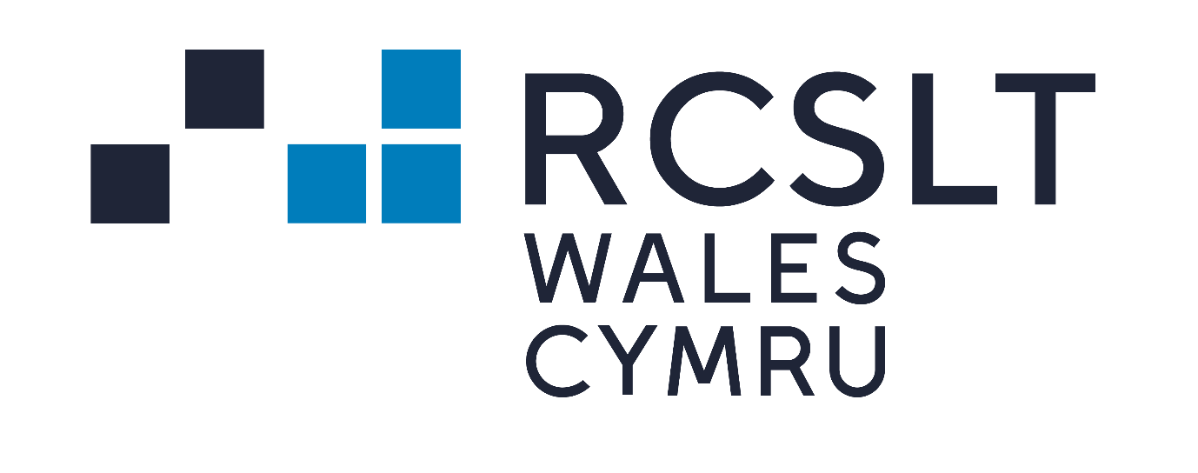
Briefing on the Welsh Government Co-operation Agreement 2021

On the 1st December 2021, the Welsh Government and the Leader of Plaid Cymru signed the Co-operation Agreement. They will work together to develop and oversee the delivery of the 46 policy areas in the Co-operation Agreement over the next three years.

Summary of the Policy Programme –

Areas that may be of particular interest to our members have been highlighted in red.

Working together, The Welsh government and Plaid Cymru will:

- Free school meals – Extend free school meals to all primary school pupils, over the lifetime of the agreement, as a further step to reaching the shared ambition that no child should go hungry. It is agreed that universal free school meals will be a transformational intervention in terms of child hunger and child poverty, which will support educational attainment and child nutrition and local food production and distribution, benefiting local economies.

- Childcare – Expand free childcare to all two year-olds with a particular focus on providing and strengthening Welsh-medium childcare.

- Future of Social Care – Set up an expert group to support the shared ambition to create a National Care Service, free at the point of need, continuing as a public service. An implementation plan will be agreed by the end of 2023. There will be a continuation to better integrate health and care and work towards parity of recognition and reward for health and care workers.

- Senedd reform – Support plans to reform the Senedd, based on 80 to 100 Members; a voting system, which is as proportional – or more – than the current one and have gender quotas in law. Support the work of the Senedd Special Purpose Committee and introduce a Senedd reform Bill 12 to 18 months after it reports.

- School term dates – Aim to reform school term dates to bring them more in line with patterns of family life and employment. Explore options to reform the rhythm of the school day to create space for more wide-ranging, culturally accessible activities and opportunities.

- Welsh language education – Introduce a Welsh Language Education Bill, which together with more immediate non-legislative work, will strengthen Welsh in Education Strategic Plans; set new ambitions and incentives to expand the proportion of the education workforce who can teach and work through the Welsh language; establish and implement a single continuum of Welsh language learning; enable existing schools to move into a higher Welsh language category and incentivise the increase of Welsh medium provision in all education settings.

- Coleg Cymraeg Cenedlaethol and National Centre for Learning Welsh – Invest in Coleg Cymraeg Cenedlaethol and the National Centre for Learning Welsh to increase the proportion of Welsh-medium apprenticeships and further education and provide free Welsh language learning for 16 to 25-year-olds.

- Mental health – Test how community facilities run by trained third sector staff with clear referral pathways into NHS services if needed – the sanctuary model – can help support young people in crisis or with an urgent mental health or emotional wellbeing issue. These would be open evenings and weekends.

- Disability – Strengthen the rights of disabled people and tackle the inequalities they continue to face. Commit to the social model of disability and together ensure the success of the Disability Task Force set up to respond to the Locked Out report.

- Race Equality Action Plan – Tackle institutionalised and systemic racism and support the publication of the Race Equality Action Plan. Work with communities, stakeholders and partners to make the plan as strong as possible.

- LGBTQ+ – Make Wales the most LGBTQ+ friendly nation in Europe and support the publication of the LGBTQ+ Action Plan. Calls for the powers to legislate to improve the lives and protect the safety of Trans people in Wales to be devolved.

The full Co-operation Agreement can be viewed here.

Next steps
Over the coming months, the RCSLT Wales office will be continue to horizon scan to look at developments and seek opportunities to influence for the profession. Please do get in touch to share your thoughts. We can be contacted on wales@rcslt.org

Naila Noori
Policy Team Wales
Naila.noori@wales.nhs.uk

