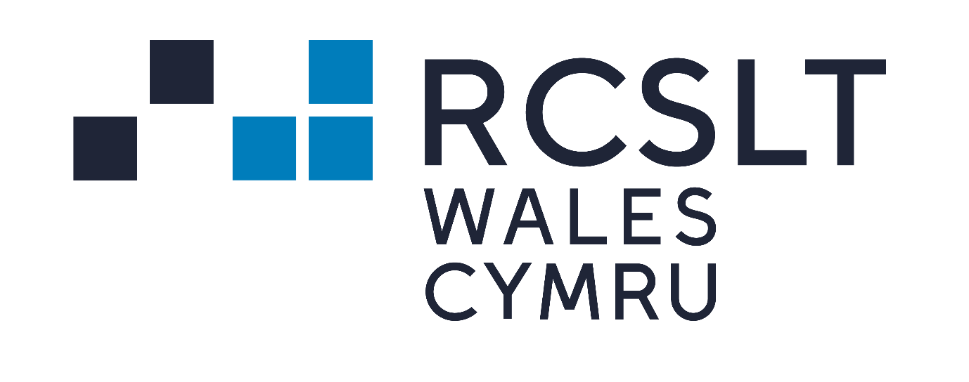Briefing from the Royal College of Speech and Language Therapists ahead of the statement by the Minister for Education and Welsh Language: Children’s Oracy and Reading, 16th November 2021

- Good early language skills are central to children’s early years development and school readiness. They play a crucial role in literacy, a child’s ability to achieve their educational potential, their social mobility, and their life chances. Beyond academic attainment, well-developed speech, language and communication skills are fundamental to the ability to form and maintain social relationships with family, peers and friends.

- Not all children have the speech, language, and communication skills they need to fully engage with their education. It is estimated that 10% of all children in the UK have long-term, persistent speech, language and communication needs (SLCN). Research shows that there is a strong correlation however between poverty and delayed language. By which we mean, those children whose language skills are developing significantly more slowly than those of other children of the same age but who do not have a specific disorder. Language skills are a critical factor in the intergenerational cycles that can perpetuate poverty.

Key statistics

- Over 50% of children in socially deprived areas may start school with impoverished speech, language and communication skills
- On average children from the poorest 20% of the population are over 17 months behind a child in the highest income group in language development at age three.
- Vocabulary at age 5 has been found to be the best predictor (from a range of measures at age 5 and 10) of whether children who experienced social deprivation in childhood were able to ‘buck the trend’ and escape poverty in later adult life Researchers have found that, after controlling for a range of other factors that might have played a part (mother’s educational level, overcrowding, low birth weight, parent a poor reader, etc), children who had normal non-verbal skills but a poor vocabulary at age 5 were at age 34 one and a half times more likely to be poor readers or have mental health problems and more than twice as likely to be unemployed as children who had normally developing language at age 5.

Current progress on early language skills

There has been an increasing focus on children’s speech, language and communication (SLC) skills within early years policy in Wales, both within the home environment and within early years provision.

We warmly welcomed the introduction of the Welsh Government Talk with Me Speech, Language and Communication Delivery Plan 2020-22 and the secondment of two speech and language therapists on a job share arrangement into Welsh Government to lead on the delivery of the plan. Since the publication of the plan, a number of positive steps have been taken including,

- the launch of the all-Wales SLC training pathway for childcare practitioners that enables practitioners to identify their personal training needs and empowers staff to access training to promote SLC skills and identify those needing early access to intervention.
- Funding agreed for a Talk With Me national campaign –this will highlight the need for families to help develop the SLC skills of their children in the early years and advise them how they can provide a language-rich home environment.
- Additional COVID recovery funding to help address SLC needs.
- Commissioning of a review of early language screening for children aged 0 and 4 years 11 months, to inform the development of an all-Wales early language screening tool.
- Training for childcare and play inspectors and Estyn on early language development.

What more needs to happen?

It is widely acknowledged that that Covid and the lockdowns it has entailed have had a huge impact on the lives of children, particularly those in deprived areas. The average child has missed 84 days of school. Children of all ages have had reduced opportunities to interact with others and experience new places which are key developing essential skills in speaking and understanding. The recent Speaking Up for the Covid Generation: ICAN report surveyed primary and secondary school teachers across England, Scotland, and Wales about the impact Covid 19 has had on their pupils speaking and understanding. The findings revealed that the majority of teachers surveyed across the UK had serious concerns about the impact of the pandemic on children’s speaking and understanding. Against this backdrop, it is essential that the focus is maintained on early language skills.

Despite the overwhelming evidence of the importance of communication skills, spoken language has often not been given the same status as reading and writing in our education system. The new curriculum offers an opportunity to ensure that oracy is prioritised. We note that the language, literacy and communication area of learning and experience is the main area of learning related to speech, language and communication needs. We welcome the fact that in the remaining areas, the Curriculum for Wales 2022 places a number of key language and communication skills at the core of the descriptions of learning and progression steps and that a speech and language therapist has been invited to be part of working groups. This area will require continued focus.

We also believe, given the importance of oracy as the foundation of education, that the following actions should be prioritised;

- training for new teachers on how to support SLC skills, and how to identify and support speech, language and communication needs.
- a focus on ensuring support staff are able to assist teachers in the provision of universal and targeted services to support language development in schools – a key element of the curriculum.
- training for Estyn inspectors to evaluate the impact of oracy education in schools, building on positive steps forward taken in relation to training for Childcare Inspectorate Wales and Estyn inspectors in relation to SLC in early years settings.

Further information

We would be happy to provide further information if this would be of interest. Please see below our contact details.
Dr. Caroline Walters, External Affairs Manager (Wales), Royal College of Speech and Language Therapists
caroline.walters@rcslt.org
07725 054345

ICAN Talk Series – Issue 2. (2009) The Cost of the Nation of Children’s Poor Communication. ICAN
Hart B & Risley T.R (2003). The early catastrophe: The 30 million word gap by 3. American Educator, 27 (1), 4 -9
Locke A, Ginsborg J, Peers I. (2002) Development and disadvantage: Implications for the early years and beyond, International Journal of Language and Communication Disorders, 37(1), pp. 3-15.
Save the Children (2014) How reading can help children escape poverty. London: Save the Children
Blanden, J. (2006) Bucking the Trend – What enables those who are disadvantaged in childhood to succeed later in life? London: Department for Work and Pensions.
Law, J. et al (2010) Modelling developmental language difficulties from school entry into adulthood. Journal of speech, language and hearing research, 52, 1401-1416
ICAN (2021). Speaking up for the Covid Generation. Available here: https://ican.org.uk/media/3753/speaking-up-for-the-covid-generation-i-can-report.pdf

