This is an easy read version of the Royal College of Speech and Language Therapists (RCSLT)
five-year vision, 2022-2027

Glossary
There are some hard words in this document. We have explained the hard words at the start. This is called a glossary.

The Royal College of Speech and Language Therapists (RCSLT) is the organisation that helps speech and language therapists in the UK and makes sure they do a good job

 | A speech and language therapist is a health professional who helps people with communication and swallowing difficulties
 | Mission is our overall aim
 | Vision is what we would like to see happen
 | Equality means every person is treated equally and fairly
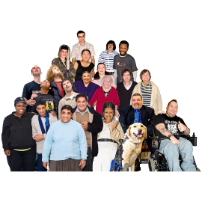 | Diversity means variety and celebrating our differences
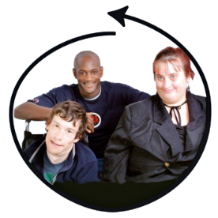 | Inclusion means making sure no one is left out
 | Co-production means working together with people who know best about their needs
 | Research means finding out what works
 | A service-user means anyone who uses speech and language services
 | Funding means how the work will be paid for
 | Innovation means coming up with new ideas
 | Workforce development means making sure that you have the right people with the right skills to do the best job now and in the future
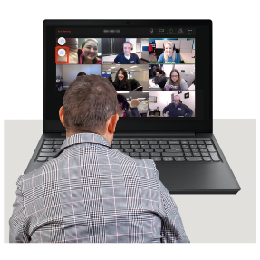 | Board of Trustees means a group of people with legal responsibility for overseeing the funding and work of the RCSLT

 | RCSLT mission: to help people with communication and swallowing needs to have better lives
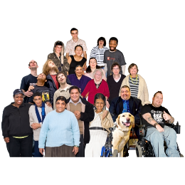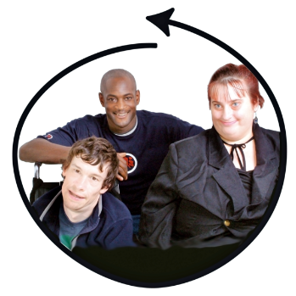 | RCSLT vision: a world that includes everyone with communication and swallowing needs

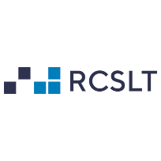 | RCSLT main aims

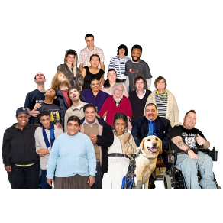 | 1. Equality, diversity, and inclusion
 | We want to make sure speech and language therapists come from lots of different backgrounds
 | We want to make sure that people from different backgrounds are fully included in the profession
We want to make sure there is no racism or discrimination

We will not accept people being treated differently because of their colour, beliefs, gender, disability, or sexual orientation

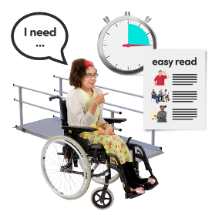 | We want to make speech and language therapy services easy to access for everyone who needs them

2. Co-production with service users and their families and carers

We want to include service-users, their families and carers in what we do
We want to involve support organisations and charities who help people with communication and swallowing needs
We want to show everyone how to include people with communication and swallowing needs

We want to make information easy for people to read and understand

 | 3. Funding
 | We want enough money so that everyone who needs speech and language therapy can get speech and language therapy
 | We want enough money for education and research
 | We want enough money to help speech and language therapists get what they need to do a good job
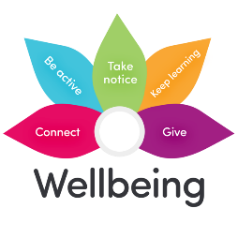 | We want enough money to help speech and language therapists stay healthy and well
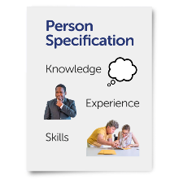 | We want to learn from experience and tell people about best ways of working

 | 4. Innovation and research
 | We want to improve speech and language therapy services based on what works best
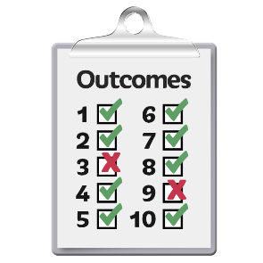 | We want to keep measuring how we are doing
 | We want to have leaders who can speak up for people with different communication and swallowing needs
 | We want to have information which is easy to understand
 | We want to have more service-users involved in research
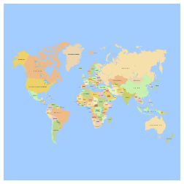 | We want to work closely with health teams in the UK and across the world
 | We want to make sure that there is technology for everyone who wants and needs it
 | We want to always think about the environment, and try not to harm the planet

 | 5. Workforce development
 | We want to make sure speech and language therapists come from different communities and backgrounds
 | We want to support strong and caring speech and language therapy leaders
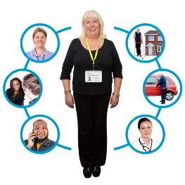 | We want to work well with other health professionals
 | We want to support different ways of people training to become speech and language therapists
 | We want to support speech and language therapists to work in different ways throughout their career
 | We want to support speech and language therapists to do more research
 | We want training and development opportunities for speech and language therapists throughout their career

 | 6. Profile and opportunity
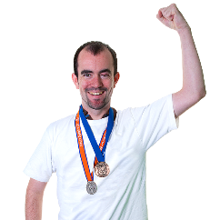 | We want to tell people about the difference that speech and language therapy makes
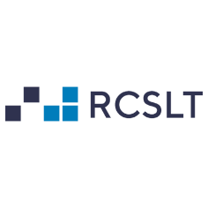 | We want to make sure that influential people and groups understand the value of speech and language therapy
 | We want to make sure everyone understands how difficulties with communication and swallowing can affect lives
 | We want to make sure people in government know about speech and language therapy and RCSLT
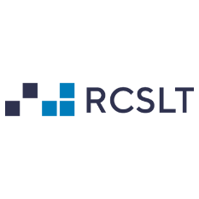 | We want to be a leader among other health professions

 | 7. Our members
 | We want to support speech and language therapists to share our vision
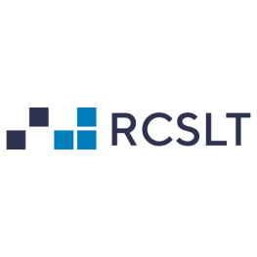 | We want speech and language therapists to lead this important work
 | We want to support speech and language therapists to be involved at local and national level

 | 8. Making RCSLT an excellent organisation
 | We want an inclusive and active Board of Trustees who work to the values of RCSLT and are open and answerable to members
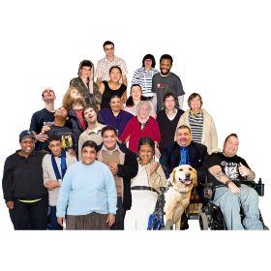 | We want to show we are excellent in equality, diversity, inclusion, and anti-racism
 | We want to make sure we have enough money to do this work now, and in the future
 | We want to be an excellent employer
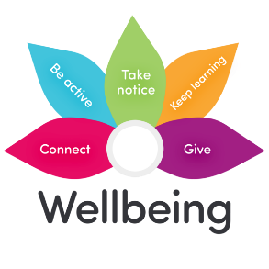 | We want to look after our staff really well
 | We want to be a flexible organisation to help staff work the best they can
 | We want to use technology and information to know what speech and language therapists need
 | We want to show people we are good at inclusive communication and employ people with communication needs
 | We want to work in a way that helps protect the planet

This is the end of the RCSLT vision

Thank you for your interest.

This is the easy read version of the RCSLT five-year vision 2022-2027

The full document was produced by members, service users, RCSLT staff leadership team and trustees: rcslt.org/vision

To give feedback contact the enquiries team at info@rcslt.org or 020 7378 3012

To learn more about the RCSLT, visit: rcslt.org

