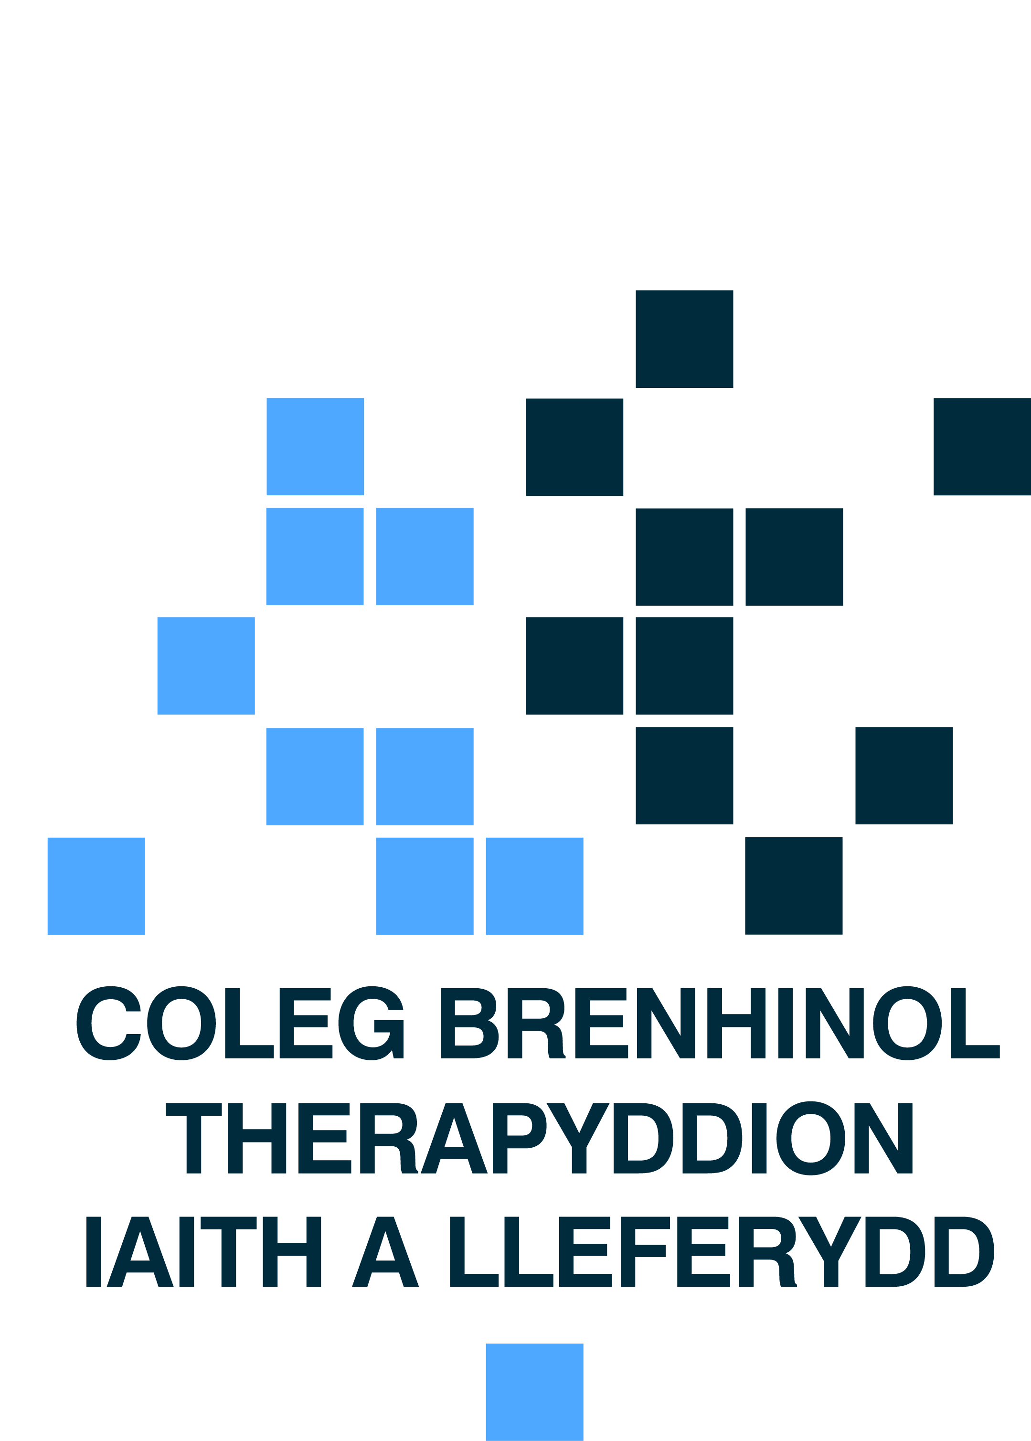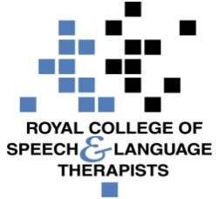 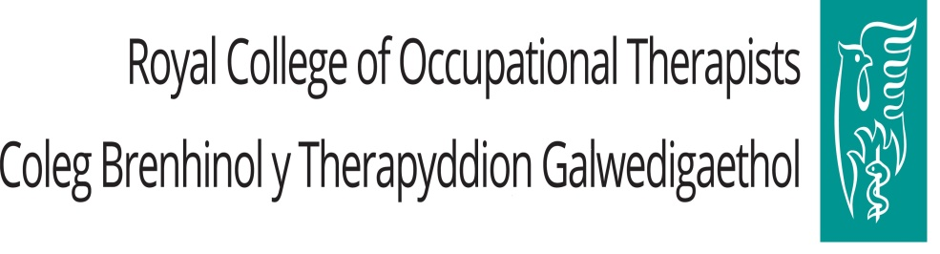

Dr Dai Lloyd AM

Chair, Health, Social Care and Sport Committee

National Assembly for Wales

Cardiff Bay  
Cardiff,

CF99 1NA

6 November 2017

Dear Dr. Lloyd AM,

**Re: Health, Social Care and Sport Committee inquiry into the use of anti-psychotic medication in care homes**

Thank you for the opportunity to give oral evidence to the committee as part of its important inquiry into the use of anti-psychotic medication in care homes. As we discussed during the session, we believe that occupational therapists and speech and language therapists have a key role to play as part of a non-pharmacological approach to managing behaviour that challenges. Following on from the detailed questioning by the committee, we would like to take the opportunity to suggest a number of recommendations to the committee.

1. **Residents of care homes should have equitable access to existing community multi-disciplinary services which should include a range of therapy professionals including speech and language therapists and occupational therapists** – Our first recommendation builds on the recommendation made by the Older People’s Commissioner for Wales in her written evidence to this inquiry that;

‘Welsh Government should ensure that multi-disciplinary team services are made available to all residents in care homes to reduce the tendency to prescribe anti-psychotic medication, improve outcomes for residents and address current inequalities in provisions for residents and older people living in the community’.

Care home residents have arguably the greatest health and social care needs yet currently may struggle to access community services available to those living in their own homes. It is not routine for speech and language therapists (SLTs), occupational therapists and other therapy professions to support care home staff and residents. This prevents residents from accessing provision such as reablement, non pharmacological interventions and behaviour support. Community Resource Teams, Community Mental Health, Mental health liaison Teams and community learning disability teams should all include a range of therapy professionals (including SLTs and occupational therapists) to ensure all older people, irrespective of social, economic or housing circumstance have equality of access to allied Health Professional (AHP) support. When located in appropriately resourced teams therapists can promote person-centred care through training, on-site role modelling and working directly with care home staff. Further information on equality of access can be found in the Royal College of Occupational Therapists report [Living Not Existing: Putting Prevention at the Heart of Care for Older People in Wales](http://3clw1r2j0esn1tg2ng3xziww.wpengine.netdna-cdn.com/wp-content/uploads/2017/07/ILSM-Phase-II-WELSH-ENGLISH.pdf)

1. **Welsh Government should consider piloting the request for assistance scheme which is currently in place in Scotland.**  The scheme would enable care homes to access specialist support and training from AHPs and others to adapt environments and change cultures above and beyond support for individual referrals. During the oral evidence sessions, the British Psychological Society highlighted the Intervention for Dementia: Education, Assessment and Support (IDEAS) service as an example of good practice in this regard. The IDEAS team in NHS Dumfries and Galloway provide specialist support to teams working with individuals who have dementia and associated behaviours contributing to stress and distress. The team works across health, social care, third sector and independent services in a rural setting and comprises a clinical psychologist, specialist nurse practitioner, occupational therapist, social worker, a speech and language therapist and an administrator. Consultation outcomes from 2016-17 showed a 50% improvement in the use of appropriate medication, 75% improvement in communication outcomes, 50% in others wellbeing and 85% improvement in stress and distress[1].
2. **The improvement functions of 1000 Lives Plus and Social Care Wales should review access to current training provision for care homes to identify best practice and ensure equitable access to the highest quality provision**. We are aware of a number of examples of award-winning, well established training packages which have been developed for care home staff such as the Dementia Reablement Training package. For more information, please see annex A. Lessons may be learnt from the recent mouthcare improvement programme for care homes.
3. **Leadership** –**Welsh Government should fund an AHP Dementia Consultant post to drive improvement and ensure the contribution of AHPs in Wales to post-diagnostic support**.  We wish to draw the committee’s attention to RCSLT, RCOT and CSP calls around the Welsh Government Dementia Strategy. A common call of families living with dementia is a lack of early, preventative support.  The practical and enabling interventions provided by therapists are a key alternative to overreliance on medication and/ or social care support. Access to and investment in AHPs is critical if the strategy is to ensure people with dementia get the post diagnosis support they need and deserve wherever their place of residence. We believe there is much to be learnt from the Scottish model of post-diagnostic support which places a strong emphasis on the skills of AHPs in enabling people to do what matters to them and was developed following a key action within the Scottish dementia strategy 2013-2016.  As part of this model, a National AHP Consultant has been employed by Alzheimer Scotland to drive improvement and ensure the contribution of Scotland’s AHPs to post-diagnostic support in dementia though the development of Connecting People Connecting Support – [**Connecting People, Connecting Support: The Allied Health Professional Offer to people affected by dementia in Scotland**](https://www.alzscot.org/assets/0002/7356/AHP_Report_2017_WEB.pdf).  The framework is supported by professional bodies, has been prioritised by Therapies Directors and AHP dementia champions have a key role in supporting improvement throughout NHS bodies and local authorities.

We believe there could be significant potential to create an AHP Dementia Consultant post in Wales, based in Alzheimer’s Society Cymru and funded by Welsh Government.  This post could benefit from the evidence base created in Scotland and drive improvement and better access to therapies post diagnosis, working closely with Directors of Therapies and Health Sciences, professional bodies, and crucially people affected by dementia.  This post should be written into the Welsh strategy with a key action to create a framework for transforming the AHP contribution to supporting people living with dementia in Wales.

We hope these four suggestions are useful to the committee in deliberating the practical actions that can be taken to deal with this vital matter and to improve the lives of people of all ages, and with a range of challenging health and social care needs who live in care homes. The contribution of therapy professions is currently underutilised in helping care home providers and staff to enable people to live with dignity, control and meaning.

Yours sincerely,

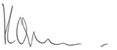

*Karin Orman,* Professional Practice Manager, Royal College of Occupational Therapists

Description: RUTH1bmp

*Ruth Crowder, Wales Policy Officer*, Royal College of Occupational Therapists

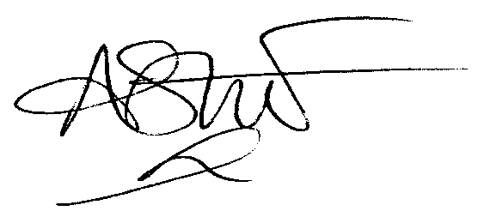

Dr. Alison Stroud, Head of Wales Office, Royal College of Speech and Language Therapists

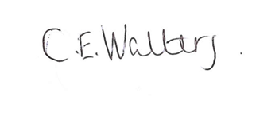

*Dr Caroline Walters, Policy Advisor, Royal College of Speech and Language Therapists*

**Annex A –existing examples of high quality dementia care training**

* Abertawe Bro Morgannwg University Health Board Dementia Care Training Team picked up two awards for their specialist training. The jointly funded team, based at Glanrhyd Hospital, were awarded Stage 1 Practice Innovation Unit by the Welsh Centre for Practice Innovation (WCPI) acknowledging continuing work to improve standards in dementia care. Plus, they’ve been Highly Commended in the National Social Care Accolades which are awarded by the Care Council for Wales.
* Helen Lambert and Alison Turner, both Occupational Therapists, and Mental Health Nurse Karyn Davies developed and delivered training to ABM and Bridgend County Borough Council staff to improve the support people with dementia received, and ensure everyone receives the same care across the area. Helen Lambert, went onto lead on the development and delivery of a Dementia Reablement Training Package for Cardiff City Council and the Social Service Improvement Agency. <http://www.ssiacymru.org.uk/home.php?page_id=8644>. This led to the development of a Dementia Reablement toolkit and service model: <http://www.ssiacymru.org.uk/resource/english--lr.pdf>. These can be translated to span care homes and the training of care home staff.
* Cwm Taf University Health Board Service News: The Mental Health Liaison occupational therapists assessments enable the multi disciplinary team to identify needs and to provide recommendations for discharge, thus reducing the length of inpatient stay within the DGH and/or community hospital settings. Data gathered has identified that 90% of patients have not been previously known to memory or mental health services prior to admission to hospital. Occupational Therapists now provide education and training to the wider multidisciplinary team including doctors and medical students. Patient’s complexity and level of support required for their mental health needs is identified earlier. Patients are then offered the most appropriate service to meet their needs and hospital length of stay has been reduced on average by 3 days. The Occupational Therapy Service in Cwm Taf UHB Mental Health Liaison is seen as an exemplar of best practice which is being implemented across Wales.

1. NHS Dumfries and Galloway. IDEAS team annual report April 2016-March 2017. Available on request.