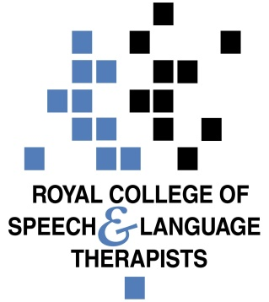
Statement from the Royal College of Speech and Language Therapists in Wales ahead of the debate on the Health, Social Care and Sport Committee inquiry on the use of anti-psychotic medication in care homes on 11 July 2018

The Royal College of Speech and Language Therapists in Wales welcomes the recommendations of the National Assembly for Wales's Health, Social Care and Sport Committee inquiry report into the inappropriate use of antipsychotic medications in care homes. We strongly support the focus of the report on the need to implement 'systemic and cultural changes to improve the care of people living with dementia.

The report sets out a wide range of actions needed to ensure that antipsychotic medication is not prescribed inappropriately. We were particularly pleased to see that two of the report recommendations specifically focussed on the role of allied health professionals, and in particular speech and language therapists, as part of a non-pharmacological approach to managing behaviour that challenges. We are delighted that these recommendations have been accepted by Welsh Government.

Dr Alison Stroud, Head of Wales Office said;

‘Communication problems occur in all forms of dementia & in the later stages these problems can become increasingly challenging. Speech and Language Therapists have the specialist knowledge and skills to directly assess the contribution that unmet speech, language and communication support needs make to behaviour that challenges and provide advice on maintaining and maximising communication function to the person with dementia, their family and carers.

We are very pleased that the committee recognised the importance of SLTs in its report recommendations and that the Welsh Government has accepted the committee’s recommendation to address the shortage of speech and language therapists in dementia care. We look forward to working with Health Education Improvement Wales (HEIW) on its scoping work to increase the numbers of Allied Health Professionals (including SLT) available in Wales.

We also welcome the positive Welsh Government response to the committee recommendation that the role of the allied health professional dementia consultant includes a requirement to work with care homes to improve access to allied health professionals for care home residents and commit to supporting the new consultant, when recruited, to make this a reality.
To view the full committee report and Welsh Government response, click here.

