Manual for HEI’s or practice educators to use to support learning through pre-registration EDS eLearning module.

Version 1.1
June 2023
Author: Kathleen Graham, Senior Project Manager, RCSLT

Table of contents
Introduction
Case 1 Adult – John
Case 2 Adult – Jim
Case 3 Child – Kevin
Case 4 Child – Charlotte
Assessment 1 Adult – Viraj
Assessment 2 Child – Ronan
Summary of competencies
List of appendixes
1: Case history template
2: Oro-facial exam template
3: Swallow assessment template
4: Quick guide to therapy outcome measures
5: Therapy outcome measure – 24 Dysphagia
6: Therapy outcome measure – 50 Paediatric dysphagia

Introduction
The purpose of the eLearning module is to enable students to have pre-registration EDS competencies signed off. This is achieved by working through 2 adult case studies and 2 paediatric case studies before they sit an assessment for an adult and a paediatric case. It is recommended that they spend at least 3 hours on case studies 1, 2, and 3 and 2 hours on case study 4. They should spend at least 1 hour on each assessment. When signing off the hours component the number of hours signed off should not exceed these. It may be useful to keep a log of how long it is taking students to complete the eLearning and if this is consistently more than the above amounts, please alert Kathleen.graham@rcslt.org to review. Simulation and technology enhanced learning can be one component of the students sign off but should not constitute it in its entirety i.e., students should have opportunity to experience EDS within a clinical setting.
Due to information governance and to enhance student learning, patient simulation actors are used to replicate real clients with eating drinking and swallowing difficulties.
Although the eLearning is comprehensive, there are several points at which further discussion can be prompted. There are also sections called “further learning” which prompt learners to explore an aspect of EDS with reference to a journal article or resource as a starting point. You may wish to have students research these areas further or discuss them in small groups etc. The case history template, oro-facial exam template, and the swallowing assessment template have been developed by the working group who consist of a range of SLT’s and HEI staff and represent a consensus on what is most appropriate to include. All items in the templates will not be applicable to every situation, but it represents a comprehensive guide to what may need to be considered. Due to the range of conditions and interventions within EDS it has not been possible to represent every situation. We are hopeful that this resource can grow over time with the cases being reviewed every two years.
Students can complete the case studies by themselves or in small groups but should undertake the assessment section alone.

Case 1: Adult – John

Background information and planning initial assessment.

Referral information
      - Referral document provided with expanded information on key components.
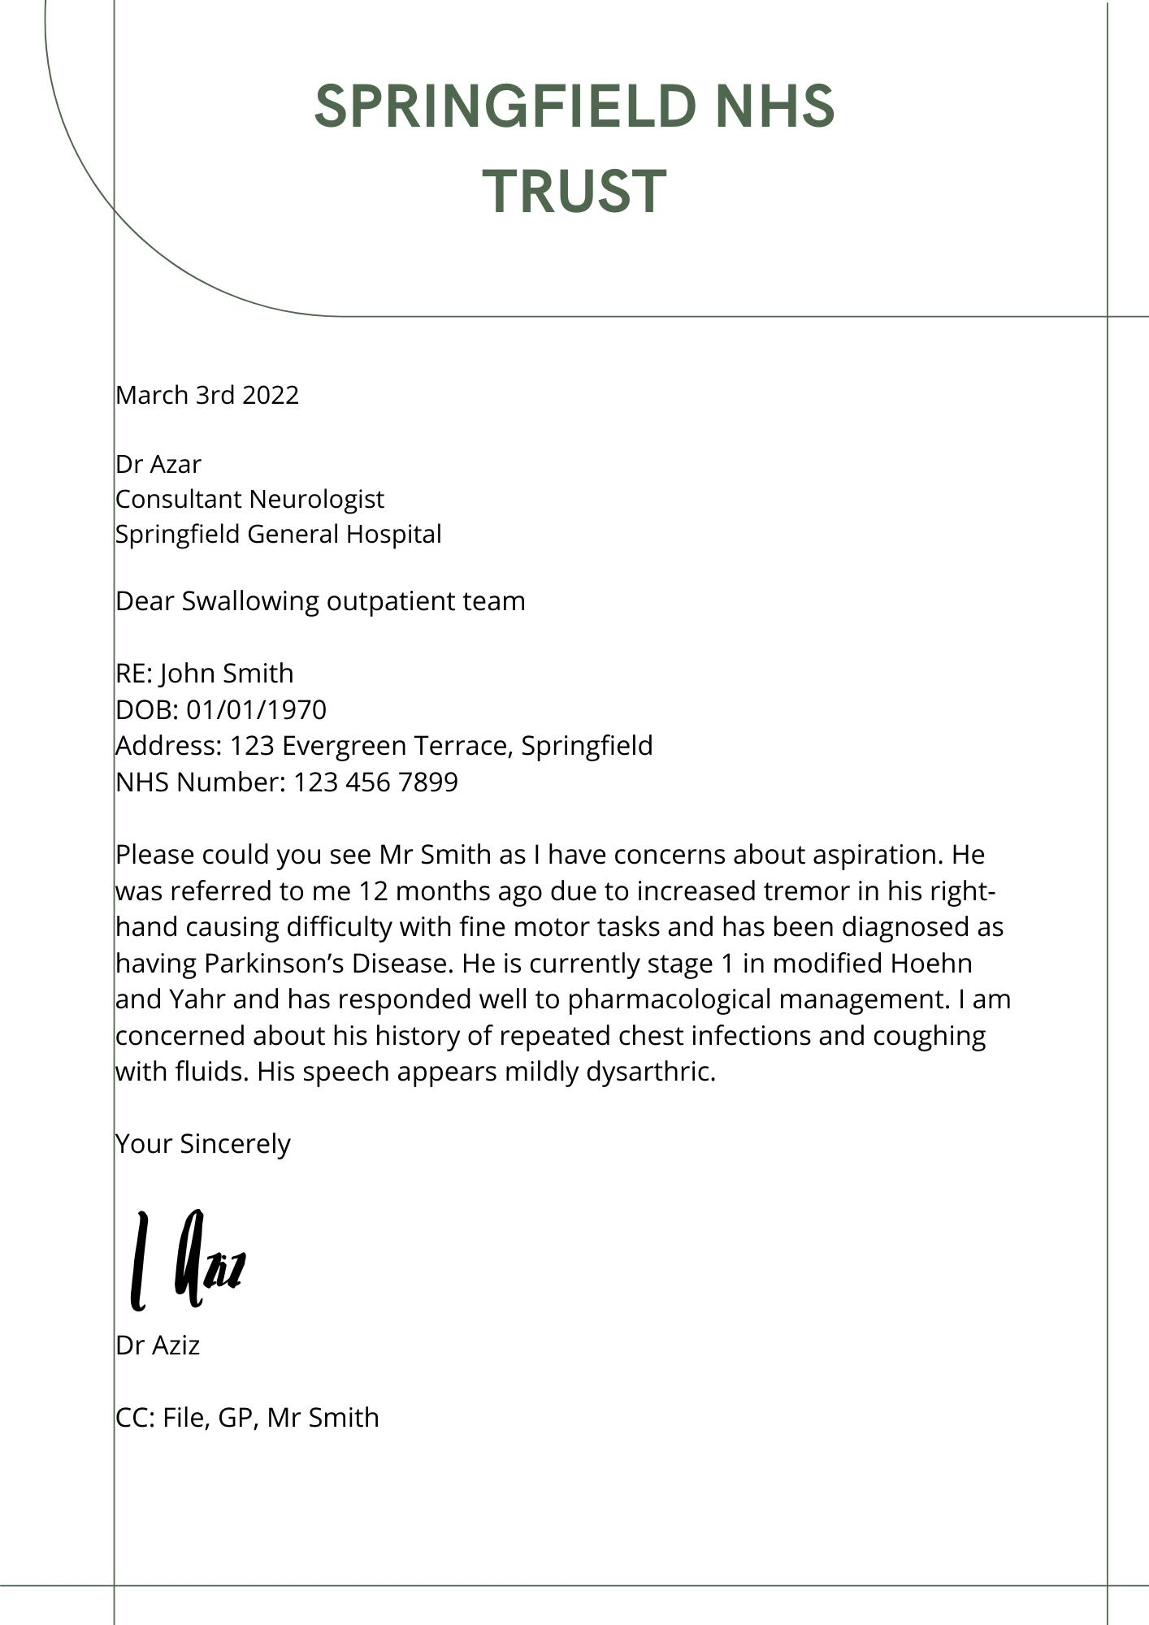
Consultant Neurologist – This indicates that he is currently actively under a Neurologist
Aspiration – Neurologist is concerned that when swallowing, the bolus is passing below the level of the vocal cords into
his airway
Tremor in his right hand – If Mr Smith is right-handed this may affect his ability to self-feed
Parkinson’s Disease – This is a progressive neurological movement disorder with up to 80% of individuals experiencing dysphagia during the course of the disease
Stage 1 modified Hoehn and Yahr – This is a scale used to measure the severity of the condition with 1 representing a mild unilateral presentation and 5 representing the most sever presentation
Pharmacological management – The use of medication to control the symptoms experience by the client. Pharmacological management within Parkinson’s Disease is common. The inability to swallow medication can have a significant impact on the management of an individual’s condition
Repeated chest infections – This may be due to aspiration however other potential causes should not be ignored e.g., viral
Coughing with fluids – This is an overt/observable sign that the bolus may have penetrated the upper airway or been aspirated.
Mildly dysarthric – A motor speech disorder impacting on the intelligibility and comprehensibility of spoken output. Impairment in speech production may indicate an impairment in the movement of oral structures for swallowing.

Discussion prompt: Why is it important to stage diseases/conditions? What impact might this have on how the referral is prioritised? How is Parkinson’s Disease managed through medication? Is this different for Parkinson’s Plus?
      - Knowledge check quiz (not scored)
Why is the referrer concerned about Mr Smith's swallowing? Select all that apply
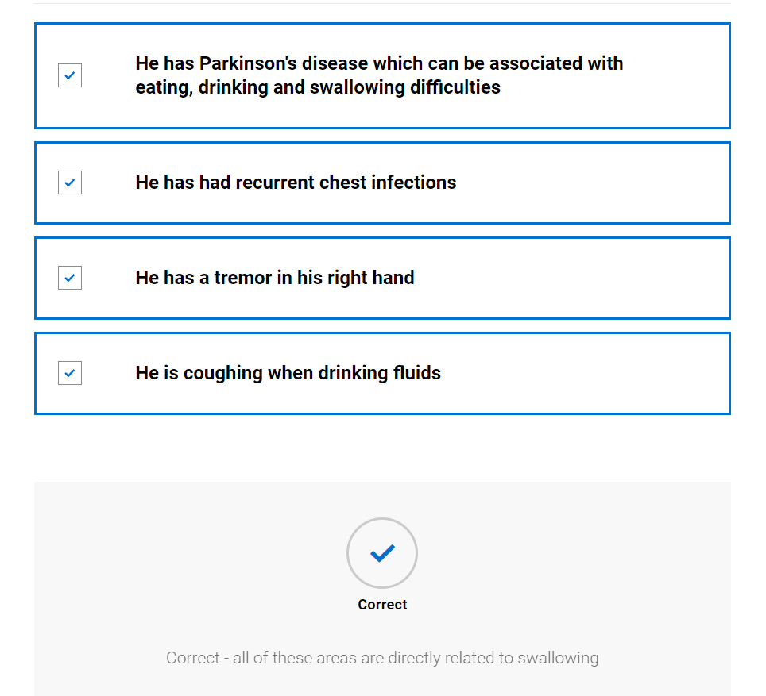

Case note review
      - Case note summary provided with expanded information on key components
      - Case notes
Past medical history
Parkinson’s disease - diagnosed 6 months ago. This presented as tremor to hands and difficulty with fine motor movements
Type 2 diabetes - diet controlled
Hypercholesterolemia

Previous SLT intervention
Not previously known to SLT

Current open referrals
Neurology, Parkinson’s disease nurse specialist, occupational therapy (referred for assessment of fine motor control and guidance)

Allergies and sensitivities
Allergy to penicillin and strawberries
Alerts
Nil

Last 3 days of entries
Triaged by Occupation therapy team as low priority and put on waiting list. Average wait time is 3 months

Triage information
Triaged as urgent due to chest infections and coughing. Aim to see within 10 working days
Parkinson’s disease – This is a progressive neurological movement disorder. It can affect the muscles required for eating, drinking, swallowing and speech
Type 2 diabetes – diet controlled – This is a difficulty related to the hormone insulin which relates blood sugar level. As Mr Smith’s diabetes is controlled by his diet it is important that he is able to eat and drink appropriate items at regular times to balance his blood sugar levels
Parkinson’s Disease Nurse Specialist – These are nurses who specialise in the management of Parkinson’s Disease. They are often able to prescribe and review medication and ensure that all the clients’ needs are met through reviews and timely referrals and liaison with other services
Occupational Therapist – Occupational therapists support people with activities of daily living. For people with Parkinson’s Disease this can involve education, rehabilitation, support with progression of disease and provision of aids. If Mr Smith is having difficulty with self-feeding; the Occupational therapist can suggest strategies and aids to assist.
Allergy to penicillin and strawberries – Any products containing strawberries should not be used during assessment.
Urgent – Referral has been triaged in accordance with service specification and criteria and deemed to be urgent. He is experiencing symptoms which would increase the likelihood he is having eating, drinking or swallowing difficulties.
Discussion questions: Discuss local service specifications and how this referral might be triaged differently depending on which services are commissioned.

      - Knowledge check (not scored)
Why is it important to know which other professionals are involved with Mr Smith? Please select one answer.
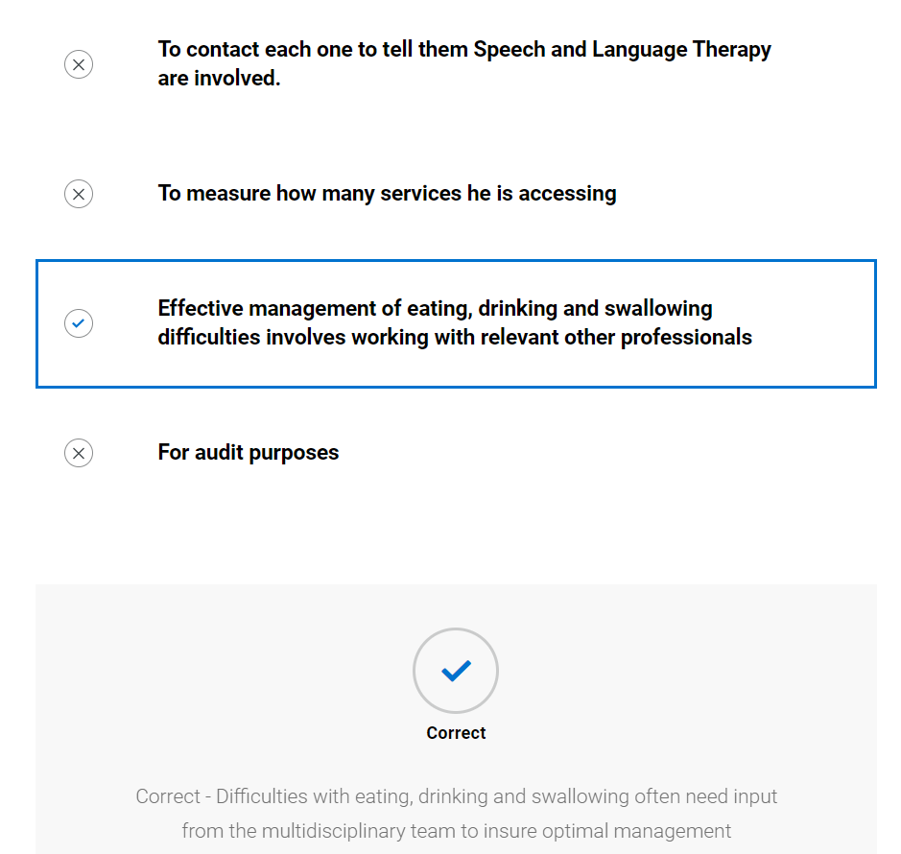

Further information gathering
      - Video of SLT contacting client
      - Knowledge check (not scored)
What information did the Speech and Language Therapist gain from the telephone call that was not available in the referral or case notes?
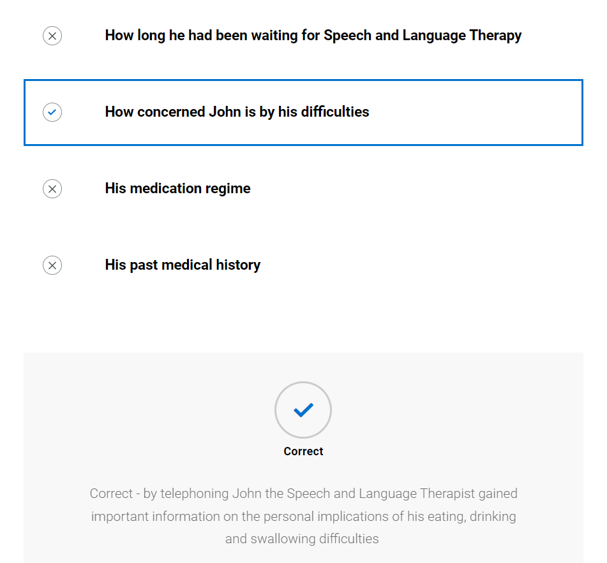

Planning
      - Images of items needed for planning along with explanation
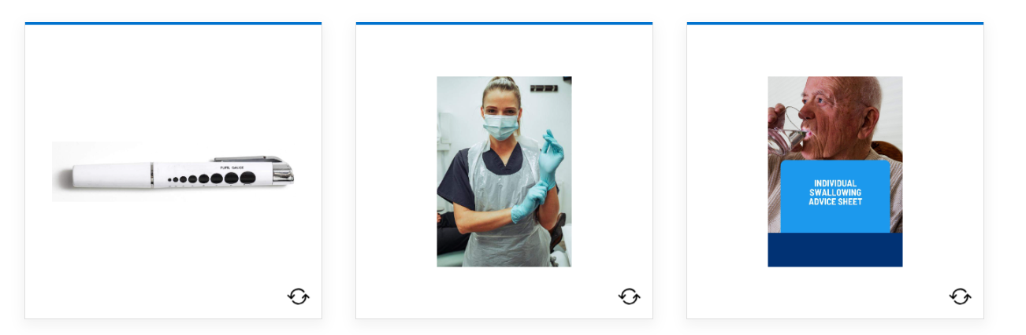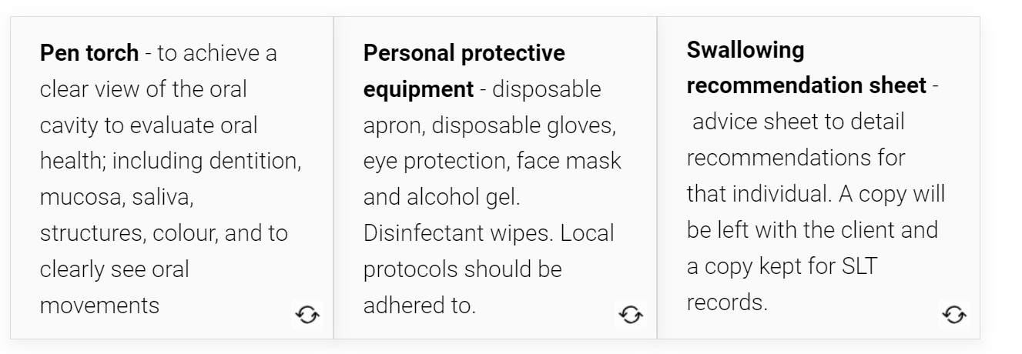
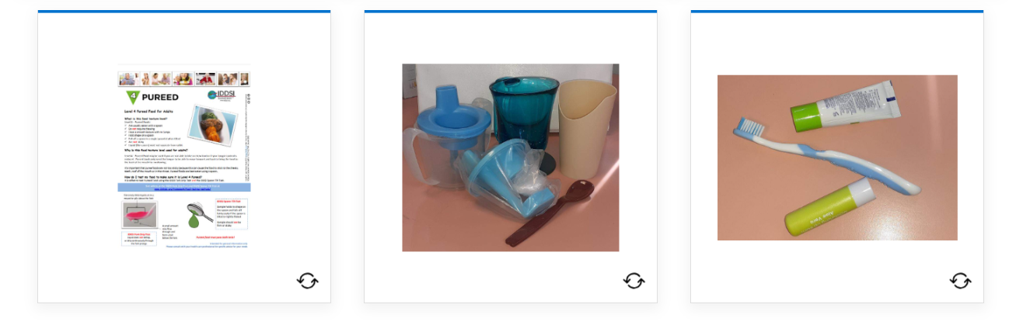
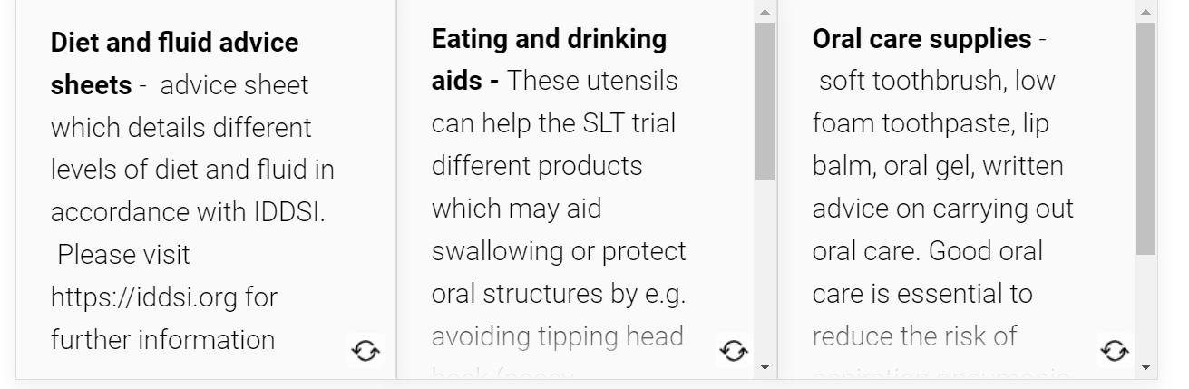
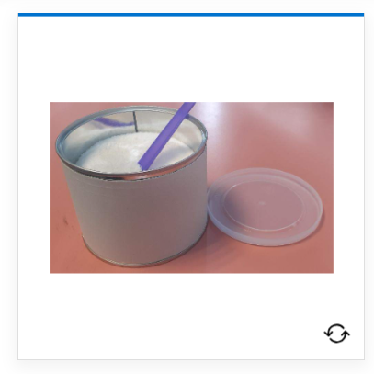
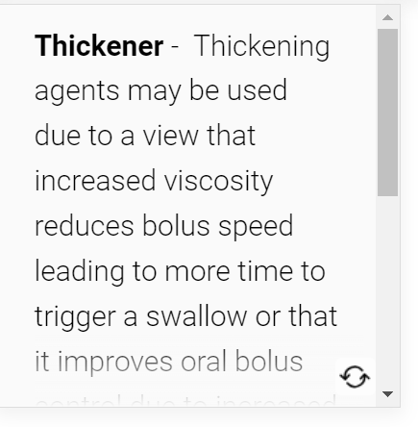

Discussion questions: How might preparation differ in a clinic compared with a domiciliary visit? Look at local versions of swallowing recommendations sheets and swallowing advice sheets to evaluate.
      - Knowledge check
Why is it important for the Speech and Language Therapist to have specialist utensils available for an assessment? Select all that apply
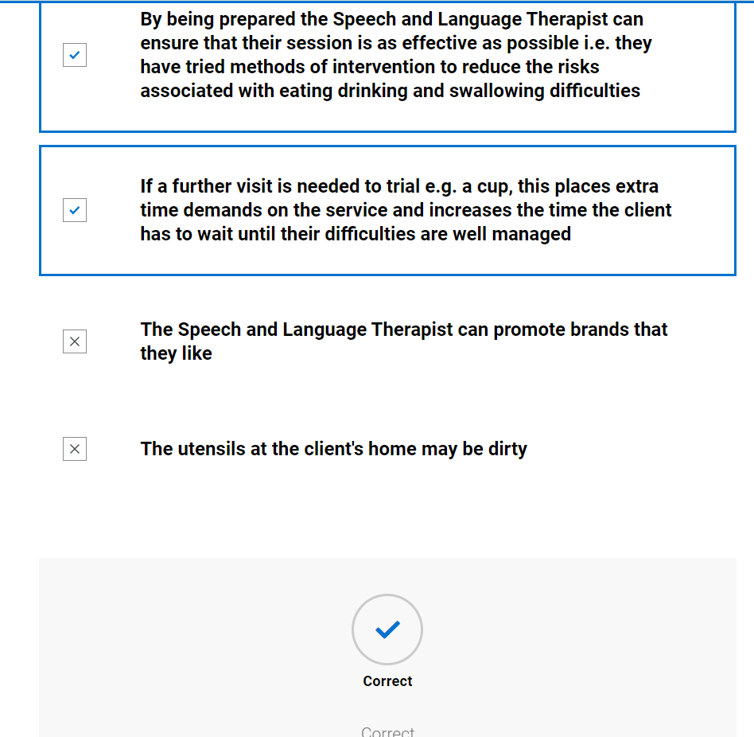

Initial assessment

Case history
      - Blank case history form provided; student advised to try to complete whilst watching video of SLT. (They can print this or send to word document to complete – it is not scored) See appendix 1
      - Video of SLT completing case history
      - SLT completed case history, student prompted to compare to theirs
Speech and Language Therapy
Initial eating, drinking and swallowing case history
Demographics | John Smith  DOB: 01/01/1970  Address: 123 Evergreen Terrace, Springfield  NHS Number: 123 456 7899
Consent | Informed consent for assessment and intervention
Assessment location and time | Seen in own home at 13:30
Reason for referral | Recurrent chest infections and reported to be coughing on fluids
Legal information including:  - Advanced care planning  - Power of attorney  - Advanced directive  - Resuscitation status | Not for resuscitation in the event of a cardiac arrest  Advanced directive in place that does not want any life prolonging treatments including non-oral feeding
Communication ability, including languages used | English speaker, John reports “not a good reader.” Fully intelligible to SLT but some mild dysarthria evident. John feels there have been some changes to his speech but that he is not concerned about them
Mental capacity | No concerns about mental capacity. Appears able to understand, retain, weight up and expression decisions
Safeguarding | No concerns
Social history | John lives with his partner Rachel. He is a recently retired car mechanic who took early retirement due to difficulties with fine motor tasks. He is a keen runner but has been finding this more difficult lately.
Person with parental responsibility/ next of kin | Rachel is John’s next of kin
Client/Carer expectations of intervention | John wants to be able to stop coughing with fluids and expects that the SLT can give advice to help with this. He doesn’t see how the chest infections are related to coughing with fluids.
Medical information
Past medical history including disorders of movement or tone | Parkinson’s disease - diagnosed 6 months ago. This presented as tremor to hands and difficulty with fine motor movements  Type 2 diabetes - diet controlled  Hypercholesteremia
Current mental wellbeing | John is disappointed he had to retire early and is trying to adjust to this. He is unconcerned about his swallowing but does feel embarrassed when coughing in public.
Main diagnosis/presenting condition | Parkinson’s disease
Level of frailty | Minimal - fully mobile
Prognosis including Gold standards framework | Consultant feels that the disease was detected in the early stages and that John could lead a healthy life for several years
Sensory impairment  - Sight, hearing, touch, smell, taste  - Reaction to sensation  - Reflexes | John is short-sighted for which he wears corrective lenses. He lost his sense of taste when he had covid 2 months ago and reports this is slowly returning.
Multidisciplinary involvement | John is known to the Neurology consultant, Parkinson’s disease specialist nurse, occupational therapy
Medication | Sinemet x 4 a day - 8am, 12 middays, 4 pm and 8pm
Sensitivities and allergies | Allergy to penicillin and strawberries
Reflux (for adults see RSI below) | 8 - gastro-oesophageal reflux is unlikely

History/Background of Dysphagia
Onset | John reports that he first became aware of difficulties at Christmas around 4 months ago, but it was only when he was taking large gulps of fluid. He reports the chest infections started around the same time
Duration | 4 months
Stability/progression | John feels it is worst in the morning when he has his cup of coffee around 7am. He doesn’t feel that things are changing but that throughout the day his swallow varies particularly for the 30 minutes before he is due to take his next Sinemet. He feels that when he has a chest infection his swallowing is worse
Social and psychosocial impact of difficulties | John has reduced his social activities involving food/drink. Previously he would have had friend over for meals and go out to the pub, but he feels that he is embarrassed by it and that he is unable to drink alcohol anymore as it makes his PD symptoms worse
Avoidance | He avoids open cups as he has had some spills so tends to drink from an insulated coffee cup. John reports he knows he is not drinking as much as he should be, but this is because of the coughing
Client/carer description | John reports it as “when I drink it feels like something is going the wrong way. This makes me cough. Sometimes I cough so much I start retching. I’m fine with foods although sometimes my muesli makes me cough a little”
Significant swallowing events | No
Cultural aspects affecting EDS | John is an atheist. He is from Ireland originally where big family meals and gatherings were important for big life events e.g., birthdays, weddings, christenings. He misses these events and feels he cannot attend as embarrassed.
Mealtime routine | 7:45 - Has breakfast, usually toast and cup of coffee, takes medication after breakfast. Notices this is when swallowing is worst  12 - Has medication then usually has a sandwich and soft drink  6 - Has main meal, usually cooked dinner of meat, veg and potatoes  Doesn’t like to snack and prefers plain foods
Enjoyment of meals | Loves meals but avoids drinks with them as this causes coughing
Current oral intake | IDDSI level 0 normal fluids from lidded thermal cup  IDDSI level 7 normal diet
Mental health/wellbeing of client and carer | Rachel is very worried about the coughing and has been researching PD and swallowing on the internet.

Respiration
Chest status (current and history) | 3 chest infections over the last 4 months. Chest currently clear but finished the last course of antibiotics 1 week ago.
Breathing pattern at rest | Within normal limits
Cough | No cough at rest, voluntary cough is strong
Oxygen/ventilatory requirements | On room air
S:Z ratio | 1:0.6

Environment, skills, and behaviours
Positioning | Able to achieve fully upright positioning
Skin integrity | No concerns
Feeding skills | John reports increased difficulty using a knife and the occupational therapist is looking into adaptive cutlery for this. He reports using a lidded thermal cup to avoid spills due to hand shaking.
Equipment/utensil used | Lidded thermal cup and regular cutlery
Environments in which client eats/drinks | Limited to eating at home due to embarrassment
Behaviours or sensory challenges/issues around eating/drinking/mealtimes | Nil

Nutrition and hydration
Nutrition and hydration status prior to assessment | John feels he is not drinking enough
Weight/BMI/MUST/ Growth and development | BMI of 22. John reports he has lost weight due to not wanting to eat when he has a chest infection. Lost 12 pounds but struggling to regain them
Urinary output | Reports urine is strong and dark in colour
Faecal output | Reports intermittent constipation

GRBASI
Component and description | 0 - normal | 1 - slight | 2 - moderate | 3 - severe
Grade - degree of hoarseness of voice | x
Roughness - impression of irregularity of vibration of vocal folds | x
Breathiness - degree to which air escaping from between the vocal folds can be heard by the examiner | x
Asthenia - degree of weakness heard in the voice |  | x
Strain - extent to which strain or hyperfunctional use of phonation is heard | x
Instability - changes in voice quality over time |  | x

Reflux symptom index
Within the last month, how did the following problems affect you? 0 = no problem, 5 = severe problem
 | 0 | 1 | 2 | 3 | 4 | 5
- Hoarseness or a problem with your voice |  | x
- Clearing your throat |  | x
- Excess throat mucus or postnasal drip | x
- Difficulty swallowing foods, liquids or pills |  |  |  |  | x
- Coughing after you ate or after lying down | x
- Breathing difficulties or choking episodes |  | x
- Troublesome or annoying cough |  | x
- Sensations of something sticking in your throat or a lump in your throat | x
- Heartburn, chest pain, indigestion or stomach acid coming up |  | x
Total (>13 indicates laryngo pharyngeal reflux) | 9

Risk factors for developing aspiration pneumonia
 | Yes | No
Dependence for oral feeding |  | x
Dependence for oral care |  | x
Poor oral/dental hygiene |  | x
Chest concerns | x
Comorbidities | x
Multiple Medications |  | x
Mobility status – significantly reduced mobility |  | x
If yes response then patient is at increased risk of aspiration pneumonia (Langmore, 1998)
Discussion questions: Discussion around risk factors for developing aspiration pneumonia.

      - Knowledge check (not scored)
What strategies has John adopted to reduce the impact of his eating, drinking and swallowing difficulties?
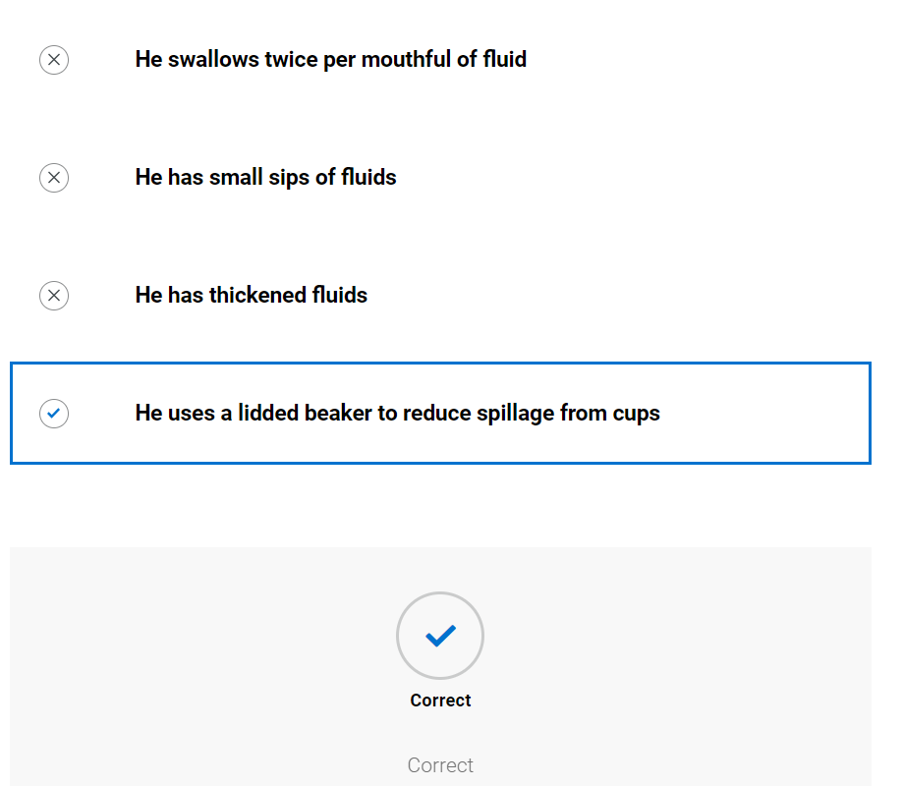

Oro-facial exam
      - Blank oro-facial exam form provided; student advised to try to complete whilst watching video of SLT. (They can print this or send to word document to complete – it is not scored) See appendix 2
      - Video of SLT completing case history
      - SLT completed oro-facial exam, student prompted to compare to theirs
Oro-facial assessment for clients with eating, drinking and swallowing difficulties
Mouth care and dentition -
Area | Comment
Dentures | Nil
Dentition | Full set of own dentition, multiple fillings
Lips | Moist
Tongue | Pink and moist
Gums | Pink and moist
Cheeks | Pink and moist
Palate - Hard and soft | Pink and moist
Under tongue | Pink and moist
Skin integrity | No concerns
Level of support for oral care | Independent
Saliva | John reports occasional mild loss of saliva anteriorly when concentrating on another task e.g. reading. No loss evident today

Cranial nerve assessment - comment on range, rate, accuracy, and strength
Nerve and function - | Possible ways to assess | Observations | Outcome
V Trigeminal –  Conveys sensation to the face and motor to the soft palate, pharynx, and muscles of mastication | 1. Tissue or cotton to nostrils should produce wrinkling of nose  2. Clench teeth and palpate masseter and temporalis muscles for bulk  3. Strength of masseter and temporalis by jaw opening – against resistance of therapist hand  4. Observation of uvula – indicating weakness of tensor veli palantini  5. Palpate dry swallow for hyoid movement |  | - Full sensation but response appeared slightly delayed  - Muscle bulk within normal limits  - Good strength although some delay in initiating movement  - Sitting in midline  - Hyoid movement felt during dry swallow
VII Facial – sensation (taste) to anterior 2/3 of tongue, soft palate, and motor function of facial muscles | 1. Taste – sweet (sugar), sour (lemon swab) or salty (salt)  2. Facial symmetry  3. Raise eyebrows - frontalis  4. Open and close eyes (orbicularis oculi)  5. Pretend to blow candles (orbicularis oris)  6. Puff cheeks out (buccinators) then try to push air out whilst keeping lips sealed (orbicularis oris). Can gently press on cheeks to check the strength of lip seal.  7. Close eyes and therapist will gently brush their finger on L+R side of face (forehead, cheek, chin) and ask them to tell you/point where they feel sensation | Changes to facial expression  Blinking  Awareness of anterior loss of saliva  Lip movements during speech/vocalisations/mouthing | Hypomimia evident in face. John able to alter facial expression with effort.  - Not assessed  - Symmetrical  - Full range but slow to initiate  - Full opening but slow to initiate  - Good lip strength and rounding but struggled to initiate and sustain  - Difficulty with coordination of movements.  - No concerns
IX Glossopharyngeal – Sensation to posterior 1/3 tongue, soft palate, pharynx, and motor to pharynx | 1. Gag reflex – NB the formal assessment of this is a controversial area within SLT and is not used by all SLT’s | Presence/absence of gag during observation including hyper and hyposensitivity | Not assessed
X Vagus – sensation to trachea, larynx, pharynx and motor to soft palate, larynx, and pharynx. (also, oesophageal motility and upper oesophageal sphincter opening and closure) | 1. Observe palatal movement when saying “ah” or “ah ah ah”  2. Posterior pharyngeal wall gag - NB the formal assessment of this is a controversial area within SLT and is not used by all SLT’s  3. Voice quality – breathy or hyper nasal possible bilateral weakness  4. Hoarse voice – unilateral weakness  5. Throat clear/cough on command | Voice quality  Coughing at rest | - Uvula elevation evident  - Not assessed  - Reduced volume  - Not hoarse  - Strong cough to command
XI Accessory – motor to shoulder, neck and soft palate | 1. Shrug shoulders up and stop therapist from pushing them down. Check symmetry and power  2. Head turn to right, stop me pushing it back – feel right sternocleidomastoid. Repeat on left | Observation of head, neck and shoulder movement.  Head control | - Delay in initiation but full strength  - Delay in initiation but full strength
XII Hypoglossal – motor function to tongue | 1. Tongue protrusion  2. Push tongue into cheek, push into cheek against SALT finger. Tongue deviates to side of lesion  3. Observe for presence/absence of tongue fasciculations | Tongue movement during speech/vocalisations/mouthing  Tongue movement in response to bolus | - Full range of protrusion  - Good range of movement and strength, some delay in initiation  - No fasciculations

Discussion questions: What does the evidence base say about the relationship between gag reflex and swallowing. What oro-facial features are common in people with Parkinson’s disease

      - Knowledge check (not scored)
How would you summarise John's oral movements? Select all that apply
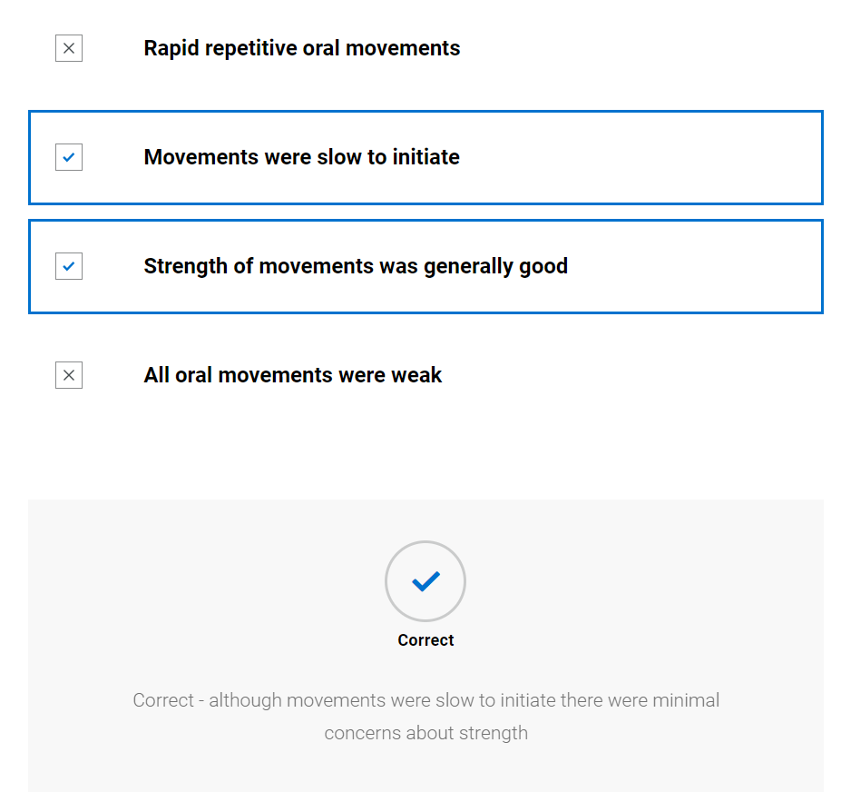
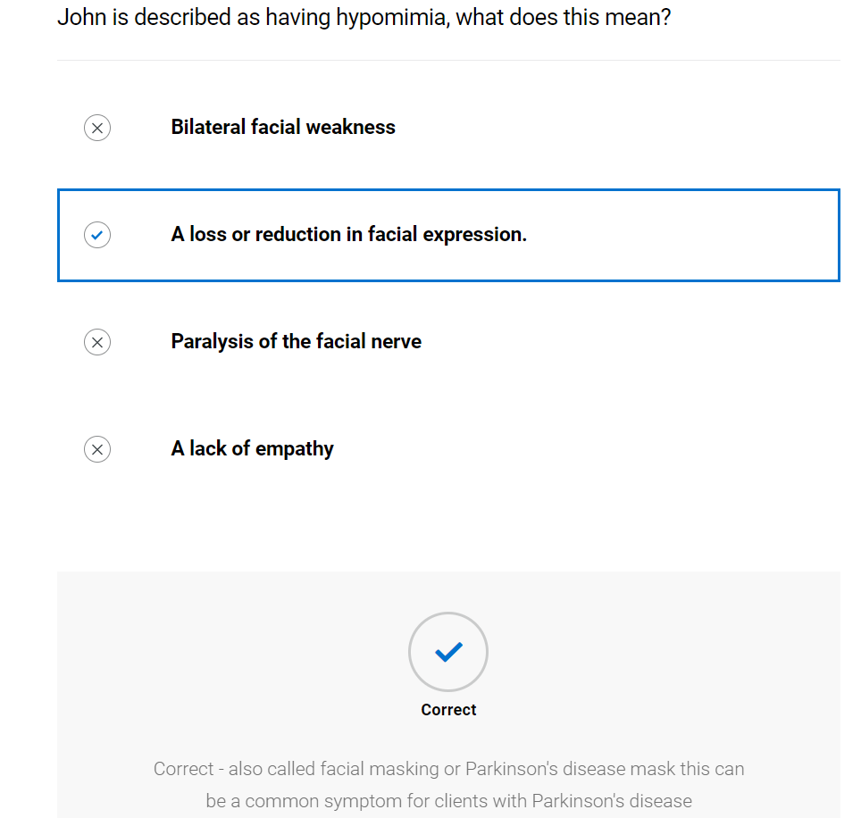

Assessment with diet and fluids
      - Blank swallow exam form provided; student advised to try to complete whilst watching video of SLT. (They can print this or send to word document to complete – it is not scored) See appendix 3
      - Video of SLT completing swallow exam
      - SLT completed swallow exam, student prompted to compare to theirs

      - Further Learning: A cup that limits bolus size is one method of altering bolus volume. Research other methods of achieving this. This article may be a useful starting point: Lawless, H.T., Bender, S., Oman, C., & Pelletier, C. (2003) Gender, age, vessel size, cup vs. straw sipping, and sequence effects on sip volume. Dysphagia, 18, 196–202
Recording sheet for swallowing assessment
Seen at breakfast, 1st meds not yet taken
 |  | Trial 1 | Trial 2 | Trial 3 | Trial 4 | Trial 5 | Trial 6
Pre-oral | Bolus description (IDDSI level) | Level 0 normal fluids | Level 0 normal fluids | Level 0 normal fluids | Level 7 Normal | Level 7 mixed consistency with level 0 fluids - cornflakes and milk | Level 0 Normal fluids
 | Manoeuvres/ strategies | Nil | Nil | Nil | Nil | Nil | Nil
 | Advice | Nil | Nil | Small sips | Nil | Nil | Nil
 | Volume and temperature | Room temperature, approximately 100mls | Room temperature, approximately 100mls | Room temperature, approximately 200mls | Biscuits | ½ small bowl | Room temperature, approximately 100mls
 | Position of client | Sat upright | Sat upright | Sat upright | Sat upright | Sat upright | Sat upright
 | Head and  trunk control lip closure at rest | No concerns | No concerns | No concerns | No concerns | No concerns | No concerns
 | Assistance required e.g. position/ role/  perspective of carer (if being fed) | None | None | None | None | None | None
 | Level of alertness/ fatigue and communicative ability | Fully alert and fully intelligible | Fully alert and fully intelligible | Fully alert and fully intelligible | Fully alert and fully intelligible | Fully alert and fully intelligible | Fully alert and fully intelligible
 | Utensil/ specialist feeding equipment | Normal cup | Lidded thermal cup | Lidded thermal cup | Self-feeding with hands | Using large dessert spoon | Limited bolus size cup
 | Feeding ability | Self-feeding but with some loss of fluid from cup | Self-feeding, no loss of fluid from cup | Self-feeding, no loss of fluid from cup | Self-feeding | Loss of some of fluid from spoonful whilst moving to mouth | Self-feeding
 | Pace of feeding - observed or advised | Slow rate of feeding due to tremor | Rate within normal limits | Rate within normal limits | Rate within normal limits | Slowed rate due to liquid loss from spoon | Rate within normal limits
 | Pre-oral behaviours | Nil | Nil | Nil | Nil | Nil | Nil
Oral | Bolus removal from utensil | Adequate lip seal around cup | Adequate lip seal around cup | Adequate lip seal around cup | Adequate lip seal | Adequate lip seal around spoon | Adequate lip seal around cup
 | Lip seal/anterior bolus control | Complete | Complete | Complete | Complete | Complete | Complete
 | Bite/suck | n/a | n/a | n/a | Able to bite one mouthful off at a time | n/a | n/a
 | Oral manipulation of bolus (including chewing) | No concerns | No concerns | No concerns | Mastication appeared complete although slightly lengthy | Mastication appeared timely and complete | No concerns
 | Changes to saliva | Nil | Nil | Nil | Nil | Nil | Nil
 | Nasal regurgitation | No | No | No | No | No | No
 | Timing of oral phase | Appeared appropriate | Appeared appropriate | Appeared appropriate | Mildly prolonged | Appeared appropriate | Appeared appropriate
 | Oral residue/ pocketing | Nil | Nil | Nil | Nil | Nil | Nil
Pharyngeal | Swallow triggered – effort, number, elevation, excursion, timing | Swallow triggered with minimal effort, laryngeal elevation, and excursion evident. Spontaneous second swallow. | Swallow triggered with minimal effort, laryngeal elevation, and excursion evident. Spontaneous second swallow. | Swallow triggered with minimal effort, laryngeal elevation, and excursion evident. Spontaneous second swallow | Piecemeal swallow. Swallow triggered with minimal effort, laryngeal elevation, and excursion evident | Piecemeal swallow. Swallow triggered with minimal effort, laryngeal elevation, and excursion evident | Single swallow triggered with minimal effort, laryngeal elevation, and excursion evident
 | Respiration changes | Nil | Nil | Nil | Nil | Nil | Nil
 | Voice quality e.g., wet/breathy | No change | No change | No change | No change | No change | No change
 | Globus | Nil | Nil | Nil | Nil | Nil | Nil
 | Cough/ throat clearing - (presence, strength, duration) | Cough triggered after second clearing swallow | Cough triggered after second clearing swallow | Cough triggered after second clearing swallow | Nil | Coughing after 3rd spoonful | Nil
 | Prompts - verbal and physical | Nil | Nil | Small sips | Nil | Nil | Nil
Oesophageal | Eructation/ belching | Nil | Nil | Nil | Nil | Nil | Nil
 | Regurgitation/ reflux | Nil | Nil | Nil | Nil | Nil | Nil
 | Other including sticking sensation, pain | Nil | Nil | Nil | Nil | Nil | Nil
Other | Altered reflexes | Nil | Nil | Nil | Nil | Nil | Nil
 | Other, including signs of distress (eye watering, colour changes) | Nil | Nil | Nil | Nil | Nil | Nil

      - Knowledge check (not scored)
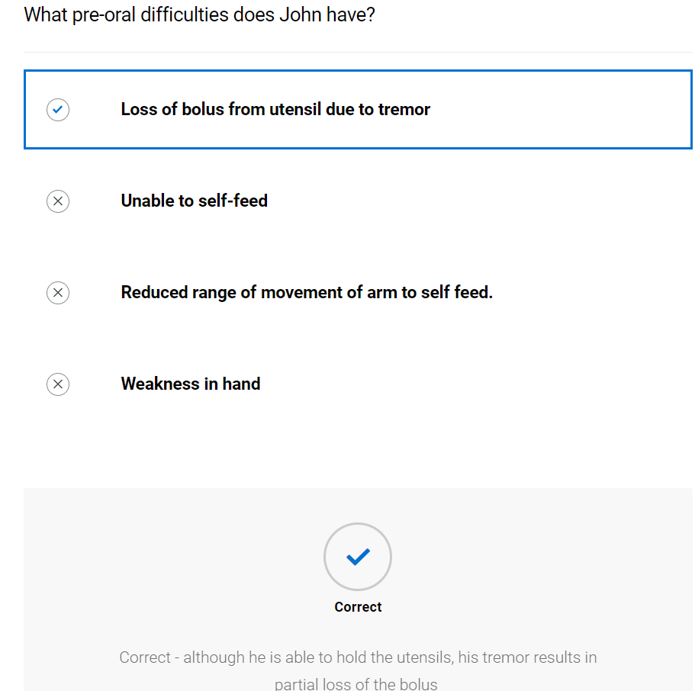

Which aspects of the assessment showed a difficulty with the pharyngeal stage of swallowing? Select all that apply
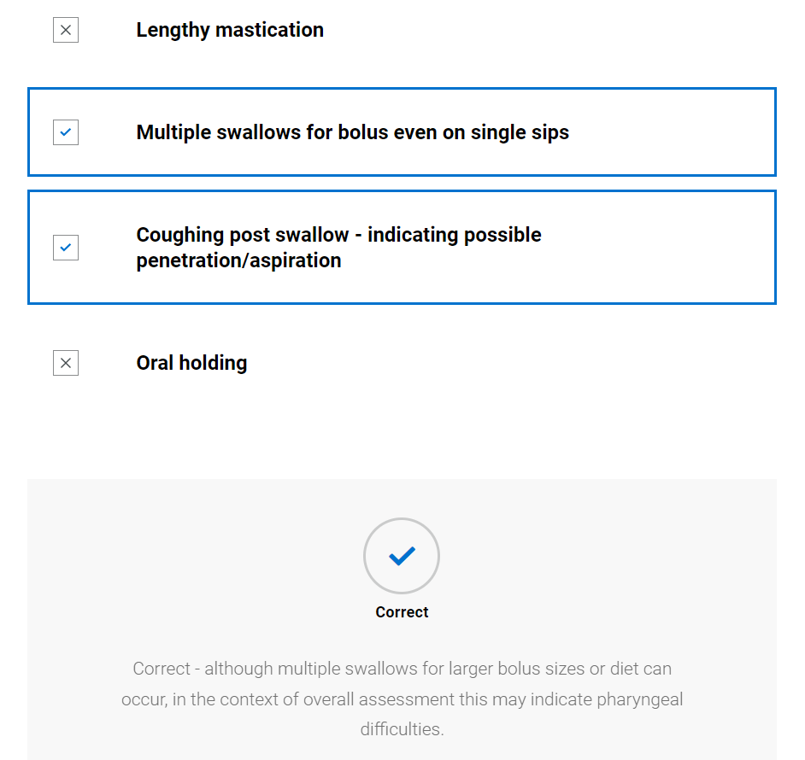

Swallow hypothesis and management plan
      - Video of SLT summarising client and forming working hypothesis and management plan
      - Completed hypothesis and management plan available to view along with TOMs
      - Further Learning: Research the effect of medication timing on swallow function for clients with Parkinson's Disease. This article may help you: Lim, A., Leow, L., Huckabee, M. L., Frampton, C., & Anderson, T. (2008) A pilot study of respiration and swallowing integration in Parkinson's disease: "on" and "off" levodopa. Dysphagia, 23(1), 76–81.

Swallow hypothesis and management
Describe the key characteristics of each stage of swallowing
 | Pre-oral | Oral | Pharyngeal | Oesophageal
Brief summary | Difficulty with tremor resulting in loss of fluid from open cup | No anterior loss of bolus, may have difficulty with bolus volume (i.e., loss over base of tongue pre-swallow) or coordination of bolus from cup | Double swallow evident, coughing at times so possible penetration/aspiration. Possible pharyngeal residue | No concerns
Intervention proposed | Limited flow cup. IDDSI level 0 normal fluids | Limited flow cup  IDDSI level 0 normal fluids. IDDSI level 7 normal diet avoiding mixed consistencies | Limited flow cup, IDDSI level 0 normal fluids.
Rationale/ evidence | Lidded cup to reduce risk of spilling drink | By limiting the bolus volume may reduce likelihood of loss over base of tongue. By avoiding consistencies that have liquid and solid bolus this allows greater oral control to avoid loss pre-swallow of liquid bolus. | By preventing overspill pre-swallow this may allow timelier swallow trigger. Limited bolus size could reduce quantity of residue that has potential to be aspirated.

Eating drinking and swallowing difficulties secondary to

Main causes of EDS difficulties
Parkinson’s disease

Their EDS difficulties are also impacted by the following concomitant factors:

Concomitant factor | Impact
Nil

This client presents with a pre-oral, oral and pharyngeal dysphagia.

Therapy Outcome Measures (For paediatrics please use paediatric TOM)

Measure | Score
Impairment | 3
Activity | 3
Participation | 1
Well-being/ Distress | 2

Management plan
- IDDSI level 0 normal fluids from limited volume cup with 10mls insert
- IDDSI level 7 normal diet avoiding mixed consistencies
- Ensure sat upright and alert for all diet/fluids
- To take meals 30mins after PD medication
- Easy read versions of advice sheets given
- SLT to review again during time 30 mins after taking medication.
      - Video of SLT feeding back to client
      - Knowledge check (not scored)
Why did the Speech and Language Therapist decide to trial a cup that limits the bolus size? Select all that apply.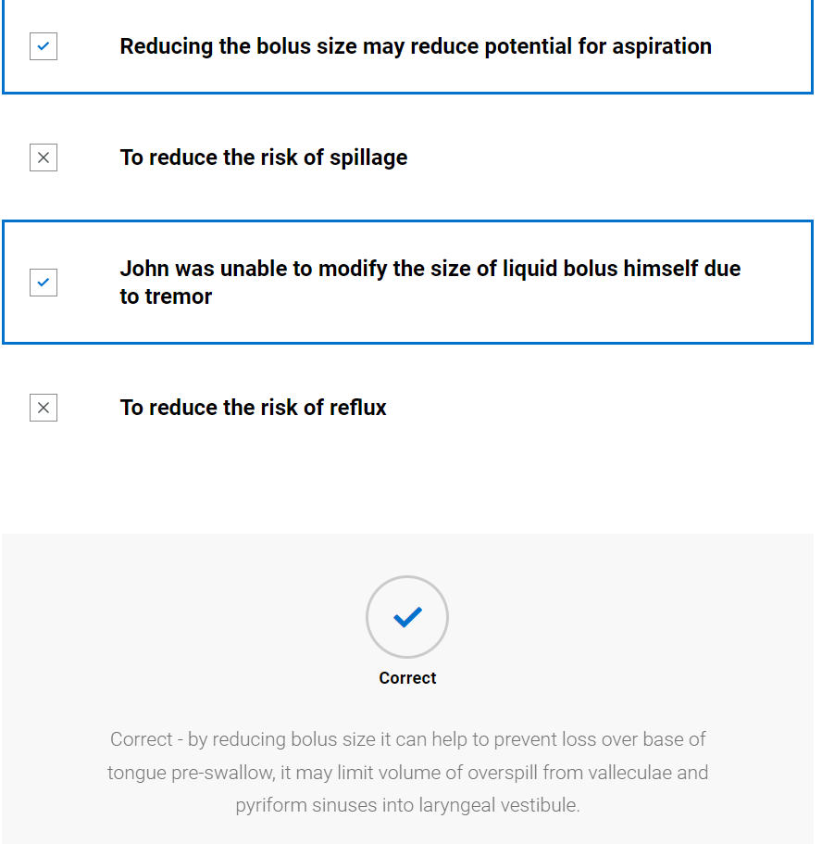
Why did the SLT recommend that he should have normal diet avoiding foods that have a liquid element? Select all that apply.
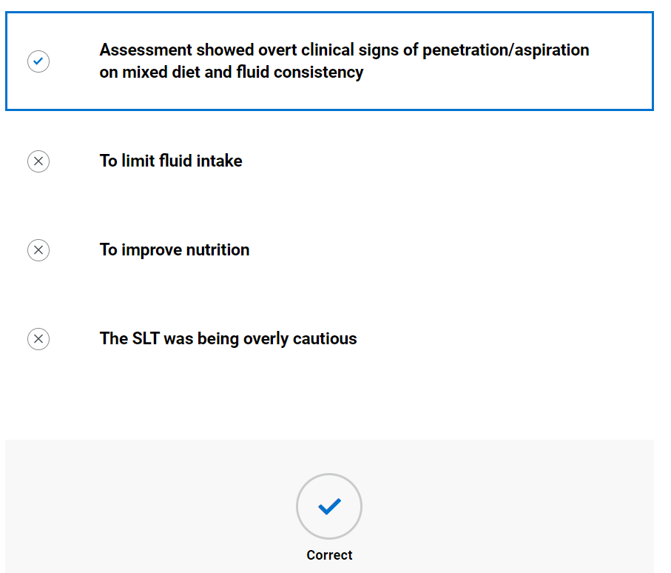

Ongoing management

The multidisciplinary team
      - Video of SLT and MDT – Discussion around timing of medication with PD nurse specialist
      - Knowledge check (not scored)
Why is the timing of medication important when working with people with Parkinson's Disease? Select all that apply.
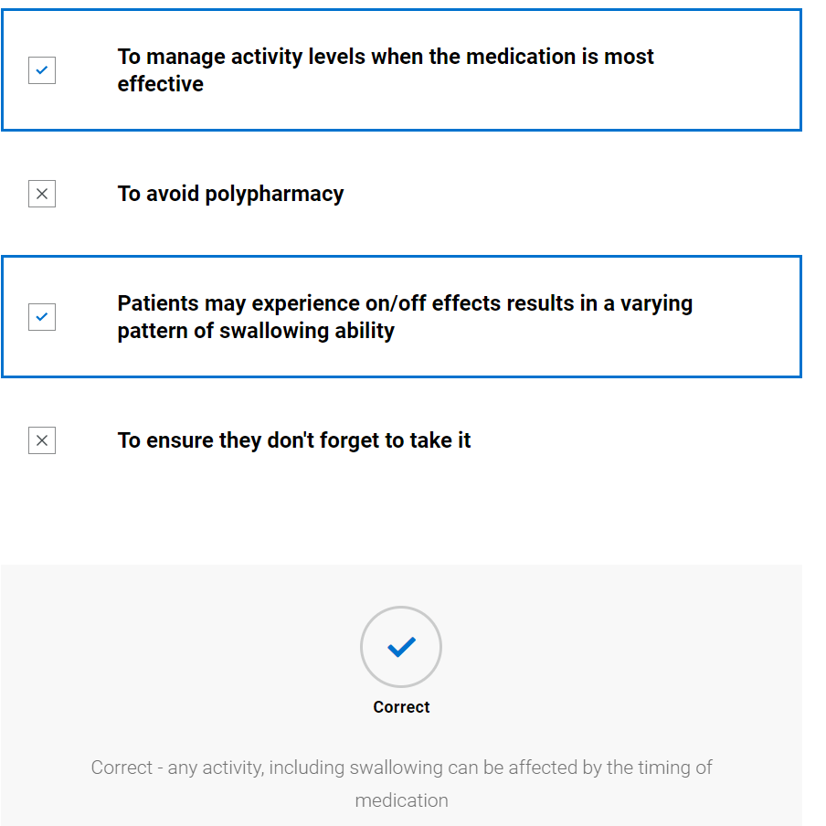

Swallow review
      - Blank swallow exam form provided; student advised to try to complete whilst watching video of SLT. (They can print this or send to word document to complete – it is not scored) See appendix 3
      - Video of SLT completing swallow exam
      - SLT completed swallow exam, student prompted to compare to theirs
      - Further Learning: The SLT will leave written information with the client about videofluoroscopies. Research why this is important. This article is a useful starting point: Kessels R. P. (2003) Patients' memory for medical information. Journal of the Royal Society of Medicine, 96(5), 219–222. Kessels R. P. (2003) Patients' memory for medical information. Journal of the Royal Society of Medicine, 96(5), 219–222.
Recording sheet for swallowing assessment
Seen at breakfast, 1st meds taken 30 minutes previous to assessment
 |  | Trial 1 | Trial 2 | Trial 3 | Trial 4 | Trial 5 | Trial 6
Pre-oral | Bolus description (IDDSI level) | Level 0 normal fluids | Level 0 normal fluids | Level 0 normal fluids | Level 7 Normal | Level 7 mixed consistency with level 0 fluids - cornflakes and milk | Level 0 Normal fluids
 | Manoeuvres/ strategies | Nil | Nil | Nil | Nil | Nil | Nil
 | Advice | Nil | Nil | Small sips | Nil | Nil | Nil
 | Volume and temperature | Room temperature, approximately 100mls | Room temperature, approximately 100mls | Room temperature, approximately 200mls | Biscuits | ½ small bowl | Room temperature, approximately 100mls
 | Position of client | Sat upright | Sat upright | Sat upright | Sat upright | Sat upright | Sat upright
 | Head and  trunk control lip closure at rest | No concerns | No concerns | No concerns | No concerns | No concerns | No concerns
 | Assistance required e.g., position/role/perspective of carer (if being fed) | None | None | None | None | None | None
 | Level of alertness/fatigue and communicative ability | Fully alert and fully intelligible | Fully alert and fully intelligible | Fully alert and fully intelligible | Fully alert and fully intelligible | Fully alert and fully intelligible | Fully alert and fully intelligible
 | Utensil/ specialist feeding equipment | Normal cup | Lidded thermal cup | Lidded thermal cup | Self-feeding with hands | Using large dessert spoon | Limited bolus size cup
 | Feeding ability | Self-feeding but with some loss of fluid from cup | Self-feeding, no loss of fluid from cup | Self-feeding, no loss of fluid from cup | Self-feeding | Loss of some of fluid from spoonful whilst moving to mouth | Self-feeding
 | Pace of feeding - observed or advised | Slow rate of feeding due to tremor | Rate within normal limits | Rate within normal limits | Rate within normal limits | Slowed rate due to liquid loss from spoon | Rate within normal limits
 | Pre-oral behaviours | Nil | Nil | Nil | Nil | Nil | Nil
Oral | Bolus removal from utensil | Adequate lip seal around cup | Adequate lip seal around cup | Adequate lip seal around cup | Adequate lip seal | Adequate lip seal around spoon | Adequate lip seal around cup
 | Lip seal/anterior bolus control | Complete | Complete | Complete | Complete | Complete | Complete
 | Bite/suck | n/a | n/a | n/a | Able to bite one mouthful off at a time | n/a | n/a
 | Oral manipulation of bolus including chewing) | No concerns | No concerns | No concerns | Mastication appeared complete although slightly lengthy | Mastication appeared timely and complete | No concerns
 | Changes to saliva | Nil | Nil | Nil | Nil | Nil | Nil
 | Nasal regurgitation | No | No | No | No | No | No
 | Timing of oral phase | Appeared appropriate | Appeared appropriate | Appeared appropriate | Mildly prolonged | Appeared appropriate | Appeared appropriate
 | Oral residue/ pocketing | Nil | Nil | Nil | Nil | Nil | Nil
Pharyngeal | Swallow triggered – effort, number, elevation, excursion, timing | Swallow triggered with minimal effort, laryngeal elevation, and excursion evident. Spontaneous second swallow. | Swallow triggered with minimal effort, laryngeal elevation, and excursion evident. Spontaneous second swallow. | Swallow triggered with minimal effort, laryngeal elevation, and excursion evident. Spontaneous second swallow | Piecemeal swallow. Swallow triggered with minimal effort, laryngeal elevation and excursion evident | Piecemeal swallow. Swallow triggered with minimal effort, laryngeal elevation, and excursion evident | Single swallow triggered with minimal effort, laryngeal elevation, and excursion evident
 | Respiration changes | Nil | Nil | Nil | Nil | Nil | Nil
 | Voice quality e.g. wet/breathy | No change | No change | No change | No change | No change | No change
 | Globus | Nil | Nil | Nil | Nil | Nil | Nil
 | Cough/ throat clearing - (presence, strength, duration) | Cough triggered after second clearing swallow | Cough triggered after second clearing swallow | Cough triggered after second clearing swallow | Nil | Coughing after 3rd spoonful | Nil
 | Prompts - verbal and physical | Nil | Nil | Small sips | Nil | Nil | Nil
Oesophageal | Eructation/ belching | Nil | Nil | Nil | Nil | Nil | Nil
 | Regurgitation/ reflux | Nil | Nil | Nil | Nil | Nil | Nil
 | Other including sticking sensation, pain | Nil | Nil | Nil | Nil | Nil | Nil
Other | Altered reflexes | Nil | Nil | Nil | Nil | Nil | Nil
 | Other, including signs of distress (eye watering, colour changes) | Nil | Nil | Nil | Nil | Nil | Nil

      - Knowledge check (not scored)
Why did the SLT suggest a videofluoroscopic examination of swallowing? Select all that apply.
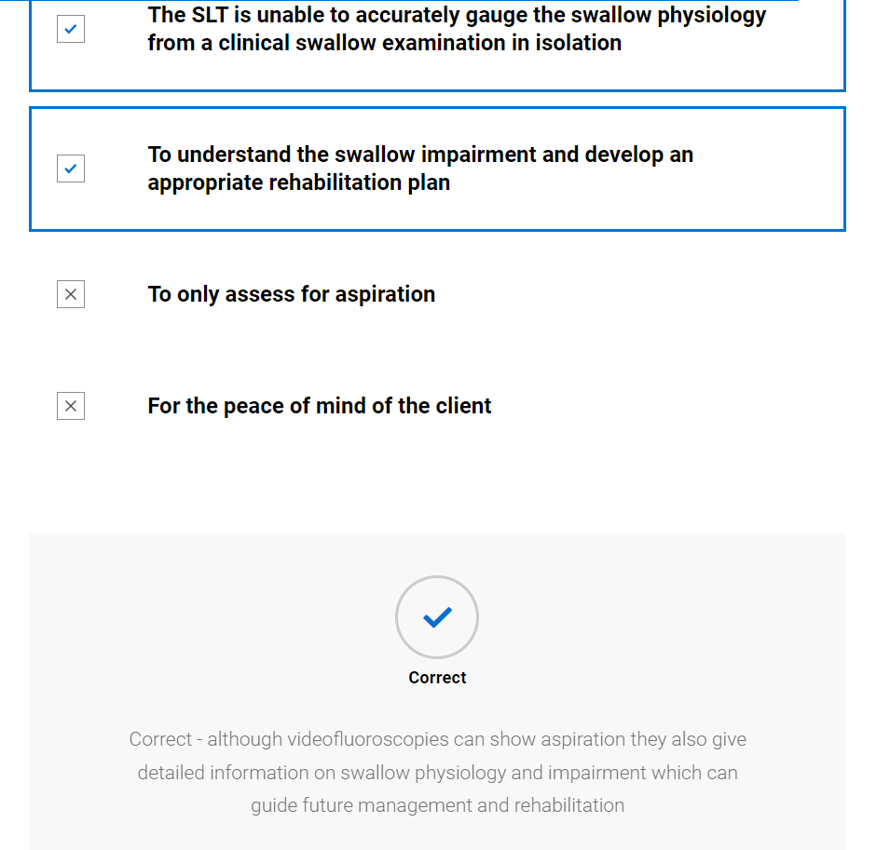

Which of the following are instrumental assessments of swallowing? Select all that apply.
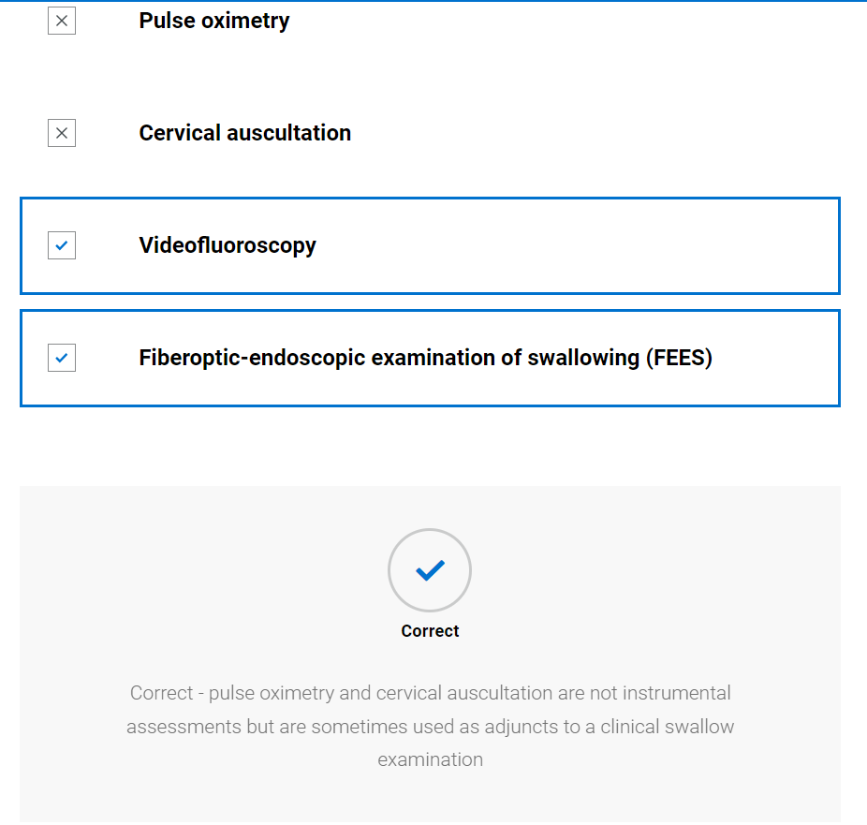

Swallowing therapy
      - Video of SLT feeding back videofluoroscopy results and implementing swallow therapy

      - Knowledge check
Why did the SLT choose expiratory muscle strength training (EMST) as an appropriate swallow rehabilitation technique for John? Select all that apply
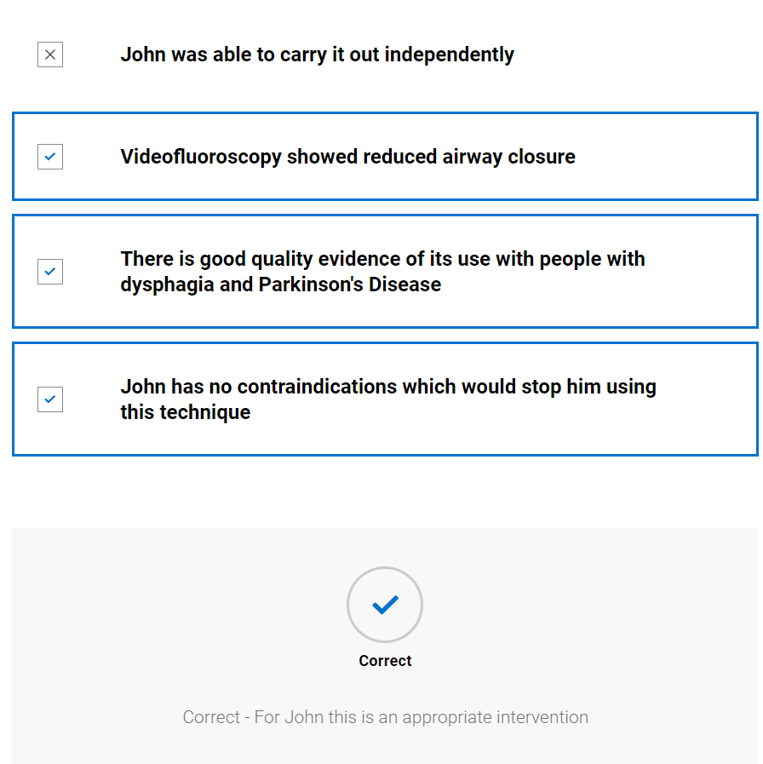

Why was it important to consider swallow rehabilitation for John? Select all that apply.
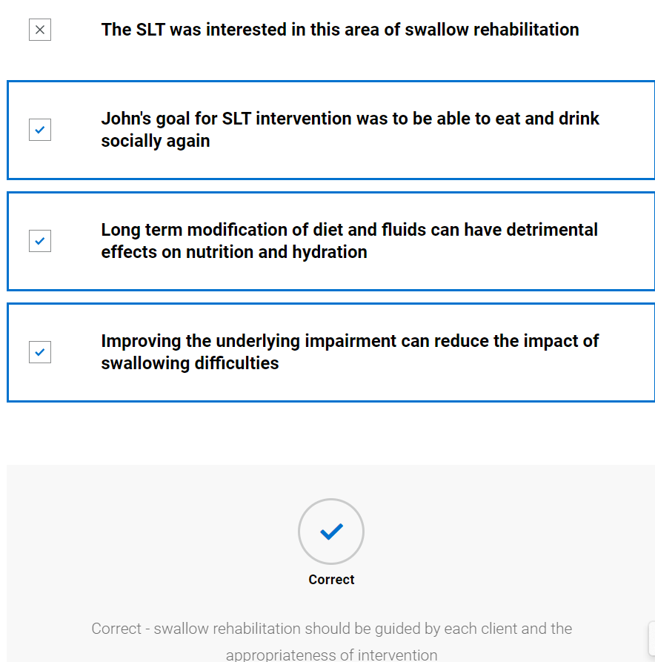

Swallow review post therapy
      - Blank swallow exam form provided; student advised to try to complete whilst watching video of SLT. (They can print this or send to word document to complete – it is not scored) See appendix 3
      - Video of SLT completing swallow exam
      - SLT completed swallow exam, student prompted to compare to theirs

Recording sheet for swallowing assessment
Seen at breakfast, 1st meds taken 30 minutes prior
 |  | Trial 1 | Trial 2
Pre-oral | Bolus description (IDDSI level) | IDDSI level 0 normal fluids | IDDSI level 7 mixed consistency with level 0 fluids - cornflakes and milk
 | Manoeuvres/ strategies | Nil | Nil
 | Advice | Nil | Nil
 | Volume and temperature | Room temperature, approximately 100mls | ½ small bowl
 | Position of client | Sat upright | Sat upright
 | Head and  trunk control lip closure at rest | No concerns | No concerns
 | Assistance required e.g., position/role/  perspective of carer (if being fed) | None | None
 | Level of alertness/fatigue and communicative ability | Fully alert and fully intelligible | Fully alert and fully intelligible
 | Utensil/ specialist feeding equipment | Lidded thermal cup | Using large dessert spoon
 | Feeding ability | Self-feeding, no loss of fluid from cup | Loss of some of fluid from spoonful whilst moving to mouth
 | Pace of feeding - observed or advised | Rate within normal limits | Slowed rate due to liquid loss from spoon
 | Pre-oral behaviours | Nil | Nil
Oral | Bolus removal from utensil | Adequate lip seal around cup | Adequate lip seal around spoon
 | Lip seal/anterior bolus control | Complete | Complete
 | Bite/suck | n/a | n/a
 | Oral manipulation of bolus (including chewing) | Adequate | Mastication appeared timely and complete
 | Changes to saliva | Nil | Nil
 | Nasal regurgitation | No | No
 | Timing of oral phase | Appeared appropriate | Appeared appropriate
 | Oral residue/ pocketing | Nil | Nil
Pharyngeal | Swallow triggered – effort, number, elevation, excursion, timing | Single swallow triggered with minimal effort, laryngeal elevation and excursion evident. | Piecemeal swallow. Swallow triggered with minimal effort, laryngeal elevation and excursion evident
 | Respiration changes | Nil | Nil
 | Voice quality e.g., wet/breathy | No change | No change
 | Globus | Nil | Nil
 | Cough/ throat clearing - (presence, strength, duration) | Nil | Nil
 | Prompts - verbal and physical | Nil | Nil
Oesophageal | Eructation/ belching | Nil | Nil
 | Regurgitation/ reflux | Nil | Nil
 | Other including sticking sensation, pain | Nil | Nil
Other | Altered reflexes | Nil | Nil
 | Other, including signs of distress (eye watering, colour changes) | Nil | Nil

      - Knowledge check (not scored)
Why did the SLT recommend normal diet and fluids? Select all that apply.
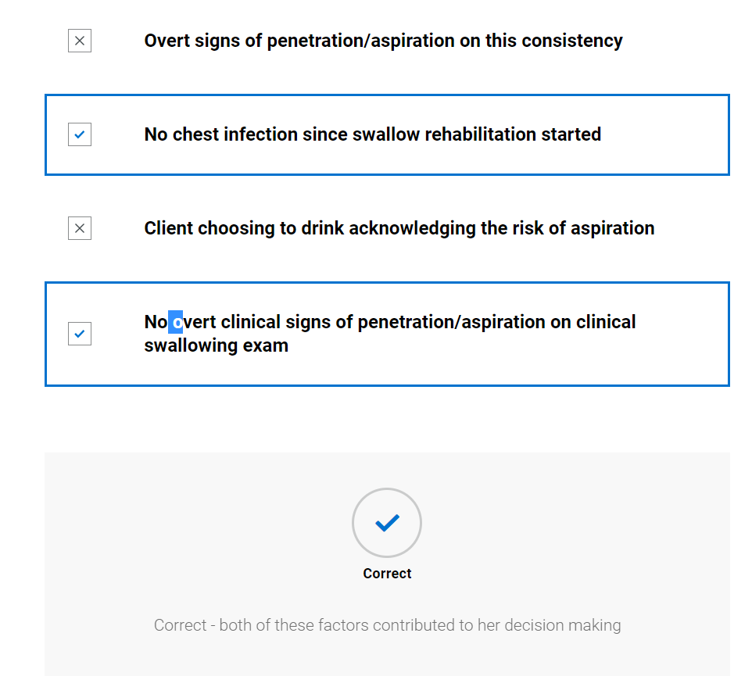

Discharge
    - Video of SLT discussing discharge with client
    - Copy of discharge report

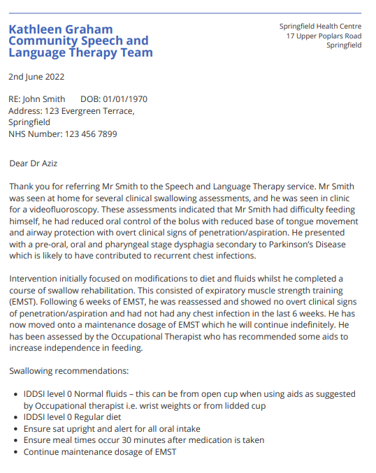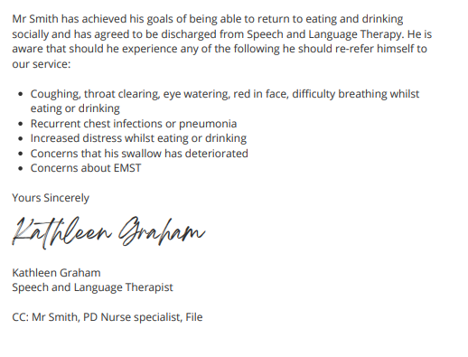

Therapy Outcome Measures – end of intervention

Measure | Score
Impairment | 4
Activity | 5
Participation | 5
Well-being/ Distress | 5
    - Knowledge check (not scored)
Why did the SLT discharge John? Select all that apply.
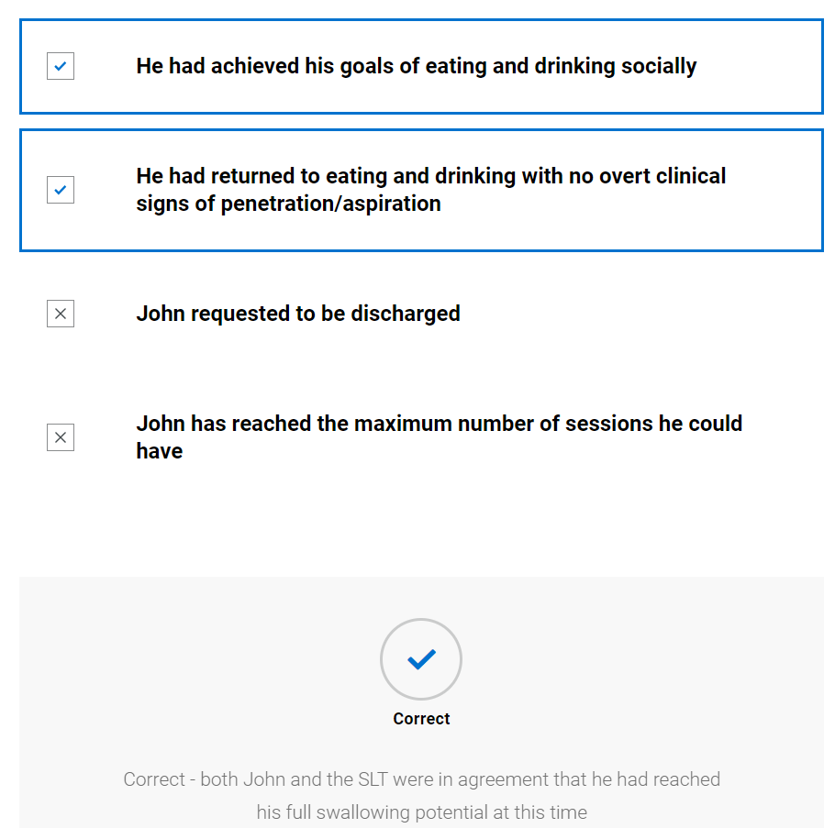

Case 2: Adult – Jim

Background information and planning initial assessment

Referral information
      - Referral document provided with expanded information on key components
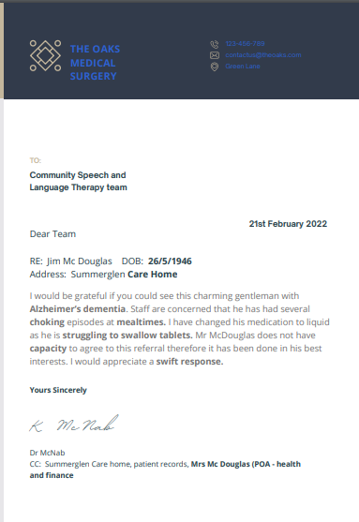

26/5/46 – Mr Mc Douglas is an older gentleman. There is an association between dysphagia and increasing age.
Care home – Research has shown that between 25 to 70% of people in care homes have dysphagia. Also, being in a care home has a correlation with developing aspiration pneumonia
Alzheimer’s dementia – The prevalence of dysphagia for people with dementia can be up to 93%
Choking – Mr McDouglas has a history of choking episodes i.e., where diet has entered his airway and blocked it resulting in the inability to breathe (asphyxiation). This may be due to swallowing difficulties and increases the urgency of the referral as choking episodes can be life threatening.
Mealtimes – The referrer has indicated that the choking episodes were specifically at mealtimes. This may indicate a dysphagia to solids.
Struggling to swallow tablets – Many people who do not have dysphagia may have difficulty swallowing tablets. If this client is struggling it could be part of a bigger picture of swallowing difficulties.
Capacity – Clients should give informed consent for a referral to be made. Mr McDouglas does not have the ability to consent to this referral as his mental capacity is diminished therefore it has been done in his best interest i.e., on the balance of risk the referral is thought to be justified and in his best interest.
A swift response – The referrer is indicating that they feel the client needs to be seen quickly as they are concerned about their swallowing difficulty
Mrs McDouglas (POA – health and finance) – This indicates that Mrs McDouglas may have Power of Attorney to makes decisions on Mr McDouglas’ behalf, i.e., she has a legal document which sets out her role as the person responsible for his health and finance as he is unable to make these decisions himself.
Further Learning: Eating drinking and swallowing difficulties are common amongst people living in care or nursing homes. Research how eating, drinking and swallowing difficulties are managed in this setting. The following article is a useful starting point: Engh, M.C.N., & Speyer, R. (2022) Management of Dysphagia in Nursing Homes: A National Survey. Dysphagia 37, 266–276. https://doi.org/10.1007/s00455-021-10275-7
      - Knowledge check quiz (not scored)
Why was Mr McDouglas prioritised by the SLT as an urgent referral needing seen within 72 hours?
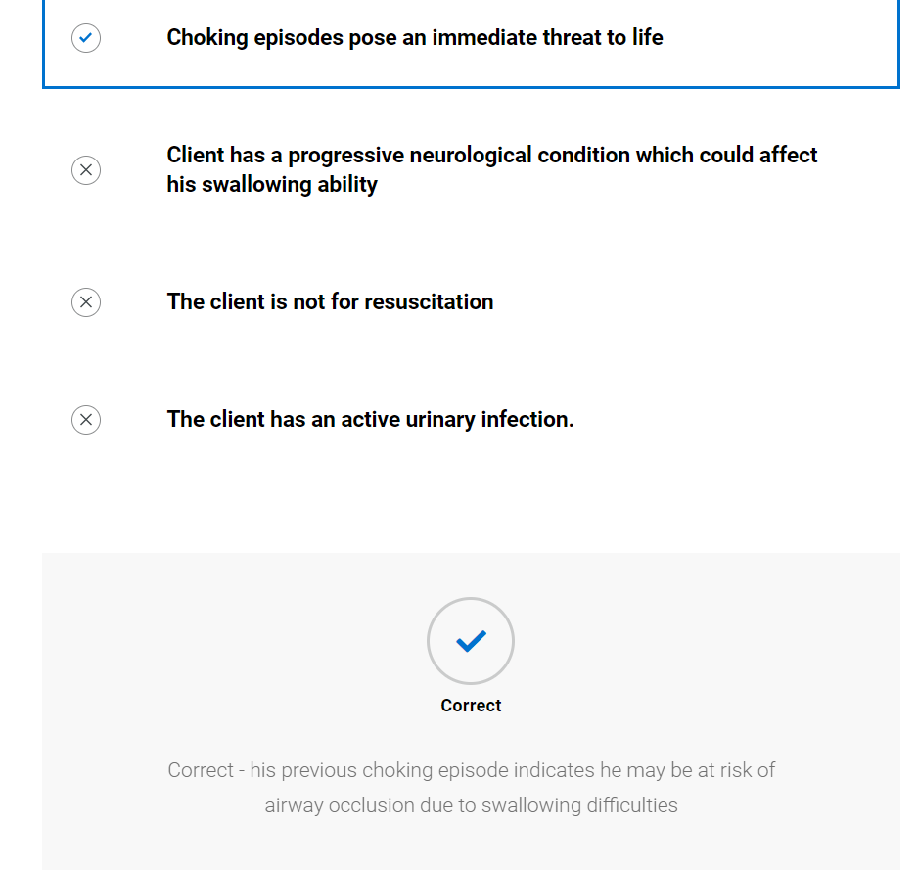

Case note review
      - Case note summary provided with expanded information on key components

Case notes
Past medical history:
Hypertension
Type 2 diabetes
Alzheimer’s dementia
Hyperlipidaemia
Suprapubic catheter
Osteoarthritis

Previous SLT intervention:
Mr McDouglas was referred to the hospital SLT in June 2021 due to coughing with fluids. He had been admitted for urinary sepsis. Seen by SLT 2 days after admission and no overt clinical signs of penetration/aspiration on any oral intake. Recommended IDDSI level 0 Normal fluids and IDDSI level 7 normal diet. Advised to refer to community SLT if any concerns in future.

Current open referrals:
Being seen by Occupational therapist for seating assessment. Referral due to inability to maintain upright position in normal chair. OT reports dependent for all ADL’s

Allergies and sensitivities
Penicillin
Statins

Alerts
Do not attempt resuscitation
Not for hospital admission unless acute reversible injury
Wife had power of attorney for health and finance

Last 3 days of entries:
19/12/2021: District nursing team – SOS call as catheter bypassing. Urine strong and foul smelling. Evidence of leukocytes and nitrates, sample sent to lab. Catheter flushed and running freely now.
20/12/2021: GP entry – lab results reveal urinary infection. Tel to care home and prescribed erythromycin BD, 5 day course. Care home to contact surgery if does not resolve
21/12/2021: GP entry – Care home telephone to say choking episode at breakfast on toast. Ambulance called but toast had dislodged upon arrival and Sp02 98%, temp 37.5, no audible adverse airway sounds. Staff report has been coughing on erythromycin therefore all medication changed to liquid. Agreed to refer to SLT team for urgent assessment.

Text to go in expanded sections
Type 2 diabetes – There is some evidence that diabetes may cause dysphagia. Also, the inability to eat and drink could impact upon blood glucose levels.
Alzheimer’s disease – If a person with dementia has dysphagia they are at risk of developing dehydration, malnutrition, losing weight and aspiration pneumonia. Dysphagia symptoms may include a reduced sense of smell that can affect taste, forgetting to eat a meal, difficulty consuming a meal due to distractibility and agitation, difficulties with oral bolus manipulation and prolonged oral phase, delayed pharyngeal response to bolus and inefficient pharyngeal clearance.
Suprapubic catheter – this is a tube inserted through an incision in the abdomen directly into the bladder instead of being placed via the urethra. They pose an infection risk and adequate fluid intake is essential to avoid blockages and urinary tract infections.
Osteoarthritis -this is pain, aching, stiffness, swelling and decreased range of movement primarily in the hands, hips, and knees. This can affect a person’s ability to prepare food and to feed themselves.
Coughing with fluids – coughing whilst drinking is one over sign of penetration/aspiration
Normal fluids and IDDSI level 7 normal diet – IDDSI is the international dysphagia diet standardisation initiative and provides a standardised approach to the description of different level of diet and fluids. It also shows how diet and fluids can be tested to confirm which level they represent.
Dependent for all ADL’s – ADLs are activities of daily living. They are all the activities that a person would complete on an average day i.e. washing, drinking, preparing food, toileting, and feeding. If someone is dependent on another person for oral care, it can impact on the cleanliness of their mouth. For feeding it means they are reliant on another person to feed them, and they have no control over bolus size, frequency of feeding, temperature, or bolus placement.
Do not attempt resuscitation – this is a document signed by a doctor which states that in the event of death, cardio-pulmonary resuscitation should not be attempted. It is not a legally binding document.
Not for hospital admission unless acute reversible injury – a decision has been made with the individual or person with power of attorney that admission to hospital would not be in the person’s best interests unless it is a condition that is acutely reversible, e.g., a broken bone.
Wife has power of attorney for health and finance – this is a legally binding document that assigns another individual the power to make decisions on the individual’s behalf for health and finance if they are unable to do it themselves.
Catheter bypassing – this happens when there is a blockage in the catheter tubing which results in urine leaking from around the tube site. Blockages can be caused by a build-up of debris or concentrated urine within the tube. Adequate hydration is important to prevent blockages and bypassing.
Urinary tract infections – this is an infection of the urinary tract which includes the bladder, urethra, or kidneys. It can cause pain, increased urinary frequency or urgency, or a temperature. For people with dementia or a urinary catheter it can cause changes in behaviour i.e., agitation or delirium, incontinence, or rigors (shivering/shaking). Reduced fluid intake and the presence of urinary catheters can cause these infections.
Choking – medical terms is asphyxiation. This is the sudden blockage of the airway, partially or fully, by a foreign body. It blocks the intake of oxygen which can lead to oxygen deprivation in the brain and other organs. Choking is a life-threatening event.
Toast – this would be represented as IDDSI level 7 normal diet. Toast can be a dry, chewy texture which requires good oral manipulation.
Coughing on erythromycin – coughing on medication may be an overt sign that the tablet has penetrated the upper airway or has been aspirated. If Jim is not consistently swallowing the medication, then it may not be effect in treating his urinary infection
All medication changed to liquid – All medication can be made available in liquid forms however this may affect:
- the volume of medication that needs to be swallowed
- dosage
- how delayed or prolonged release medication work
- it is often more expensive and may need special preparation by a pharmacist

Urgent assessment – The referrer has given an indication of how they feel this referral should be prioritised from their experience. The referrer feels this referral is urgent due to the risk of life from the choking episode.
72 hours – The SLT has triaged the referral according to their service level specification and internal triage protocols. For this service the most urgent cases are prioritised as needing to be seen within 72 hours. This is a target response which the service may be measured against.
Further Learning: Jim has a urinary tract infection which may be impacting on his swallowing. Research how eating, drinking and swallowing are impacted by a loss of functional reserve in older clients. The following article is a useful starting point: Sakai, K., Nakayama, E., Yoneoka, D., Sakata, N., Iijima, K., Tanaka, T., Hayashi, K., Sakuma, K., & Hoshino, E. (2022) Association of Oral Function and Dysphagia with Frailty and Sarcopenia in Community-Dwelling Older Adults: A Systematic Review and Meta-Analysis. Cells, 11(14), 2199.
      - Knowledge check (not scored)
Why was Mr McDouglas prioritised by the SLT as an urgent referral needing seen within 72 hours?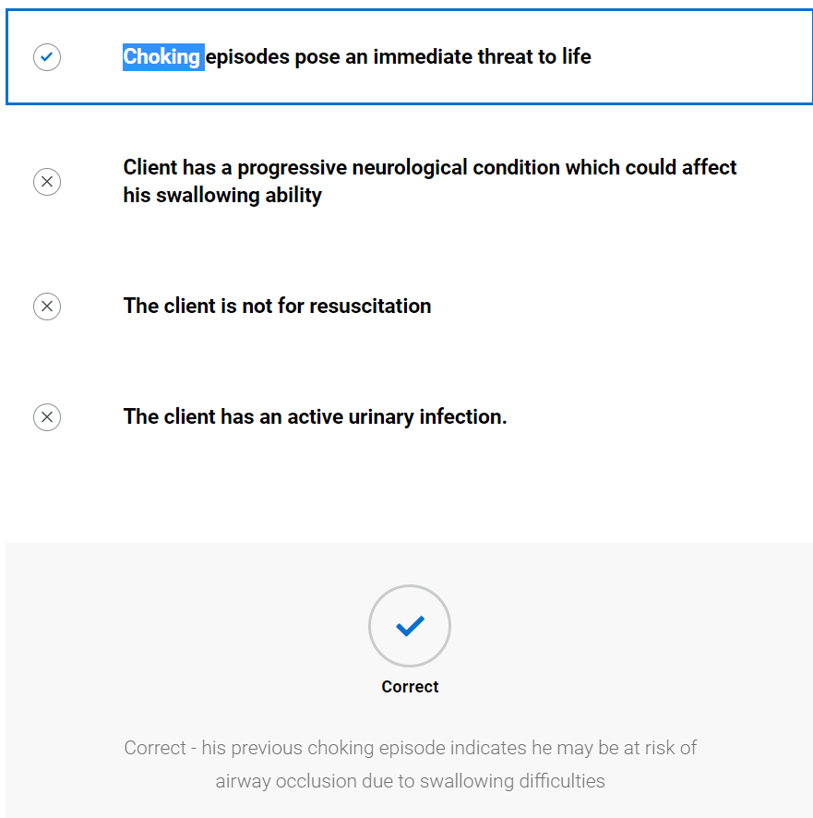

Further information gathering
      - Video of SLT contacting client
      - Knowledge check (not scored)
Why did the SLT contact Mrs McDouglas? Select all that apply.
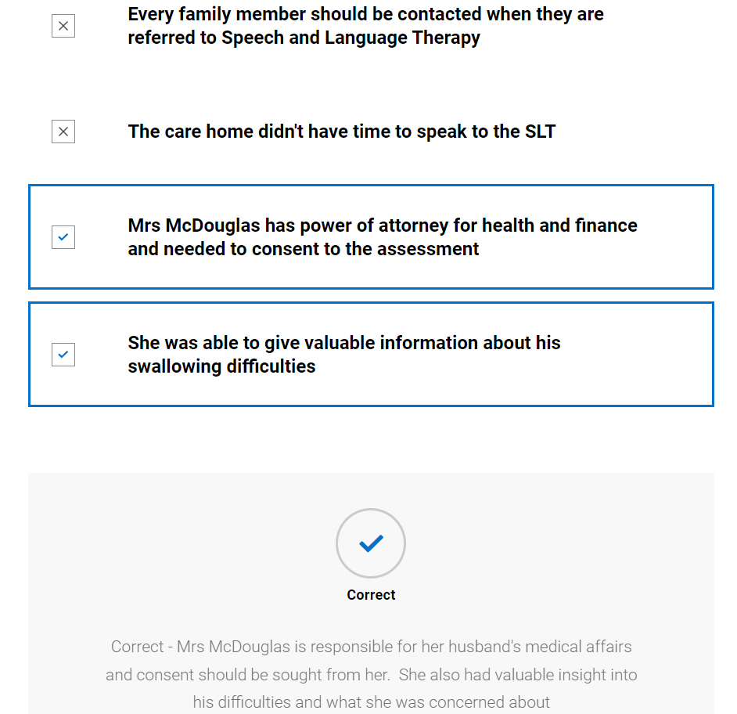

Planning
      - Images of items needed for planning along with explanation
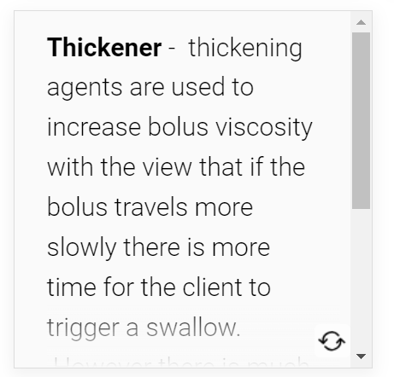

Pen torch – to achieve a clear view of the oral cavity
Personal protective equipment – disposable apron, disposable gloves, eye protection, face mask and alcohol gel. Disinfectant wipes. Local protocols should be adhered to
Swallowing recommendation sheets – advice sheet to detail recommendations for that individual. This will become part of the care plan and a copy will be left with the care home, one sent to his wife and a copy kept for SLT records.
Diet and fluid advice sheets – advice sheet which details different levels of diet and fluid in accordance with IDDSI
Utensils and feeding apparatus – These utensils can help the SLT to trial different methods to aid swallowing by e.g., avoiding tipping head back (nosey cup/dysphagia cup), reducing the strength of suction required (valved straw), avoid damage to dentition (Maroon spoon of silicon spoon), control bolus volume (cup which controls bolus size)
Oral care supplies – soft toothbrush, low foam toothpaste, lip balm, oral gel, instructions. Good oral care is essential to reduce the risk of aspiration pneumonia. Carers and patients may need to be trained in effective oral care.
Thickener – thickening agents are used to increase bolus viscosity with the view that if the bolus travels more slowly there is more time for the client to trigger a swallow. However, there is much controversy in this area as research has shown there are many side effects and it may not reduce the risk of aspiration pneumonia.
General swallowing paper resources: Giving clients or carers access to written information can reinforce the advice and information discussed

Further Learning: Research how thickener is currently used in the management of eating, drinking and swallowing difficulties. The following articles provide a useful starting point: Logemann, J.A., Gensler, G., Robbins, J., Lindblad, A.S., Brandt, D., Hind, J.A., Kosek, S., Dikeman, K., Kazandjian, M., Gramigna, G.D. & Lundy, D. (2008) A randomized study of three interventions for aspiration of thin liquids in patients with dementia or Parkinson’s disease. Journal of speech, language and hearing research. 51(1), 173-183. Hansen, T., Beck, A. M., Kjaesrgaard, A., & Poulsen, I. (2022) Second update of a systematic review and evidence-basedrecommendations on texture modified foods and thickened liquids foradults (above 17 years) with oropharyngeal dysphagia. Clinical Nutrition ESPEN 49, 551-555. Kuhlemeier, K., Palmer, J. & Rosenberg, D. (2001) Effect of Liquid Bolus Consistency and Delivery Method on Aspiration and Pharyngeal Retention in Dysphagia Patients. Dysphagia, 16, 119–122.
      - Knowledge check
Why is it important to wear appropriate personal protective equipment (PPE)?
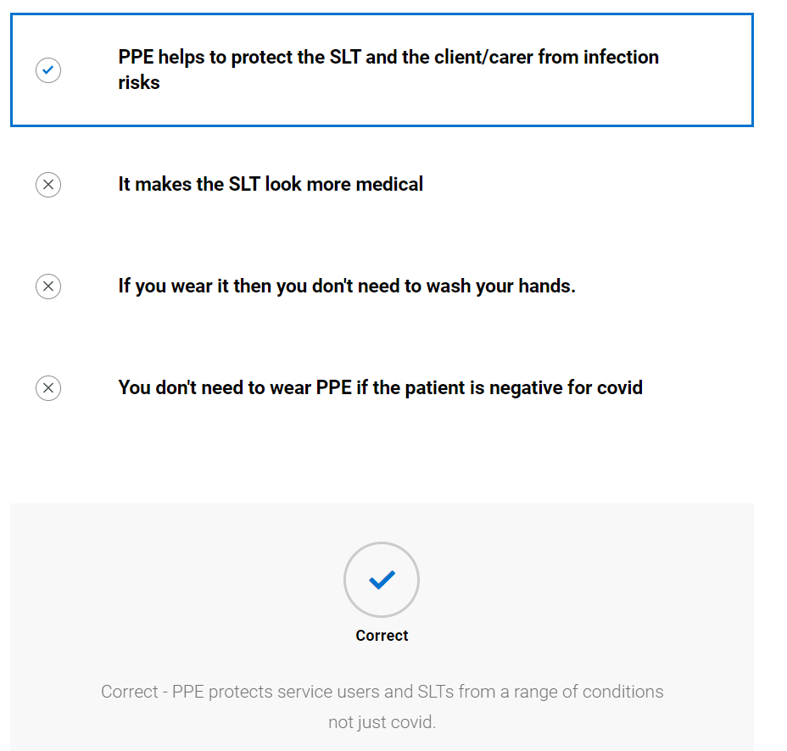

Initial assessment

Case history
      - Blank case history form provided; student advised to try to complete whilst watching video of SLT. (They can print this or send to word document to complete – it is not scored) See appendix 1
      - Video of SLT completing case history
      - SLT completed case history, student prompted to compare to theirs
Speech and Language Therapy
Initial eating, drinking and swallowing case history
Yellow = information prepopulated from info gathered to date
Demographics |  | Jim McDouglas DOB: 26/5/1960  Address: Summerglen Care Home
Consent |  | GP has completed best interest decision that Jim should have assessment.
Assessment location and time |  | Care home 12:00
Reason for referral |  | Referral from GP as staff are concerned that he has had several choking episodes at mealtimes. He is struggling to swallow tablets.  Senior carer reports he is really concerned about his swallowing, they have placed him on an IDDSI level 4 diet until he could be seen by SALT to reduce choking risk. This has not stopped the coughing episodes.
Legal information including:  - Advanced care planning  - Power of attorney  - Advanced directive  - Resuscitation status |  | Wife has power of attorney for health and finance  Do not attempt resuscitation order is place  Not for hospital admission unless acute reversible injury
Communication ability, including languages used |  | English speaker, no functional communication. Carer reports will vocalise for pain only
Mental capacity |  | He is unable to consent to assessment – best interest decision by GP to make referral and wife has consented to referral
Safeguarding |  | No alert on system
Social history |  | Has lived in the care home for the past 3 years as he was becoming less mobile, and his wife was unable to manage him at home as her own health is deteriorating. Wife is struggling to visit due to deterioration in her own health
Person with parental responsibility/ next of kin |  | Mrs McDouglas
Client/Carer expectations of intervention |  | Senior carer would like Mr McDouglas to be able to have a meal without coughing. He expects recommendations from SLT that they can follow after the initial assessment.
Medical information
Past medical history including disorders of movement or tone | Type 2 diabetes  Alzheimer’s dementia  Suprapubic catheter  Osteoarthritis
Current mental wellbeing | Due to severity of dementia carer reports he is unable to tell this but that he cooperates with washing and dressing and does not appear to be in pain currently
Main diagnosis/presenting condition | Alzheimer’s dementia
Level of frailty | Moderate/severe. Although he looks well, carers report he is immobile and relies on them for all activities of daily living
Prognosis including Gold standards framework | Mr McDouglas is currently on the palliative register with a prognosis of months due to severity of Alzheimer’s and urinary problems
Sensory impairment  - Sight, hearing, touch, smell, taste  - Reaction to sensation  - Reflexes | Carer reports only reacts to pain
Multidisciplinary involvement | Was seen by OT yesterday who has completed seating assessment. They report he has new chair and is now able to sit upright in it
Medication | Losartan for hypertension  Metformin for diabetes  Paracetamol for pain relief  Erythromycin for urine infection  All medication in liquid form
Sensitivities and allergies | Penicillin  Statins
Reflux (for adults see RSI below) | Carer reports no concerns about this, no episodes of vomiting

History/Background of Dysphagia
Onset | Carer reports that his general health has significantly deteriorated over the last 12 months. He has been coughing with food and medication for past 3 months.
Duration | 3 months
Stability/progression | Carer feels it is worsening as coughing more frequently even on puree diet
Social and psychosocial impact of difficulties | Mr McDouglas seems unaware of his difficulties. Carer reports he is not distressed by coughing but staff are and feel very anxious when feeding him. Wife is very concerned about the situation
Avoidance | Avoiding all foods more textured than puree as advised by care home manager until SLT could assess
Client/carer description | Carer feels there is something wrong with his throat but doesn’t know why
Significant swallowing events | He choked on toast, and they had to call an ambulance
Cultural aspects affecting EDS | None reported
Mealtime routine | Has breakfast whilst sat upright in bed, lunch and evening meal are in the dining room with the other residents
Enjoyment of meals | Carer reports Mr McDouglas really enjoys his meals and has always been a “good eater”
Current oral intake | IDDSI level 0 normal fluids from open cup  IDDSI level 4 smooth puree diet via teaspoon
Mental health/wellbeing of client and carer | Carer reports wife is very worried about him, and staff do not feel confident feeding him

Respiration
Chest status (current and history) | No history of chest infections in the last 3 months
Breathing pattern at rest | Normal
Cough | No coughing at rest
Oxygen/ventilatory requirements | On room air
S:Z ratio | Unable to complete due to severity of Alzheimer’s

Environment, skills and behaviours
Positioning | Staff report new chair means he is sitting upright with no concerns
Skin integrity | Staff report some reddening around catheter site but is under district nurses for this
Feeding skills | Reliant on staff to feed him
Equipment/utensil used | Open cup for fluids – they report occasional loss from mouth, teaspoon for diet
Environments in which client eats/drinks | Own room and dining room
Behaviours or sensory challenges/issues around eating/drinking/mealtimes | Can fatigue at mealtimes especially if he has a urinary infection

Nutrition and hydration
Nutrition and hydration status prior to assessment | Fluid balance chart shows average intake of 1800mls per day, staff report eats healthy balanced diet
Weight/BMI/MUST/ Growth and development | BMI of 25 - Within normal BMI range
Urinary output | Catheter now running freely although it had been very concentrated
Faecal output | Carer reports normal

Risk factors for developing aspiration pneumonia
 | Yes | No
Dependence for oral feeding | X
Dependence for oral care | X
Poor oral/dental hygiene |  | X
Chest concerns |  | X
Comorbidities | X
Multiple Medications | X
Mobility status i.e. significantly reduced mobility | x
If yes response then patient is at increased risk of aspiration pneumonia (Langmore, 1998)

      - Knowledge check (not scored)
What measures have the care home implemented to reduce the risk of further choking episodes? Select all that apply.
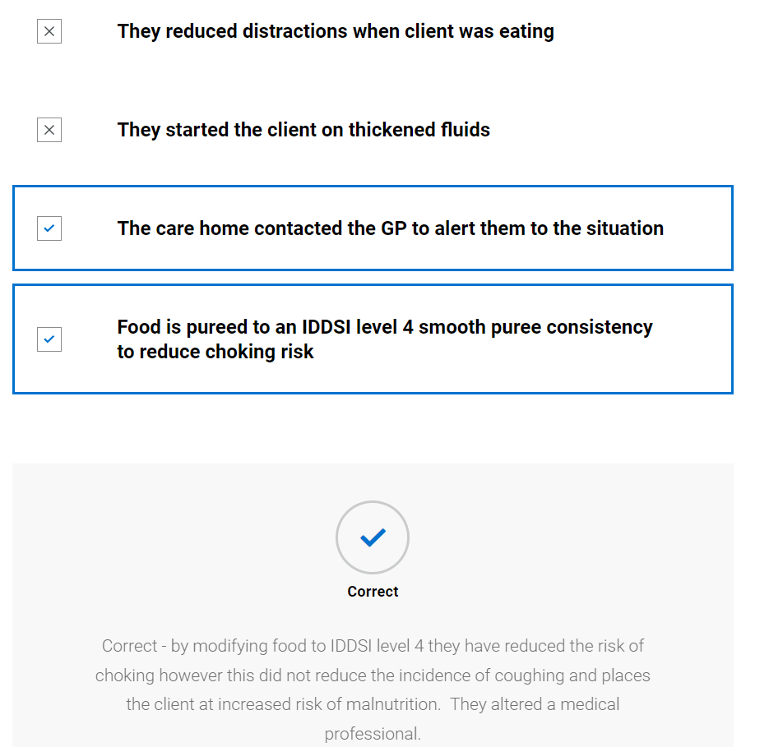

Why did the SLT ask about his respiratory status? Select all that apply.
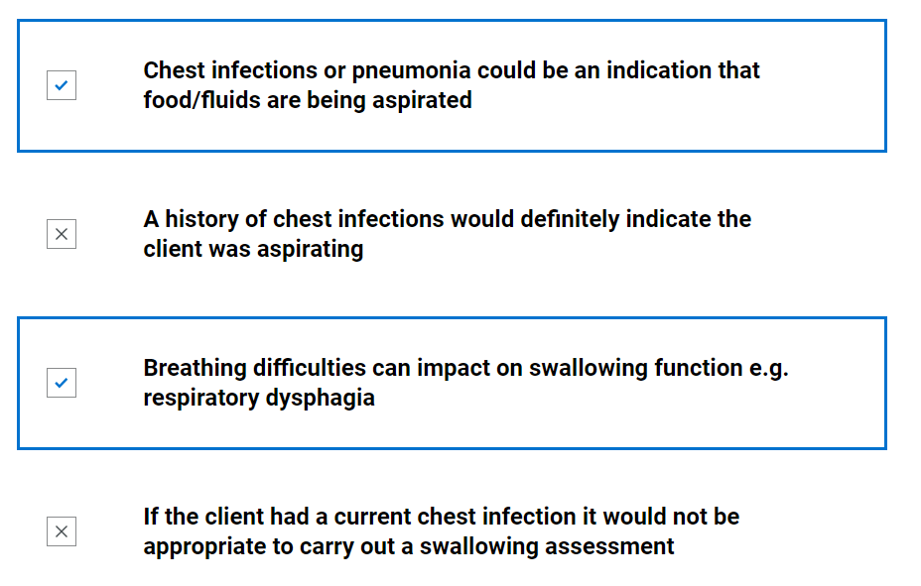
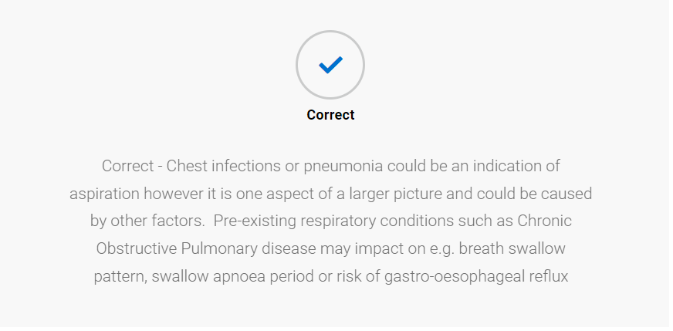

Oro-facial exam
      - Blank oro-facial exam form provided; student advised to try to complete whilst watching video of SLT. (They can print this or send to word document to complete – it is not scored) See appendix 2
      - Video of SLT completing case history
      - SLT completed oro-facial exam, student prompted to compare to theirs
Oro-facial assessment for clients with eating, drinking and swallowing difficulties
Mouth care and dentition -
Area | Comment
Dentures | Nil
Dentition | Own dentition. Multiple fillings but no active concerns. Adequate dentition for mastication
Lips | Pink and moist
Tongue | Pink and moist
Gums | Pink and moist
Cheeks | Pink and moist
Palate - Hard and soft | Pink and moist
Under tongue | Pink and moist
Skin integrity | Good
Level of support for oral care | Full support needed
Saliva | Within normal limits

Cranial nerve assessment - comment on range, rate, accuracy, and strength
Nerve and function - | Possible ways to assess | Observations | Outcome
V Trigeminal –  Conveys sensation to the face and motor to the soft palate, pharynx, and muscles of mastication | 1. Tissue or cotton to nostrils should produce wrinkling of nose  2. Clench teeth and palpate masseter and temporalis muscles for bulk  3. Strength of masseter and temporalis by jaw opening – against resistance of therapist hand  4. Observation of uvula – indicating weakness of tensor veli palantini  5. Palpate dry swallow for hyoid movement |  | Face quite flaccid at rest  1. No response to SLT touching nose with tissue  2. Unable to complete  3. Unable to complete  4. Unable to complete  5. Anterior hyoid movement felt during dry spontaneous swallows.
VII Facial – sensation (taste) to anterior 2/3 of tongue, soft palate and motor function of facial muscles | 1. Taste – sweet (sugar), sour (lemon swab) or salty (salt)  2. Facial symmetry  3. Raise eyebrows - frontalis  4. Open and close eyes (orbicularis oculi)  5. Pretend to blow candles (orbicularis oris)  6. Puff cheeks out (buccinators) then try to push air out whilst keeping lips sealed (orbicularis oris). Can gently press on cheeks to check the strength of lip seal.  7. Close eyes and therapist will gently brush their finger on L+R side of face (forehead, cheek, chin) and ask them to tell you/point where they feel sensation | Changes to facial expression  Blinking  Awareness of anterior loss of saliva  Lip movements during speech/vocalisations/mouthing | - Not assessed  - No change to facial expression at rest, looks symmetrical at rest  - Unable to complete  - Blinking spontaneously  - Unable to complete  - Unable to complete  - Unable to complete
IX Glossopharyngeal – Sensation to posterior 1/3 tongue, soft palate, pharynx, and motor to pharynx | 1. Gag reflex – NB the formal assessment of this is a controversial area within SLT and is not used by all SLT’s | Presence/absence of gag during observation including hyper and hyposensitivity | - Not assessed
X Vagus – sensation to trachea, larynx, pharynx and motor to soft palate, larynx, and pharynx. (also, oesophageal motility and upper oesophageal sphincter opening and closure) | 1. Observe palatal movement when saying “ah” or “ah ah ah”  2. Posterior pharyngeal wall gag - NB the formal assessment of this is a controversial area within SLT and is not used by all SLT’s  3. Voice quality – breathy or hype nasal possible bilateral weakness  4. Hoarse voice – unilateral weakness  5. Throat clear/cough on command | Voice quality  Coughing at rest | No vocalisations heard  - Unable to assess  - Not assessed  - Unable to assess  - Unable to assess  - Unable to assess on command
XI Accessory – motor to shoulder, neck and soft palate | 1. Shrug shoulders up and stop therapist from pushing them down. Check symmetry and power  2. Head turn to right, stop me pushing it back – feel right sternocleidomastoid. Repeat on left | Observation of head, neck and shoulder movement.  Head control | - Unable to assess  - Unable to assess
XII Hypoglossal – motor function to tongue | 1. Tongue protrusion  2. Push tongue into cheek, push into cheek against SALT finger. Tongue deviates to side of lesion  3. Observe for presence/absence of tongue fasciculations | Tongue movement during speech/vocalisations/mouthing  Tongue movement in response to bolus | - Unable to assess  - Unable to assess  - No fasciculations evident

Further Learning: Oral assessments and mouthcare are an important part of managing the effects of eating, drinking and swallowing difficulties. Mouthcare matters is a comprehensive eLearning programme with resources that is available on the eLearning for Health platform: https://www.e-lfh.org.uk/programmes/mouth-care-matters/(opens in a new tab) Review your lecture notes on the anatomy and physiology of a normal swallow. You may find the following article useful: Matsuo, K., & Palmer, J. B. (2008). Anatomy and physiology of feeding and swallowing: normal and abnormal. Physical medicine and rehabilitation clinics of North America, 19(4), 691–vii. https://doi.org/10.1016/j.pmr.2008.06.001
      - Knowledge check (not scored)

How would you summarise the client's oro-facial assessment?
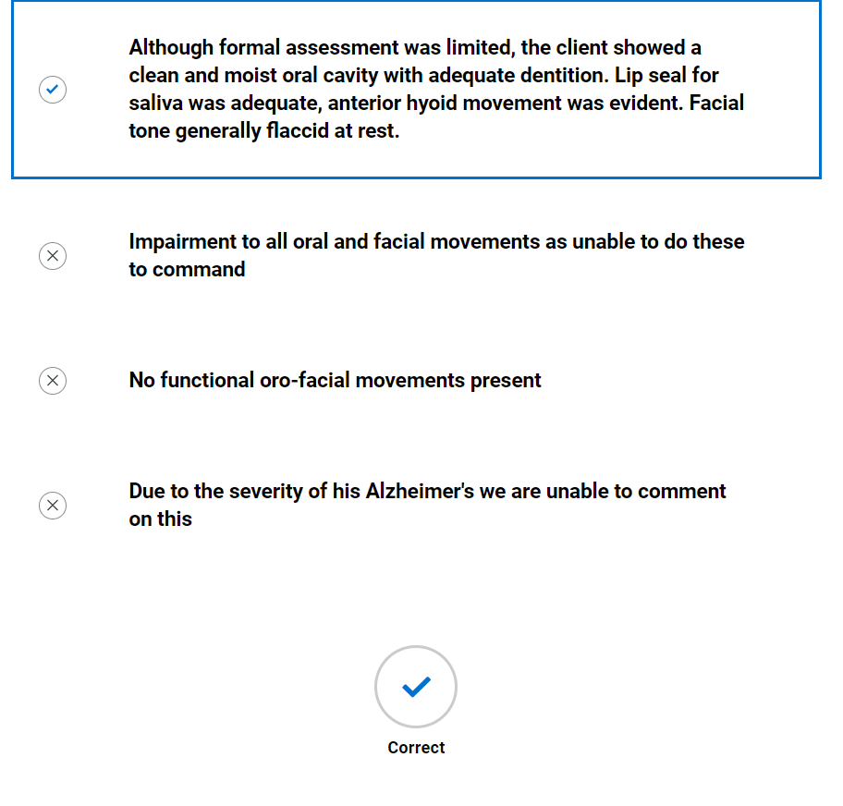

Assessment with diet and fluids
- Blank swallow exam form provided; student advised to try to complete whilst watching video of SLT. (They can print this or send to word document to complete – it is not scored) See appendix 3
- Video of SLT completing swallow exam
- SLT completed swallow exam, student prompted to compare to theirs
Swallow exam
 |  | Trial 1 | Trial 2 | Trial 3 | Trial 4 | Trial 5 | Trial 6
Pre-oral | Bolus description (IDDSI level) | IDDSI level 0 Tea | IDDSI level 4 smooth mousse | IDDSI level 4 smooth mousse | IDDSI level 5 minced and moist | IDDSI level 6 soft and bite sized | IDDSI level 7 easy to chew sponge and custard
 | Manoeuvres/ strategies | None | None | None | None | None | None
 | Advice | None | None | Reduce rate of feeding, allow client to swallow twice for every mouthful before giving next one | Reduce rate of feeding, allow client to swallow twice for every mouthful before giving next one | Reduce rate of feeding, allow client to swallow twice for every mouthful before giving next one | Reduce rate of feeding, allow client to swallow twice for every mouthful before giving next one
 | Volume and temperature | Warm but no burn risk | 1/2 small pot  Cold | 1/2 small pot  Cold | ½ mashed banana | ½ banana | Warm, small portion
 | Position of client | Sat upright in chair | Sat upright in chair | Sat upright in chair | Sat upright in chair | Sat upright in chair | Sat upright in chair
 | Head and  trunk control, lip closure at rest | No concerns | No concerns | No concerns | No concerns | No concerns | No concerns
 | Assistance required e.g., position/ role/  perspective of carer (if being fed) | Carer sat in chair at side of client to feed. | Carer sat in chair at side of client to feed. | Carer sat in chair at side of client to feed. | Carer sat in chair at side of client to feed. | Carer sat in chair at side of client to feed. | Carer sat in chair at side of client to feed.
 | Level of alertness/fatigue and communicative ability | Alert, no verbal output | Alert, no verbal output | Alert, no verbal output | Alert, no verbal output | Alert, no verbal output | Alert, no verbal output
 | Utensil/ specialist feeding equipment | Normal cup | Metal teaspoon | Metal teaspoon | Silicone spoon | Silicone spoon | Silicone spoon
 | Feeding ability | Reliant on carer to feed | Reliant on carer to feed | Reliant on carer to feed | Reliant on carer to feed | Reliant on carer to feed | Reliant on carer to feed
Oral | Pace of feeding - observed or advised | Normal | Fast pace | Pacing following above advice | Pacing following above advice | Pacing following above advice | Pacing following above advice
 | Pre-oral behaviours | Opening mouth in anticipation of drink | Slow to open mouth to spoon | Opening mouth in anticipation of next spoonful | Opening mouth in anticipation of next spoonful | Opening mouth in anticipation of next spoonful | Opening mouth in anticipation of next spoonful
 | Bolus removal from utensil | Adequate | Complete | Complete but at times metal spoon bumping into dentition | Complete | Complete | Complete
 | Lip seal/anterior bolus control | Some minimal anterior oral leakage | Complete | Complete | Complete | Complete | Complete
 | Bite/suck | n/a | n/a | n/a | n/a | n/a | n/a
 | Oral manipulation of bolus (including chewing) | Some possible oral holding | Prolonged repetitive movement of bolus in mouth | Prolonged repetitive movement of bolus in mouth | Prolonged repetitive movement of bolus in mouth | Prolonged repetitive chewing | Very prolonged repetitive chewing
 | Changes to saliva | Nil | Nil | Nil | Nil | Nil | Nil
 | Nasal regurgitation | Nil | Nil | Nil | Nil | Nil | Nil
 | Timing of oral phase | Oral holding before swallow triggered | Oral holding before swallow triggered | Oral holding before swallow triggered | Oral holding before swallow triggered | Oral holding before swallow triggered | Oral holding before swallow triggered
 | Oral residue/ pocketing | Nil | Mild bilateral residue in sulci post 1st swallow | Mild bilateral residue in sulci post 1st swallow but cleared with spontaneous 2nd swallow | Mild bilateral residue in sulci post 1st swallow but cleared with spontaneous 2nd swallow | Mild bilateral residue in sulci post 1st swallow but cleared with spontaneous 2nd swallow | Large amounts of bilateral residue in sulci, not clearing by subsequent swallows/drinks
Pharyngeal | Swallow triggered – effort, number, elevation, excursion, timing | Swallow triggered with elevation and excursion evident, spontaneous second swallow for all sips | Swallow triggered with elevation and excursion, single swallow | Swallow triggered with elevation and excursion evident, spontaneous second swallow for all tsp | Swallow triggered with elevation and excursion evident, spontaneous second swallow for all tsp | Swallow triggered with elevation and excursion evident, spontaneous second swallow for all tsp | Multiple swallows triggered for single bolus, laryngeal elevation, and excursion evident
 | Respiration changes | Nil | Nil | Nil | Nil | Nil | Nil
 | Voice quality e.g., wet/breathy | No change | No change | No change | No change | No change | No change
 | Globus | n/a | n/a | n/a | n/a | n/a | n/a
 | Cough/ throat clearing - (presence, strength, duration) | Nil | Strong cough | Nil | Nil | Nil | Nil
 | Prompts - verbal and physical | Nil | Nil | Nil | Nil | Nil | Prompted by carer to swallow and physical stroking under chin
Oesophageal | Eructation/ belching | Nil | Nil | Nil | Nil | Nil | Nil
 | Regurgitation/ reflux | Nil | Nil | Nil | Nil | Nil | Nil
 | Other including sticking sensation, pain | Nil | Nil | Nil | Nil | Nil | Nil
Other | Altered reflexes | Nil | Nil | Nil | Nil | Nil | Nil
 | Other, including signs of distress (eye watering, colour changes) | Nil | Carer appears to be giving him the next spoonful before he is ready. Red in face, possible eye watering | Nil | Nil | Nil | Sips of IDDSI level 0 did not help to clear oral residue

- Knowledge check (not scored)
On which trial did the client show overt signs of aspiration?
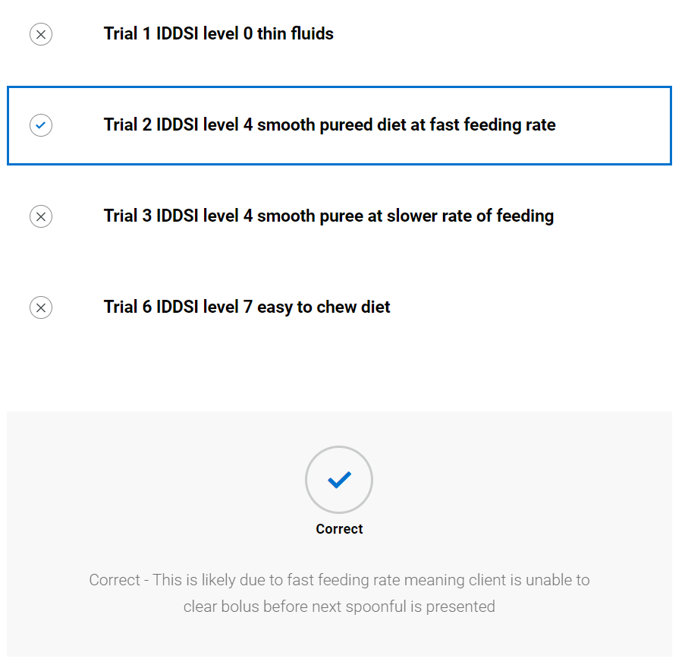

On which consistency does the client show the longest oral phase with the inability to clear oral residue?
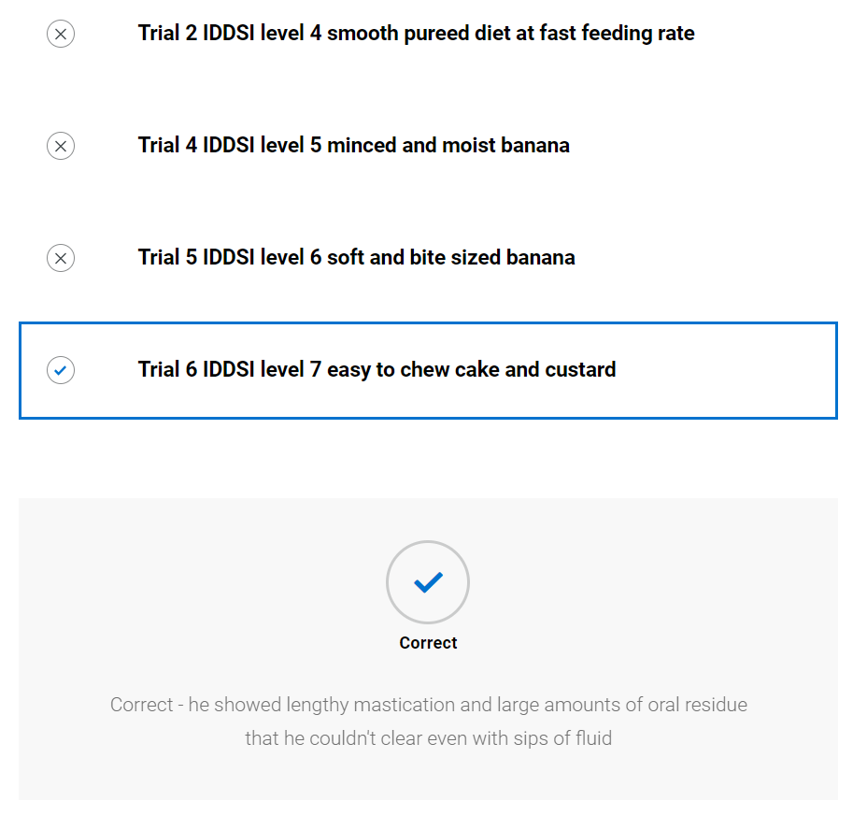

Swallow hypothesis and management plan
- Video of SLT summarising client and forming working hypothesis and management plan
- Completed hypothesis and management plan available to view along with TOMs
Swallow hypothesis and management
Describe the key characteristics of each stage of swallowing
 | Pre-oral | Oral | Pharyngeal | Oesophageal
Brief summary | Unable to self-feed | Prolonged, repetitive tongue movements when chewing, oral residue | Requiring two swallows per bolus otherwise coughing | Nil observed
Intervention proposed | Fed by Carer but education as to feed slowly and allow 2 swallows per bolus, ensure bolus cleared from mouth before continuing | IDDSI level 6 diet  IDDSI level 0 fluids from open cup  Feed via maroon spoon to avoid damage to teeth | Allow two swallows per bolus | n/a
Rationale/ evidence | Unable to feed self | Significant oral residue in mouth on IDDSI level 7a easy to chew diet which he was unable to clear. Cognitively unable to use any strategies to clear this | Possible pharyngeal or oral residue that needs additional swallow to clear | n/a

Eating drinking and swallowing difficulties secondary to

Main causes of EDS difficulties
Advanced dementia

Their EDS difficulties are also impacted by the following concomitant factors:

Concomitant factor | Impact
Staff were feeding too quickly | For diet, this did not give him enough time to clear any possible oral or pharyngeal residue which may have then been aspirated or penetrated the upper airway

Diagnosis : This client presents with a pre-oral, oral and pharyngeal dysphagia.

Therapy Outcome Measures (For paediatrics please use paediatric TOM)
Measure | Score
Impairment | 3
Activity | 4
Participation | 0
Well-being/ Distress | 4
Management plan
- IDDSI level 0 normal fluids from open cup
- IDDSI level 6 soft and bite sized diet from maroon spoon
- Carer to feed ensuring sat at eye level, feed slowly, ensure has swallowed twice for every diet bolus, check mouth for any oral residue and ensure cleared before next spoonful given
- Ensure sat upright and alert for all diet/fluids
- Staff to disseminate this information to other people within the care home
- SLT to update wife on plan and ensure he is happy with it
- SLT to review in 2 weeks or sooner if contacted by wife or care home
- Carers to be alert for any signs of distress whilst eating/drinking e.g. coughing, eye watering, shortness of breath; and contact SLT if this occurs
- SLT advises that all staff complete online dysphagia training available on eLearning for health

  - Video of SLT feeding back to client
  - Knowledge check (not scored)

Why did the speed at which the carer was feeding impact on Jim's swallowing? Select all that apply
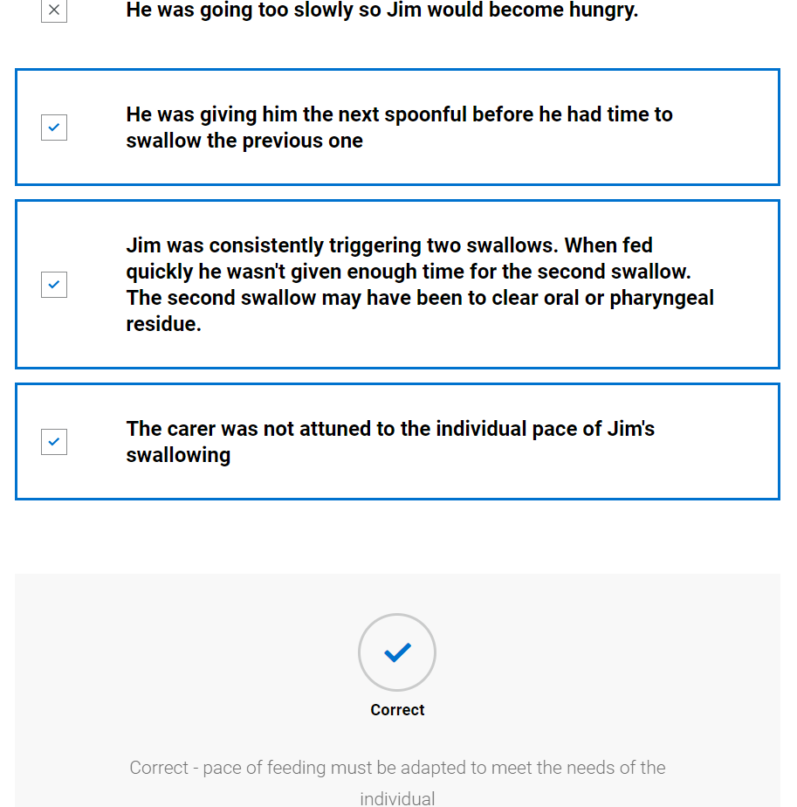

Which phases of swallowing did Jim have difficulty with? Select all that apply
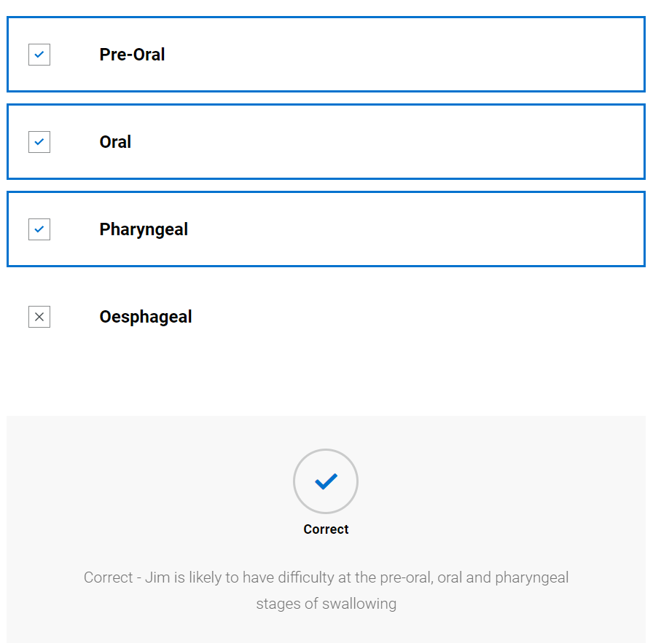

Ongoing management

Multidisciplinary management
- Video of SLT and MDT – discussion between district nurse and SLT, highlights safeguarding concern that staff are not following recommendations and discussion as to whether urinary infections are related to swallowing
- Knowledge check (not scored)
Why did the SLT consult with the district nurse about Jim's case? Select all that apply.
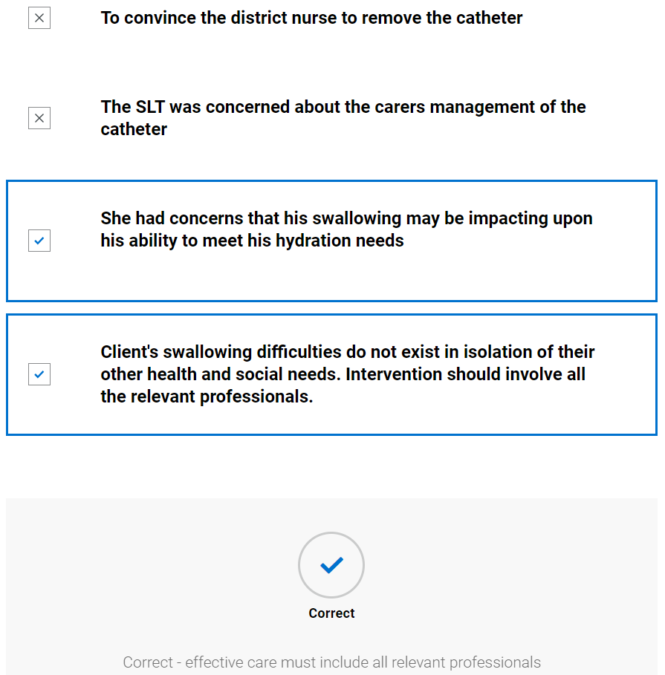

Review
- Blank swallow exam form provided; student advised to try to complete whilst watching video of SLT. (They can print this or send to word document to complete – it is not scored) See appendix 3
- Video of SLT completing swallow review and feeding back to carer
- SLT completed swallow review, student prompted to compare to theirs
Recording sheet for swallowing assessment
 |  | Trial 1 | Trial 2 | Trial 3
Pre-oral | Bolus description (IDDSI level) | 0 normal thin tea | 6 soft and bite sized | 7 easy to chew sponge and custard
 | Manoeuvres/strategies | Nil | Nil | Nil
 | Advice | Nil | Reduce rate of feeding, allow client to swallow twice for every mouthful before giving next one | Reduce rate of feeding, allow client to swallow twice for every mouthful before giving next one
 | Volume and temperature | Warm but no burn risk | ½ banana | Warm, small portion
 | Position of client | Sat upright in chair | Sat upright in chair | Sat upright in chair
 | Head and trunk control, lip closure at rest | No concerns | No concerns | No concerns
 | Assistance required e.g., position/role/perspective of carer (if being fed) | Carer sat in chair at front of client to feed. | Carer sat in chair at front of client to feed. | Carer sat in chair at front of client to feed.
 | Level of alertness/fatigue and  communicative ability | Alert, no verbal output | Alert, no verbal output | Alert, no verbal output
 | Utensil/ specialist feeding equipment | Normal open cup | Silicon spoon | Silicon spoon
 | Feeding ability | Reliant on carer to feed | Reliant on carer to feed | Reliant on carer to feed
 | Pace of feeding – observed or advised | Normal | Pacing following above advice | Pacing following above advice
 | Pre-oral behaviours | Opening mouth in anticipation of drink | Opening mouth in anticipation of next spoonful | Not opening mouth for next spoonful? due to lengthy oral phase and inability to clear
Oral | Bolus removal from utensil | Adequate | Complete | Complete
 | Lip seal/anterior bolus control | Some minimal anterior oral leakage | Complete | Complete
 | Bite/suck | n/a | n/a | n/a
 | Oral manipulation of bolus (including chewing) | Adequate | Prolonged repetitive chewing | Very prolonged repetitive chewing
 | Changes to saliva | Nil | Nil | Nil
 | Nasal regurgitation | Nil | Nil | Nil
 | Timing of oral phase | Oral holding before swallow triggered | Oral holding before swallow triggered | Oral holding before swallow triggered
 | Oral residue/ pocketing | Nil | Mild bilateral residue in sulci post 1st swallow but cleared with spontaneous second swallow | Large amounts of bilateral residue in sulci, not cleared by subsequent swallows
Pharyngeal | Swallow triggered – effort, number, elevation, excursion, timing | Swallow triggered with elevation and excursion evident, spontaneous second swallow for all sips | Swallow triggered with elevation and excursion evident, spontaneous swallow for all tsp | Multiple swallows triggered for single bolus, laryngeal elevation and excursion evident
 | Respiration changes | Nil | Nil | Nil
 | Voice quality e.g. wet/breathy | No change observed but no verbal output | No change observed but no verbal output | No change observed but no verbal output
 | Globus | Patient unable to report this due to advanced dementia | Patient unable to report this due to advanced dementia | Patient unable to report this due to advanced dementia
 | Cough/ throat clearing - (presence,  strength, duration) | Nil | Nil | Strong cough
 | Prompts - verbal and physical | Nil | Nil | Physical prompts to clear with little success
Oesophageal | Eructation/ belching | Nil | Nil | Nil
 | Regurgitation/ reflux | Nil | Nil | Nil
 | Other including sticking sensation, pain | Patient unable to report this due to advanced dementia | Patient unable to report this due to advanced dementia | Patient unable to report this due to advanced dementia
Other | Altered reflexes | None observed | None observed | None observed
 | Other, including signs of distress (eye watering, colour changes)

- Knowledge check (not scored)
What overt signs of aspiration does Jim show whilst having cake and custard?
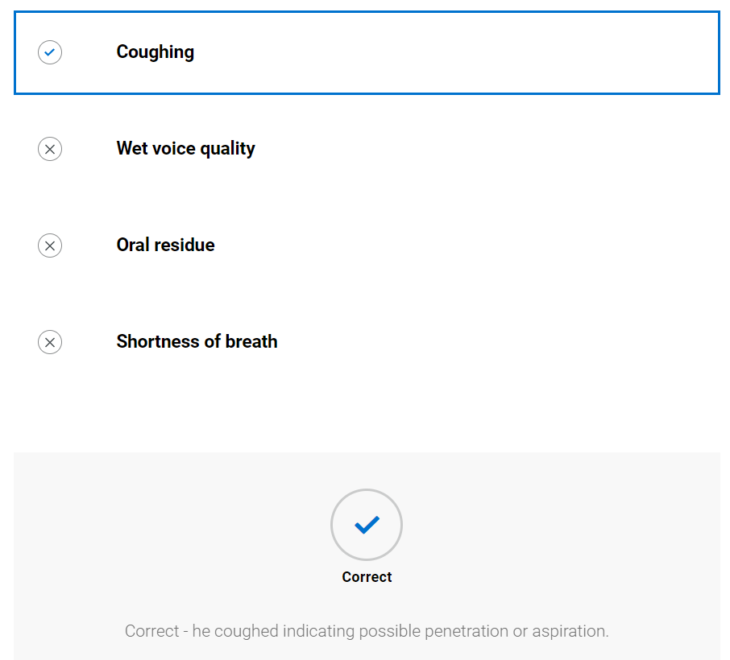

Jim completes multiple swallows whilst eating the easy to chew food. What could cause this? Select all that apply.
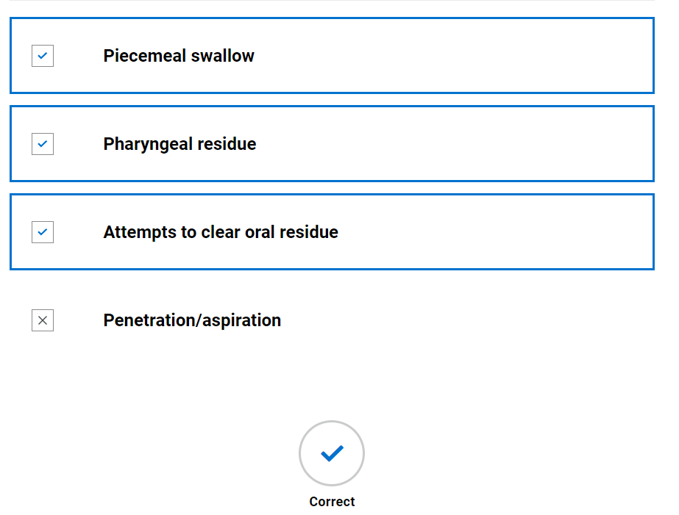

Safeguarding
- SLT piece to camera discussing safeguarding issue
Further Learning: When speech and language therapists visit care or nursing homes they may experience safeguarding concerns that are not as easily resolved as this scenario. It is important to understand local safeguarding procedures but also lessons learned from serious case reviews. Read the following series case review and consider the implications for a speech and language therapist: Department of health and social care (2012) Winterbourne View Hospital: Department of Health review and response. Available at: https://www.gov.uk/government/publications/winterbourne-view-hospital-department-of-health-review-and-response(opens in a new tab) [accessed 18 October 2022]
- Knowledge check (not scored)
Why did the SLT not put in a safeguarding alert?
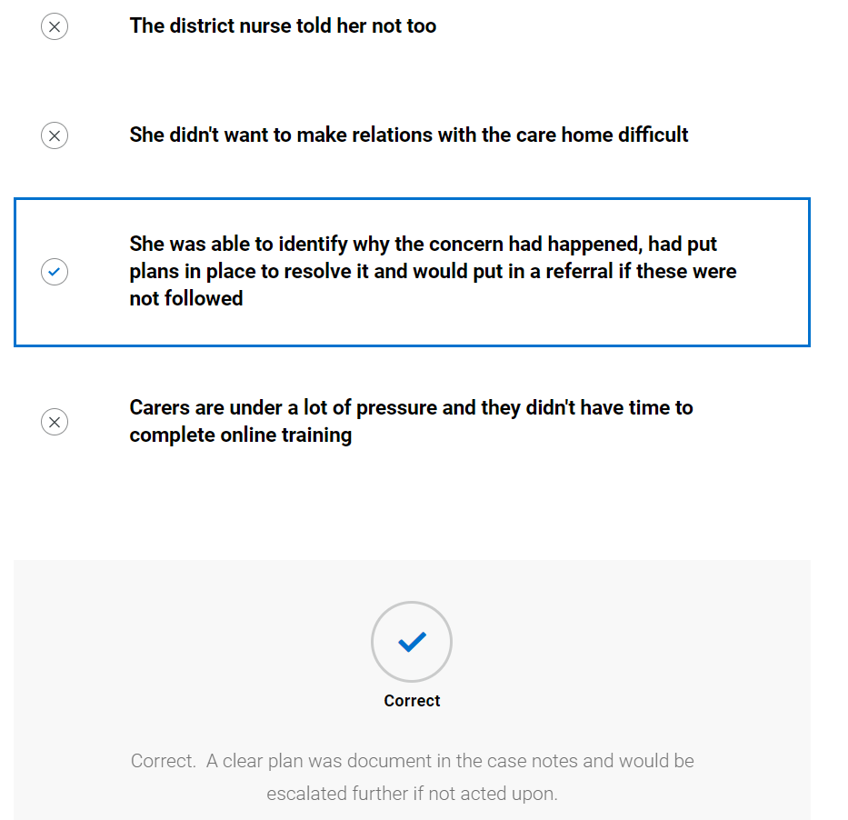

Discharge
- Video of SLT discussing discharge with client
- Copy of discharge report
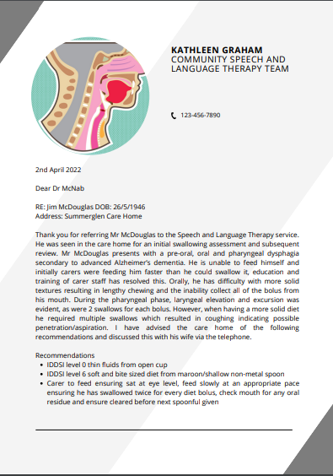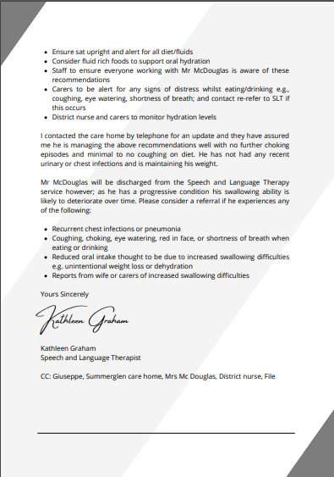

- Copy of final TOM’s – student to attempt to rescore

Therapy Outcome Measures – end of intervention

Measure | Score
Impairment | 4
Activity | 4
Participation | 0
Well-being/ Distress | 5

Further Learning: The SLT recommended the care home staff complete online learning in dysphagia management. Review the RCSLT (2020) Eating, Drinking and Swallowing Competency Framework. Available from: https://www.rcslt.org/wp-content/uploads/media/docs/EDSCF_UPDATED_FINAL.pdf(opens in a new tab) [Accessed 18 October 2022] and the associated eLearning https://www.e-lfh.org.uk/programmes/dysphagiaguide/(opens in a new tab) Consider how the effective use of this eLearning could impact on effective management of eating, drinking and swallowing difficulties.

- Knowledge check (not scored)
Why did the SLT discharge Mr McDouglas when he has a progressive condition which is likely to result in a deterioration in his swallowing in the future? Select all that apply.
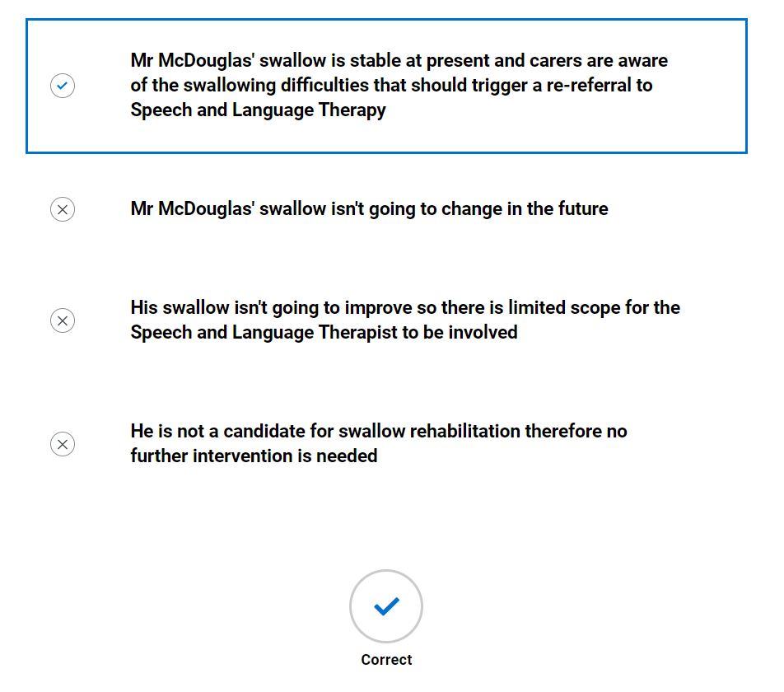

Case 3: Child – Kevin

Background information and planning initial assessment

Referral information
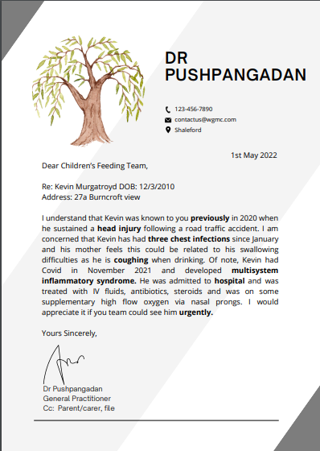
- Referral document provided with expanded information on key components
Previously – Kevin was previously seen by the service so should have previous records to refer to giving an idea of previous swallowing ability
Head injury – traumatic injury to the brain could have resulted in swallowing and communication difficulties
3 chest infections – recurrent chest infection may indicate aspiration of bolus or may be related to multisystem inflammatory syndrome
Coughing – this is an overt sign of penetration/aspiration indicating the bolus may be entering the upper airway or passing below the vocal cords
Multisystem inflammatory syndrome – a rare but serious condition associated with covid-19 where parts of the body become inflamed
Hospital – the severity of Kevin’s condition resulted in hospital admission where it appears his lungs were affected. This may have affected his swallowing
Urgently – the GP is concerned about Kevin and feels he should be seen urgently
- Knowledge check quiz (not scored)
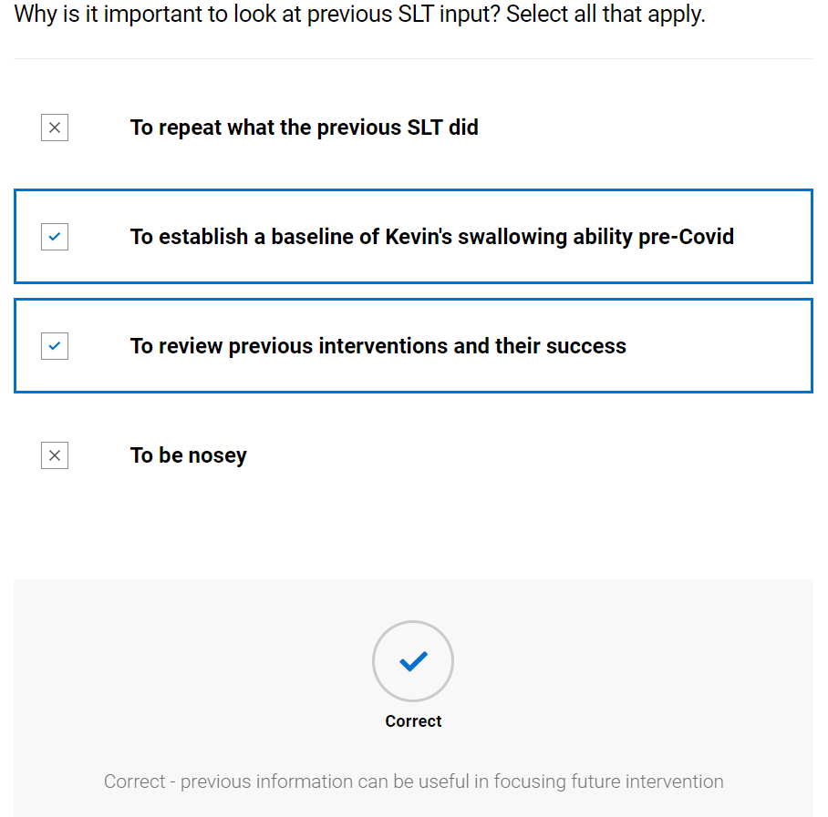
Further learning: Research the impact of traumatic brain injury on eating, drinking and swallowing in children. The following article is a good starting point: Dodrill, P. (2020) Chapter 14 - Disorders affecting feeding and swallowing in infants and children. In M.E. Groher & M.A. Crary (eds). Dysphagia: Clinical management in adults and children. (pp.279-312). Mosby.

Case note review
- Case note summary provided with expanded information on key components
Case notes
Past medical history
All vaccinations administered
Recurrent tonsillitis – removed at age 8
Traumatic brain injury secondary to road traffic accident 2020
Covid 19 2021
Multisystem inflammatory syndrome 2021
Chest infection January 2022
Chest infection March 2022
Chest infection April 2022

Previous SLT intervention
Kevin was referred to the acute paediatric SLT team following a road traffic accident causing a subarachnoid haemorrhage. This required a craniectomy. He was intubated and ventilated for 5 days. Trache inserted when became alert. Wean from trache over 7 days. Paediatric ICU staff concerned that coughing with solid diet and fluids, had NG in situ. Transferred to paediatric main ward. Initial clinical swallow assessment showed left sided facial weakness, with loss of fluids anteriorly. Voice was weak and horse with reduced breath support. Although swallow triggered there was minimal laryngeal movement and coughing on IDDSI level 0, 1, 2 and 3 fluids. Referred for videofluoroscopy which showed loss over base of tongue pre-swallow, swallow triggering when bolus reached pyriform sinuses, reduced airway protection. Bolus passes below level of vocal cords but was spontaneously ejected by coughing – Penetration/aspiration scale of 6. The aim of intervention was to increase safety of the swallow by the introduction of small amounts of oral tasters and re-evaluation over time. Kevin made steady progress and at the point of discharge was having IDDSI level 2 fluids and Normal diet avoiding mixed consistencies that contained thin fluids.

Current open referrals
Nil
Allergies and sensitivities
Erythromycin
Entries within the last 3 days on medical records
2nd May 2022 Seen in GP surgery with mum. Mum concerned that recurrent chest infections are because of his previous swallowing problem and would like referral to SALT. Agreed and sent
Triage information
Triage as urgent due to recurrent chest infections
Traumatic brain injury – a disruption to the normal functioning of the brain due to a violent and sudden impact. This results in a bleed in his brain where they needed to remove part of his skulls to reduce the impact of swelling on the brain
Covid 19 – This can impact on tastes, respiratory function and muscle reserve for swallowing ability
Multisystem inflammatory syndrome – a rare complication causing inflammation in parts of the body, for Kevin this was mainly respiratory
Chest infection – indicating possible aspiration or may be due to multisystem inflammatory syndrome
Intubated and ventilated – A breathing tube inserted through the airway into the lungs to assist mechanical ventilation. It can cause injury to the oral cavity, pharynx and larynx although every care is taken to reduce this.
Trache – The breathing tube is replaced by making an incision through the front lower section of the neck into the trachea; and placing a tube which sits exteriorly in the neck and interiorly in the trachea.
7 days – this is the length of time the team were attempting to wean Kevin from the breathing tube.
Coughing – possible overt clinical signs of penetration/aspiration
Left sided facial weakness – possible impairment to VII facial nerve
Videofluoroscopy – an x-ray filmed to show the anatomy and physiology of swallowing to guide management
Penetration/aspiration scale – a standardised scale used to explain the different degrees of penetration/aspiration
Discharge – Kevin is no longer under this service and his previous optimum was IDDSI level 2 mildly thick fluids and IDDSI level 7 regular diet avoiding mixed consistencies that contained liquids
Urgent – The SLT triaging has determined this meets the service criteria for an urgent referral

- Knowledge check (not scored)
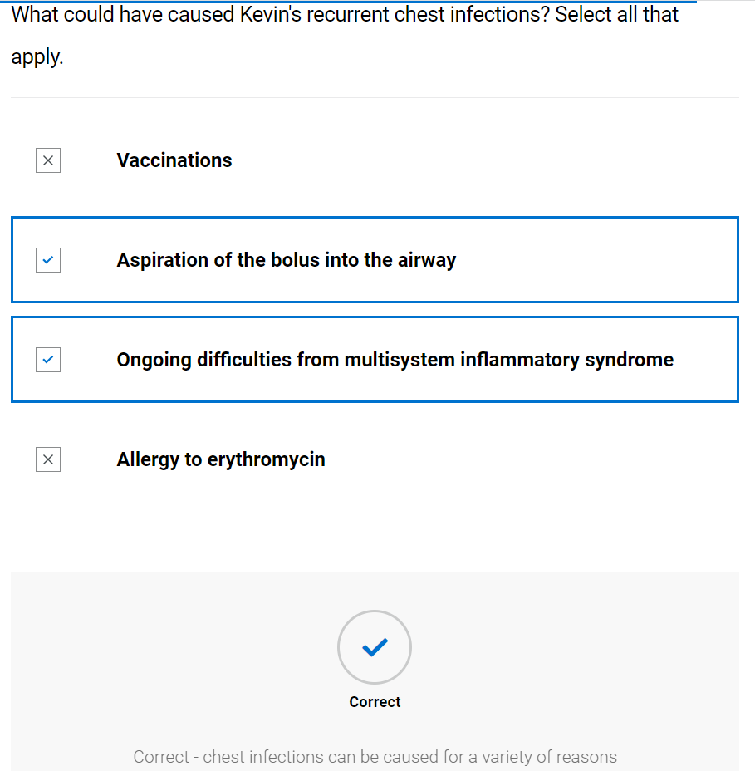
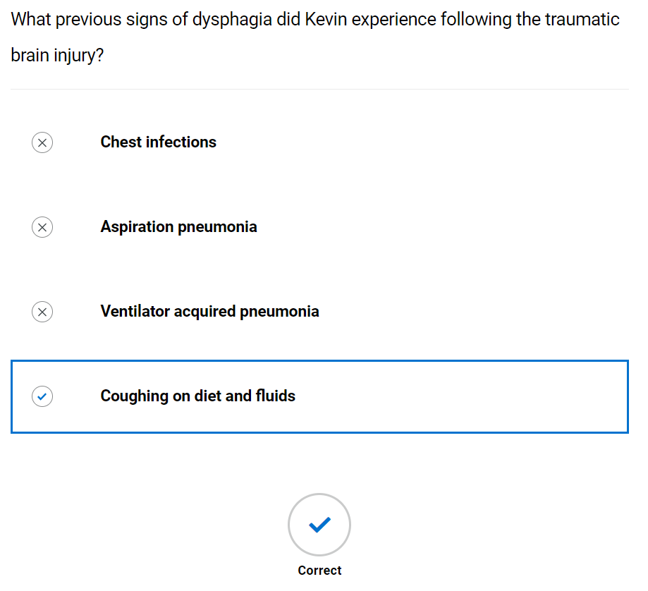

Initial assessment

Case history
- Blank case history form provided; student advised to try to complete whilst watching video of SLT. (They can print this or send to word document to complete – it is not scored) See appendix 1
- Video of SLT completing case history
- SLT completed case history, student prompted to compare to theirs
Speech and Language Therapy
Initial eating, drinking and swallowing case history
Demographics | Kevin Murgatroyd DOB: 12/3/2010  Address: 27a Burncroft view
Consent | Mum has consented
Assessment location and time | Home at 11 am
Reason for referral | Mum concerned recurrent chest infections may be related to previous swallowing problems
Legal information including:  - Advanced care planning  - Power of attorney  - Advanced directive  - Resuscitation status | Mum is single parent and has sole parental responsibility
Communication ability, including languages used | English speaker, some mild high level cognitive communication difficulties evident. Expressive and receptive language is mildly delayed in relation to age.
Mental capacity | Mum reports Kevin is involved in all his medical decisions
Safeguarding | No alert on system
Social history | Lives with mum and 3 younger siblings
Person with parental responsibility/ next of kin | Mum
Client/Carer expectations of intervention | Mum wants the chest infections to stop and is worried about him being admitted to hospital. Kevin states he just wants it to be easier to swallow and that he dislikes the thickener

Medical information
Past medical history including disorders of movement or tone | All vaccinations administered  Recurrent tonsillitis – removed at age 8  Traumatic brain injury secondary to road traffic accident 2020  Covid 19 2021  Multisystem inflammatory syndrome 2021  Chest infection January 2022  Chest infection March 2022  Chest infection April 2022
Current mental wellbeing | Kevin said he is worried he is falling behind at school because he missed so much time because he was unwell and that he always struggles a bit. Has 1:1 classroom support for 10 hours per week
Main diagnosis/presenting condition | New deterioration of dysphagia since multisystem inflammatory syndrome
Level of frailty | Mobile with mild left sided weakness to arm and left
Prognosis including Gold standards framework

Sensory impairment  - Sight, hearing, touch, smell, taste  - Reaction to sensation  - Reflexes | Kevin reports that sometimes he struggles when the classroom is noisy, and he can’t concentrate
Multidisciplinary involvement | Under SENCO at school as mild cognitive impairment and physical difficulties since RTA
Medication | Nil
Sensitivities and allergies | Erythromycin
Reflux (for adults see RSI below) | No symptoms of reflux

History/Background of Dysphagia
Onset | Mum reports that he has always had an occasional cough when eating/drinking since the RTA but that since he came home from hospital after Multisystem inflammatory syndrome, he is coughing a lot more and has had lots of chest infections
Duration | 5 months
Stability/progression | Mum feels it got better when she put him back on thickener
Social and psychosocial impact of difficulties | Mum is finding it hard to juggle his ill health with work and the younger kids. She is really worried he will be ill again.  Kevin states that he is embarrassed by coughing when he eats but he is also embarrassed having to put thickener in his drinks as it makes him feel different
Avoidance
Client/carer description | Kevin reports it feels like they go down ok but then make him cough
Significant swallowing events
Cultural aspects affecting EDS | None reported
Mealtime routine | Has breakfast before school at kitchen table, mum says he is a really slow eater plus she can’t get him off his phone. Has lunch at school, Kevin says all his friends finish first so he doesn’t eat everything so he can finish when they do. Mum reports he is really hungry when he gets home from school and has a large snack then his evening meal
Enjoyment of meals | Kevin reports he loves food especially burger and chips
Current oral intake | IDDSI level 2 mildly thick fluids and IDDSI level 7 normal diet avoiding mixed consistencies where there is a liquid element
Mental health/wellbeing of client and carer | Kevin reports he feels fine and that his mum worries about everything

Respiration
Chest status (current and history) | Recurrent chest infections, 3 in last 6 month but nil between discharge from SLT and developing covid
Breathing pattern at rest | Normal
Cough | No cough at rest
Oxygen/ventilatory requirements | On room air

Environment, skills, and behaviours
Positioning | Able to maintain upright position independently
Skin integrity | No reported concerns
Feeding skills | Self-feeding. Is right-handed. Struggles to use left hand to cut things but swaps knife into right hand
Equipment/utensil used | Regular cutlery
Environments in which client eats/drinks | Home, school, restaurants
Behaviours or sensory challenges/issues around eating/drinking/mealtimes

Nutrition and hydration
Nutrition and hydration status prior to assessment | No concerns from Kevin or mum
Weight/BMI/MUST/ Growth and development | Mum reports she doesn’t weigh him regularly but that he looks a similar weight and height to his peers and doesn’t appear to have lost any weight
Urinary output | No concerns
Faecal output | No concerns

GRBASI – unable to complete as no speech production observed
Component and description | 0 - normal | 1 - slight | 2 - moderate | 3 - severe
Grade - degree of hoarseness of voice | X
Roughness - impression of irregularity of vibration of vocal folds | X
Breathiness - degree to which air escaping from between the vocal folds can be heard by the examiner | X
Asthenia - degree of weakness heard in the voice | X
Strain - extent to which strain or hyperfunctional use of phonation is heard | X
Instability - changes in voice quality over time | x
Total |  |  |  | 0
Further Learning: Kevin discontinued thickener against advice/without reassessment but did not have any adverse impacts until his Covid-19 infection. Consider what protective factors Kevin might have. You may find the following article a useful starting point: Pavithran, J., MS, Puthiyottil, I. V., Narayan, M., Vidhyadharan, S., Menon, J. R., MS, & Iyer, S. (2018) Observations from a pediatric dysphagia clinic: Characteristics of children at risk of aspiration pneumonia. The laryngoscope, 129 (11), p2614-2618"
- Knowledge check (not scored)
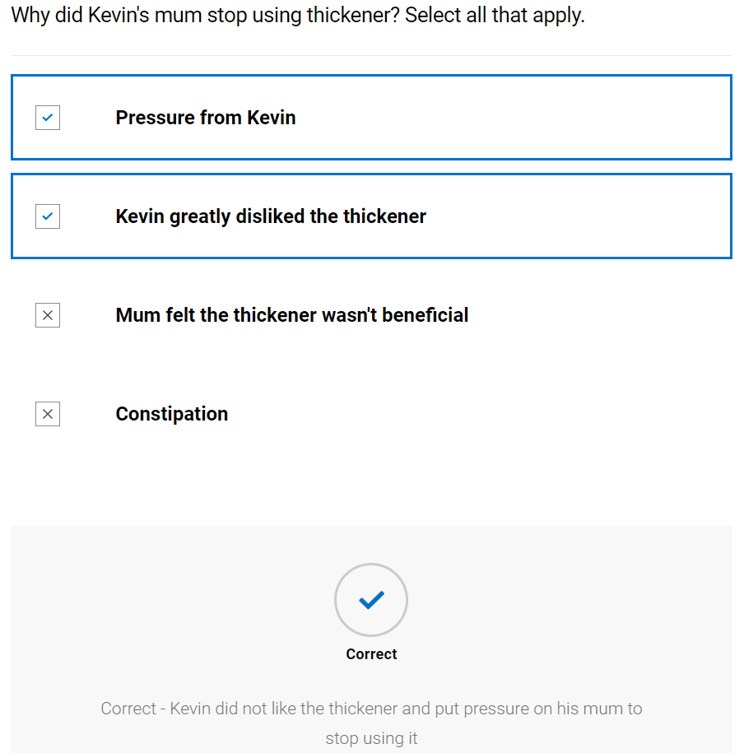
Did the withdrawal of thickener have a negative impact on Kevin's respiratory health?
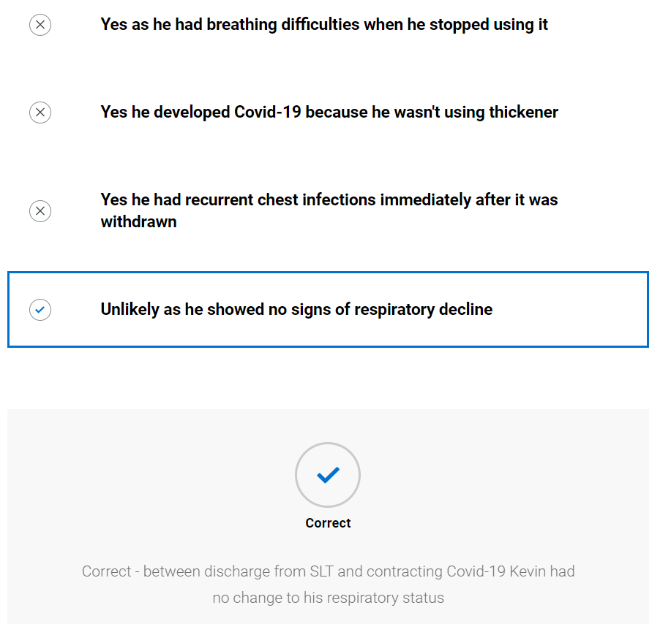

Oro-facial exam
- Blank oro-facial exam form provided; student advised to try to complete whilst watching video of SLT. (They can print this or send to word document to complete – it is not scored) See appendix 2
- Video of SLT completing case history
- SLT completed oro-facial exam, student prompted to compare to theirs
Oro-facial assessment for clients with eating, drinking and swallowing difficulties
Mouth care and dentition -
Area | Comment
Dentures | Nil
Dentition | Own dentition
Lips | Pink and moist
Tongue | Pink and moist
Gums | Pink and moist
Cheeks | Pink and moist
Palate - Hard and soft | Pink and moist
Under tongue | Pink and moist
Skin integrity | Good
Level of support for oral care | Full support needed
Saliva | Within normal limits

Cranial nerve assessment - comment on range, rate, accuracy, and strength
Nerve and function - | Possible ways to assess | Observations | Outcome
V Trigeminal –  Conveys sensation to the face and motor to the soft palate, pharynx, and muscles of mastication | 1. Tissue or cotton to nostrils should produce wrinkling of nose  2. Clench teeth and palpate masseter and temporalis muscles for bulk  3. Strength of masseter and temporalis by jaw opening – against resistance of therapist hand  4. Observation of uvula – indicating weakness of tensor veli palantini  5. Palpate dry swallow for hyoid movement |  | 1.Slightly reduced response to left hand side  2. within normal limits  3. Within normal limits  4. Within normal limits  5. Hyoid movement felt during dry spontaneous swallows possibly reduced
VII Facial – sensation (taste) to anterior 2/3 of tongue, soft palate and motor function of facial muscles | 1. Taste – sweet (sugar), sour (lemon swab) or salty (salt)  2. Facial symmetry  3. Raise eyebrows - frontalis  4. Open and close eyes (orbicularis oculi)  5. Pretend to blow candles (orbicularis oris)  6. Puff cheeks out (buccinators) then try to push air out whilst keeping lips sealed (orbicularis oris). Can gently press on cheeks to check the strength of lip seal.  7. Close eyes and therapist will gently brush their finger on L+R side of face (forehead, cheek, chin) and ask them to tell you/point where they feel sensation | Changes to facial expression  Blinking  Awareness of anterior loss of saliva  Lip movements during speech/vocalisations/mouthing | - Not assessed  - Symmetrical at rest  - Complete  - Complete  - Slight left sided weakness  - Slight left sided weakness with mild air escape  - Reduced sensation on left side
IX Glossopharyngeal – Sensation to posterior 1/3 tongue, soft palate, pharynx and motor to pharynx | 1. Gag reflex – NB the formal assessment of this is a controversial area within SLT and is not used by all SLT’s | Presence/absence of gag during observation including hyper and hyposensitivity | Not assessed
X Vagus – sensation to trachea, larynx, pharynx and motor to soft palate, larynx, and pharynx. (also, oesophageal motility and upper oesophageal sphincter opening and closure) | 1. Observe palatal movement when saying “ah” or “ah ah ah”  2. Posterior pharyngeal wall gag - NB the formal assessment of this is a controversial area within SLT and is not used by all SLT’s  3. Voice quality – breathy or hypernasal possible bilateral weakness  4. Hoarse voice – unilateral weakness  5. Throat clear/cough on command | Voice quality  Coughing at rest | - Complete  - Not assessed  - Within normal limits  - Not hoarse  - Strong cough
XI Accessory – motor to shoulder, neck and soft palate | 1. Shrug shoulders up and stop therapist from pushing them down. Check symmetry and power  2. Head turn to right, stop me pushing it back – feel right sternocleidomastoid. Repeat on left | Observation of head, neck and shoulder movement.  Head control | - Complete  - Complete
XII Hypoglossal – motor function to tongue | 1. Tongue protrusion  2. Push tongue into cheek, push into cheek against SALT finger. Tongue deviates to side of lesion  3. Observe for presence/absence of tongue fasciculations | Tongue movement during speech/vocalisations/mouthing  Tongue movement in response to bolus | - Full protrusion  - Full movement  - No fasciculations
- Knowledge check (not scored)
Which of the following was apparent from the assessment?
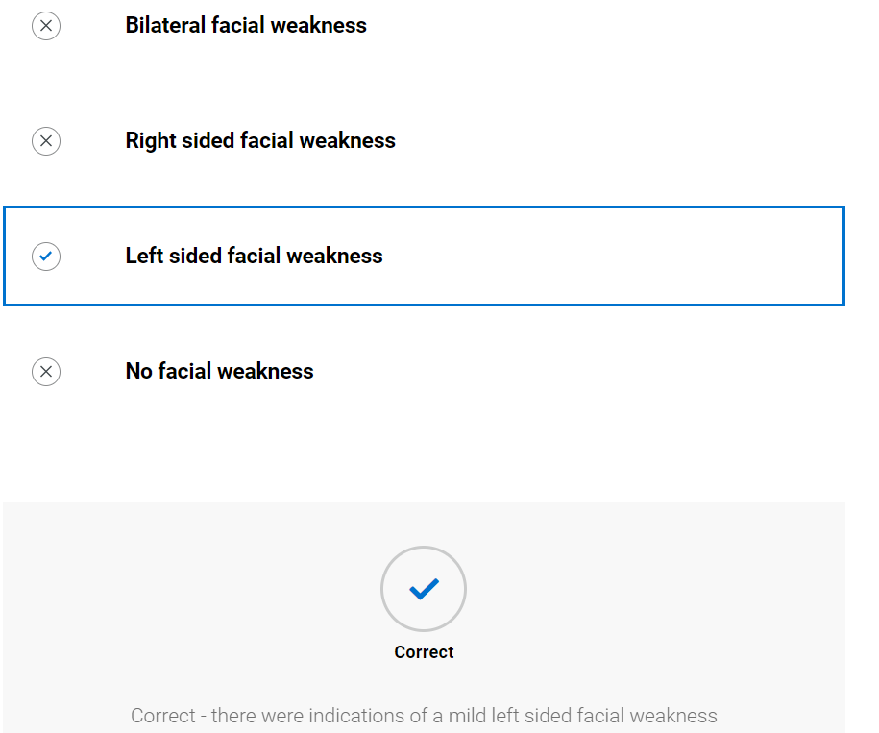

Assessment with diet and fluids
- Blank swallow exam form provided; student advised to try to complete whilst watching video of SLT. (They can print this or send to word document to complete – it is not scored) See appendix 3
- Video of SLT completing swallow exam
- SLT completed swallow exam, student prompted to compare to theirs
Swallow exam
 |  | Trial 1 | Trial 2 | Trial 3 | Trial 4 | Trial 5 | Trial 6
Pre-oral | Bolus description (IDDSI level) | IDDSI level 0 | IDDSI level 0 | IDDSI level 1 fluids | IDDSI level 1 fluids | IDDSI level  7 biscuits | IDDSI level  7 mixed consistencies
 | Manoeuvres/ strategies | Nil | Small sips with effortful swallow | Nil | Small sips with effortful swallow | Nil | Nil
 | Advice | Nil | As above | Nil | As above | Nil | Nil
 | Volume and temperature | Room temperature, 50 mls | Room temperature, 50mls | Room temp, 50mls | Room temp, 50mls | Room temperature | Room temperature with cold milk, ½ bowl
 | Position of client | Sat upright in chair | Sat upright in chair | Sat upright in chair | Sat upright in chair | Sat upright in chair | Sat upright in chair
 | Head and  trunk control lip closure at rest | No concerns | No concerns | No concerns | No concerns | No concerns | No concerns
 | Assistance required e.g., position/role/  perspective of carer (if being fed) | Nil | Nil | Nil | Nil | Nil | Nil
 | Level of alertness/fatigue and communicative ability | Alert and communicative throughout | Alert and communicative throughout | Alert and communicative throughout | Alert and communicative throughout | Alert and communicative throughout | Alert and communicative throughout
 | Utensil/ specialist feeding equipment | Open cup | Open cup | Open cup | Open cup | Finger feeding | Regular spoon
 | Feeding ability | Self-feeding no concerns | Self-feeding no concerns | Self-feeding no concerns | Self-feeding, no concerns | Self-feeding, no concerns | Self-feeding, no concerns
 | Pace of feeding - observed or advised | Within normal limits | Within normal limits | Within normal limits | Within normal limits | Within normal limits | Within normal limits
 | Pre-oral behaviours | Nil | Nil | Nil | Nil | Nil | Nil
Oral | Bolus removal from utensil | Complete | Complete | Complete | Complete | Complete | Complete
 | Lip seal/anterior bolus control | Good lip seal | Good lip seal | Good lip seal | Good lip seal | Good lip seal | Good lip seal
 | Bite/suck | n/a | n/a | n/a | n/a | Appropriate bite and tear | n/a
 | Oral manipulation of bolus (including chewing) | Appeared appropriate | Appeared appropriate | Appeared appropriate | Appeared appropriate | Lengthy mastication | Lengthy mastication
 | Changes to saliva | Nil | Nil | Nil | Nil | Nil | Nil
 | Nasal regurgitation | Nil | Nil | Nil | Nil | Nil | Nil
 | Timing of oral phase | Appeared appropriate | Appeared appropriate | Appeared appropriate | Appeared appropriate | Prolonged due to lengthy mastication | Prolonged due to lengthy mastication
 | Oral residue/ pocketing | Nil | Nil | Nil | Nil | Nil | Nil
Pharyngeal | Swallow triggered – effort, number, elevation, excursion, timing | Multiple swallows, laryngeal elevation and excursion palpated possibly reduced | 2 swallows per bolus, laryngeal elevation and excursion palpated possibly reduced | 2 swallows per bolus, laryngeal elevation and excursion palpated but poss reduced | 2 swallows per bolus, laryngeal elevation and excursion palpated but poss reduced | 2 swallows per bolus, laryngeal elevation and excursion palpated but poss reduced | Multiple swallows, laryngeal elevation and excursion palpated possibly reduced
 | Respiration changes | Nil | Nil | Nil | Nil | Nil | Nil
 | Voice quality e.g. wet/breathy | No change | No change | No change | No change | No change | No change
 | Globus | Nil reported | Nil reported | Nil reported | Nil reported | Nil reported | Nil reported
 | Cough/ throat clearing - (presence, strength, duration) | Extensive coughing | Delayed cough | Delayed cough | Nil | Nil | Extensive coughing
 | Prompts - verbal and physical | Nil | Nil | Nil | Nil | Nil | Nil
Oesophageal | Eructation/ belching | Nil | Nil | Nil | Nil | Nil | Nil
 | Regurgitation/ reflux | Nil | Nil | Nil | Nil | Nil | Nil
 | Other including sticking sensation, pain | Nil | Nil | Nil | Nil | Nil | Nil
Other | Altered reflexes | Nil | Nil | Nil | Nil | Nil | Nil
 | Other, including signs of distress (eye watering, colour changes) | Nil | Nil | Nil | Nil | Nil | Nil

- Knowledge check (not scored)
What strategies did the SLT use to reduce the risk of penetration/aspiration? Select all that apply.
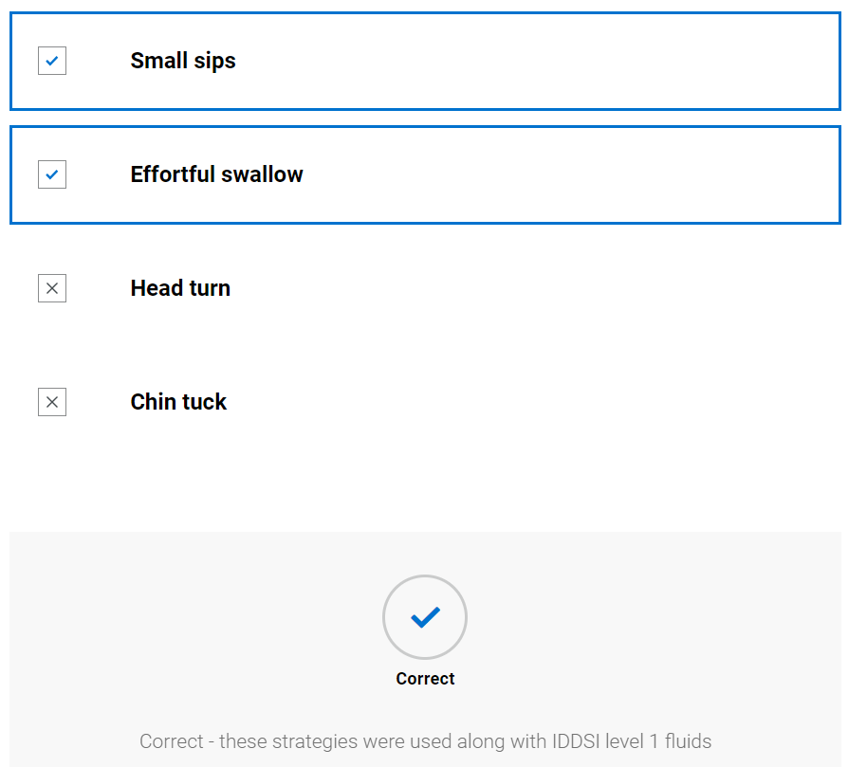

Kevin completed multiple swallows per bolus. What could this indicate?
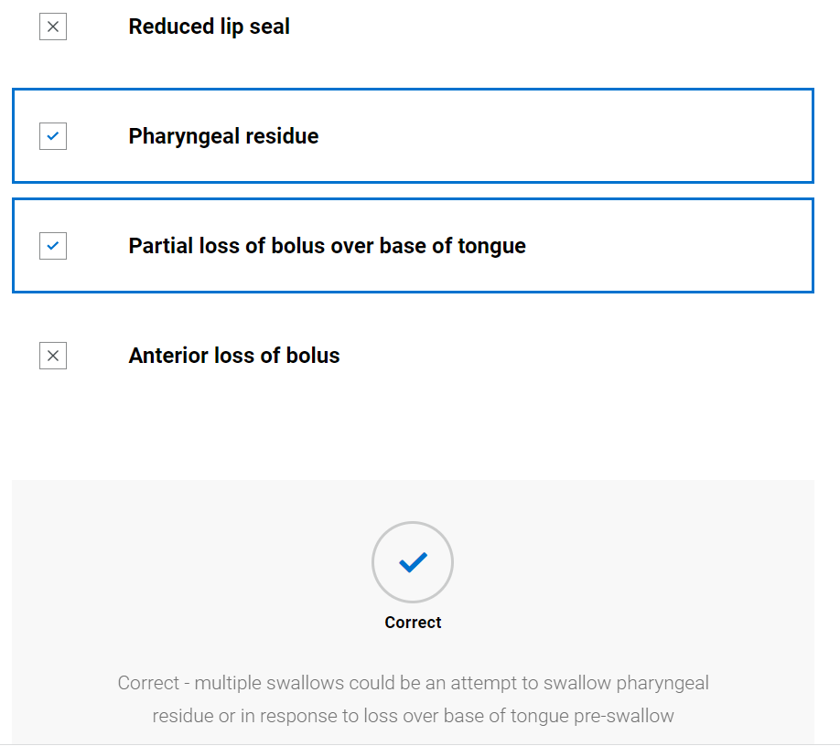

Swallow hypothesis and management plan
- Video of SLT summarising client and forming working hypothesis and management plan
- Completed hypothesis and management plan available to view along with TOMs
Swallow hypothesis and management
Describe the key characteristics of each stage of swallowing
 | Pre-oral | Oral | Pharyngeal | Oesophageal
Brief summary | Difficulty using left hand to cut but compensates well | Prolonged mastication for diet, possible loss over base of tongue pre-swallow (as this was seen on previous VF’s) | Difficulty with fluids, multiple swallows, possible reduced laryngeal elevation and excursion | Nil observed
Intervention proposed | Nil | IDDSI level 7 normal diet avoiding mixed consistencies. IDDSI level 1 fluids with small sips and effortful swallow. | IDDSI level 1 fluids, small sips and effortful swallow | n/a
Rationale/ evidence | n/a | It is important to Kevin that he “fits in” with his peers, therefore SLT attempting to balance safest consistency with one that is acceptable to Kevin. Thickened fluids may help to reduce loss of bolus over base of tongue pre swallow by increased oral transit time. | Overt signs of aspiration on IDDSI level 0. Thickened fluids to act as interim measure until can be seen for Videofluoroscopy | n/a

Eating drinking and swallowing difficulties secondary to
Main causes of EDS difficulties
Possible exacerbation of pre-existing dysphagia from traumatic head injury, by acute episode of ill health – multisystem inflammatory syndrome

Their EDS difficulties are also impacted by the following concomitant factors:
Concomitant factor | Impact
Social impact of swallowing difficulties | Kevin is embarrassed by his difficulties and is reluctant to do anything that makes him appear different to his peers

This client presents with a pre-oral, oral and pharyngeal dysphagia.
Therapy Outcome Measures – paediatric dysphagia
Measure | Score
Impairment | 3
Activity | 4
Participation | 4
Well-being/ Distress | 3.5

Management plan
- IDDSI level 1 slightly thickened fluids from open cup, small sips and effortful swallow
- IDDSI level 7 normal diet avoiding consistencies with mixed liquids
- SLT to update school on plan
- SLT to refer for videofluoroscopy
- Mum and Kevin to be alert for any signs of distress whilst eating/drinking e.g., coughing, eye watering, shortness of breath; and contact SLT if this occurs
- SLT discusses the use of naturally thicker fluids to avoid Kevin feeling different from his peers at school

Discussion: The SLT has suggested one possible management technique (thickener). What other intervention/adaptions could she have trialled? Kevin has a history of refusing thickener. Do you think he will use it this time? What could the SLT have done to increase cooperation in using thickener? Kevin indicates that he did not have a videofluoroscopy previously, however we can see he did have one from his notes. Why do you think he doesn't remember it? How could the SLT have engaged Kevin more in the decision-making process around management options? From the information gathered to date, do you think Kevin may have ongoing cognitive communication difficulties? If so, how could the SLT raise this concern?

- Video of SLT feeding back to client

- Knowledge check (not scored)
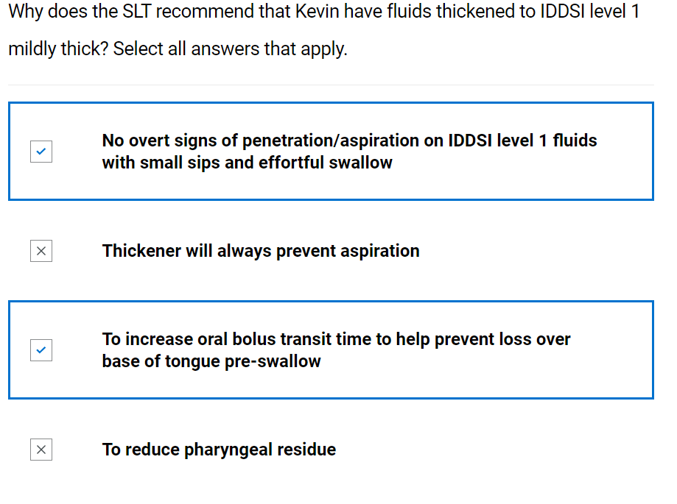
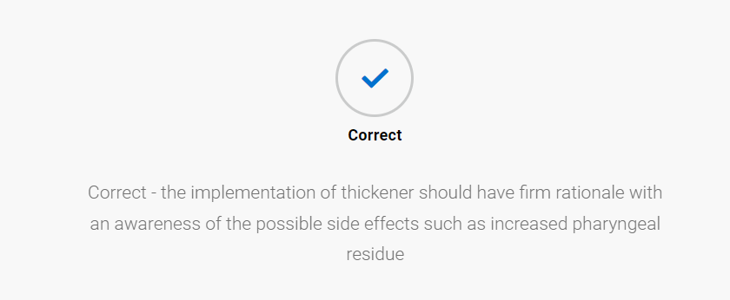
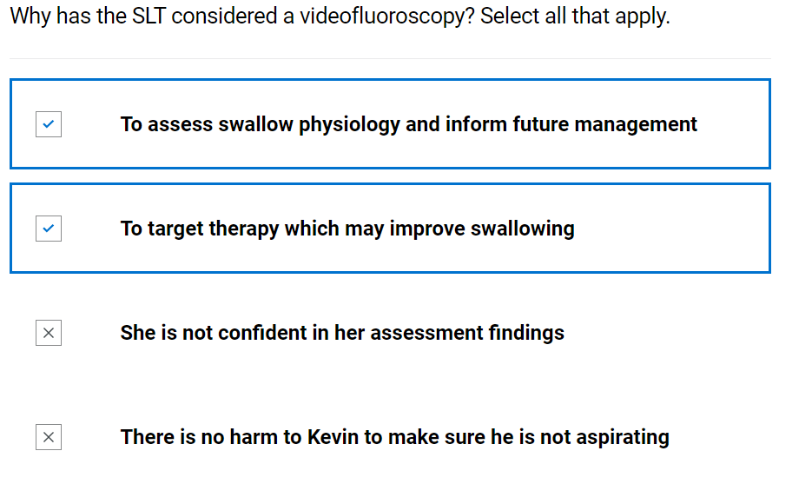
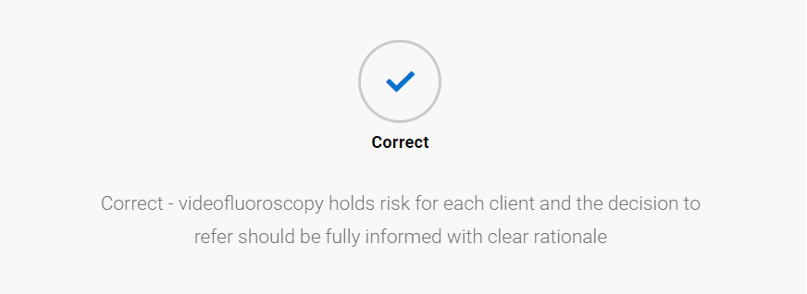

Ongoing management

The multidisciplinary team
- Video of SLT and MDT – discussion with Kevin’s teaching assistant
- Knowledge check (not scored)
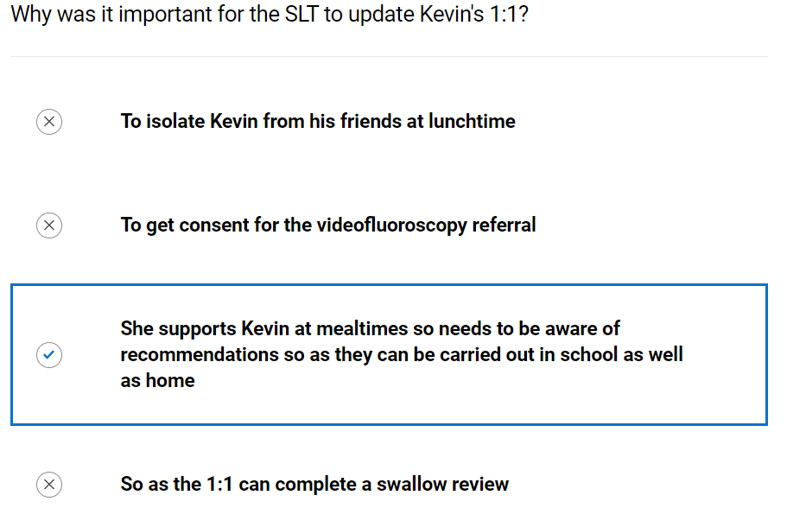
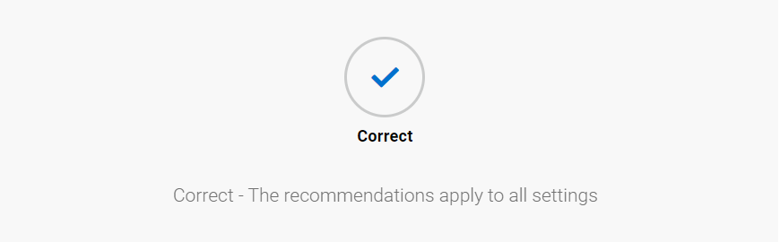

Swallow therapy
- Video of SLT feeding back videofluoroscopy results and implementing swallow therapy
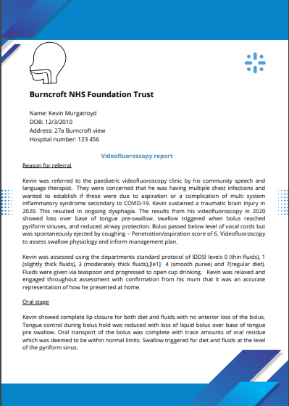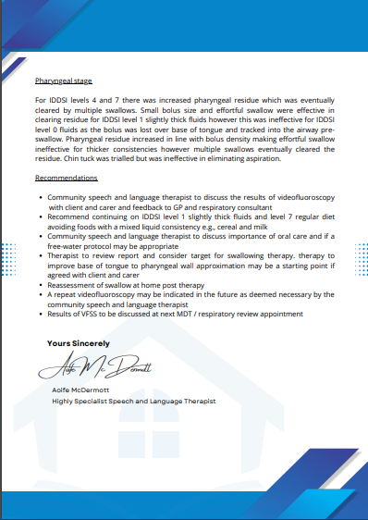
Further Learning: The videofluoroscopy report recommends consideration of a free water protocol. Research what this protocol entails and how it may have been used in this case. You may find the following article a useful starting point: Panther, K. (2005) The Frazier free water protocol. Perspectives on Swallowing and Swallowing Disorders. Dysphagia, 14, 4-9.

Discussion: Within eating, drinking and swallowing difficulties, SLTs use a lot of technical terms which may be difficult for the carer or client to understand. What alternatives to this terminology could you use? Practise feeding back results to a peer or relative who has no medical background. Is there anything further that could support their understanding? Research apps and digital learning aids that could support the information provided.
- Knowledge check
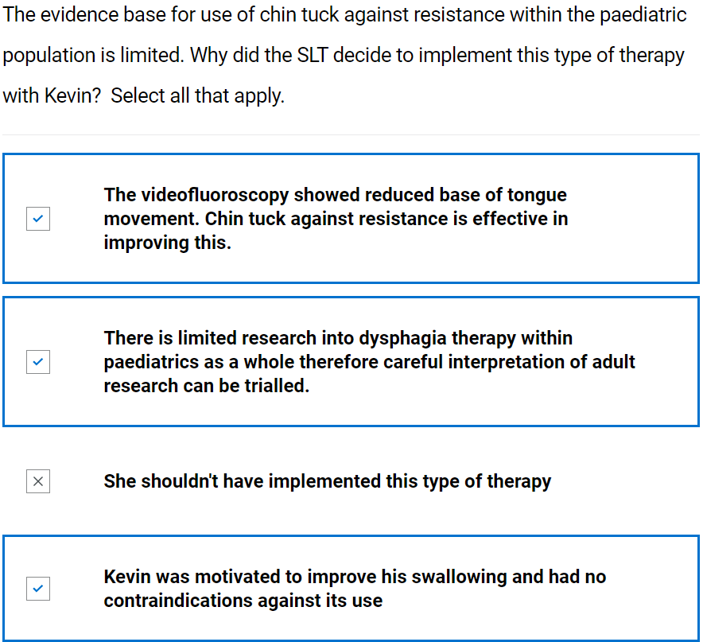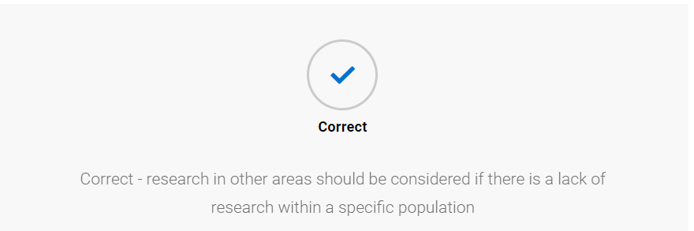

Swallow review
- Blank swallow exam form provided; student advised to try to complete whilst watching video of SLT. (They can print this or send to word document to complete – it is not scored) See appendix 3
- Video of SLT completing swallow review and feeding back to carer
- SLT completed swallow review, student prompted to compare to theirs
Swallow review
 |  | Trial 1 | Trial 2
Pre-oral | Bolus description (IDDSI level) | IDDSI level 0 | IDDSI level 7 mixed consistency
 | Manoeuvres/ strategies | Nil | Nil
 | Advice | Nil | Nil
 | Volume and temperature | 100mls room temperature | ½ small bowl, cold milk
 | Position of client | Sat upright in chair | Sat upright in chair
 | Head and  trunk control lip closure at rest | No concerns | No concerns
 | Assistance required e.g., position/role/  perspective of carer (if being fed) | Nil | Nil
 | Level of alertness/fatigue and communicative ability | Alert and communicative | Alert and communicative
 | Utensil/ specialist feeding equipment | Normal cup | Regular cutlery
 | Feeding ability | Self-feeding | Self-feeding
 | Pace of feeding - observed or advised | Slow single sips spontaneously | Slow pace spontaneously
 | Pre-oral behaviours | Nil | Nil
Oral | Bolus removal from utensil | Adequate | Complete
 | Lip seal/anterior bolus control | Complete | Complete
 | Bite/suck | n/a | n/a
 | Oral manipulation of bolus (including chewing) | Some oral holding before swallow triggered | Lengthy mastication
 | Changes to saliva | Nil | Nil
 | Nasal regurgitation | Nil | Nil
 | Timing of oral phase | Oral holding before swallow triggered | Oral holding before swallow triggered
 | Oral residue/ pocketing | Nil | Nil
Pharyngeal | Swallow triggered – effort, number, elevation, excursion, timing | Swallow triggered with elevation and excursion evident, spontaneous second swallow for all sips | Swallow triggered with elevation and excursion evident, spontaneous second swallow
 | Respiration changes | Nil | Nil
 | Voice quality e.g. wet/breathy | No change | No change
 | Globus | Nil reported | Nil reported
 | Cough/ throat clearing - (presence, strength, duration) | Nil | Nil
 | Prompts - verbal and physical | Nil | Nil
Oesophageal | Eructation/ belching | Nil | Nil
 | Regurgitation/ reflux | Nil | Nil
 | Other including sticking sensation, pain | Nil | Nil
Other | Altered reflexes | Nil | Nil
 | Other, including signs of distress (eye watering, colour changes) | Nil | Nil

- Knowledge check (not scored)

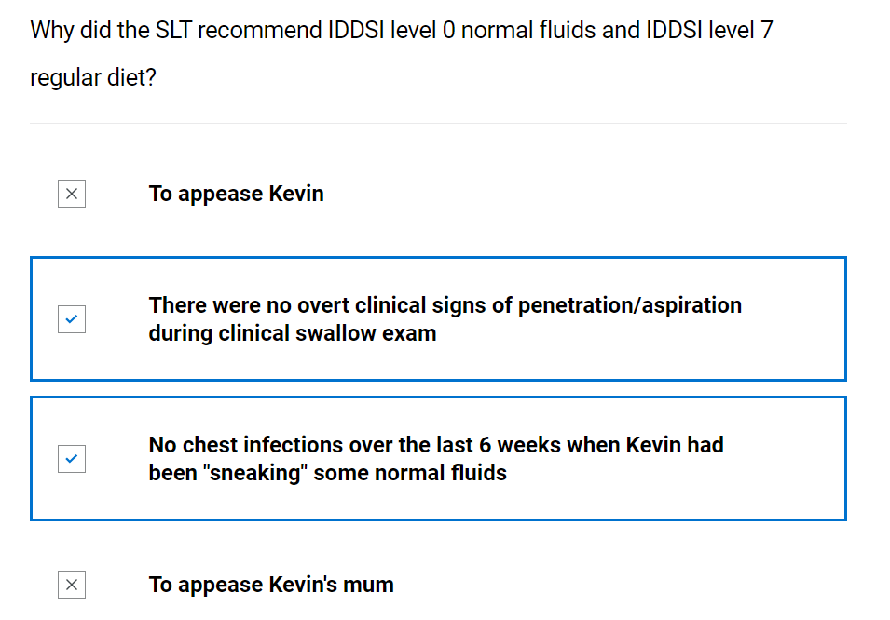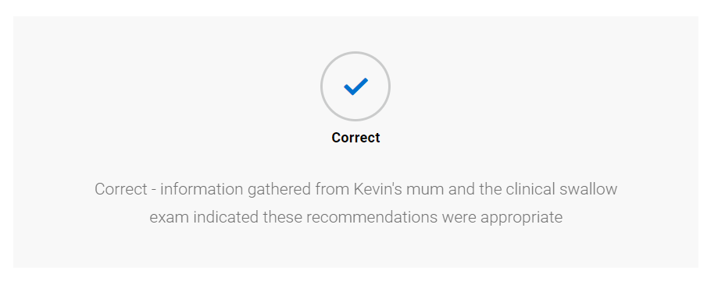

Safeguarding
- SLT piece to camera discussing safeguarding issue
- Knowledge check (not scored)
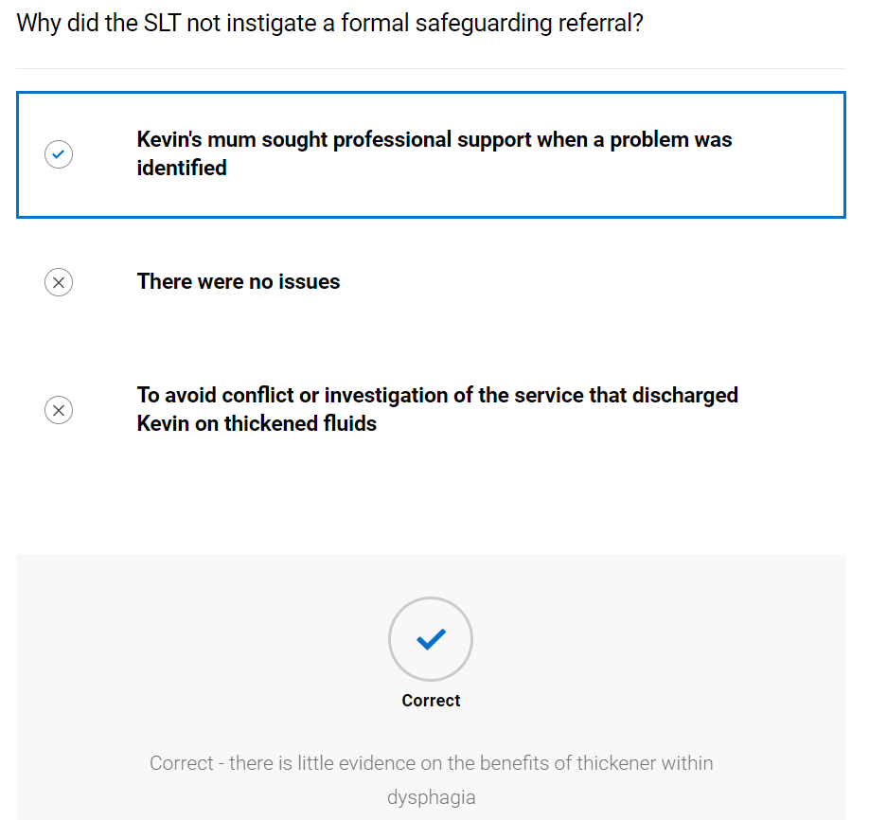

Discharge
- Video of SLT discussing discharge with client
- Copy of discharge report
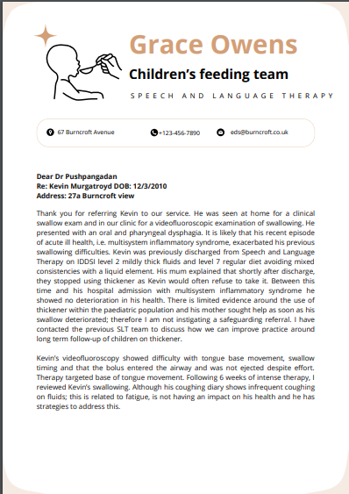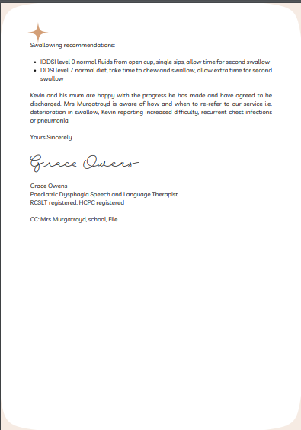

- Copy of final TOM’s – student to attempt to rescore

Therapy Outcome Measures – paediatric dysphagia – end of intervention

Measure | Score
Impairment | 4
Activity | 5
Participation | 5
Well-being/ Distress | 5
- Knowledge check (not scored)
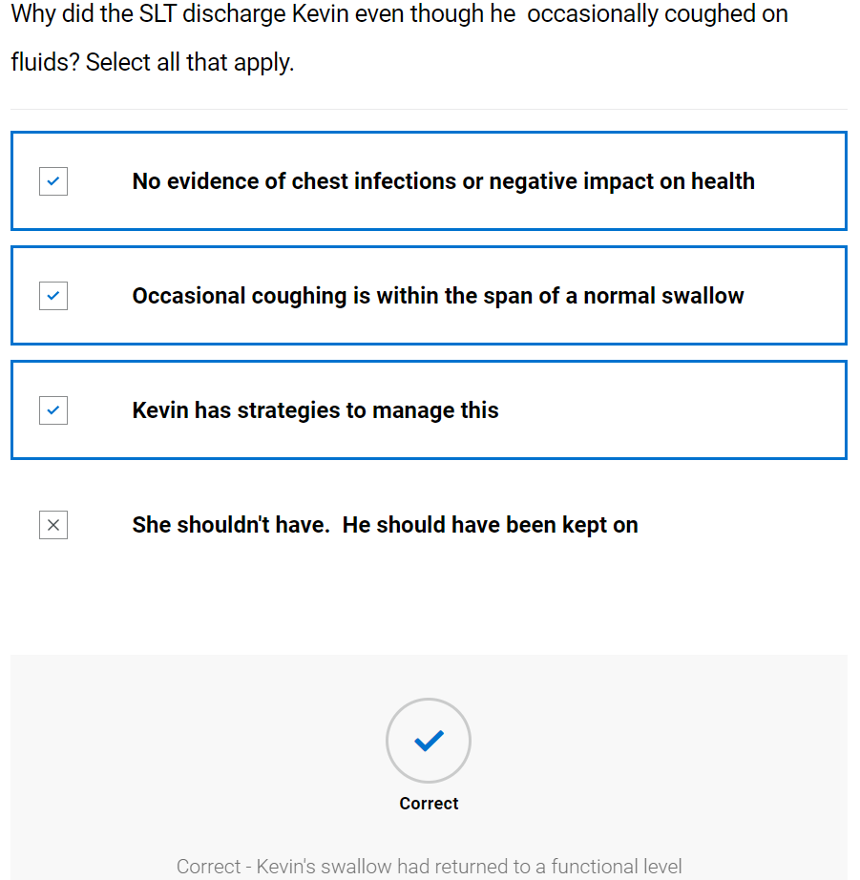

Case 4: Child – Charlotte

Background information and planning initial assessment

Referral information
- Referral document provided with expanded information on key components
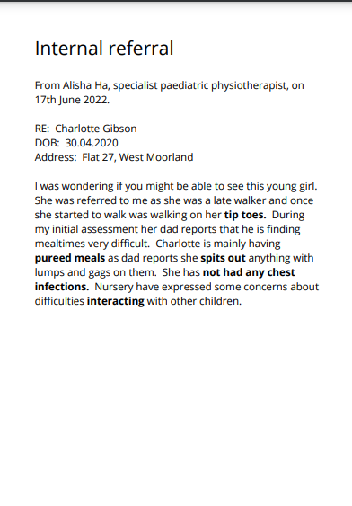

Tip toes – There are many possible reasons for this including Autistic Spectrum disorder
Pureed meals – At 2, Charlotte should have progressed beyond pureed meals. They are unlikely to meet her nutrition requirements
Spits out – Indicating possible oral aversion to texture
Not had any chest infections – No apparent respiratory impact from swallowing difficulties
Interacting – This may be an indication of difficulties with social interaction which would support a possible diagnosis of Autistic Spectrum Disorder however there may be other causes. She may need communication and swallowing intervention
- Knowledge check quiz (not scored)
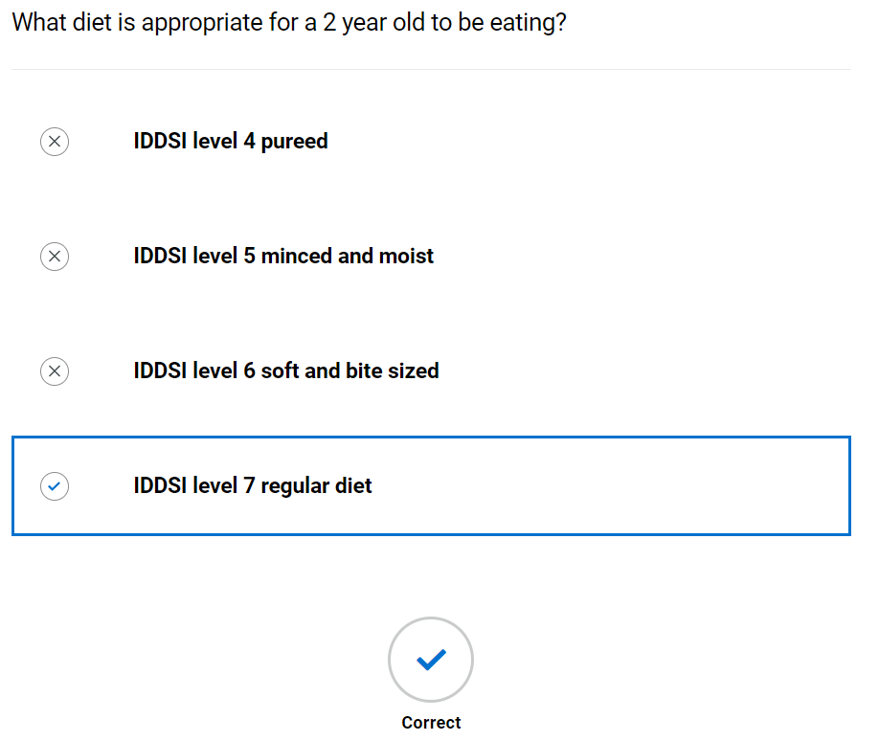

Case note review
- Case note summary provided with expanded information on key components

Case notes
Past medical history
Born pre-term at 32 + 2 weeks. Initially needed respiratory support and showed jaundice. Feeding tube in place for 4 weeks but slowly weaned onto bottle feeding then breast feeding
Previous SLT intervention
Seen by SLT in NICU to support development of suck swallow. Dummy used with introduction of expressed breast milk via slow flow teat. Managing all intake orally for 2 weeks prior to discharge from NICU with appropriate weight gain. Discharged from neonatal SLT
Current open referrals
Physiotherapist- late walker and walking on tip toes
Allergies and sensitivities
Cow’s milk protein allergy
Entries within the last 3 days on medical records
Nil
Triage information
Triage as routine

Pre-term – Charlotte was born before 37 weeks of pregnancy were completed
Respiratory support – pre-term infants often need respiratory support as their lungs have not fully developed before they are born
Feeding tube – A tube which is usually inserted through the mouth or nose directly into the stomach to feed
Suck swallow – The ability to move the tongue and mouth to achieve suction to bring milk into the mouth to swallow it
Dummy – These can be used for non-nutritive sucking to help strengthen the sucking action
Slow flow – a teat where there is a smaller hole which allows less milk to flow from it which reduces the bolus size
All oral intake – swallow progressed to the stage that she was able to meet all her nutrition requirements orally i.e. she no longer needed a feeding tube
Physiotherapist – The physiotherapist is involved due to walking difficulties and has made the referral
Cow’s milk protein allergy – this will affect which foods and liquids she can drink and may affect growth in some children
Further Learning: The SLT is an important member of the NICU team. To find out more visit the following eLearning: https://www.e-lfh.org.uk/programmes/small-wonders/
- Knowledge check (not scored)
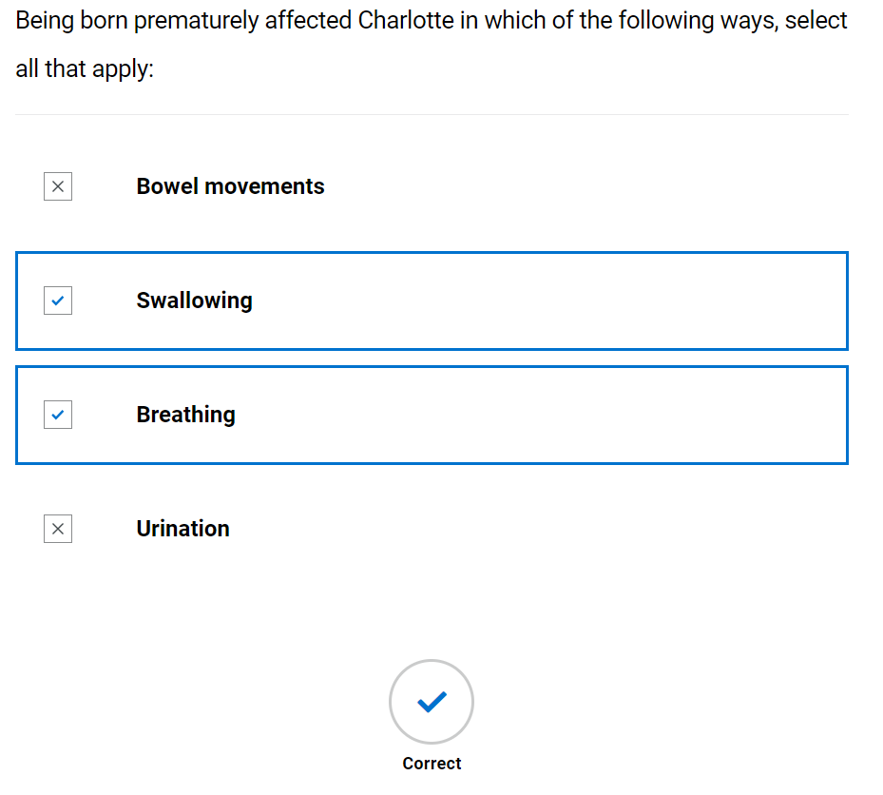
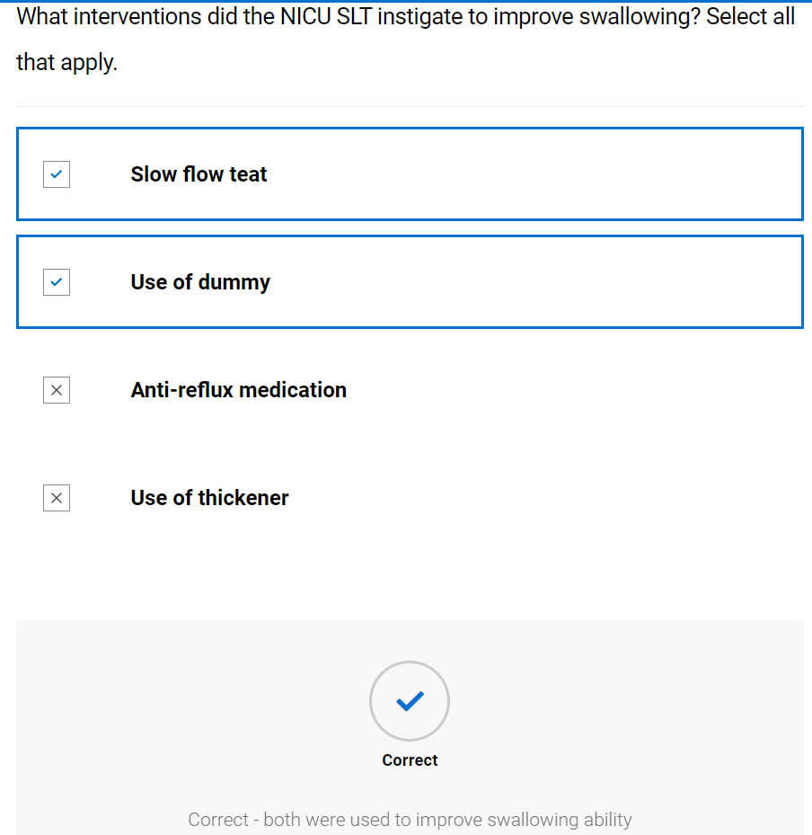

Initial assessment

Case history
- Blank case history form provided; student advised to try to complete whilst watching video of SLT. (They can print this or send to word document to complete – it is not scored) See appendix 1
- Video of SLT completing case history
- SLT completed case history, student prompted to compare to theirs
Speech and Language Therapy
Initial eating, drinking and swallowing case history
Demographics |  | Charlotte Gibson  30.04.2020  Flat 27, West Moorland
Consent |  | Dad has consented
Assessment location and time |  | Home at 2pm
Reason for referral |  | Dad expressed concerns during initial physiotherapy appointment that mealtimes are difficult. Charlotte will spit out anything that is lumpy or gags on it
Legal information including:  - Advanced care planning  - Power of attorney  - Advanced directive  - Resuscitation status |  | Dad is a single parent as mum passed away when Charlotte was a year old due to breast cancer.
Communication ability, including languages used |  | English speaker, nursery report some concerns interacting with peers to health visitor but that she is still settling in, all interactions appropriate today. Dad feels this is because of the lockdowns and the fact that she is an only child
Mental capacity
Safeguarding |  | No alert on system
Social history |  | Mum had thought lumps in breast were due to breast feeding so had a late diagnosis of stage 4 breast cancer. Charlotte lives with dad with some support from his parents. Dad reports he feels guilty that her swallowing problems are his fault as he didn’t focus enough on weaning, but that there was so much happening with his wife’s health at the time he was struggling to cope.
Person with parental responsibility/ next of kin |  | Dad
Client/Carer expectations of intervention |  | Dad wants to be able to enjoy having meals together and not worry about how much she is going to eat. He wants her to eat a healthy range of foods
Medical information
Past medical history including disorders of movement or tone | All vaccinations administered  Born pre-term at 32 + 2 weeks. Initially needed respiratory support and showed jaundice. Feeding tube in place for 4 weeks but slowly weaned onto bottle feeding and then breast feeding  Meeting milestones later i.e. walking, babble, fine motor
Current mental wellbeing | No concerns
Main diagnosis/presenting condition | Unclear
Level of frailty | n/a
Prognosis including Gold standards framework | n/a
Sensory impairment  - Sight, hearing, touch, smell, taste  - Reaction to sensation  - Reflexes | Dad reports that she struggles in noisy environments and will cover her ears.
Multidisciplinary involvement | Under specialist paediatric physiotherapist, under Paediatrician for routine follow-up due to being pre-term. Was previously known to dietitians due to cow milk protein allergy but discharged now
Medication | Nil
Sensitivities and allergies | Dairy products – vomiting. Has confirmed cow’s milk protein allergy
Reflux (for adults see RSI below) | Dad reports that sometimes she will bring up mouthfuls of diary free milk after she has finished a full bottle at night

History/Background of Dysphagia
Onset | Dad reports that she was initially easy to wean onto puree baby foods and had a good appetite. He reports he kept her on puree until she was 18 months old due to social situation and when he introduced food with lumps she started gagging and he hasn’t been able to progress.
Duration | 6 months
Stability/progression | Dad feels it hasn’t got any worse, but he is aware that her peers are eating a variety of foods and she is not
Social and psychosocial impact of difficulties | Dad reports that he spends so much time trying to encourage and plead with her to eat that he often doesn’t have time to eat himself and becomes upset with situation
Avoidance | Dairy products
Client/carer description | Dad feels she can’t swallow anything lumpy and is worried it is related to being premature. He started weaning at 8 months old as he was unsure of when to start as she was premature.
Significant swallowing events | He reports that once she gagged so much, she vomited
Cultural aspects affecting EDS | None reported
Mealtime routine | Breakfast – baby porridge with rice milk  Lunch – usually has this at nursery, dad brings in ready-made puree baby meals  Evening meal – puree baby food from jar or pouch, dad will try every dad by starting with some food with a lump texture but often Charlotte gets really upset and then won’t eat main meal.  Has snacks which are mostly dairy free yoghurts or puree fruit
Enjoyment of meals | Dad reports she appears to enjoy puree but hates anything textured
Current oral intake | IDDSI level 4 puree diet and IDDSI level 0 dairy free toddler milk from bottle and spouted free flow beaker
Mental health/wellbeing of client and carer | Dad is struggling to cope and tearful

Respiration
Chest status (current and history) | No concerns
Breathing pattern at rest | Normal
Cough | No cough at rest
Oxygen/ventilatory requirements | On room air

Environment, skills and behaviours
Positioning | Able to maintain upright position independently
Skin integrity | No reported concerns
Feeding skills | Attempting to self-feed
Equipment/utensil used | Baby spoon
Environments in which client eats/drinks | Home, nursery
Behaviours or sensory challenges/issues around eating/drinking/mealtimes | Becoming very upset and gagging on lumps

Nutrition and hydration
Nutrition and hydration status prior to assessment | No concerns from Dad.
Weight/BMI/MUST/ Growth and development | Although she is gaining weight she is dropping down the centiles i.e. was 9th centile at 6 months old and now on 0.4th centile for weight. Length and head circumference on 50th Centile and tracking along this. Dad is worried about her weight and the drop through the percentiles
Urinary output | No concerns
Faecal output | No concerns

- Knowledge check (not scored)
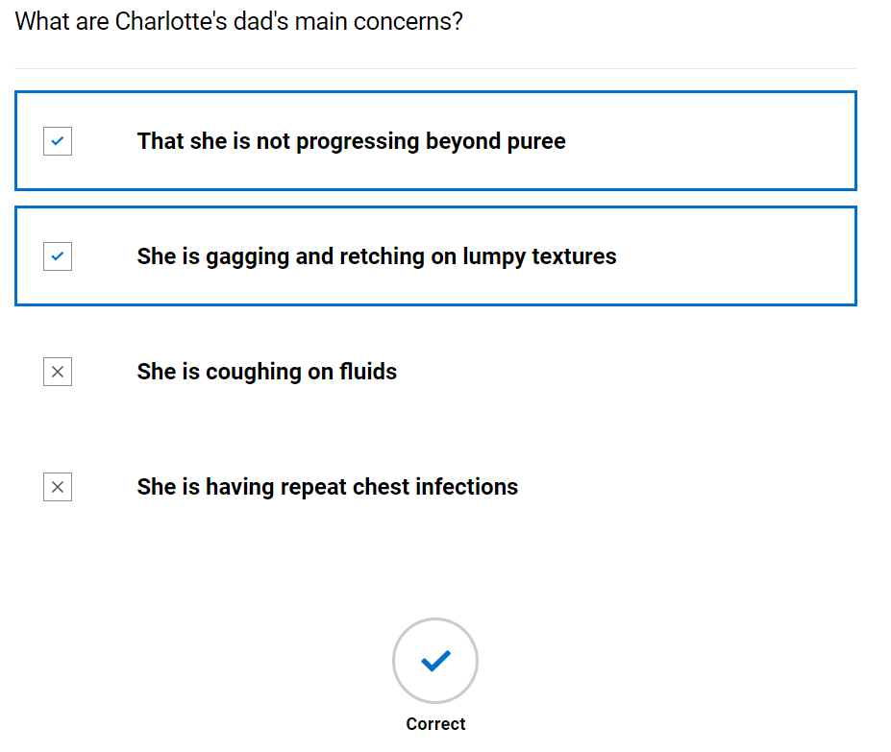
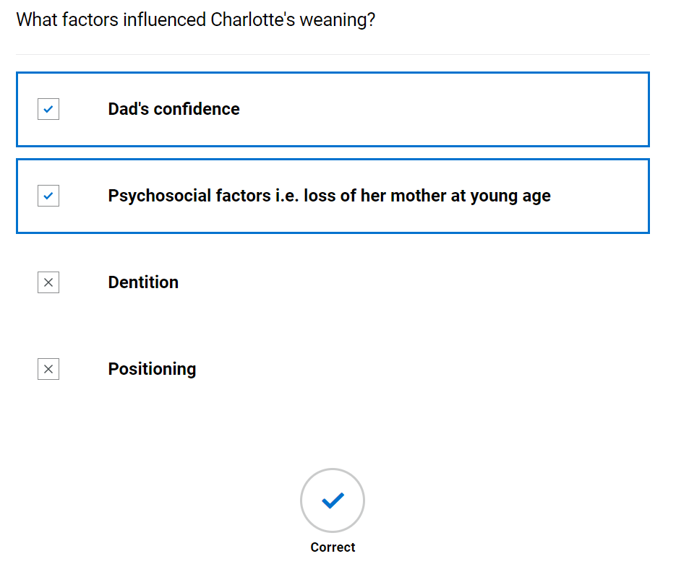

Oro-facial exam
- Blank oro-facial exam form provided; student advised to try to complete whilst watching video of SLT. (They can print this or send to word document to complete – it is not scored) See appendix 2
- Video of SLT completing case history
- SLT completed oro-facial exam, student prompted to compare to theirs
Oro-facial assessment for clients with eating, drinking and swallowing difficulties

Mouth care and dentition -
Area | Comment
Dentures | n/a
Dentition | Own dentition, appropriate for age, clean and white, no cavities
Lips | Pink and moist
Tongue | Pink and moist
Gums | Pink and moist
Cheeks | Pink and moist
Palate - Hard and soft | Pink and moist
Under tongue | Pink and moist
Skin integrity | Good
Level of support for oral care | Dad carries out all dental hygiene
Saliva | Within normal limits

Cranial nerve assessment - comment on range, rate, accuracy, and strength
Nerve and function - | Possible ways to assess | Observations | Outcome – achieved through observation
V Trigeminal –  Conveys sensation to the face and motor to the soft palate, pharynx, and muscles of mastication | 1. Tissue or cotton to nostrils should produce wrinkling of nose  2. Clench teeth and palpate masseter and temporalis muscles for bulk  3. Strength of masseter and temporalis by jaw opening – against resistance of therapist hand  4. Observation of uvula – indicating weakness of tensor veli palantini  5. Palpate dry swallow for hyoid movement |  | Opening and closing mouth during speech with no difficulties
VII Facial – sensation (taste) to anterior 2/3 of tongue, soft palate and motor function of facial muscles | 1. Taste – sweet (sugar), sour (lemon swab) or salty (salt)  2. Facial symmetry  3. Raise eyebrows - frontalis  4. Open and close eyes (orbicularis oculi)  5. Pretend to blow candles (orbicularis oris)  6. Puff cheeks out (buccinators) then try to push air out whilst keeping lips sealed (orbicularis oris). Can gently press on cheeks to check the strength of lip seal.  7. Close eyes and therapist will gently brush their finger on L+R side of face (forehead, cheek, chin) and ask them to tell you/point where they feel sensation | Changes to facial expression  Blinking  Awareness of anterior loss of saliva  Lip movements during speech/vocalisations/mouthing | - Not assessed  - Symmetrical  - Complete  - Complete  - Complete  - Not assessed  - Not assessed
IX Glossopharyngeal – Sensation to posterior 1/3 tongue, soft palate, pharynx and motor to pharynx | 1. Gag reflex – NB the formal assessment of this is a controversial area within SLT and is not used by all SLT’s | Presence/absence of gag during observation including hyper and hyposensitivity | Not assessed
X Vagus – sensation to trachea, larynx, pharynx and motor to soft palate, larynx, and pharynx. (also oesophageal motility and upper oesophageal sphincter opening and closure) | 1. Observe palatal movement when saying “ah” or “ah ah ah”  2. Posterior pharyngeal wall gag - NB the formal assessment of this is a controversial area within SLT and is not used by all SLT’s  3. Voice quality – breathy or hypernasal possible bilateral weakness  4. Hoarse voice – unilateral weakness  5. Throat clear/cough on command | Voice quality  Coughing at rest | Voice is clear and strong
XI Accessory – motor to shoulder, neck and soft palate | 1. Shrug shoulders up and stop therapist from pushing them down. Check symmetry and power  2. Head turn to right, stop me pushing it back – feel right sternocleidomastoid. Repeat on left | Observation of head, neck and shoulder movement.  Head control | Good head control and movement during observation
XII Hypoglossal – motor function to tongue | 1. Tongue protrusion  2. Push tongue into cheek, push into cheek against SALT finger. Tongue deviates to side of lesion  3. Observe for presence/absence of tongue fasciculations | Tongue movement during speech/vocalisations/mouthing  Tongue movement in response to bolus | - Full protrusion  - Full movement  - No fasciculations

- Knowledge check (not scored)
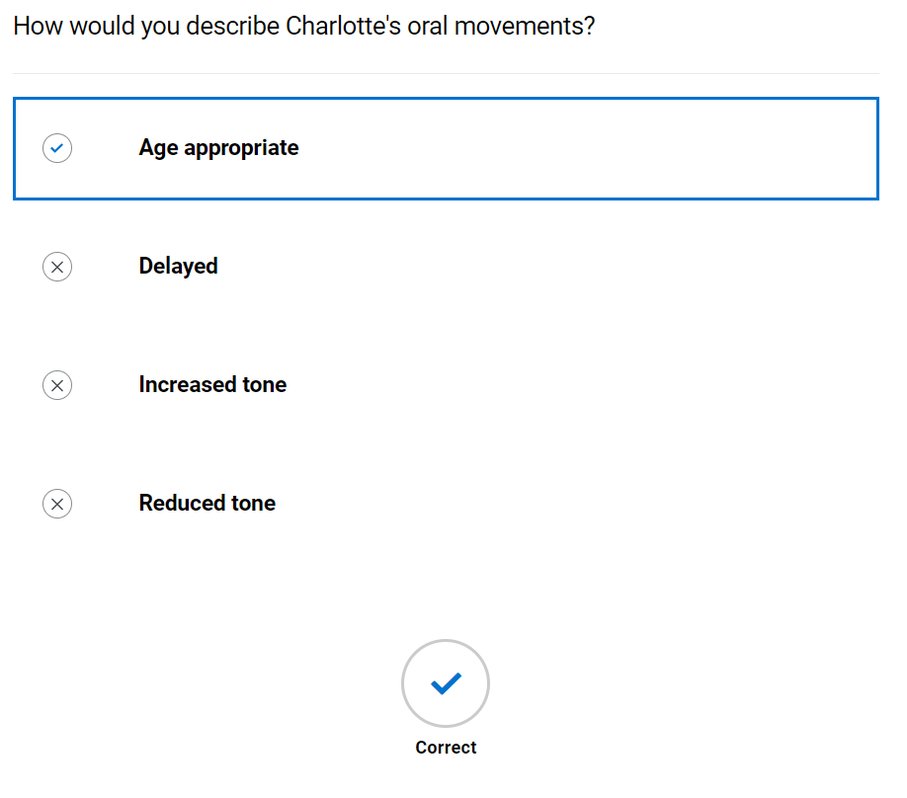
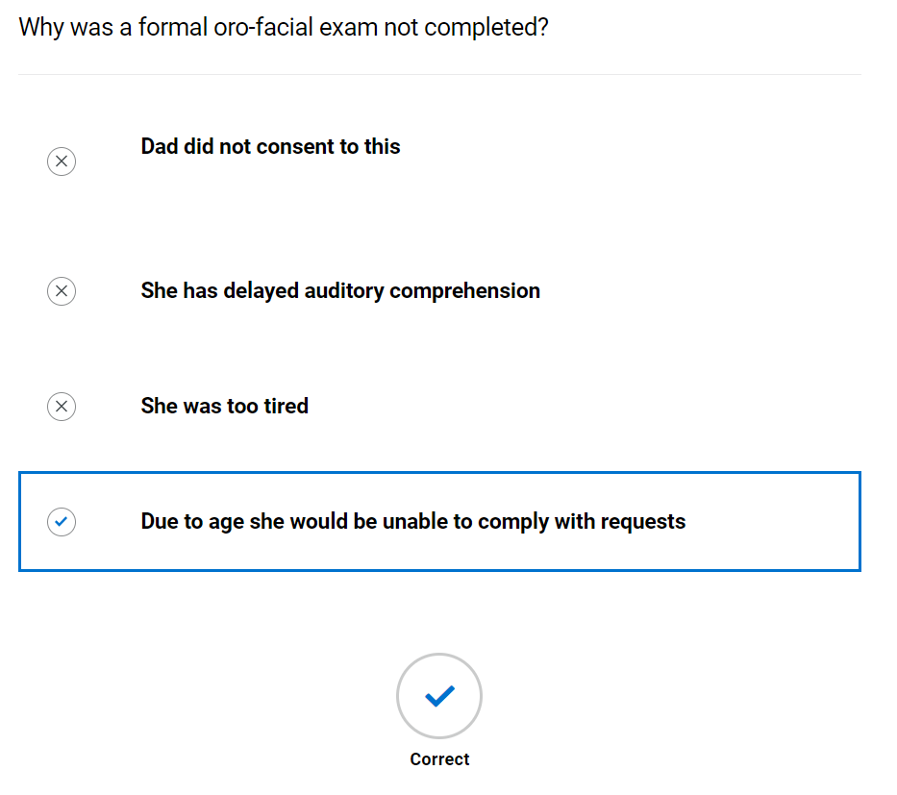

Assessment with diet and fluids
- Blank swallow exam form provided; student advised to try to complete whilst watching video of SLT. (They can print this or send to word document to complete – it is not scored) See appendix 3
- Video of SLT completing swallow exam
- SLT completed swallow exam, student prompted to compare to theirs
Swallow exam
 |  | Trial 1 | Trial 2 | Trial 3 | Trial 4
Pre-oral | Bolus description (IDDSI level) | IDDSI level 0 | IDDSI level 4 puree | IDDSI Transition food bite and dissolve | IDDSI level 7 regular
 | Manoeuvres/ strategies | Nil | Nil | Nil | Nil
 | Advice | Nil | Nil | Nil | Nil
 | Volume and temperature | Room temperature | Chilled | Room temp | Chilled
 | Position of client | Sat on Dad’s lap | Sat on Dad’s lap | Sat on Dad’s lap | Sat on Dad’s lap
 | Head and  trunk control lip closure at rest | No concerns | No concerns | No concerns | No concerns
 | Assistance required e.g. position/role/  perspective of carer (if being fed) | Self-feeding with encouragement | Mixture of feeding from Dad and attempting self-feeding | Self-feeding | Self-feeding
 | Level of alertness/fatigue and communicative ability | Alert | Alert | Alert | Alert
 | Utensil/ specialist feeding equipment | Spouted free flow cup | Baby spoon | Nil | Nil
 | Feeding ability | No concerns | No concerns | No concerns | No concerns
 | Pace of feeding - observed or advised | Within normal limits | Within normal limits | Within normal limits | Within normal limits
 | Pre-oral behaviours | Some reluctancy to drink | Some reluctancy to feed | Some reluctancy to feed | Some reluctancy to feed
Oral | Bolus removal from utensil | Complete | Complete | n/a | n/a
 | Lip seal/anterior bolus control | Good lip seal | Good lip seal | Good lip seal | Good lip seal
 | Bite/suck | Good sucking | n/a | n/a | n/a
 | Oral manipulation of bolus (including chewing) | Adequate | Some mild oral holding | No rotary chewing, oral holding | No rotary chewing, oral holding
 | Changes to saliva | Nil | Nil | Nil | Nil
 | Nasal regurgitation | Nil | Nil | Nil | Nil
 | Timing of oral phase | Appeared appropriate | Appeared appropriate | Prolonged | Prolonged
 | Oral residue/ pocketing | Nil | Nil | Nil | Nil
Pharyngeal | Swallow triggered – effort, number, elevation, excursion, timing | Not tolerating palpation | Not tolerating palpation | Not tolerating palpation | Not tolerating palpation
 | Respiration changes | Nil | Nil | Nil | Nil
 | Voice quality e.g. wet/breathy | No change | No change | No change | No change
 | Globus | n/a | n/a | n/a | n/a
 | Cough/ throat clearing - (presence, strength, duration) | Nil | Nil | Nil | Nil
 | Prompts - verbal and physical | Needing reassurance | Needing reassurance | Needing reassurance | Needing reassurance
Oesophageal | Eructation/ belching | Nil | Nil | Nil | Nil
 | Regurgitation/ reflux | Nil | Nil | Nil | Nil
 | Other including sticking sensation, pain | Nil | Nil | Nil | Nil
Other | Altered reflexes | Nil | Nil | Nil | Nil
 | Other, including signs of distress (eye watering, colour changes) | Nil | Nil | Nil | Nil

- Knowledge check (not scored)
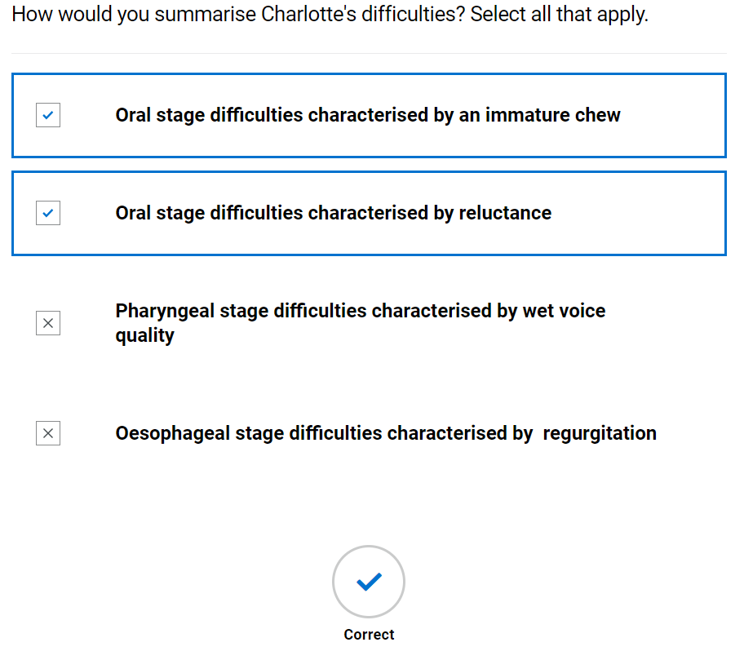
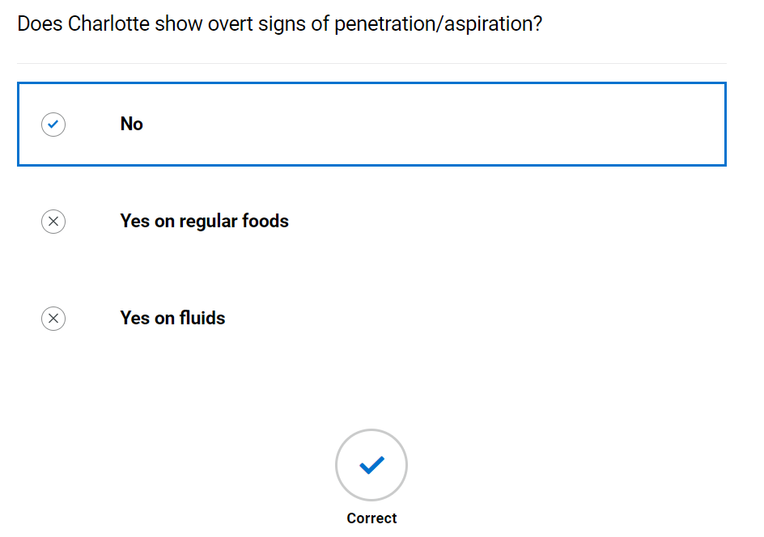

Swallow hypothesis and management plan
- Video of SLT summarising client and forming working hypothesis and management plan
- Completed hypothesis and management plan available to view along with TOMs
Swallow hypothesis and management

Describe the key characteristics of each stage of swallowing

 | Pre-oral | Oral | Pharyngeal | Oesophageal
Brief summary | Able to self-feed for drinks and finger foods but dad feeding for IDDSI level 4. Having a bottle at night | Prolonged oral holding and underdeveloped chewing | Nil observed | Nil observed but reports of possible reflux
Intervention proposed | To stop bottle feeding at night, trial open cup and spouted beaker drinking | SOS approach to intake. Gradual upgrading of diet textures. Food play to encourage positive experience around manipulation of food. Promote self-feeding. Use of transition/ bite and dissolve foods to support progression. Advice to reduce bottle feeds and increased drinks from cup as prolonged sucking from bottle can reinforce anterior-posterior tongue development.  Encourage family mealtimes. | n/a | Monitor
Rationale/ evidence | n/a | We know that children pick up on parental stress and also sometimes use food to maintain some control in their life (especially in times of high stress, loss of mum) | n/a | Impact of reflux on swallowing

Eating drinking and swallowing difficulties secondary to

Main causes of EDS difficulties
Cause remains unclear at present. Possible missed windows of opportunities for acceptance of new tastes/textures

Their EDS difficulties are also impacted by the following concomitant factors:

Concomitant factor | Impact
Social impact of swallowing difficulties | Loss of mum impacted on support of Charlotte through early stages of weaning. High level of carer stress

Diagnosis (please delete as appropriate)
This client presents with an oral dysphagia and possible oesophageal dysphagia.

Therapy Outcome Measures - paediatric TOM)
Measure | Score
Impairment | 4
Activity | 4
Participation | 4
Wellbeing/ Distress | 2

Management plan
- IDDSI level 0 normal fluids from free flow spouted cup
- Try to decrease bottle feeding and increase cup drinking
- Introduction of SOS approach
- Gradual upgrading of textures
- Use of IDDSI transition/ bite and dissolve foods
- Introduction of food-based play to reduce cycle of anxiety and stress around textures other than puree
- SLT to feedback to nursery
  - Video of SLT feeding back to client
  - Knowledge check (not scored)
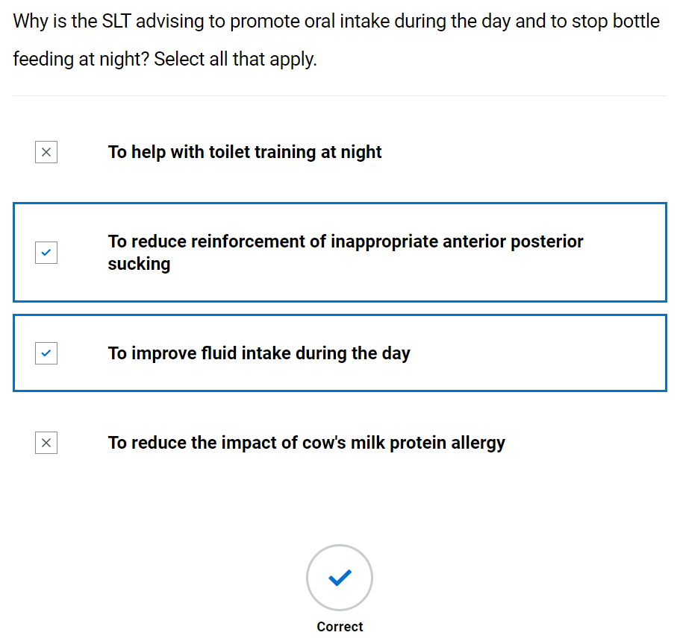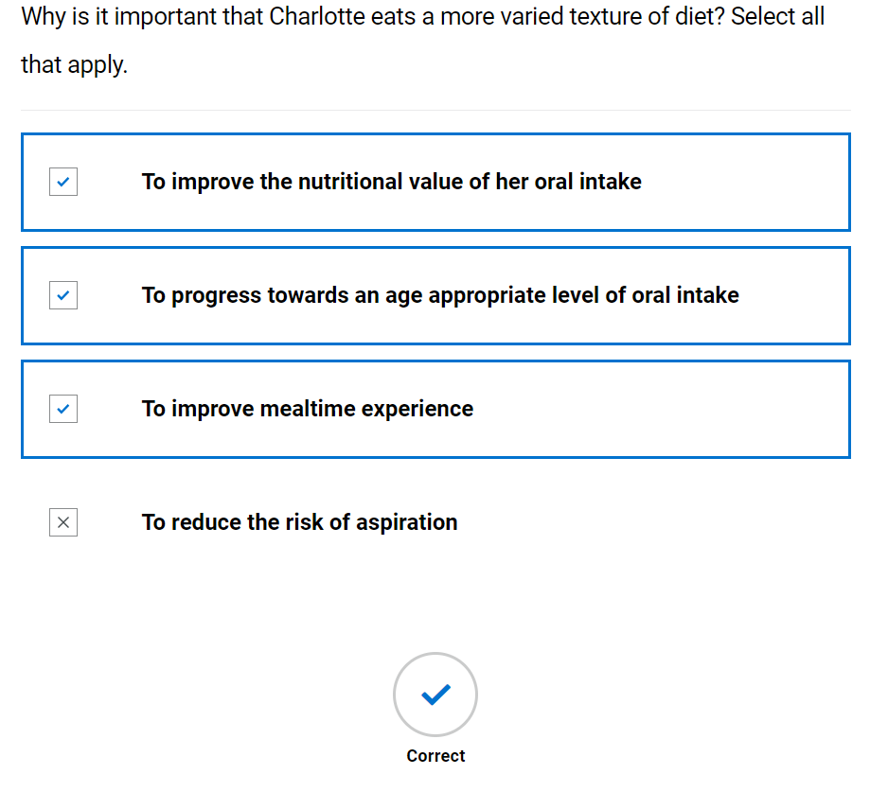

Ongoing management

Multidisciplinary working
- Video of SLT and MDT – discussion with nursery staff
- Further Learning: Research how gastroesophageal reflux can impact upon eating, drinking and swallowing in young children. The following article may be a good starting point: Putnam P., E. (1997). Gastroesophageal reflux disease and dysphagia in children. Seminars in speech and language, 18(1), 25–38."
- Knowledge check (not scored)
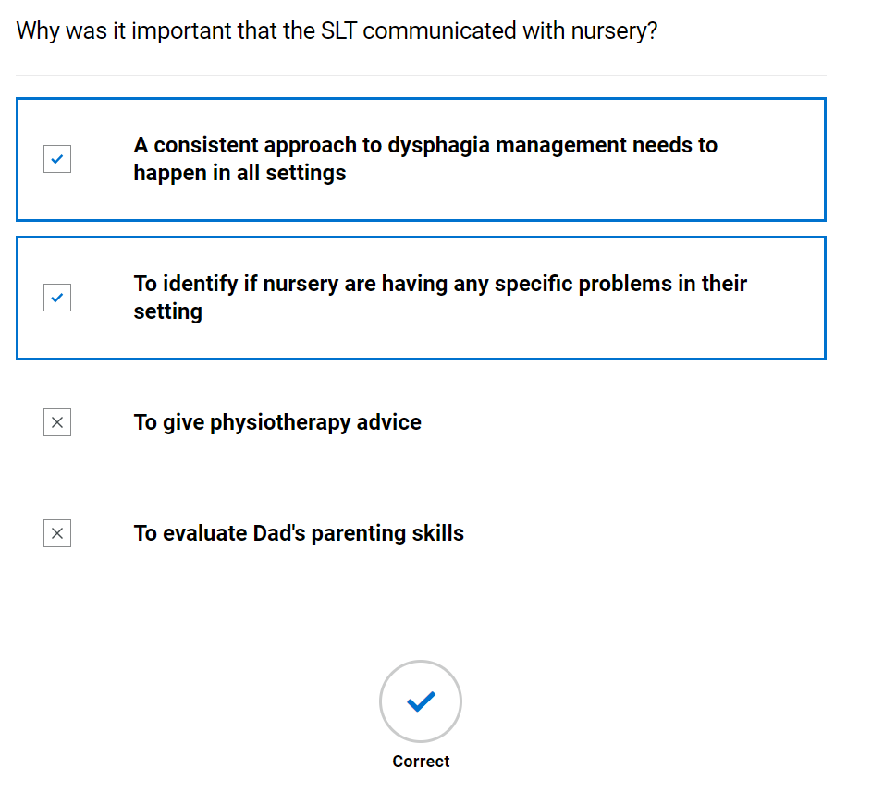

Swallow review
- Blank swallow exam form provided; student advised to try to complete whilst watching video of SLT. (They can print this or send to word document to complete – it is not scored) See appendix 3
- Video of SLT completing swallow review and feeding back to carer
- SLT completed swallow review, student prompted to compare to theirs

Swallow exam
 |  | Trial 1 | Trial 2
P re-oral | Bolus description (IDDSI level) | IDDSI level 0 | IDDSI level 7 Regular diet
 | Manoeuvres/ strategies | Nil | Nil
 | Advice | Nil | Nil
 | Volume and temperature | Room temperature | Room temperature, sandwich, and small gummy snack
 | Position of client | Sat on Dad’s lap | Sat on Dad’s lap
 | Head and  trunk control lip closure at rest | No concerns | No concerns
 | Assistance required e.g., position/role/  perspective of carer (if being fed) | Nil | Nil
 | Level of alertness/fatigue and communicative ability | Alert | Alert
 | Utensil/ specialist feeding equipment | Open cup | n/a
 | Feeding ability | Self-feeding – some difficulty as cup not rigid | Self-feeding
 | Pace of feeding - observed or advised | Within normal limits | Within normal limits
 | Pre-oral behaviours | Nil | Nil
Oral | Bolus removal from utensil | Adequate | n/a
 | Lip seal/anterior bolus control | reduced lip seal – this skill still developing | Good lip seal
 | Bite/suck | n/a | Appropriate bite and tear for bread
 | Oral manipulation of bolus (including chewing) | Adequate | Adequate more rotary chew evident
 | Changes to saliva | Nil | Nil
 | Nasal regurgitation | Nil | Nil
 | Timing of oral phase | Appeared appropriate | Appeared appropriate possibly slightly prolonged
 | Oral residue/ pocketing | Nil | Nil
Pharyngeal | Swallow triggered – effort, number, elevation, excursion, timing | Not tolerating palpation | Not tolerating palpation
 | Respiration changes | Nil | Nil
 | Voice quality e.g. wet/breathy | Nil | Nil
 | Globus | n/a | n/a
 | Cough/ throat clearing - (presence, strength, duration) | Nil | Nil
 | Prompts - verbal and physical | Nil | Nil
Oesophageal | Eructation/ belching | Nil | Nil
 | Regurgitation/ reflux | Nil | Nil
 | Other including sticking sensation, pain | Nil | Nil
Other | Altered reflexes | Nil | Nil
 | Other, including signs of distress (eye watering, colour changes) | Nil | Nil

- Knowledge check (not scored)
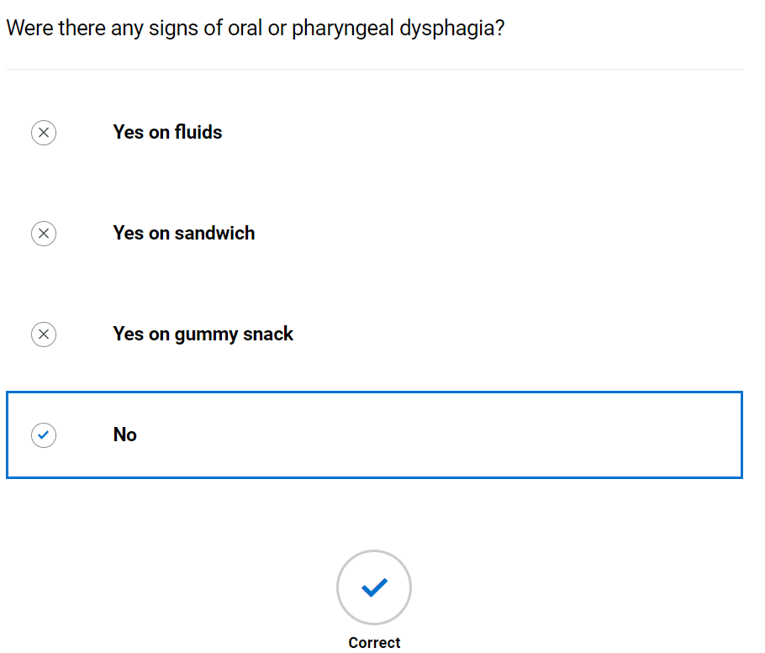

Discharge
- Video of SLT discussing discharge with client
- Copy of discharge report
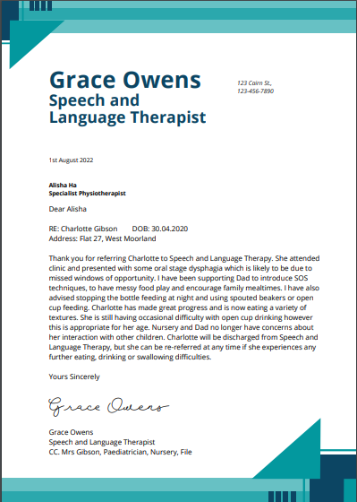

- Copy of final TOM’s – student to attempt to rescore

Therapy Outcome Measures - paediatric TOM – end of intervention

Measure | Score
Impairment | 5
Activity | 5
Participation | 5
Wellbeing/ Distress | 5
- Knowledge check (not scored)
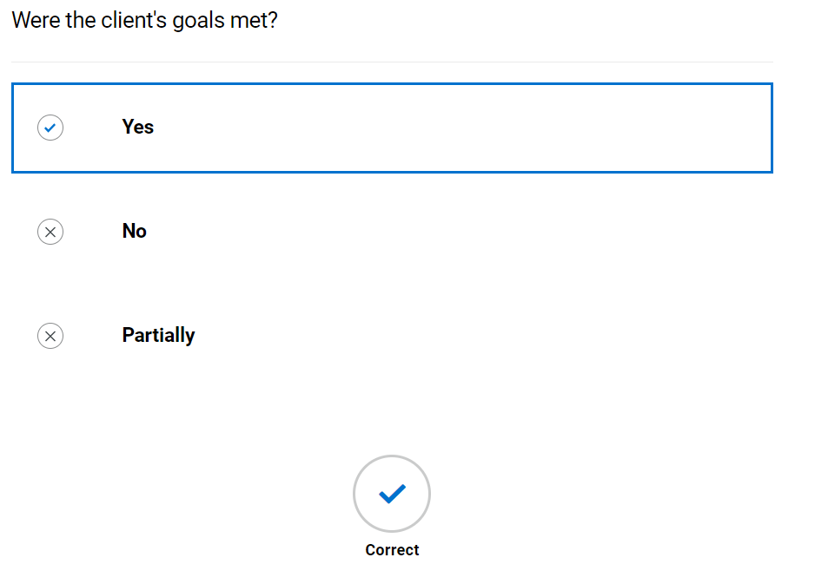

Assessment 1: Adult – Viraj

Background information and planning initial assessment

Referral information
      - Comp 3

Case note review
      - Comp 4

Further information gathering
      - Comp 1

Initial assessment

Case history
      - Comp 9

Oro-facial exam
      - Comp 10

Assessment with diet and fluids
      - Comp 8

Synthesis of information
      - Comp 11, 15

Management plan
      - Comp 12, 16, 17

Ongoing management

The multidisciplinary team
      - Comp - 13

Eating and drinking with acknowledged risk
      - Comp 6, 19

Swallow review
      - Comp 17, 14

Discharge
  - Comp 18

Assessment 2: Child – Ronan

Background information and planning initial assessment

Referral information
      - Comp 3

Case note review
      - Comp 4

Initial assessment

Case history
      - Comp 9

Oro-facial exam
      - Comp 10

Assessment with diet and fluids
      - Comp 8

Management plan
      - Comp 12,16,17

Ongoing management

The multidisciplinary team
      - Comp 13

Swallow review
      - Comp 17, 14

Non-oral nutrition and hydration
      - Comp 6, 7

Safeguarding
      - Comp 20

Discharge
  - Discharge report
  - Comp 18

Summary of competencies against assessments
Comp no | 1 | 2 | 3 | 4 | 5 | 6 | 7 | 8 | 9 | 10 | 11 | 12 | 13 | 14 | 15 | 16 | 17 | 18 | 19 | 20
Assessment 1 | √ | x | √ | √ | x | √ | √ | √ | √ | √ | √ | √ | √ | √ | √ | √ | √ | √ | √ | x
Assessment 2 | x | x | √ | √ | x | √ | √ | √ | √ | √ | x | √ | √ | √ | x | √ | √ | √ | x | √

Appendix 1: Case history form
Speech and Language Therapy
Initial eating, drinking and swallowing case history
Demographics
Consent
Assessment location and time
Reason for referral
Legal information including:
- Advanced care planning
- Power of attorney
- Advanced directive
- Resuscitation status

Communication ability, including languages used
Mental capacity
Safeguarding
Social history
Person with parental responsibility/ next of kin
Client/Carer expectations of intervention
Medical information
Past medical history including disorders of movement or tone
Current mental wellbeing
Main diagnosis/presenting condition
Level of frailty
Prognosis including Gold standards framework

Sensory impairment
- Sight, hearing, touch, smell, taste
- Reaction to sensation
- Reflexes
Multidisciplinary involvement
Medication

Sensitivities and allergies
Reflux (for adults see RSI below)

History/Background of Dysphagia
Onset
Duration
Stability/progression
Social and psychosocial impact of difficulties
Avoidance
Client/carer description
Significant swallowing events
Cultural aspects affecting EDS
Mealtime routine
Enjoyment of meals
Current oral intake
Mental health/wellbeing of client and carer

Respiration
Chest status (current and history)
Breathing pattern at rest
Cough
Oxygen/ventilatory requirements
S:Z ratio

Environment, skills, and behaviours
Positioning
Skin integrity
Feeding skills
Equipment/utensil used
Environments in which client eats/drinks
Behaviours or sensory challenges/issues around eating/drinking/mealtimes

Nutrition and hydration
Nutrition and hydration status prior to assessment
Weight/BMI/MUST/ Growth and development
Urinary output
Faecal output
Risk factors for developing aspiration pneumonia
 |  | Yes | No
Dependence for oral feeding
Dependence for oral care
Poor oral/dental hygiene
Chest concerns
Comorbidities
Multiple Medications
Mobility status
If yes response then patient is at increased risk of aspiration pneumonia (Langmore, 1998)

Appendix 2: Oro-facial exam
Oro-facial assessment for clients with eating, drinking and swallowing difficulties
Mouth care and dentition -
Area | Comment
Dentures
Dentition
Lips
Tongue
Gums
Cheeks
Palate - Hard and soft
Under tongue
Skin integrity
Level of support for oral care
Saliva

Cranial nerve assessment - comment on range, rate, accuracy, and strength
Nerve and function - | Possible ways to assess | Observations | Outcome
V Trigeminal –  Conveys sensation to the face and motor to the soft palate, pharynx, and muscles of mastication | 1. Tissue or cotton to nostrils should produce wrinkling of nose  2. Clench teeth and palpate masseter and temporalis muscles for bulk  3. Strength of masseter and temporalis by jaw opening – against resistance of therapist hand  4. Observation of uvula – indicating weakness of tensor veli palantini  5. Palpate dry swallow for hyoid movement
VII Facial – sensation (taste) to anterior 2/3 of tongue, soft palate, and motor function of facial muscles | 1. Taste – sweet (sugar), sour (lemon swab) or salty (salt)  2. Facial symmetry  3. Raise eyebrows - frontalis  4. Open and close eyes (orbicularis oculi)  5. Pretend to blow candles (orbicularis oris)  6. Puff cheeks out (buccinators) then try to push air out whilst keeping lips sealed (orbicularis oris). Can gently press on cheeks to check the strength of lip seal.  7. Close eyes and therapist will gently brush their finger on L+R side of face (forehead, cheek, chin) and ask them to tell you/point where they feel sensation | Changes to facial expression  Blinking  Awareness of anterior loss of saliva  Lip movements during speech/vocalisations/mouthing
IX Glossopharyngeal – Sensation to posterior 1/3 tongue, soft palate, pharynx, and motor to pharynx | 1. Gag reflex – NB the formal assessment of this is a controversial area within SLT and is not used by all SLT’s | Presence/absence of gag during observation including hyper and hyposensitivity
X Vagus – sensation to trachea, larynx, pharynx and motor to soft palate, larynx, and pharynx. (also, oesophageal motility and upper oesophageal sphincter opening and closure) | 1. Observe palatal movement when saying “ah” or “ah ah ah”  2. Posterior pharyngeal wall gag - NB the formal assessment of this is a controversial area within SLT and is not used by all SLT’s  3. Voice quality – breathy or hypernasal possible bilateral weakness  4. Hoarse voice – unilateral weakness  5. Throat clear/cough on command | Voice quality  Coughing at rest
XI Accessory – motor to shoulder, neck and soft palate | 1. Shrug shoulders up and stop therapist from pushing them down. Check symmetry and power  2. Head turn to right, stop me pushing it back – feel right sternocleidomastoid. Repeat on left | Observation of head, neck and shoulder movement.  Head control
XII Hypoglossal – motor function to tongue | 1. Tongue protrusion  2. Push tongue into cheek, push into cheek against SALT finger. Tongue deviates to side of lesion  3. Observe for presence/absence of tongue fasciculations | Tongue movement during speech/ vocalisations/ mouthing  Tongue movement in response to bolus

Appendix 3: Swallow assessment
Recording sheet for swallowing assessment
 | Trial 1 | Trial 2 | Trial 3 | Trial 4 | Trial 5 | Trial 6
Pre-oral
Bolus description (IDDSI level)
Manoeuvres/ strategies
Advice
Volume and temperature
Position of client
Head and trunk control lip closure at rest
Assistance required e.g., position/role/perspective of carer (if being fed)
Level of alertness/fatigue and communicative ability
Utensil/ specialist feeding equipment
Feeding ability

Pace of feeding – observed or advised
Pre-oral behaviours
Oral
Bolus removal from utensil
Lip seal/anterior bolus control
Bite/suck
Oral manipulation of bolus (including chewing)
Changes to saliva
Nasal regurgitation
Timing of oral phase
Oral residue/pocketing
Pharyngeal
Swallow triggered – effort, number, elevation, excursion, timing
Respiration changes
Voice quality e.g., wet/breathy
Globus
Cough/ throat clearing - (presence, strength, duration)
Prompts - verbal and physical

Oesophageal
Eructation/ belching
Regurgitation/ reflux
Other including sticking sensation, pain
Other
Altered reflexes
Other, including signs of distress
(eye watering, colour changes)

Appendix 4: A quick guide to using TOMS within the eLearning module
Definitions

Impairment
Impairment is concerned with the integrity of body systems and includes psychological and physiological structures. It relates the disease or medical disorder experienced by the individual. The medical diagnosis is embraced in the domain.
Impairments include: stroke, learning disability, autism, diabetes, musculoskeletal conditions, respiratory disorders, schizophrenia, dysphagia, language disorder, etc

Activity/disability/functioning
These terms are all concerned with what someone can do, and these terms are frequently used interchangeably. They describe the ability to execute tasks and/or limitations on actions by an individual, indicating the level of dependence and independence. This domain concerns the degree of abnormality (as compared to someone of the same age, gender, and culture) in terms of difference from the norm of what someone undertakes.
Activities include: walking, communicating reading, washing etc

Participation
Participation is concerned with the advantage/disadvantage experience by the individual, reflecting social participation, integration, interaction, and autonomy. It reviews the individual in a social setting and reflects access to the environment, employment, recreation, education, and family participation.
Participation includes: having hobbies, friends, autonomy, getting out, being respected,
etc.

Wellbeing/distress
This domain is concerned with emotions, feelings, burden of upset, concern and anxiety, and level of satisfaction. This domain is not included in the WHO ICF 2001 but was added to the first edition of the Therapy Outcome Measure (Enderby, John, & Petheram, 1999) following a review of goals of therapists and rehabilitation services where it was found that improving the wellness of the individual as well as their family members or carers was a frequent goal/objective of services and therefore needed to be included in the review of outcomes of those services.
There are two concepts related to wellbeing; the first is related to the severity of any upset, concern, anxiety, anger (how severe) and the second is related to the frequency of experiencing this, e.g., all the time, frequently, often. So, for example, one should consider whether the person is extremely anxious/depressed all the time, or occasionally gets very cross, or frequently gets mildly cross, and so on.
Carer wellbeing scale
If one of the objectives of the intervention is to improve wellbeing of the carer of the client, then it may be appropriate to reflect this by using the same wellbeing scale to determine the level of challenge experienced by the carer at the beginning and the end of intervention. In some cases, this may be the only objective of an intervention. Do not use this scale if management of this is not part of your intervention plan or you do not see/know the cares.

Explaining the rating scale

The TOM domains (impairment, activity, participation, and wellbeing) are rated on an ordinal scale, with 0 representing the severe end of the scale and 5 being considered normal for age, sex, and culture of the client.

0 | 0.5 | 1 | 1.5 | 2 | 2.5 | 3 | 3.5 | 4 | 4.5 | 5

The integers (whole numbers) are given a description that identifies the severity of the difficulty experienced on each dimension. Half points increase the scale to 11 points. The half points (which have no descriptor) allow the assessor to indicate whether the person is better or worse than what is described. In summary, there are six descriptions on each scale and five undefined half points providing an 11-point scale.

When using scales, the assessor should identify the point on the scale that is ‘best fit’; it is not essential that the individual presents with all the features described. The half points on the scale can assist with this. For example, if the individual presents with some of the features described in the descriptor for ‘4’ and some in ‘3’, it may be appropriate to score a 3.5.

When to rate

All outcome measures endeavour to examine change associated with a course of action or treatment. Thus, the TOM is used at the beginning and the end of an intervention.

In this module you will be prompted when to complete a TOM. Only TOMs related to dysphagia will be used although many other areas are available.

A rating should be ascribed to an individual when you are ready to start your treatment/intervention. During an initial assessment of eating, drinking and swallowing you will be completing the initial TOM when you have ascertained the severity of their condition but before you introduce any manoeuvres/therapy/strategies. For example, a client is referred to speech and language therapy following a swallow screen by a nurse and is nil by mouth. An SLT completes an eating, drinking and swallowing assessment and notes that the client coughs when taking consecutive sips of IDDSI level 0 normal fluids from an open cup, their swallow reflex is present, they have right sided anterior oral loss of the bolus. They are able to eat an IDDSI level 7 normal diet with mild right sided oral residue but no coughing. The client reports that his difficulties only started when he became unwell with a urinary infection and was admitted to hospital. He has lost some weight and has been placed on 1 oral supplement drink a day. He is not concerned about his difficulties and feel they will resolve when he is feeling better and that they don’t have much of an impact on him currently. This client could have an impairment score of 3 Moderate dysphagia, an activity score of 4 Total/mostly oral intake requiring minimal support, and a participation score of 4 Occasionally some restriction.

Appendix 5: Therapy Outcome Measures
24 Dysphagia

Identify descriptor that is ‘best fit’ The patient/client/student does not have to have each feature mentioned. Use 0.5 to indicate if patient/client/student is slightly better or worse than a descriptor and as appropriate to age.
Please note minor changes to wording to the one recorded in 2015

Impairment
0 Profound. Aphagia: Not safe to swallow due to cognitive status/no bolus control/aspiration/absence of oral/pharyngeal swallow. Aspiration risk identified on all consistencies with clinical signs of aspiration. No effective cough reflex. Not able to manage oral secretions. May need regular suction.
1 Severe dysphagia. Weak oral movements/no bolus control/ inadequate/ inconsistent swallow reflex. High and constant risk of aspiration on some but not all consistencies or daily. Can occasionally manage oral secretions
2 Severe/moderate dysphagia. Cough/swallow reflexes evident but abnormal or delayed. Uncoordinated oral movements. At regular risk of aspiration (several times a week). Difficulty managing oral secretions in some positions or at some times of the day.
3 Moderate dysphagia. Swallow and cough reflex present. May have poor oral control. At occasional risk of aspiration. Occasional difficulty with managing oral secretions.
4 Mild oral/pharyngeal dysphagia. Incoordination but no clinical risk or evidence of aspiration. No difficulty with managing oral secretions.
5 No evidence of dysphagia.

Activity
0 Unable to safely take any fluid/diet/modified consistencies. Unable to manage oral secretions. Needs experienced and constant surveillance. Requires non-oral methods to meet all hydration and nutritional needs. This may or may not be advised to be in the patient’s interests by the responsible clinician and multidisciplinary team.
1 Oral intake insufficient to meet hydration and nutritional needs. Requires nonoral methods to meet all hydration and nutritional needs feeding or supplements. Occasionally able to take small amounts of food or drink/modified consistencies using compensatory strategies. Constantly refuses oral intake or holds bolus in the mouth. Requires experienced assistance, prompting and supervision. Requires non-oral
methods to meet all hydration and nutritional needs. This may or may not be advised to be in the patient’s interests by the responsible clinician and multidisciplinary team.
2 Additional non-oral nutrition, hydration or supplements needed. Consistently able to take small amounts of small amounts of food or drink/modified consistencies using compensatory strategies. Frequently refuses oral intake or holds bolus in the mouth. Needs experienced assistance, prompting and supervision.
3 Oral intake sufficient to meet hydration and nutrition needs but may require supplements. Consistently able to take modified consistencies using compensatory strategies. May occasionally refuse oral intake but responds to encouragement. Needs some supervision/encouragement. May eat extremely slowly.
4 Although eating and drinking is abnormal, it is good enough to meet nutritional requirements. No assistance/supervision required. No alternative or supplement feeding required. May take extra time and avoid certain foods, drinks, or eating situations.
5 Functionally eating and drinking a normal diet.

Participation

0 Unable to fulfil any social/ educational/ family role. Not involved in decision making/no autonomy/no control over environment, no social integration.
1 Low self-confidence/poor self-esteem/limited social integration/socially isolated/contributes to some basic and limited decisions. Cannot achieve potential in any situation.
2 Some self-confidence/some social integration/makes some decisions and influences control in familiar situations.
3 Some self-confidence; autonomy emerging. Makes decisions and has control of some aspects of life. Able to achieve some limited social integration/educational activities. Diffident over control over life. Needs encouragement to achieve potential.
4 Mostly confident; occasional difficulties integrating or in fulfilling social/role activity. Participates in all appropriate decisions. May have difficulty in achieving potential in some situations occasionally.
5 Achieving potential. Autonomous and unrestricted. Able to fulfil social, educational, and family role.

Wellbeing/Distress (client/carer)

0 Severe constant: High and constant levels of distress/upset/concern/ frustration/anger/embarrassment/withdrawal/ severe depression or apathy. Unable to express or control emotions appropriately.
1 Frequently severe: Moderate distress/upset/concern/frustration/anger /embarrassment/withdrawal/severe depression or apathy. Becomes concerned easily, requires constant reassurance/support, needs clear/tight limits and structure, loses emotional control easily.
2 Moderate consistent: distress/upset/concern/frustration/anger/ embarrassment/withdrawal/severe depression or apathy in unfamiliar situations. Frequent emotional encouragement and support required.
3 Moderate frequent: Distress/upset/concern/frustration/anger/ embarrassment/withdrawal/severe depression or apathy. Controls emotions with assistance, emotionally dependent on some occasions, vulnerable to change in routine, etc., spontaneously uses methods to assist emotional control.
4 Mild occasional: distress/upset/concern/frustration/anger/ embarrassment/ withdrawal/severe depression or apathy. Able to control feelings in most situations, generally well-adjusted/stable (most of the time/most situations), occasional emotional support/encouragement needed.
5 Not inappropriate: Distress/upset/concern/frustration/anger/ embarrassment/withdrawal/severe depression or apathy. Well adjusted, stable, and able to cope emotionally with most situations, good insight, accepts and understands own limitations

Appendix 6: Therapy Outcome Measures
50 Paediatric Dysphagia

Impairment

0 Profound dysphagia. No detectable swallow on clinical assessment or anatomically unable to achieve oesophageal transit. May have audible pharyngeal pooling of saliva. Consistent, high risk of aspiration or choking.
1 Severe dysphagia. Swallow trigger attempts but ineffective. Limited attempts at rooting, latching, or sucking. May show some limited oral control/very late or delayed swallow initiation/very poor pharyngeal clearance/severe laryngeal incompetence/severe oesophageal dysmotility. Swallow is ineffective for any texture of food or drink.
High risk of aspiration or choking.
2 Moderate dysphagia. May show normal non-nutritive sucking, with inadequate/dysfunctional suck:swallow:breathe synchrony. May show limited oral control/late or delayed swallow initiation/poor pharyngeal clearance/moderate laryngeal incompetence/oesophageal dysmotility. Oropharyngeal skills are ineffective for some textures. Moderate risk of aspiration or choking.
3 Occasional moderate dysphagia. Secondary to temporary health issues affecting endurance/fatigue/appetite/motivation/experience. May show physiological stress cues. Inconsistent risk of aspiration or choking (can also be used for mild‒moderate dysphagia).
4 Mild dysphagia. May show immature suck:swallow:breathe synchrony for gestational age. May show reduced oral control/late or delayed swallow initiation/reduced pharyngeal clearance/mild laryngeal incompetence. Oropharyngeal skills are ineffective or inconsistent for one texture. Occasional risk of aspiration or choking.
5 No difficulty.

Activity

0 Non-oral feeding to meet all hydration and nutritional needs. No oral intake.
1 Non-oral feeding to meet all hydration and nutritional needs. Minimal oral intake,
e.g., dummy dips/tastes purée, 5mls or less per feed.
2 Dependent upon non-oral feeding, with consistent intake of food and/or fluid greater than 5mls.
3 Total/mostly oral intake requiring special conditions, e.g., limited volume/frequency/time allowed for oral feed. May need thickened feed, puréed diet where not age appropriate. May need specialist equipment.
4 Total/mostly oral intake requiring minimal support, e.g., using top-ups to support volume required, slow flow teat, side-lying/pacing, or avoidance of challenging textures, supportive seating.
5 Age appropriate, fully oral intake.

Participation (if applicable)
Compare with a typically developing child of similar age, gender, and culture. Not applicable for infant under 12 months. Note as ‘not assessed’.

0 Unable to participate in family/social/school life. No autonomy/independence or integration in any setting.
1 Very limited participation or ability to make choices in family/social/school life. Very occasionally has some autonomy/integration/independence in one setting.
2 Limited participation in family/social/school life. Limited independence/autonomy and integration in some settings.
3 Integrated, autonomous, and independent in a limited number of family/social/school life settings.
4 Occasionally some restriction in participation in family/social/school life and for independence/autonomy and integration.
5 Integrated, valued, and autonomous in family/social/school life.

Wellbeing/Distress (rate for parent/carer and, if appropriate, also for the child)

0 Severe, constant: Consistently high levels of distress/anxiety/frustration/confusion.
1 Frequently severe: Frequent, high levels of distress/anxiety/frustration/confusion.
2 Moderate, consistent: Consistent, moderate distress/anxiety/frustration/confusion.
3 Moderate, frequent: Frequent, moderate distress/frustration/anxiety/confusion.
4 Mild, occasional: Occasional, mild distress/frustration/anxiety/confusion.
5 Not distressed.

Acknowledgement: Developed by Bev Curtis. Cardiff and Vale University Health
Board in collaboration with Pam Enderby

