Professional development framework FAQs

Spring 2024

This set of FAQs is based on questions sent in by attendees at a series of RCSLT webinars about the professional development framework. With thanks to those attendees for their engagement.
Sections
1. Getting started
2. Types of user
3. Practical considerations
4. Embedding the framework

- Getting started
How do I get started with the Professional Development Framework?
- When and how do I use the framework to guide and support my CPD?
- What are the most necessary modules of the framework for a basic member's first step of using the framework?
- How do you choose which reflective questions to start with?
To start with, familiarise yourself with the structure including: Five core components (practitioner wellbeing, impact, inclusion and diversity, sustainability, co-production); Four domains of practice (professional practice; facilitation of learning; evidence, research and innovation; leadership and management) Professional development levels (foundation, proficient, enhanced, advanced, expert).
There is no right or wrong way to use the RCSLT Professional Development Framework – it has been designed to be used flexibly to meet your needs (see Figure 2). Depending on the time you have, you can do all or some of the following and use the outcome when planning your learning, career development and progression plans.
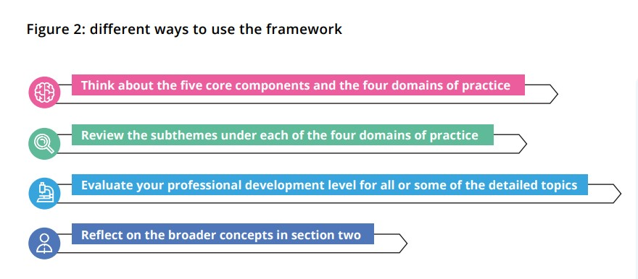
Diagram from p10 of the Professional Development Framework.

- How do we practically apply this day to day? Does it link to our CPD diary/goals?
You can apply this as flexibly as you like. Yes, you can align it to your CPD diary and goals. The framework is designed to:
- be used flexibly to guide practitioners, teams, and organisations
- be used as a whole or in parts, returning to it at different times within your career
- identify existing knowledge and skills with individuals and teams
- inspire future learning for knowledge and skills development
- provide a structure to support the CPD Diary (where appropriate)

For supervision
- How do people use it as a tool to support the supervision process?
This is a very good tool for use in supervision. A lot of its power is in giving space and structure to reflective conversations. You can be quite broad, or very narrow in focus.
For appraisal
- How can it be used as a tool in the appraisal process?
This is a very good tool for use in appraisal. The appraisee can map themselves in and reflect on where they want to develop and where they have developed over the previous period.
- Types of user
For independent practice
- I am interested in how to apply to independent practice, working in mainstream school.
- How can you apply this within independent practice effectively?
The framework is designed for all speech and language therapists and any setting in which they work. You can use it by yourself or with a manager or supervisor, critical friend, or peers. You can use it at formal periods of contact with others such as appraisals, or more informally as a starting point for conversations about your career, your CPD needs and your aspirations.
For international affiliates
- Does this framework apply if you are an international affiliate?
We have created this with a UK audience in mind, having consulted with members and stakeholders there. However, this tool is very flexible and so could be considered if you are working in other countries.

For students and apprentices
- How can it benefit students and newly registered SLTs?
- Does the new scheme for apprentice SLTS have its own framework or can they engage with this main one?
It is not targeted at students or apprentices as they have a lot to fit in with the curriculum or NQP goals. However, we think it is worth them having an awareness of the framework to help them start thinking about career opportunities and development.
For Newly Qualified Practitioners
- Can it be used with newly qualified practitioner SLTs?
It is not targeted at NQPs as they have a lot to fit in with completing their NQP goals. However, it would be good for them to have an awareness of the framework to help them start thinking about career opportunities and development.
For other Allied Health Professions
- Could use of the framework support development for other allied health professionals?
It has been designed by speech and language therapists for speech and language therapists. However, we have heard examples from some services where they are using this framework with other allied health professions. We welcome this approach.
- Practical considerations
- Is there a resource like pebble pad that the RCSLT recommends that can be used to log and manage CPD and link to the framework?
We recommend using the RCSLT CPD diary which can be found on our website.

- Is there a provider who is recommended for Independent SLTs to use to complete mandatory training for AHPs?
We cannot recommend particular providers as we have a duty to remain impartial. However, CPD providers pay for advertising in the back of Bulletin and on our website on our course listings page: https://www.rcslt.org/course-listings/

- How does the framework relate to the new CPD requirements from the HCPC?
The HCPC requires registrants to comply with its five standards for CPD https://www.hcpc-uk.org/standards/standards-of-continuing-professional-development/ . The framework is designed to work with those requirements. The HCPC provides general standards for all its registrants whereas the framework relates to professional development within the area of speech and language therapy.
- How does this align to other competence documents when they are reviewed?
The framework acts as a broad overview of areas in which SLTs can work whereas competence documents focus in on particular areas. The framework is flexible enough to sit alongside competence documents. As RCSLT develops/reviews competence frameworks we will be ensuring that any mapping with the framework is made explicit.
- How do we rate staff on cultural competence?
It is the ability to show cultural humility and cultural responsiveness.
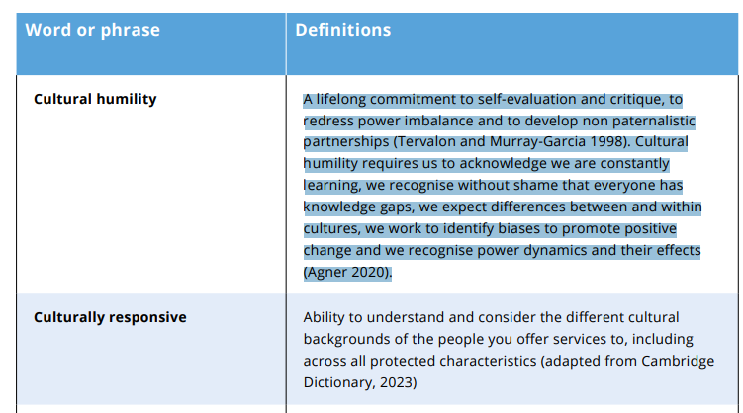

Taken from the framework, p53
- How does this relate to movement between NHS pay bands?
The framework is not about pay or terms and conditions of employment. Rather, it provides a structure to guide you towards areas of learning and professional development for your career because service users expect us to have up-to-date knowledge and skills.
- I am based in Scotland so wonder how this fits with TURAS?
The framework was developed with input from members and stakeholders across all four nations of the UK. The framework acts as a broad overview of areas in which SLTs can work whereas competence documents focus in on particular areas. The framework is flexible enough to sit alongside competence documents.
- I'm still not really sure what the difference is between enhanced and advanced and expert. Can you explain?
The professional development levels are adapted from and based on work originally proposed by Dreyfus and Dreyfus (1980) and subsequently developed into health and care by Benner (1982). You are invited to reflect on your level of knowledge and skills with each detailed topic, appreciating that any form of self-evaluation is based on the view we have of ourselves at that moment in time.
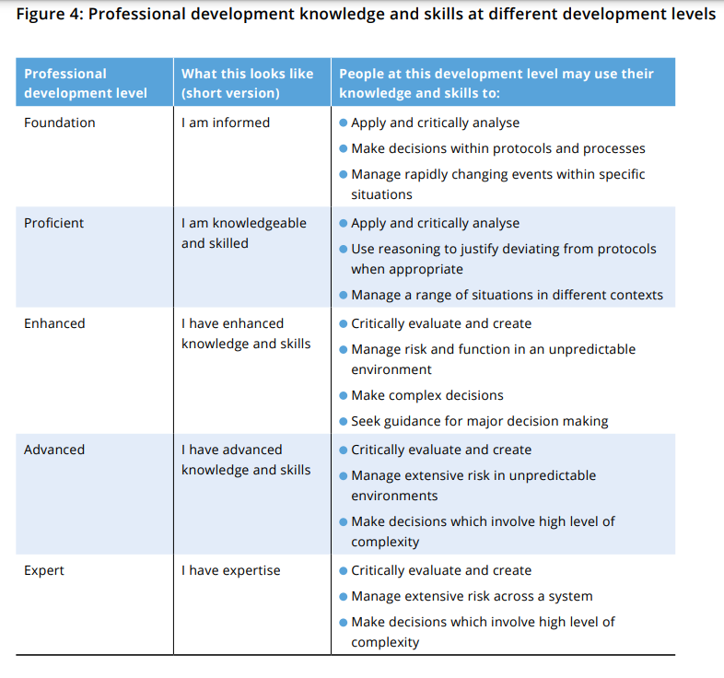
Diagram from p20 of the Professional Development Framework.
- Can it be used to support writing job descriptions for consultant posts?
Yes, this could be used for consideration of JDs for consultant posts.
In general, these vary significantly and more often than not, it seems like people have to write their own job descriptions once they get to this level. We have looked into opportunities to create a general template but feedback indicated that this may not be overly helpful due to the variation of content.
We developed an ‘advanced’ clinical academic JD – this is the highest level and can be found here:https://www.rcslt.org/members/get-involved/current-rcslt-projects/workforce-reform-programme/clinical-academic-job-descriptions/#section-2
If you get in touch with our Professional Enquiries team we have other examples- in acute and in neurosciences. They can also link you up with a leadership mentor or clinical advisor if you need further help. You can also get in touch with us to speak to a leadership/ clinical advisor.

- Embedding the framework

- Do you have suggestions on how to build this into trust policies?
It will vary on where you are but you should have an SLT lead.
If you are in England you should have an SLT lead in your AHP faculty and council.
There are equivalents in health boards in Wales; the health and social care trusts in Northern Ireland and boards in Scotland.
Can you talk with them about the framework? Do you have evidence of where it has been effective. Identify the pain points for them such as retention and wellbeing of staff. The safety reasons for a continually developing workforce. How can the framework help that?

- How does RCSLT see the framework developing in future?
in 2024-5 we want to keep raising awareness. We will then be evaluating it and making any relevant updates. We will also be looking to see how it aligns with other frameworks across the career journey and listening to members about any points where we can make it easier to move between them.

