**RCSLT Sustainability resources**

Please note: the resources on this page are provided for informational purposes only. No endorsement is expressed or implied, unless otherwise stated.

**Guidance and frameworks**

* [Council of Deans of Health guidance: education fo sustainable healthcare within UK pre-registration curricula for allied health professions](https://www.councilofdeans.org.uk/2023/12/guidance-education-for-sustainable-healthcare/) - the Council of Deans of Health [guidance](https://www.councilofdeans.org.uk/wp-content/uploads/2023/12/ES-curricula-guidance-CoDH-version_SM-final-no-links.pdf) sets the groundwork for the next generation of health and care professionals. It will support future AHPs to understand the relationship between health and the environment, to deliver sustainable healthcare and be advocates for environmental sustainability.
* [ENT UK, Environmental sustainability guidance - flexible nasoendoscopy](https://www.entuk.org/resources/211/environmental_sustainability_guidance_flexible_nasoendoscopy/) - ENT UK have written review evidence and provide recommendations on safety and environmental impact of using flexible nasendoscopy in practice. This has been endorsed by the RCSLT.
* [The King's Fund, My role in tackling health inequalities: a framework for allied health professionals -](https://assets.kingsfund.org.uk/f/256914/x/dd211304ca/framework_allied_health_professionals_2021.pdf) this framework for allied health professionals support AHPs to tackle health inequalities. See page 7 for the model we have based this position statement on.

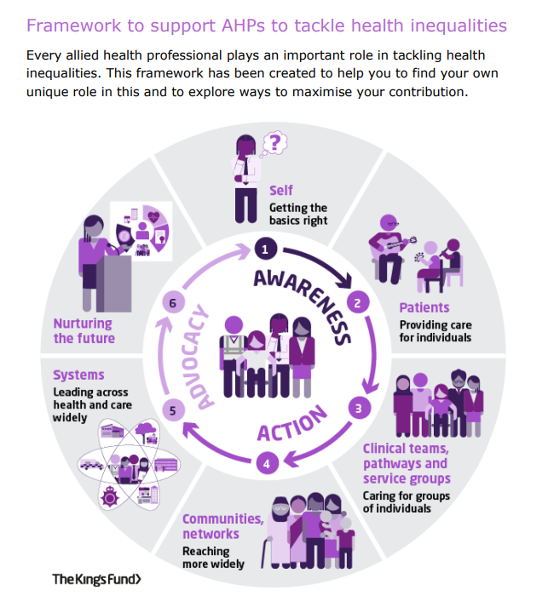

**Health bodies and regulators**

* [AHP Green Guide - Health Education Improvement Wales](https://heiw.nhs.wales/our-work/allied-health-professions-ahps/professional-development/ahp-green-guide/) - the AHP Green Guideisa resource created for theAllied Health Professions workforce across Wales to start their journey in delivering sustainable healthcare.
* [CQC environmental sustainability - sustainable development](https://www.cqc.org.uk/guidance-regulation/providers/assessment/single-assessment-framework/well-led/environmental-sustainability) - this provides information about the quality statement and external links to legislation and best practice guidance.
* [NICE environmental sustainability](https://www.nice.org.uk/about/who-we-are/sustainability) – the National Institute of Clinical Excellence (NICE) environmental sustainability discusses how climate change is affecting the ability to deliver healthcare.
* [NHS England Greener NHS](https://www.england.nhs.uk/greenernhs/) - the NHS England Greener NHS programme focuses on sharing ideas to reduce the impact on public health and the environment, save money and reach net carbon zero.
* [NHS Wales Decarbonisation Strategic Delivery Plan](https://www.gov.wales/sites/default/files/publications/2021-03/nhs-wales-decarbonisation-strategic-delivery-plan.pdf) - this NHS Wales Decarbonisation Strategic Delivery Plan highlights how NHS Wales can consider long-term persistent problems such as poverty, health inequalities, and climate change.
* [Net Zero Reporting - Welsh Public Sector 2023 Carbon Emissions](https://www.gov.wales/sites/default/files/publications/2024-06/net-zero-reporting-welsh-public-sector-2023-carbon-emissions.pdf) - this net zero reporting document provides year-on year trends of carbon emissions and also provides a summary of 2023 Welsh Public Sector carbon emissions at a national, sub sector and individual public body level.
* [Our Decarbonisation and Sustainability Plan 2024-2026: Public Health Wales](https://phw.nhs.wales/about-us/working-together-for-a-healthier-wales/our-decarbonisation-and-sustainability-plan-2024-2026/) - the decarbonisation and sustainability plan outlines how to achieve the [Public Health Wales Long Term Strategy (2023-2035)](https://phw.nhs.wales/about-us/working-together-for-a-healthier-wales/) and details the actions taken to be a carbon-negative organisation.

**Research and evidence**

* Mortimer, F. (2010) The sustainable physician. *Clinical Medicine.* 10 (2) 110-111. <https://doi.org/10.7861/clinmedicine.10-2-110>
* Sherratt, S. (2021) What are the implications of climate change for speech and language therapists? *International Journal of Language and Communication Disorders.* 56 (1), 215-227. <https://doi.org/10.1111/1460-6984.12587>

**RCSLT resources**

* [RCSLT Connect Wales_sustainability presentation](https://rcslt.sharepoint.com/:p:/r/jp/Shared%20Documents/Sustainability/Green%20SLT%20Group_meetings/220724_meeting/RCSLT%20Connect%20Wales_sustainability%20presentation.pptx?d=w2b140cf52eca4301895e6ab4963c280f&csf=1&web=1&e=Ynd2AE) - this presentation was delivered at the RCSLT Connect Wales day
* [RCSLT Professional Development Framework](https://www.rcslt.org/wp-content/uploads/2023/03/RCSLT-Professional-Development-Framework-2023.pdf#page=15) - sustainability is a core component of the RCSLTs Professional Development Framework

**Networks and memberships**

* [Joy app](http://www.thejoyapp.com) - the joy app connects people with local services easily, showcasing measurable outcomes.
* [Students Organising for Sustainability - UK](http://www.sos-uk.org) -the students organising for sustainability (SOS) UK is a student led education charity focusing on sustainability.
* [Sustainable Healthcare Coalition - ideas to transition to sustainable healthcare](https://shcoalition.org/care-pathway-carbon-calculator-2/) - the sustainable healthcare coalition network drives action on net-zero healthcare.
* Sustainable healthcare networks - there is a [Sustainable SLT](https://networks.sustainablehealthcare.org.uk/speech-language-therapy-sustainability-network/stream) and a  [Sustainable Allied Health Professionals](https://networks.sustainablehealthcare.org.uk/allied-health-professions-sustainability-network/stream) network hosted by the centre for sustainable healthcare (CSH),
* [The planetary health alliance -](https://www.planetaryhealthalliance.org/join) apply for the planetary health alliance membership if you want to develop your understanding and address the impacts of global environmental change on human health and well-being.

**Social and green social prescribing**

The resources and literature below highlights the efficacy of social and green social prescribing in health domains relevant to Speech and Language Therapy.

* Coventry, P. et al. (2021) Nature-based outdoor activities for mental and physical health: Systematic review and meta-analysis. *SSM - population health.* 16 (December 2021) 100934. <https://doi.org/10.1016/j.ssmph.2021.100934>
* Fancourt, D., Steptoe, A., Cadar, D. (2019) Community engagement and dementia risk: Time-to-event analyses from a national cohort study. *Journal of Epidemiology and Community Health*. 74 (1) 71-77. <https://doi.org/10.1136/jech-2019-213029>
* NHS England. (n.d.) *Social prescribing*. <https://www.england.nhs.uk/personalisedcare/social-prescribing/>. 2021. [Accessed 17.03.2025]
* Su, S. et al (2022) Leisure activities and the risk of dementia: A systematic review and meta-analysis. *Neurology* .  99 (15) e1651–e1663. <https://doi.org/10.1212/WNL.0000000000200929>

**Further reading and elearning**

* [Comisiwn Bevan Commission - Let's Not Waste](https://bevancommission.org/lets-not-waste/) - this programme from September 2022 – August 2024 supports waste reduction and decarbonisation in the Welsh health and care sector.
* [Lets Not Waste – measuring waste in healthcare](https://bevancommission.org/wp-content/uploads/2024/07/Measuring-Waste-in-Healthcare.-Guideline-to-Baselines-and-Indicators-June-2024.pdf) – this guide is to assist managers in the design and implementation of strategies for measuring and reducing waste in healthcare.
* [Climate Action Wales](https://www.climateaction.gov.wales/) - Climate Action Wales is a hub that provides practical tips to make greener choices, inspiring stories of positive change, and a glimpse into the incredible benefits of going green.
* [Climate and Health Scorecard Initiative](https://www.climatehealthscorecard.com/) - the climate and health scorecard initiative assesses climate action over a two year period.
* [Institute for Healthcare Improvement - accelerating decarbonization in clinical care](https://www.ihi.org/resources/tools/accelerating-decarbonization-clinical-care?utm_campaign=tw&utm_medium=email&_hsenc=p2ANqtz--8ZTyIjDBUwy-_fzys61WjoQi1E94z9xGMFyX5MgSizjLSzXaKNWm74spsyMTj9LTRU-uic-2oxX6KQY24NT2NPcSJAifgC2yeZOML6JS0d0iKuXM&_hsmi=309813702&utm_content=309639998&utm_source=hs_email) - the accelerating decarbonization in clinical care guide presents strategies and change ideas for health systems to reduce greenhouse gas emissions.
* [London Environment Network. Environmentalism in Action: Understanding Environmental Justice and Intersectionality](https://www.londonenvironment.net/environmentalism_in_action_environmental_justice_and_intersectionality) - this blog explores what intersectionality is and how it relates to environmental justice.
* [Mental Health UK - what is climate anxiety and what can we do about it?](https://mentalhealth-uk.org/blog/what-is-climate-anxiety-and-what-can-we-do-about-it/) - this blog defines climate anxiety and provides details about what can be done about it.
* [NHS England elearning for healthcare hub environmentally sustainable healthcare programme](https://www.e-lfh.org.uk/programmes/environmentally-sustainable-healthcare/) – the environmentally sustainable healthcare programme is 3 part e-learning series. Sessions 1 and 2 are suitable for all health care professionals.
* [NHS England carbon literacy for healthcare](https://www.e-lfh.org.uk/programmes/carbon-literacy-for-healthcare/) - the NHS England carbon literacy for healthcare programme is available on the NHS Learning Hub. It focuses on deepening your understanding of the critical link between climate change and healthcare.
* [Our Health, Our Planet](https://ourhealthourplanet.co.uk/) - Our Health, Our Planet is an information resource and is not intended to replace or provide medical advice.
* [Sustainable Healthcare Coalition - care pathway carbon calculator](https://shcpathways.org/) - the care pathway carbon calculator estimates the carbon footprint for specific pathway and patient populations.
* [Sustainability in Quality Improvement (SusQI)](https://www.susqi.org/templates) - SusQI provides resources and templates to carry out a Sustainability in Quality Improvement project.
* [The planetary health report card](https://phreportcard.org/) - the planetary health report card is a metric-based tool for evaluating and improving planetary health content in health professional schools.
* [The Resilience Project](https://theresilienceproject.org.uk/resources) - the Resilience Project is an inclusive and sustainable international youth movement. The project has an open-source library of resources.
* [The #TalkingClimate Handbook](https://climateoutreach.org/reports/how-to-have-a-climate-change-conversation-talking-climate/) - the #TalkingClimate Handbook outlines how to have conversations about climate change in daily life.
* [The Vegan Society - Plate up for the Planet campaign](https://www.vegansociety.com/get-involved/campaigns/plate-planet) - the Plate up for the Planet campaign provides information about how to use plant-based alternatives in your diet.
* [The Vegan Society One Litte Switch eBook -](https://uploads-ssl.webflow.com/63036d99301bfc006e9eb41d/633efce48d7fe7be8e550f39_8383_VS_PUFTP_iPDF_AW_03.pdf) the Vegan Society One Little Switch ebook   explains the science behind the impact of our diets on the planet in a very short and digestible way. It contains information on easy food swaps, recipes, lifestyle tips and more to help get you started on reducing your carbon footprint through your diet and purchasing choices.
* [UK Health Alliance Sustainable Healthcare](https://ukhealthalliance.org/sustainable-healthcare/) - the UK Health Alliance has resources on sustainable health care and information about their sustainable influencing policies.
* [Website carbon calculator](https://www.websitecarbon.com/) - use this calculator to see the carbon rating for a web page.
* [World Wildlife Fund: How big is your environmental footprint? -](https://footprint.wwf.org.uk/) complete this questionnaire to see how big your environmental footprint is.