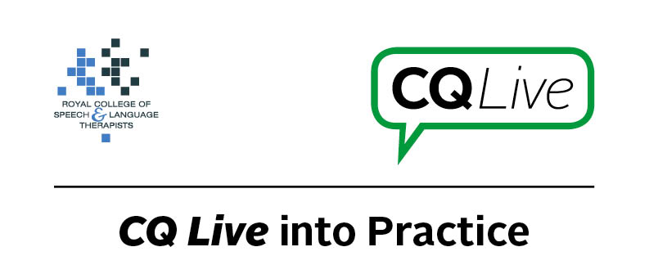
Recommended AAC app

About this document
This document is designed to take you through a practice-based scenario to help you reflect on what you might do if faced with a similar situation. It can be used to guide your thoughts and prompt discussion with your colleagues. Working through this document counts towards your continuing professional development (CPD). Your reflections on this document are not assessed and you do not have to send your responses to the RCSLT.
You can work through it on your own, with a colleague or supervisor, or in groups, eg as part of an RCSLT Hub or Clinical Excellence Network.
This document is broken into five parts:
- The scenario: for you to read
- The issues to consider: for you to gather your thoughts on practice issues relating to this scenario
- Next steps: for you to plan out what you would need to do next
- Prompts for consideration: RCSLT prompts for further consideration
- Sources of further information: links to CQ Live themes
- Update your CPD diary: for you to do

- The scenario

You are treating a patient with a severe communication impairment following a stroke which is affecting their expressive and receptive language, reading and writing.
A family member would like you to recommend an AAC app they could use to communicate but you feel that this may be inappropriate given the severity of the patient’s communication difficulties and their cognitive deficits.
What do you do in this scenario?

- The issues to consider

What do you need to consider?
Think about the above scenario and its implications and jot down your notes about issues you may need to consider. Please feel free to use extra sheets of paper if you need. Or, if you are in a group, you may like to record on a whiteboard or flipchart.

- Next steps

What steps do you think you need to take next?

- Prompts for consideration

The use of AAC can be challenging for individuals with aphasia due to language impairment and often a difficulty understanding categories. It is likely that individuals with cognitive difficulties may have further issues.
Apps with simple grids and a reduced need for intact categorisation skills, visual scene display apps as well as apps with pre-stored phrases may be better options for individuals with language and/or cognitive impairments.
An AAC assessment should be carried out to determine if the individual may be able to use a form of AAC. Training should be given to the individual with aphasia and family members.
High-tech AAC is not appropriate for every individual and in some cases low-tech AAC such as simple communication charts, talking photo albums and topic boards are more suitable.
It is recommended that you think about the following prompt questions and formulate a considered strategy to deal with the problem.
Remember that if you are faced with a similar situation you will need to think about it in relation to the frameworks within which you work, such as the Health and Care Professions Council (HCPC) Standards, RCSLT professional guidance and resources, local and national policies and also policies of your employer (or your own policies if practising independently). Communicating Quality Live (www.rcslt.org/cq_live) and the list of prompts that follow, will help with your thinking.
Please note that this list is not exhaustive and does not constitute legal advice.
Prompt questions to consider
- Does the family member have a good understanding of the patient’s communication difficulties?
- Has the family member observed a treatment session with the individual to gain a better understanding of their communication difficulties?
- Does the family member have an understanding of the abilities/skills the patient would need to have in order to successfully use an AAC app?
- Has the patient been trialed with low-tech AAC?
- Has an AAC assessment been carried out?
Possible next steps
- Provide more education to family, including supported conversation strategies.
- Suggest a low-tech option that could be trialled, eg photo book, simple communication chart, topic board.
- Carry out an AAC assessment to help determine what may be most appropriate.
- Explain the types of high-tech AAC apps that are available, and why they may be difficult for the patient to use.
- Explain to the relative that using an inappropriate app may be detrimental to the individual’s general wellbeing and confidence if they are unable to use this.
- If appropriate, explore possible AAC apps that may best meet the needs of the individual and provide a trial.
- Provide training to the individual and the family member if an AAC app is chosen following a successful trial.

- Sources of further information

Communicating Quality Live (http://www.rcslt.org/cq_live)
The following areas of professional practice within CQ Live are particularly relevant:
1 - Promote and safeguard the interests of service users and carers
http://www.rcslt.org/cq_live/service_user_interests/service_user_interests
2 - Communicate appropriately and effectively http://www.rcslt.org/cq_live/communication/communicate_appropriately_and_effectively

- Update your CPD diary

Working through this scenario counts towards your continuing professional development (CPD). Once you have completed this scenario, please record this learning and your reflections in your CPD diary.

