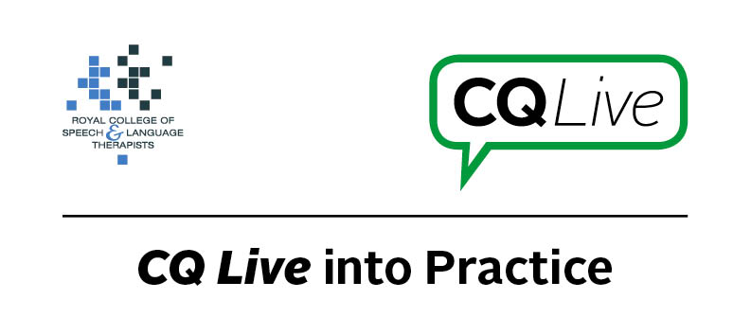
Confidentiality and tablet use

About this document
This document is designed to take you through a practice-based scenario to help you reflect on what you might do if faced with a similar situation. It can be used to guide your thoughts and prompt discussion with your colleagues. Working through this document counts towards your continuing professional development (CPD). Your reflections on this document are not assessed and you do not have to send your responses to the RCSLT.
You can work through it on your own, with a colleague or supervisor, or in groups, eg as part of an RCSLT Hub or Clinical Excellence Network.
This document is broken into five parts:
- The scenario: for you to read
- The issues to consider: for you to gather your thoughts on practice issues relating to this scenario
- Next steps: for you to plan out what you would need to do next
- Prompts for consideration: RCSLT prompts for further consideration
- Sources of further information: links to CQ Live themes
- Update your CPD diary: for you to do

- The scenario

Your trust has bought iPads but does not yet allow therapists to use them with clients. This is due to concerns about them possibly accessing patient confidential information.

What do you do in this scenario?

- The issues to consider

What do you need to consider?
Think about the above scenario and its implications and jot down your notes about issues you may need to consider. Please feel free to use extra sheets of paper if you need. Or, if you are in a group, you may like to record on a whiteboard or flipchart.

- Next steps

What steps do you think you need to take next?

- Prompts for consideration

Concerns often arise about confidentiality when using tablet devices in schools, hospitals and speech and language therapy departments. It is important to ensure that appropriate confidentiality measures are taken. Therapists should therefore have an understanding of how confidentiality can be ensured.
It is recommended that you think about the following prompt questions and formulate a considered strategy to deal with the problem.
Remember that if you are faced with a similar situation you will need to think about it in relation to the frameworks within which you work, such as the Health and Care Professions Council (HCPC) Standards, RCSLT professional guidance and resources, local and national policies and also policies of your employer (or your own policies if practising independently). Communicating Quality Live (www.rcslt.org/cq_live) and the list of prompts that follow, will help with your thinking.
Please note that this list is not exhaustive and does not constitute legal advice.
Prompt questions to consider
- Do you save an individual’s personal photos, videos or information on a device that has multiple users?
- If so, have you gained written consent from the client? Are they aware that personal photos are being stored on a shared device?
- Do you interact with clients when they are using the apps and monitor what they are looking at/accessing?
- Have you considered using Guided Access feature if using an iOS device and Sure Lock if using an Android tablet?
Possible next steps
- To lock an iPad to single-app use, implement Guided Access. Consider the Sure Lock app if using an Android tablet.
- Generally avoid storing a patient/student’s personal photos and videos on a device that has multiple users. If, however, your department has one iPad and you wish to store personal photos of individuals within an app to support their communication/for use in therapy, gain written consent and ensure that your information governance departments agrees. In such cases, there needs to be a balance between possible benefits and confidentiality.
- Ensure that you are interacting with the individual when they are using a tablet device.
- Add a passcode to tablet devices.
- Discuss with the trust why this restriction is in place. Read further guidance on confidentiality when using apps in the Role of Apps in Speech and Language Therapy and explain to the trust how you will manage the risk of confidentiality breaches.

- Sources of further information

Communicating Quality Live (http://www.rcslt.org/cq_live)
The following areas of professional practice within CQ Live are particularly relevant:
1 - Promote and safeguard the interests of service users and carers
http://www.rcslt.org/cq_live/service_user_interests/service_user_interests
2 - Communicate appropriately and effectively http://www.rcslt.org/cq_live/communication/communicate_appropriately_and_effectively
6 - Manage risk
http://www.rcslt.org/cq_live/manage_risk/manage_risk
The Role of Apps in Speech and Language Therapy, Common Issues and Concerns
http://www.rcslt.org/cq_live/resources_a_z/apps_directory/apps

- Update your CPD diary

Working through this scenario counts towards your continuing professional development (CPD). Once you have completed this scenario, please record this learning and your reflections in your CPD diary.

