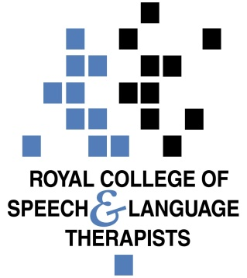

National Assembly for Wales Children, Young People and Education Committee consultation on Flying Start
Executive Summary
The Royal College of Speech and Language Therapists (RCSLT) Wales welcomes the opportunity to respond to the Children, Young People and Education Committee’s consultation on Flying Start. Given the strong relationship between social disadvantage and early language delay, the Flying Start programme has prioritised speech, language and communication. Speech and language therapists (SLTs) have played a key role in programme delivery with an SLT employed at every Flying Start team in Wales.
Our response below has been developed with feedback from the Clinical Excellence Network of Flying Start SLTs. It reflects on learning from our involvement in the programme and responds to the three questions posed within the terms of reference.
Key recommendations to the Children, Young People and Education Committee
- The committee should recognise the positive impact of the prioritisation of speech, language and communication within the Flying Start programme.
- The committee should recommend a broader, cross-cutting response to early language development. Such a response should prioritise;
- developing options for extending early language support for children living in poverty outside of Flying Start settings
- ensuring training and frameworks for childcare practitioners have a focus on supporting language rich environments and
- maximising all opportunities to ensure parents, carers and the wider workforce understand the importance of speech, language and communication are exploited and key public health messages are shared e.g. parenting campaigns.

About the Royal College of Speech and Language Therapists

- RCSLT is the professional body for speech and language therapists, SLT students and support workers working in the UK. The RCSLT has 17,500 members in the UK (500 in Wales) representing approximately 95% of SLTs working in the UK (who are registered with the Health & Care Professions Council). We promote excellence in practice and influence health, education, care and justice policies.

- Speech and Language Therapy manages the risk of harm and reduces functional impact for people with speech, language and communication support needs and/ or swallowing difficulties.

- Speech and Language Therapists are experts in supporting children with speech, language and communication needs and training the wider workforce and families so that they can identify the signs of speech, language and communication needs (SLCN), improve communication environments and provide effective support.

Background

- Good early language skills are central to children’s early years development and school readiness. They play a crucial role in literacy, a child’s ability to achieve their educational potential, their social mobility, and their life chances. However not all children have the speech, language, and communication skills they need to fully engage with their education. It is estimated that 10% of all children in the UK have long-term, persistent speech, language and communication needs (ICAN, 2006). Research shows that children living in poverty suffer disproportionately from transient early language delay (Law, 2013). Children affected by transient early language delay are those whose language skills are developing significantly more slowly than those of other children of the same age but who do not have a specific disorder. Language skills are a critical factor in the intergenerational cycles that can perpetuate poverty as poor communication skills are passed down from parent to child (Hart and Risley, 2003).

Key facts

- Over 50% of children in socially deprived areas may start school with impoverished speech, language and communication skills (Locke, Ginsborg, Peers, 2002)
- Researchers have found that, after controlling for a range of other factors that might have played a part (mother’s educational level, overcrowding, low birth weight, parent a poor reader, etc), children who had normal non-verbal skills but a poor vocabulary at age 5 were at age 34 one and a half times more likely to be poor readers or have mental health problems and more than twice as likely to be unemployed as children who had normally developing language at age 5 (Law, 2010).
- Vocabulary at age 5 found to be the best predictor (from a range of measures at age 5 and 10) of whether children who experienced social deprivation in childhood were able to ‘buck the trend’ and escape poverty in later adult life (Blanden, 2006).

- The consequences of not supporting children’s early language skills, and not identifying long-term or persistent speech, language and communication needs, can lead to a range of potentially negative outcomes later in life, relating to educational achievement, mental health, employability and social inequality. Research shows that:

- Up to 60% of young people in the youth justice estate have communication difficulties (Bryan et al, 2007).
- 88% of long-term unemployed young men in the South Wales Valleys have speech, language and communication needs (Elliott, 2009).
- Without effective help, a third of children with speech, language and communication difficulties will need treatment for mental health problems in adult life (Clegg et al, 1999).

The outreach element of Flying Start

- Each Flying Start area has a set budget for outreach (2.5% of uplift since 2012). There are a number of different ways in which this can be spent according to Welsh Government Outreach Guidance which may include providing services to children moving out of Flying Start areas with medium-high needs, services to Refuges and Homeless Hostels which are located in Flying Start areas and services to traveller communities. Our members have told us that the outreach element varies significantly across local authority areas with a request for funding for childcare by far the most popular outreach application. Historically, certain Flying Start projects have provided services in small areas not included in the original Flying Start Lower Super Output Areas (LSOAs) but which have been identified as benefiting from the service due to the nature of the area and their proximity to the LSOA eligible streets. A number of Flying Start services are being offered to Flying Start children that have entered the care system and moved out of the designated Flying Start area whilst in foster placement. However, as budgets tighten, there is increasing pressure to decline requests for outreach. This is against a backdrop of increasing demand for outreach services.

- As the research we highlighted in section 1 shows, children living in poverty suffer disproportionately from transient early language delay (Law,2013). Hard to reach families tend to face more challenges in creating communication and language rich home learning environments. There has been significant progress in Wales in recent years on early language development. To support this key strand of work within the Flying Start programme, a SLT was seconded into Welsh Government for six months to write the evidence-based programme guidance document on speech, language and communication. In addition, a SLT has been employed at every Flying Start team in Wales. Part of the role of the therapist is both to upskill the early years workforce in these areas and to improve parents’ knowledge and skills to support children’s early language development. As we note in paragraph 9 below, this investment is having a significant impact on outcomes for our poorest children. However we remain concerned that many young children living in poverty in Wales are unable to access the support offered by Flying Start given the limitations around outreach. Too many are entering school without the speech, language and communication skills needed to fully access the Foundation Phase. This is borne out by recent research shared by Professor Sir Michael Marmott at the Bevan Commission conference on the development of children by the end of the reception year which highlighted that poorer children are performing better in poorer areas than poorer children in richer areas.

- In the view of RCSLT, the consequences of not supporting children’s early language skills, and not identifying long-term or persistent speech, language and communication needs are harmful enough to necessitate a broader, cross-cutting response. Such a response should prioritise;

- ensuring that the training and quality assurance frameworks developed for childcare practitioners have a focus on supporting language rich environments and are developed in partnership with SLTs.
- ensuring all opportunities to ensure parents, carers and the wider workforce understand the importance of speech, language and communication are exploited and key public health messages are shared e.g. via health visitors, parenting programmes and campaigns.
- developing options for extending early language support for children living in poverty outside of Flying Start settings, making best use of resource.

In Northern Ireland a strategic post has been created to ensure a cross cutting approach to early language development across portfolios. We believe there would be significant potential to consider a similar role in Wales to ensure the necessary focus and expertise on this key area. We would also welcome publication of the refresh of the Welsh Government Building a Brighter Future Early Years and Childcare Plan with a renewed focus on early language development.

The evidence on outcomes for parents and children in Flying Start areas compared to the outcomes for parents and children in areas that are most similar in terms of deprivation but are not Flying Start areas

- As highlighted above, given the strong correlation between disadvantage and early language delay, the Flying Start programme has prioritised speech, language and communication, employing an SLT at every Flying Start project in Wales. The positive outcomes of this model are already becoming clear. In 2015, the Bridgend Flying Start Speech and Language Therapists (SLTs) won an NHS Wales award for their work in reducing language delay in two and three year olds. The SLTs worked with Flying Start nurseries in Bridgend to achieve a significant reduction in the number of children with delayed language skills. Out of over 600 children screened on starting nursery, 73% were assessed as having significant language delay, which would impact on future learning development. After the interventions delivered by nursery staff which were planned and supported by the Flying Start SLTs, 68% of the children with the worst language delay had improved (Jones,2015).

- Further evidence from Torfaen has also highlighted the impact of the investment in SLT in Flying Start. Figures released in April this year have revealed that 54% of children were assessed as having significant language delay pre-intervention, aged 18 months. Following the intervention, the children were screened again at 3 years. 85% of children screened were assessed as having age appropriate language skills with 8% recorded as having significant language delay (Butler, 2017).

- The following graph shows progress made in closing the gap between those children in receipt of free school meals and those not in receipt of free school meals at the end of Year 2 in Ceredigion, which is helpful in terms of considering outcomes for children living in poverty in both Flying Start and non-Flying Start areas. Caution should be applied when looking at these figures given the small numbers and need to collate several years of similar results. However the results clearly show the shift in the progress of those children entitled to support from Flying Start, when compared to their peers (Rees, 2017).

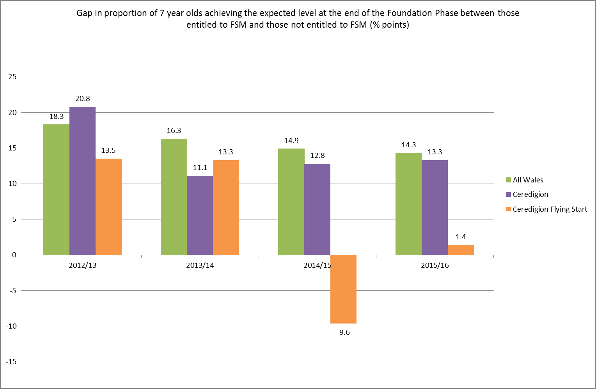

Further Information

- We would be happy to provide any additional information required to support the Committee’s decision making and scrutiny. For further information, please contact:

Dr Caroline Walters
Policy Officer, Wales
029 2039 7729/ caroline.walters@rcslt.org

References
Blanden, J. (2006) Bucking the Trend – What enables those who are disadvantaged in childhood to succeed later in life? London: Department for Work and Pensions.
Bryan K, Freer J, Furlong C. Language and communication difficulties in juvenile offenders. International Journal of Language and Communication Difficulties 2007; 42, 505-520.
Butler C (2017). Torfaen Flying Start Speech and Language Service : Performance Evaluation Report.Start Speech and Language Service : Performance Evaluation Report Torfaen Flying Start Speech and Language Service : Performance Evaluation Report
Clegg J, Hollis C, Rutter M. Life Sentence. RCSLT Bulletin 1999; 571, 16-18.
Elliott N (2009) Interim results from PhD in preparation. An investigation into the communication skills of long-term unemployed men.
Hart B & Risley T.R (2003). The early catastrophe: The 30 million word gap by 3. American Educator, 27 (1), 4 -9
ICAN Talk Series – Issue 2. (2009) The Cost to the Nation of Children’s Poor Communication. ICAN
Jones, Rebecca (2015). Reducing the impact of language delay on two to three year olds in Bridgend. Abertawe Bro Morgannwg University Health Board: Swansea. http://www.nhswalesawards.wales.nhs.uk/previous-nhs-wales-awards-winners

Law, J, Todd, L, Clark, J, Mroz, M and Carr, J (2013a) Early Language Delays in the UK. Save the Children
Law, J. et al (2010) Modelling developmental language difficulties from school entry into adulthood. Journal of speech, language and hearing research, 52, 1401-1416
Locke A, Ginsborg J, Peers I. (2002) Development and disadvantage: Implications for the early years and beyond, International Journal of Language and Communication Disorders, 37(1), pp. 3-15.

Rees R (2017). Results Based Accountability Framework for Service: Reaching Potential – Early Language Development – Speech and Language Therapy (Ceredigion)

Professor Sir Miachel Marmott (2017). Presentation at the Bevan Foundation Conference September 2017. Awaiting further information on references.

