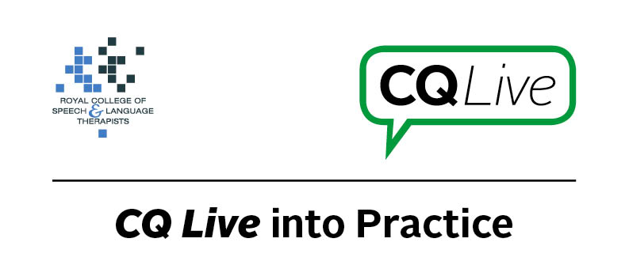
Email attachments

About this document
This document is designed to take you through a practice-based scenario to help you reflect on what you might do if faced with a similar situation. It can be used to guide your thoughts and prompt discussion with your colleagues. Working through this document counts towards your continuing professional development (CPD). Your reflections on this document are not assessed and you do not have to send your responses to the RCSLT.
You can work through it on your own, with a colleague or supervisor, or in groups, eg as part of an RCSLT Hub or Clinical Excellence Network.
This document is broken into five parts:
- The scenario: for you to read
- The issues to consider: for you to gather your thoughts on practice issues relating to this scenario
- Next steps: for you to plan out what you would need to do next
- Prompts for consideration: RCSLT prompts for further consideration
- Sources of further information: links to CQ Live themes
- Update your CPD diary: for you to do

- The scenario

A parent has been emailing you video clips of their child in different situations such as interacting with child peers, family members and out in public. Are there any professional practice issues you need to consider?
What do you do in this scenario?

- The issues to consider

What do you need to consider?
Think about the above scenario and its implications and jot down your notes about issues you may need to consider. Please feel free to use extra sheets of paper if you need. Or, if you are in a group, you may like to record on a whiteboard or flipchart.

- Next steps

What steps do you think you need to take next?

- Prompts for consideration

If a parent is sending you videos of their child you need to be sure that those who have been filmed have given their consent otherwise there may be a data protection issue. There may also be concerns around safeguarding of the child as they may be identifiable and the network over which the videos have been sent may not be secure.
You will need to consider carefully what you do with the videos once they are in your possession. Will you delete them? Do you need to keep the videos for clinical reasons? If so, what are your data protection guidelines and is the parent aware of the processes and potential risks? You will need to think of appropriate ways to discuss these issues with the parent.
It is recommended that you think about the following prompt questions and formulate a considered strategy to deal with the problem.
Remember that if you are faced with a similar situation you will need to think about it in relation to the frameworks within which you work, such as the Health and Care Professions Council (HCPC) Standards, RCSLT professional guidance and resources, local and national policies and also policies of your employer (or your own policies if practising independently). Communicating Quality Live (www.rcslt.org/cq_live) and the list of prompts that follow, will help with your thinking.
Please note that this list is not exhaustive and does not constitute legal advice.
Prompt questions to consider
- Consider if there are any breaches to the Data Protection Act.
- Safeguarding issues – is there likely to be any risk here?
- What are the security issues? For example, does your email system have good security protocols? If you need to store media, do you have systems in place to do so securely?
- Why are the parents doing it? Have you asked for the videos or are they unsolicited?
- Is there consent from the parents to use the videos? If so, is it documented or implied?
- What could be the ongoing benefits/drawbacks of the parents sharing videos?
- Have the other people in the videos given their consent to it being shared?
- Is there a document trail for this?
- Independent practitioners are unlikely to have as extensive IT safeguards as NHS systems.
Possible next steps
- Alert your line manager if employed.
- Find out if there is a policy for receiving emails, images and videos from service users. If there are no policies, raise this as an issue. (Any policies should be able to support the Data Protection Act, ie storing data securely, processing adequately and disposing effectively when no longer needed.)
- If you are practising independently, ensure there is a policy in place for receiving emails, images and videos from service users.
- Complete an incident report.
- Consider your processes to ensure there is no recurrence unless you need the videos – in which case consider whether there is an alternative and secure way of gathering this information.
- Talk with the parents about potential risks regarding using and emailing videos, and alternative options. Discuss the ethical and security issues.
- If clinically relevant, ask parents for permission to store files in a secure location.
- Use encryption and secure email if video data is clinically indicated.
- Make a note in client’s record to ensure clear document trail.
- Review whether your employer has a process in place for secure transfer.
- Clarify access to the video (eg can it be shared with other professionals in their care?).

- Sources of further information

Links to CQ Live themes
Communicating Quality Live (http://www.rcslt.org/cq_live)
The following areas of professional practice within CQ Live are particularly relevant:
1 - Promote and safeguard the interests of service users and carers
http://www.rcslt.org/cq_live/service_user_interests/rcslt_guidance/rcslt_guidance
5 - Respect confidentiality
http://www.rcslt.org/cq_live/respect_confidentiality/rcslt_guidance/rcslt_guidance
6 - Manage risk
http://www.rcslt.org/cq_live/manage_risk/rcslt_guidance/rcslt_guidance
10 - Keep records of their work
http://www.rcslt.org/cq_live/record_keeping/rcslt_guidance/rcslt_guidance

- Update your CPD diary

Working through this scenario counts towards your continuing professional development (CPD). Once you have completed this scenario, please record this learning and your reflections in your CPD diary.

