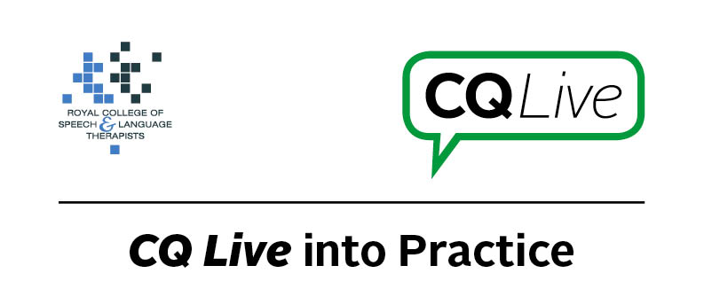
Facebook friends

About this document
This document is designed to take you through a practice-based scenario to help you reflect on what you might do if faced with a similar situation. It can be used to guide your thoughts and prompt discussion with your colleagues. Working through this document counts towards your continuing professional development (CPD). Your reflections on this document are not assessed and you do not have to send your responses to the RCSLT.
You can work through it on your own, with a colleague or supervisor, or in groups, eg as part of an RCSLT Hub or Clinical Excellence Network.
This document is broken into five parts:
- The scenario: for you to read
- The issues to consider: for you to gather your thoughts on practice issues relating to this scenario
- Next steps: for you to plan out what you would need to do next
- Prompts for consideration: RCSLT prompts for further consideration
- Sources of further information: links to CQ Live themes
- Update your CPD diary: for you to do

- The scenario

A teenage service user who has an extreme stammer contacts you through Facebook, asking to be your friend. You know that they suffer with anxiety and depression.
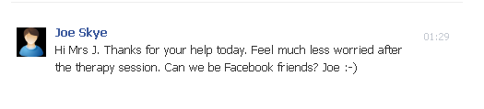
What do you do in this scenario?

- The issues to consider

What do you need to consider?
Think about the above scenario and its implications and jot down your notes about issues you may need to consider. Please feel free to use extra sheets of paper if you need. Or, if you are in a group, you may like to record on a whiteboard or flipchart.

- Next steps

What steps do you think you need to take next?

- Prompts for consideration

This is a scenario that SLTs may face as social media blurs boundaries between people’s professional and home lives. Key in this particular scenario is to ensure that you maintain professional boundaries while ensuring that the young man gets the support he needs in the appropriate way.
It is recommended that you think about the following prompt questions and formulate a considered strategy to deal with the problem.
Remember that if you are faced with a similar situation you will need to think about it in relation to the frameworks within which you work, such as the Health and Care Professions Council (HCPC) Standards, RCSLT professional guidance and resources, local and national policies and also policies of your employer (or your own policies if practising independently). Communicating Quality Live (www.rcslt.org/cq_live) and the list of prompts that follow, will help with your thinking.
Please note that this list is not exhaustive and does not constitute legal advice.
Prompt questions to consider
- Does the HCPC have regulations about this type of scenario?
- Is there local guidance about this type of scenario?
- Does your employment contract (if employed) cover this scenario?
- If you are practising independently, do you have a social media policy?
- Are there safeguarding issues?
- Is it ethical to get involved?
- What should the key differences be between online and off-line relationships with clients?
- Does the client have a good support network?
- What is the client’s current level of wellbeing?
- What is the client’s likely response to a polite decline?

Possible next steps
- Work with the client regarding relationships and the concept of friendships. For example, talk about relationship circles.
- Consider your own use of social media. Would it be appropriate to have separate work and home social media accounts?
- Do you need to take any steps regarding the personal information the client may have already been able to view?
- Discuss with the client and colleagues other possible sources of online support.

- Sources of further information

Communicating Quality Live (http://www.rcslt.org/cq_live)
The following areas of professional practice within CQ Live are particularly relevant:
1 - Promote and safeguard the interests of service users and carers
http://www.rcslt.org/cq_live/service_user_interests/rcslt_guidance/rcslt_guidance
2 - Communicate appropriately and effectively
http://www.rcslt.org/cq_live/communication/rcslt_guidance/rcslt_guidance
5 - Respect confidentiality
http://www.rcslt.org/cq_live/respect_confidentiality/rcslt_guidance/rcslt_guidance
6 - Manage risk
http://www.rcslt.org/cq_live/manage_risk/rcslt_guidance/rcslt_guidance
7 - Report concerns about safety
http://www.rcslt.org/cq_live/report_concerns/rcslt_guidance/rcslt_guidance

- Update your CPD diary

Working through this scenario counts towards your continuing professional development (CPD). Once you have completed this scenario, please record this learning and your reflections in your CPD diary.

