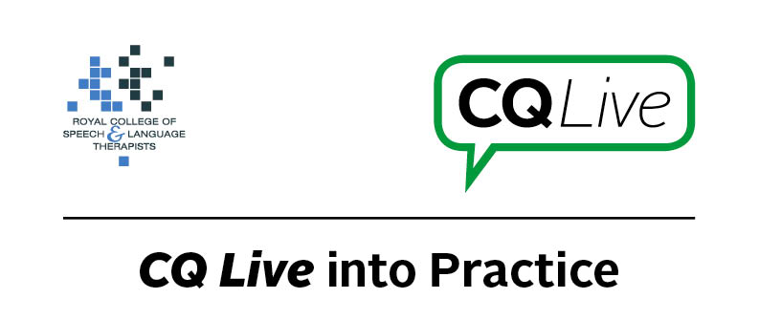
Facebook privacy

About this document
This document is designed to take you through a practice-based scenario to help you reflect on what you might do if faced with a similar situation. It can be used to guide your thoughts and prompt discussion with your colleagues. Working through this document counts towards your continuing professional development (CPD). Your reflections on this document are not assessed and you do not have to send your responses to the RCSLT.
You can work through it on your own, with a colleague or supervisor, or in groups, eg as part of an RCSLT Hub or Clinical Excellence Network.
This document is broken into five parts:
- The scenario: for you to read
- The issues to consider: for you to gather your thoughts on practice issues relating to this scenario
- Next steps: for you to plan out what you would need to do next
- Prompts for consideration: RCSLT prompts for further consideration
- Sources of further information: links to CQ Live themes
- Update your CPD diary: for you to do

- The scenario

You are a member of a Facebook group about carers of people with selective mutism. You open the group pages to see there is a post from a parent about their child – a young boy – accompanied by his photo and where he is being treated.
What do you do in this scenario?

- The issues to consider

What do you need to consider?
Think about the above scenario and its implications and jot down your notes about issues you may need to consider. Please feel free to use extra sheets of paper if you need. Or, if you are in a group, you may like to record on a whiteboard or flipchart.

- Next steps

What steps do you think you need to take next?

- Prompts for consideration

A key concern in this scenario is that the message, though well-meaning, could have repercussions. The child in this case would be traceable as their name and where they are being treated is in the public domain, which brings up safeguarding issues. Further to this, the child is already vulnerable due to their selective mutism diagnosis.
You would need to carefully assess factors such as how the family is prepared to share the information on social media, how well you know the family, and whether you could provide guidance to prevent it from happening again.
It is recommended that you think about the following prompt questions and formulate a considered strategy to deal with the problem.
Remember that if you are faced with a similar situation you will need to think about it in relation to the frameworks within which you work, such as the Health and Care Professions Council (HCPC) Standards, RCSLT professional guidance and resources, local and national policies and also policies of your employer (or your own policies if practising independently). Communicating Quality Live (www.rcslt.org/cq_live) and the list of prompts that follow, will help with your thinking.
Please note that this list is not exhaustive and does not constitute legal advice.
Prompt questions to consider
- Are there safeguarding issues, ie is a vulnerable child being made more vulnerable?
- Do you need to document the risks?
- What are the short- and long-term implications of a post like this on social media?
- How long will this conversation remain online?
- Is this conversation likely to be widely shared, ie is it a closed group?
- How do you explain the importance of confidentiality clearly and concisely to parents?
- Is your role clear within the group?
- Should you be a member of the group as a professional?
- Is the boy on your caseload?
- What support is the family looking for in this case, and could it be provided without sharing this confidential information?
- How old is the child – what rights does he have?
Possible next steps
- Consider speaking to the group moderator about removing the specific posts or making them private.
- Ask the group moderator to ensure that the rules are re-defined to cover this issue (or reinforced if they are already in place). This includes emphasising the risks of posting personal information. If this is a family you know, consider speaking with them about the risks.

- Sources of further information

Communicating Quality Live (http://www.rcslt.org/cq_live)
The following areas of professional practice within CQ Live are particularly relevant:
1 - Promote and safeguard the interests of service users and carers
http://www.rcslt.org/cq_live/service_user_interests/rcslt_guidance/rcslt_guidance
2 - Communicate appropriately and effectively http://www.rcslt.org/cq_live/communication/communicate_appropriately_and_effectively
5 - Respect confidentiality
http://www.rcslt.org/cq_live/respect_confidentiality/rcslt_guidance/rcslt_guidance
6 - Manage risk
http://www.rcslt.org/cq_live/manage_risk/manage_risk

- Update your CPD diary

Working through this scenario counts towards your continuing professional development (CPD). Once you have completed this scenario, please record this learning and your reflections in your CPD diary.

