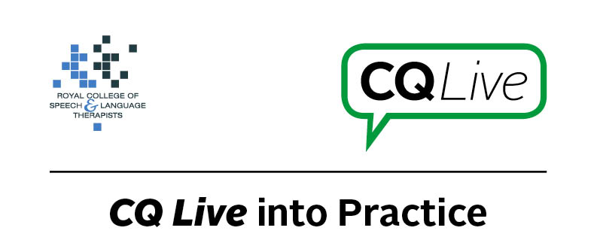
Incorrect advertising of services

About this document
This document is designed to take you through a practice-based scenario to help you reflect on what you might do if faced with a similar situation. It can be used to guide your thoughts and prompt discussion with your colleagues. Working through this document counts towards your continuing professional development (CPD). Your reflections on this document are not assessed and you do not have to send your responses to the RCSLT.
You can work through it on your own, with a colleague or supervisor, or in groups, eg as part of an RCSLT Hub or Clinical Excellence Network.
This document is broken into five parts:
- The scenario: for you to read
- The issues to consider: for you to gather your thoughts on practice issues relating to this scenario
- Next steps: for you to plan out what you would need to do next
- Prompts for consideration: RCSLT prompts for further consideration
- Sources of further information: links to CQ Live themes
- Update your CPD diary: for you to do

- The scenario

You come across a new website promoting a local independent speech and language therapy practice. The concern you have is that the two newly-qualified practitioners are advertising themselves as specialists in SLI, autism, dysphagia, cerebral palsy and stroke.
What do you do in this scenario?

- The issues to consider

What do you need to consider?
Think about the above scenario and its implications and jot down your notes about issues you may need to consider. Please feel free to use extra sheets of paper if you need. Or, if you are in a group, you may like to record on a whiteboard or flipchart.

- Next steps

What steps do you think you need to take next?

- Prompts for consideration

Newly-qualified practitioners (NQPs) are not allowed by law to practise as speech and language therapists. Only those who are qualified (ie have passed their NQP competencies) and are registered with the Health and Care Professions Council (HCPC) are allowed to use this title. There is a risk to the safety of patients being treated by these NQPs. It is also a risk to the NQPs to be practising this way as they are not covered by insurance for things which may go wrong.
It is recommended that you think about the following prompt questions and formulate a considered strategy to deal with the problem.
Remember that if you are faced with a similar situation you will need to think about it in relation to the frameworks within which you work, such as the Health and Care Professions Council (HCPC) Standards, RCSLT professional guidance and resources, local and national policies and also policies of your employer (or your own policies if practising independently). Communicating Quality Live (www.rcslt.org/cq_live) and the list of prompts that follow, will help with your thinking.
Please note that this list is not exhaustive and does not constitute legal advice.
Prompt questions to consider
- What are the regulatory (HCPC) standards relating to this scenario?
- Is there local or employer guidance around this issue?
- What are the risks to the NQPs and their patients?
- Have you documented the risks?
- Is there a need to report concerns?
- How did you know these therapists were NQPs – is this clearly stated on their website and other advertising literature, and does it make a difference to your decision making if they do state this?
- Are the NQPs linking to other organisations, and if so does this affect your next steps?

Possible next steps
- Report the situation to your line manager or supervisor or, if you are working independently, speak to other professionals in your networks to get their opinion.
- Seek advice from ASLTIP.
- Consider contacting the NQPs to advise them about the HCPC rules about the need to be fully qualified and registered before practising as a speech and language therapist.

- Sources of further information

Communicating Quality Live (http://www.rcslt.org/cq_live)
The following areas of professional practice within CQ Live are particularly relevant:
1 - Promote and safeguard the interests of service users and carers
http://www.rcslt.org/cq_live/service_user_interests/rcslt_guidance/rcslt_guidance
3 - Work within the limits of their knowledge and skills
http://www.rcslt.org/cq_live/Knowledge_and_skills/rcslt_guidance/rcslt_guidance
6 - Manage risk
http://www.rcslt.org/cq_live/manage_risk/manage_risk
7 - Report concerns about safety
http://www.rcslt.org/cq_live/report_concerns/rcslt_guidance/rcslt_guidance
9 - Be honest and trustworthy
http://www.rcslt.org/cq_live/be_honest_and_trustworthy/rcslt_guidance/rcslt_guidance

- Update your CPD diary

Working through this scenario counts towards your continuing professional development (CPD). Once you have completed this scenario, please record this learning and your reflections in your CPD diary.

