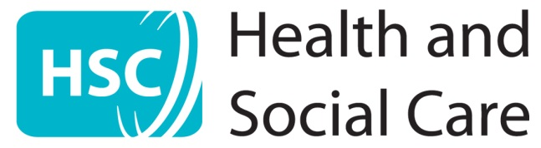

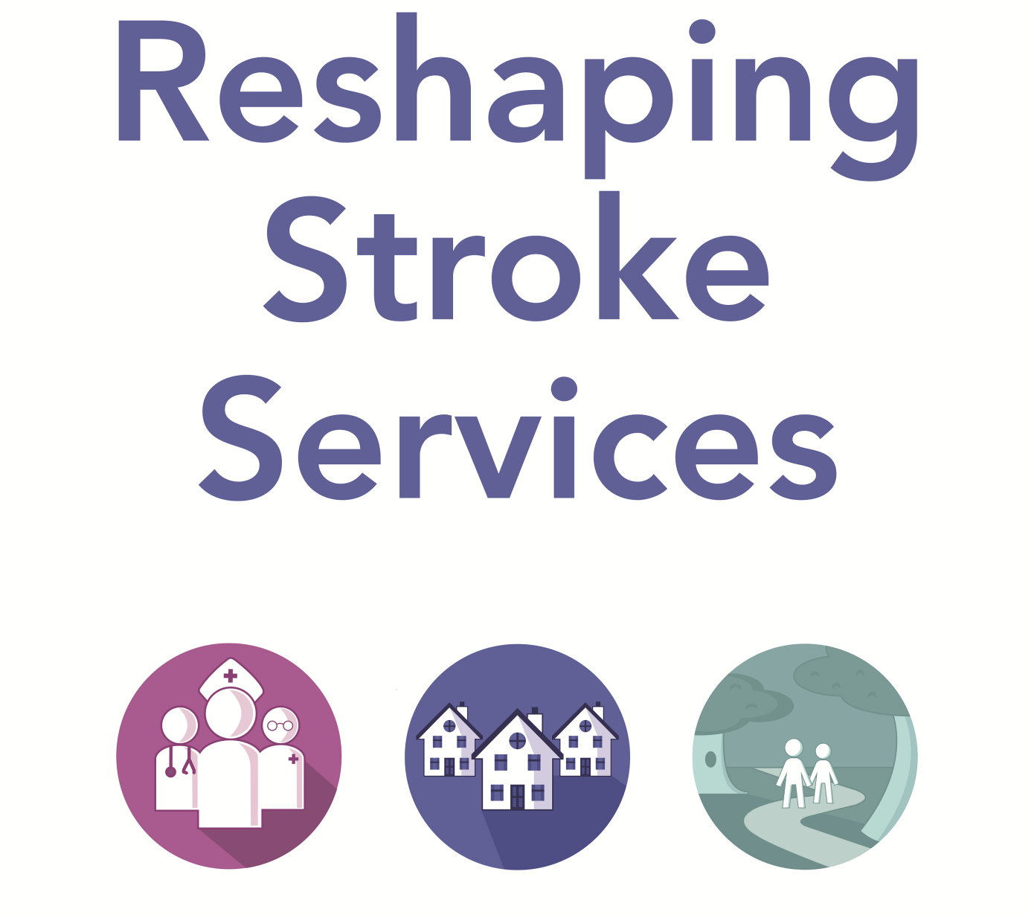
RESPONSE QUESTIONIARE
Responses must be submitted by 5pm 15 September 2017

Response Questionnaire
It is important to fully involve people and consider their opinions about these proposals. In particular we are keen to hear from people who may be using stroke services or those caring for people who have used stroke services, people who are working in affected services, and groups representing people who might be affected.
Here are some of the ways that you can respond to this document:
- Email us at ReshapingStroke@hscni.net

- Write to us at:
Reshaping Stroke Services
Health and Social Care Board
12-22 Linenhall Street
Belfast
BT2 8BS
- Complete the questionnaire online at
www.hscboard.hscni.net/response-form-stroke
- Attend specially arranged meetings details of which can be found at
www.hscboard.hscni.net/stroke
Before you submit your response please read the annex of this document regarding the confidentiality of responses in the context of the Freedom of Information Act 2000.
Please tell us if you are responding on your own behalf or on behalf of an organisation by placing a tick in the appropriate box:
I am responding as an individual

I am responding on behalf of an organisation ✓

As a member of health and social care staff

Name | Peter Gregg
Title | Policy Officer  –Royal College of Speech and Language Therapists
 | Royal College of Speech and Language Therapists
Address | Arthur House
 | Belfast
 | BT1 4GB
Telephone | 02890446385
Email

May we contact you to get further information on your response?
Yes ✓
No

Question 1

Do you agree with proposal 1?
Provide seven day assessment for patients at an appropriate number of Stroke Units for patients experiencing a suspected TIA.

Agree | Neither agree or disagree | Disagree
✓
Comments
Yes – but this will only be fully effective if TIA assessed ‘at risk’ patients are clearly identified and properly assessed at primary care level. RCSLT is particularly concerned about the results of a recent audit that showed that 29% of high risk patients were not assessed within the recommended 24 hours.
Primary care services would need to be enhanced to ensure that suspected transient ischemic attack (TIA) patients who require rapid access to stroke specialists seven days a week can access this service through primary care as well as presenting themselves at emergency departments (ED).
General practitioner (GP) referrals of TIA to stroke specialist units in the current primary care model can result in a five day a week service only. The consultation document offers little insight into how this will be addressed.

Question 2

Do you agree with proposal 2?
Provide assessment for clot busting treatment ‘thrombolysis’ on an appropriate number of sites.

Agree | Neither agree or disagree | Disagree
✓
Comments
Yes however how are you planning to achieve this?
Equality of access across Northern Ireland to clot busting drugs should be a top priority for any reorganisation.
The 60 minute criteria needs to build in factors such as potential for road delays, access to transport, and the predominance of rural road networks in NI.
Public and political buy-in is essential. Without this, reconfiguration will fail, as history has shown.
Thrombolysis treatments are only suitable for a certain number of stroke patients. Other interventions need to be available in tandem immediately following assessment such as screening for eating, drinking and communication difficulties.
Early assessment and intervention by a speech and language therapist (SLT) can have maximum impact in addressing language and swallowing impairment during the acute phase of stroke recovery.

Question 3
Do you agree with proposal 3?
Provide a clot removal service ‘mechanical thrombectomy’ 24 hours a day and seven days a week for suitable patients.

Agree | Neither agree or disagree | Disagree
✓
Comments
Yes – the Royal College of Speech and Language Therapists (RCSLT) welcomes the proposal to reorganise stroke services to enable better access to mechanical thrombectomy. It is not clear how equality of access to patients living outside the Royal Victoria Hospital (RVH) catchment area will be achieved especially as a mechanical thrombectomy service needs to be co-located with other highly specialist neuro-related services to be effective.

Question 4

Do you agree with proposal 4?
Provide an appropriate number of Hyperacute Stroke Units to deliver specialist early inpatient care to every stroke patient.

Agree | Neither agree or disagree | Disagree
✓
Comments

The RCSLT welcomes the proposal around larger, better equipped and resourced Hyperacute Stroke Units (HSUs).
It is very clear that more HSUs in addition to the RVH will be needed.
As noted above under proposal two timing for patients who live outside the 60 minute ‘zone’ around the RVH need equality of access. This equality should extend to access to SLTs, as part of the multi-disciplinary expert team involved in early assessment and treatment.

Question 5

Do you agree with proposal 5?
Establish an appropriate number of Acute Stroke Units co-located with Hyperacute Stroke Units whenever possible.

Agree | Neither agree or disagree | Disagree
✓
Comments
Yes.
Acute stroke units, preferably co-located with HSUs, are the only way to ensure that morbidity and mortality rates within a specialist stroke unit framework are reduced.
Early intervention by an SLT is crucial to address any language and swallowing impairment during the acute phase of stroke recovery and is best achieved in an acute stroke unit setting.
Whilst important, the number and location of the acute stroke units is only part of the picture. The RCSLT would like to see detailed proposals on how both HSUs and ASUs will operate and be resourced.

Question 6

Do you agree with proposal 6?
Provide community stroke services that are resourced to deliver Early Supported Discharge, the recommended amounts of therapy and respond over seven days.

Agree | Neither agree or disagree | Disagree
✓
Comments
Yes.
The intention to increase survival rates by improving stroke mortality will ultimately result in greater pressures on community services. Therefore sufficient weight and emphasis needs to be placed on ensuring that community stroke services will be able to meet increasing demands. The availability of regular, consistent and adequate speech and language therapy is essential to support Early Supported Discharge.
HSUs and ASUs are likely to face significant pressures to discharge patients as early as possible from hospital.
RCSLT has clear evidence of the need for adequate follow-up specialist care, for example over one third of stroke survivors have persistent speech, language or communication problems with 11% suffering from persistent swallowing difficulties. The RCSLT consider that a new configuration of stroke services should place equal emphasis upon delivering high quality specialist interventions in the community to ensure that individuals achieve their maximum re-ablement potential.

Question 7

Do you agree with proposal 7?
Ensure that stroke survivors and carers have timely access to services from both Health and Social Care and voluntary sector organisations to optimise recovery.

Agree | Neither agree or disagree | Disagree
✓
Comments
Yes
The stroke care pathway provided by statutory and non statutory bodies must be seamless. This requires clear lines of responsibility, good communication, accountability and leadership. Our members in statutory and voluntary organisations describe the importance of giving stroke survivors and their carers bespoke options along the care pathway according to their needs at given points.
Patients and carers value early and frequent attention to their difficulties. Partnership working can achieve this but only if properly resourced and managed.

Additional Comments

Additional comments on the information contained within this document can be included here.

General Comments
- The RCSLT welcomes this review and broadly agrees with the proposals outlined. It is very clear however that a deeper analysis of issues, detailed service descriptions and planning is required.
- Stroke services in Northern Ireland need a well thought out and systematic overhaul. Both nationally and locally steps to strengthen stroke policy and improve service delivery is a key aspirational aim for RCSLT. Whilst death rates from stroke have declined by around 50% in the past 20 years, problems associated with the current delivery model demonstrate that there is room for significant improvement.
- Unfortunately changing demographics are likely to result in a significant increase in the number of stroke patients in NI given that three out of four people who experience stroke are over the age of 65.
- An increase in survival rates will require increased resourcing by acute and community multidisciplinary teams.
- Speech and Language therapists are predominantly involved in dealing with the complex needs of post-stroke patients. They play a vital role at all stages along the care pathway from immediate acute care to long term rehabilitation.

RCSLT would like offer the additional comments under each of the proposals that we hope are helpful and can be addressed in more detail in the full consultation.

Proposal 1. Provide seven day assessment at an appropriate number of Stroke Units for patients experiencing a suspected TIA.
RCSLT supports any measure that deals much more effectively with patients deemed to be at risk of a TIA or major stroke, at primary care level and through a continuation of health awareness public campaigns. Educating a growing older population to be more aware of the signs of a stroke and to know how to reduce their own vulnerability, should be prioritised. Changes in a person’s speech language and communication are one of the earliest signs of stroke and the general public could benefit from a more strategic approach to early stroke detection, which includes information about speech, language and communication changes. SLTs are acutely aware of the devastating impacts on patients and their families that a stroke can bring and in that regard the RCSLT would support measures, to be outlined in the full consultation document, that reduce the incidents of stroke and promote earlier awareness of the signs of stroke.

RCSLT recommends a more strategic approach to educating the general public about changes in speech, language and communication as early warning signs of a stroke.

Proposal 2. Provide assessment for clot busting treatment ‘thrombolysis’ on an appropriate number of sites.
Speech and Language therapists have a key role to play in the hours and days immediately following a stroke. RCSLT recognises that equality of access across Northern Ireland to clot busting drugs and related specialist treatments should be a top priority for any reorganisation. We cautiously welcome the proposal to deliver this through a smaller number of better equipped EDs with more centralised and accessible expertise. The current configuration of service delivery that too often dictates survival and consequential impacts of a stroke according to geographical location is unacceptable in a modern health service. However, we are concerned that the pre-consultation document has a focus on medical interventions in ED and makes very little reference to the need for early 24/7 SLT or other allied health professions (AHPs) input. RCSLT is aware that only one health and social care trust (HSCT) currently provides SLT in ED and this provision is only funded on a pilot basis, six days per week.

As part of any reconfiguration RCSLT recommends that the proposals for emergency care should also reference equality of access to SLT intervention in ED units to screen for eating, drinking and communication difficulties.

Proposal 3. Provide the clot removal procedure ‘mechanical thrombectomy’ 24 hours a day and seven days a week for suitable patients.

No further comments

Proposal 4. Provide an appropriate number of Hyperacute Stroke Units to deliver specialist early inpatient care to every stroke patient.

RCSLT recommends that these units should be adequately resourced by SLTs to ensure equality of access for screening of eating, drinking and communication difficulties from the outset.

Proposal 5. Establish an appropriate number of Acute Stroke Units co-located with Hyperacute Stroke Units whenever possible.
RCSLT has undertaken extensive research on the staffing levels and models of best practice for acute stroke units.

The RCSLT recommends that in an acute stroke unit there must be one speech and language therapist for every ten people who have had a stroke. Every stroke survivor must have prompt referral to speech and language therapy to allow rapid development of methods of communication in the immediate days following a stroke.

In the full consultation, RCSLT would like to see a clear policy description, strong commitment and more detail about the size and make up of teams that will operate both the HASUs and ASUs. These units will only be effective if they have the right number and expertise of multi-disciplinary staff to provide the quality of service that underpin any reorganisation. Speech and language therapists and other professional groups need to be consulted and closely involved in any reconfiguration proposals.

The RCSLT calls on the HSC board to develop a comprehensive workforce plan to set benchmarks and minimum standards as part of this reshaping plan and to work with professional bodies to ensure appropriate minimum staffing levels.

Proposal 6. Provide community stroke services that are resourced to deliver Early Supported Discharge, the recommended amounts of therapy and respond over seven days.

The RCSLT has significant evidence to demonstrate the benefits of SLT support to stroke patients in community settings. These include:
- Early identification of dysphagia to prevent aspiration and readmission to hospital.
- Ensuring stroke survivors have acess to communication methods to enable them to demonstrate their capacity, make choices and live independently.
- Ensuring accessible communication environments by training carers and family members to use appropriate communication models.
- Helping patients reduce or avoid depression and improve overall care experience.
- Better functional outcomes.
- Communication therapy to improve health and mental well being.
Targeted speech and language therapy can reduce impairment and improve the ability to communicate. SLTs have a significant role to play in the rehabilitation phase of the care pathway. We need to close the gap that exists between hospitals and community that results in individuals waiting too long for follow up speech and language therapy and other support services. To provide early supported discharge from stroke units, it is essential that there are adequate specialist stroke SLTs working in the community. The RCSLT would like to see this need fully analysed and encompassed into a workforce plan that will form part of the reshaping services proposals. The economic benefits of patients spending fewer days in hospital through greater access to more intensive rehabilitation at home also needs to be better understood and fully costed.

RCSLT recommends a review of current SLT provision in early discharge teams and a commitment to ensure regionally equitable and adequate specialist community stroke SLT provision.

Proposal 7. Ensure that stroke survivors and carers have timely access to services from both Health and Social Care and voluntary sector organisations to optimise recovery.

RCSLT acknowledges that the needs of post-stroke patients vary. Many will require ongoing intervention of a specialist speech and language therapist to work on specific speech and language deficits, others may need interventions that deal with enabling communication skills to prepare for returning to work, social activities, confidence building and supporting living adjustments.

In all cases consideration must be given to individuals’ overall post-stroke profile through detailed assessment in order to target therapy through tailored responses. Patients and carers value early and frequent attention to their difficulties and we agree that a range of statutory and voluntary organisations working in partnership and in a joined-up approach can deliver this.

It is important that a reconfiguration of stroke services recognises that whilst saving lives in the acute phase of recovery is paramount, resources and expertise to enable stroke survivors to have a life worth living must also be a priority. The RCSLT is concerned that the pre-consultation document mainly focuses on medical/acute provision and does not sufficiently address the post acute stage and rehabilitation needs of the stroke survivor. Reshaping Stroke services must encompass both.

The RCSLT recommends that proposals are balanced at all stages in the stroke care pathway and we look forward to seeing further detail in the full consultation document.

Annex Confidentiality
Freedom of Information Act (2000) – Confidentiality of Consultations
It is expected that we will publish a summary of responses following the completion of this engagement exercise. Your responses and all other responses may be disclosed on request. We can only refuse to disclose information in exceptional circumstances.
Before you submit your response, please read the paragraphs below on the confidentiality as they will give you guidance on the legal position about any information given by you in response to this pre-consultation.
The Freedom of Information Act gives the public a right of access to any information held by a public authority, namely, the Health and Social Care Board (HSCB) in this case. This right of access to information includes information provided in response this pre-consultation. The HSCB cannot automatically consider as confidential information supplied to it in response this pre-consultation. However, it does have the responsibility to decide whether any information provided by you in response to this pre-consultation, including information about your identity should be made public or be treated as confidential.
This means that information provided by you in response to this pre-consultation is unlikely to be treated as confidential, except in very particular circumstances. The Lord Chancellor’s Code of Practice on the Freedom of Information Act provides that:
The HSCB should not agree to hold information received from third parties “in confidence” which is not confidential in nature. Acceptance by the HSCB of confidentiality provisions must be for good reasons, capable of being justified to the Information Commissioner.
For further information about confidentiality of responses please contact The Information Commissioner's Office, or see website at: https://www.gov.uk/government/organisations/information-commissioner-s-office.

