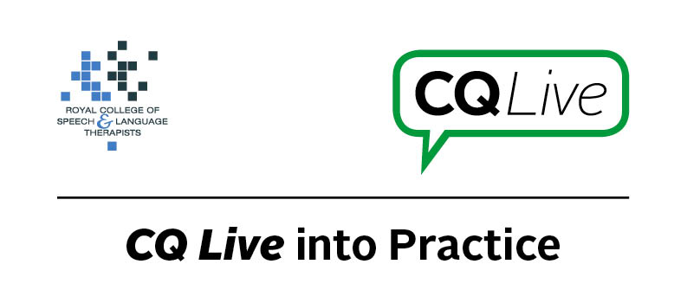
Screen time for children

About this document
This document is designed to take you through a practice-based scenario to help you reflect on what you might do if faced with a similar situation. It can be used to guide your thoughts and prompt discussion with your colleagues. Working through this document counts towards your continuing professional development (CPD). Your reflections on this document are not assessed and you do not have to send your responses to the RCSLT.
You can work through it on your own, with a colleague or supervisor, or in groups, eg as part of an RCSLT Hub or Clinical Excellence Network.
This document is broken into five parts:
- The scenario: for you to read
- The issues to consider: for you to gather your thoughts on practice issues relating to this scenario
- Next steps: for you to plan out what you would need to do next
- Prompts for consideration: RCSLT prompts for further consideration
- Sources of further information: links to CQ Live themes
- Update your CPD diary: for you to do

- The scenario

You are using an app with a child in a speech therapy session.
The parent says that they do not wish for you to use the app as they are concerned about the amount of screen time their child has.

What do you do in this scenario?

- The issues to consider

What do you need to consider?
Think about the above scenario and its implications and jot down your notes about issues you may need to consider. Please feel free to use extra sheets of paper if you need. Or, if you are in a group, you may like to record on a whiteboard or flipchart.

- Next steps

What steps do you think you need to take next?

- Prompts for consideration

Given the increasing number of available apps for use in speech and language therapy and the increased frequency of use of technology in general by children, some parents may worry that the amount of time their child/children spend using technology could be detrimental to their language development. It is important to try to balance any concerns with the potential benefits of using an app in therapy.
It is recommended that you think about the following prompt questions and formulate a considered strategy to deal with the problem.
Remember that if you are faced with a similar situation you will need to think about it in relation to the frameworks within which you work, such as the Health and Care Professions Council (HCPC) Standards, RCSLT professional guidance and resources, local and national policies and also policies of your employer (or your own policies if practising independently). Communicating Quality Live (www.rcslt.org/cq_live) and the list of prompts that follow, will help with your thinking.
Please note that this list is not exhaustive and does not constitute legal advice.
Prompt questions to consider
- What is the stated purpose of the app that you are using?
- What is the benefit of using an app for this therapy task, as opposed to other materials?
- Are you interacting with the child when using the app?
- Is the parent aware of the importance of interacting with their child when they are using an app?
- Does the parent understand why you are using the app?
- How frequently do you use apps in therapy with the child compared to other materials?
- How much screen time does the child typically have at home?
- Are there any current guidelines on screen use for that age group?
- Does the child have any visual fatigue issues that may restrict their use of the app?
Possible next steps
- Acknowledge that you understand the parent’s concerns.
- Explain why you are using the app with the child and the possible benefits.
- Note that you will be interacting with the child when they are using the app.
- Ensure that the parent has an understanding of the importance of interacting with their child when they are using an app.
- Ask the parent how much screen time the child has per day.
- Consider discontinuing using the app with the child and investigate other materials that potentially could be used if the parent remains concerned.

- Sources of further information

Communicating Quality Live (http://www.rcslt.org/cq_live)
The following areas of professional practice within CQ Live are particularly relevant:
2 - Communicate appropriately and effectively http://www.rcslt.org/cq_live/communication/communicate_appropriately_and_effectively
6 - Manage risk
http://www.rcslt.org/cq_live/manage_risk/manage_risk
The Role of Apps in Speech and Language Therapy, Common Issues and Concerns
http://www.rcslt.org/cq_live/resources_a_z/apps_directory/apps_common_issues_and_concerns

- Update your CPD diary

Working through this scenario counts towards your continuing professional development (CPD). Once you have completed this scenario, please record this learning and your reflections in your CPD diary.

