Name and address of school
Dear [headteacher name]

Careers information for your students: Speech and Language Therapy
I am contacting you to offer to talk to, or provide information to, your students about a professional career as a speech and language therapist. As a small healthcare profession we know that most teenagers have not heard of speech and language therapy and if they have they might think it is only about helping children who stammer! They may not realise that you need a degree to become a speech and language therapist. It is really important to us to encourage students from all backgrounds to consider it as a career so the profession can better reflect the diversity of the populations they serve.
If your school has a careers fair, or perhaps a day when professionals are invited to talk to students, we hope you might consider whether we can contribute to those. In addition, our professional body, The Royal College of Speech and Language Therapists, has a careers guide available aimed at teenagers Speech and language therapy careers guide . You are welcome to circulate this link.
We are enthusiastic and keen to engage with potential students in our own locality to promote our profession, so we hope to hear from you about how we can help.
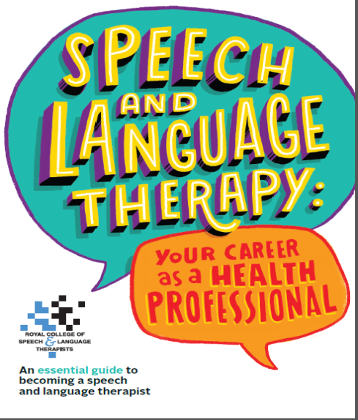
Kind regards

