Setting up for a tele-swallow session
- Position the camera on a table so that there is a good image of your face and the therapists face (see image below).
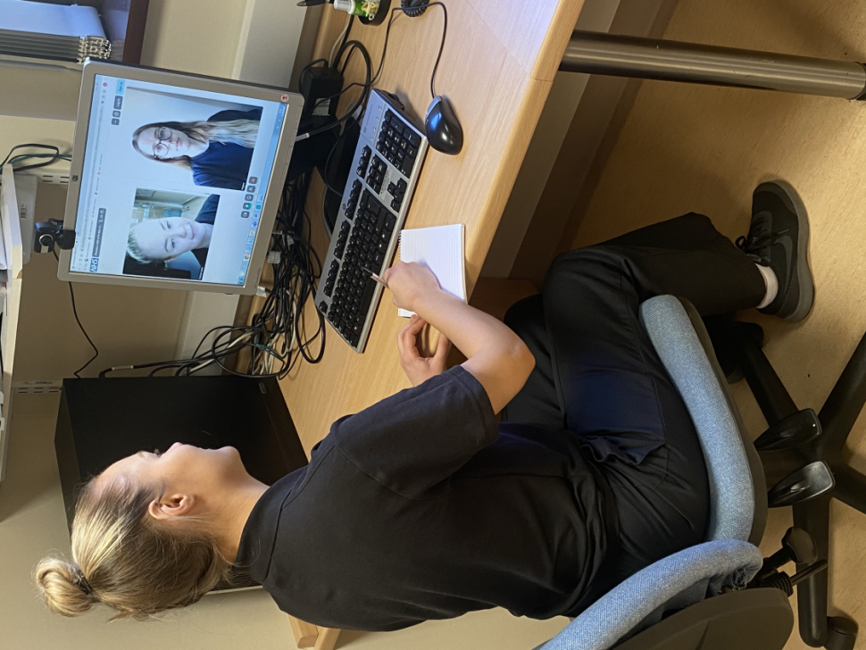

- Position the patients chair directly behind the table.
- Position another chair next to the patient’s chair behind/at the side of the table for you to sit at during the assessment to support the patient.
- Have all the resource’s that the speech and language therapist asked for you to prepare ready on a table next to you. For example any food, drinks or a torch that the speech therapist might ask.
- The speech and language therapist will send you a text when they are ready.
- You will get a message that sends you a link to the video call. Please click on that and wait for the speech and language therapist to start the session.
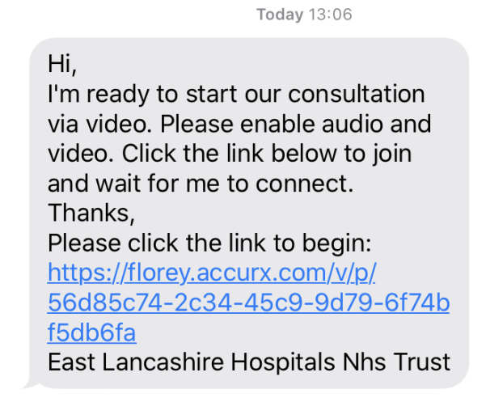

- You and the clinician can then check that the microphone and speakers are working with you when the video consultation starts.
During the session the speech and language therapist might ask you to move the camera around so they can get the best view of your swallowing. Here are some ways they may ask your to move the camera.
1.Full face view - used for general interaction and facial and lip exercises during oromotor assessment. | 2. Close up of mouth - used for assessment of oral cavity, tongue and soft palate function during the oromotor assessment.  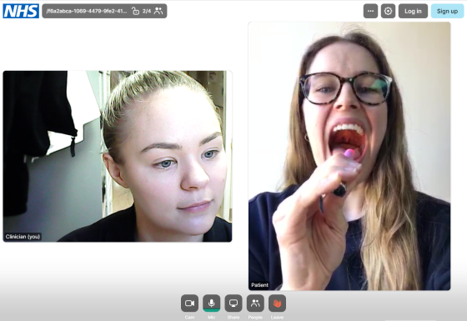 | 3.Side/lateral view of head and neck - use for viewing introduction of food/fluid into the oral cavity, mastication and swallowing function.

