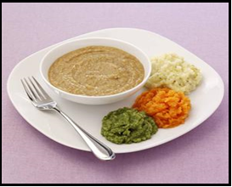  MINCED & MOIST  (LEVEL 5)  Pre-mashed with some texture/small lumps, needs very little chewing. |  | SLIGHTLY THICK FLUIDS  (LEVEL 1)  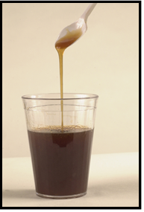  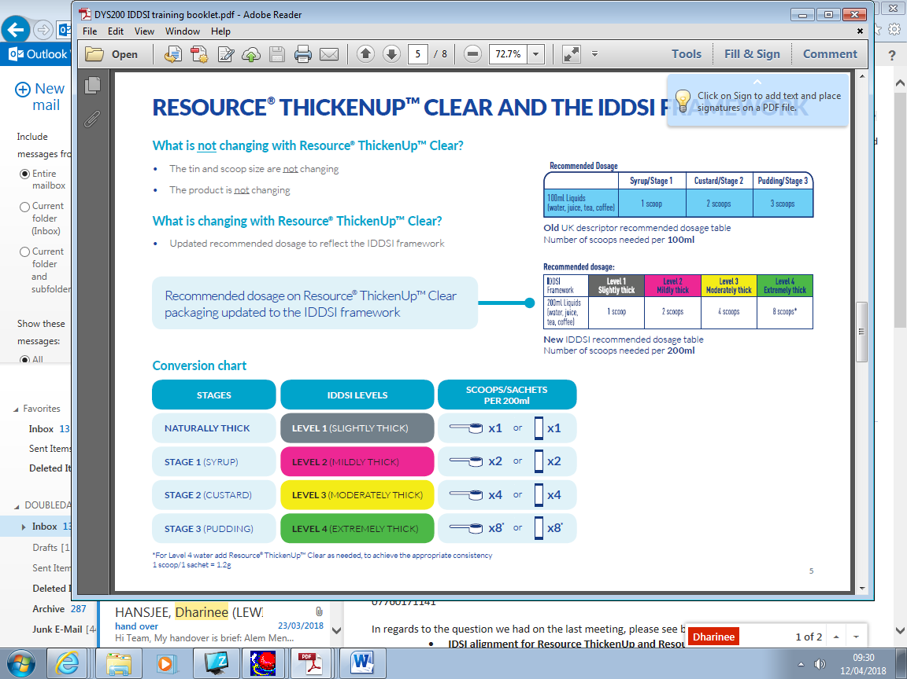  1 SCOOP thickener  per 200ml

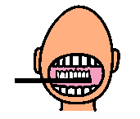  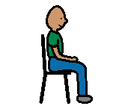    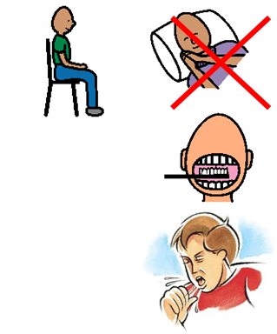 | Must be SAT UPRIGHT and ALERT  ORAL CARE after meals  Stop if COUGHING or WET VOICE
OTHER:

SPEECH & LANGUAGE THERAPY DEPARTMENT
Patient: Date: SLT:

